Accessibility Guide for Greenlands Barn Self Catering Accommodation
greenlandsfarm@outlook.com, 01787224895, www.greenlandsfarm@outlook.com
Contact for accessibility enquiries: Carol Williams
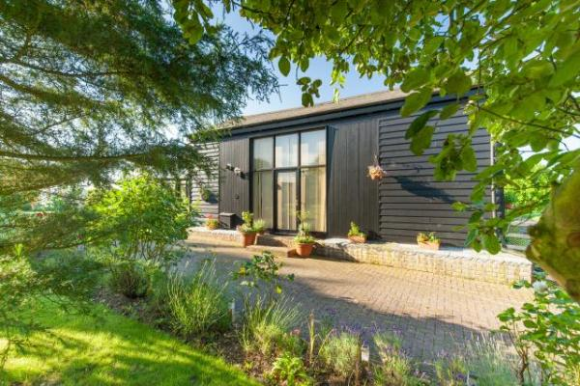

Welcome
Greenlands Barn is a wooden converted barn down a no through road in a rural area one mile from Great Tey.
All accommodation is on the ground floor.

At a Glance

Level Access
- The main entrance has 2 steps. There is no lift and no ramp.
- There is level access from the main entrance to:
  - Greenlands Barn Lounge

Access with steps
- There are steps from the main entrance to:
  - Greenlands Barn gardens

Bedrooms
- We have non-allergic bedding.

Level access bedrooms
- From the main entrance to the bedroom, there is level access.
- The route to the bedroom is 750mm wide, or more.

Visual
- The walls and the doors have high colour contrast.

Getting here
Greenlands Farm
Lamberts Lane, Earls Colne
Colchester
CO6 2LE

Arrival

Path to main entrance
- From the street to the main entrance, there is level access.
- The path is 1828mm wide, or more.

Main entrance
- The door is 780mm wide.
- The main entrance has 2 steps.
- The main door is side hung and manual.
- When you arrive, we can help carry your luggage.

Getting around inside

Visual Impairment - General Information
- We have high colour contrast between walls and doorframes.

Bedrooms
- All bedrooms have windows.
- Bedrooms have ceiling lights, bedside lamps and natural daylight.
- Lights are LED. All bedrooms are non-smoking.
- We have non-allergic bedding.
- All bedrooms have fitted carpets.
- From the main entrance to this area, there is level access.
- The direction of transfer onto the toilet is to the front only.

Self catering kitchen

Greenlands Barn Kitchen
- We have a separate kitchen and dining room. From the main entrance to the kitchen, there is level access.
- The route is 1000mm wide, or more.
- The door is 650mm wide.
- The work surface is available at a height between 650mm and 900mm.
- The hob is available at a height between 650mm and 900mm.
- The sink is available at a height between 650mm and 900mm.
- The oven is available at a height between 650mm and 900mm.
- From the main entrance to the dining room, there is level access. The route is 1000mm wide, or more.

Lounge

Greenlands Barn Lounge
- From the main entrance to the lounge, there is level access.
- Main entrance is to the lounge, there is no separate door to the lounge.

Getting around outside

Greenlands Barn gardens
- From the main entrance to the gardens, there are 2 steps. There is no lift and no ramp.

Terrace

Greenlands Barn Terrace
- To get to a table, there are 2steps steps.

Customer care support

Accessibility equipment
- None
- For assistance dogs there are many country footpaths nearby.

Emergency evacuation procedures
- We have emergency evacuation procedures for disabled visitors.

Guide last updated: 25 March 2021

