Accessibility Guide for The Dairy
Admin@rowhornefarm.co.uk, 07590480590, www.amberleighcottages.co.uk
Contact for accessibility enquiries: Brett Varker
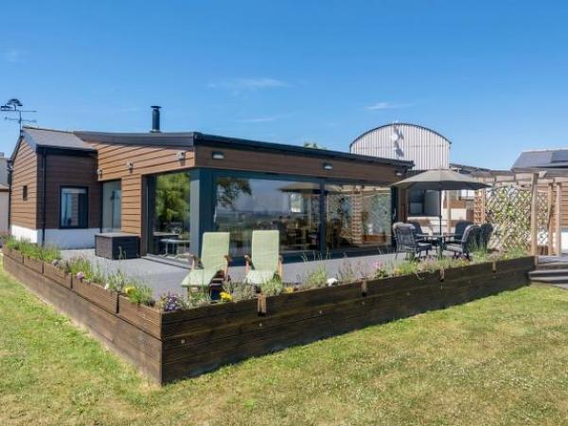

Welcome
The Dairy is a Barn conversion completed in 2017 and provides all of the accommodation on one level, with level access from the parking area to the entrance door. There are two double bedrooms (one with En-Suite Shower room) and one twin bedroom plus a family Bathroom. There is an open plan Lounge/Kitchen/Dining area with floor to ceiling windows to make the most of the panoramic views of the countryside, estuary views and distant sea views.
There is a large decking area with level access from the Lounge area and a shallow ramp down to the terraced lawn area.

At a Glance

Level Access
- There is level access from the main entrance to:
  - Bedroom: Master Bedroom
  - Lounge Area
  - Decking Area
  - Lawn Area

Bedrooms
- We have non-allergic bedding.

Level access bedrooms
- From the main entrance to the bedroom, there is level access.
- The route to the bedroom is 750mm wide, or more.
- The bedroom door is 750mm wide, or more.
- There is unobstructed floor space 1200mm by 900mm, or more.

Hearing
- The (bedroom) TVs have subtitles.
- Some staff have disability awareness training.

Visual
- Glass doors have contrast markings.
- The walls and the doors have high colour contrast.

General
- Some staff have disability awareness training.

Getting here
The Dairy, Rowhorne Farm
Rowhorne Road, Nadderwater
Exeter
EX4 2 LQ

Travel by taxi
- You can get a taxi with Apple Taxi's by calling 01392 666666. The taxi company has a wheelchair accessible vehicle.
- You can get a taxi with Sowton & Topsham Cars by calling 01392 879090.

Parking
- We have a car park. There are accessible parking spaces. The parking is less than 50 metres from the main entrance. Parking is free.
- There is a drop-off point at the main entrance. The drop-off point has a dropped kerb.
- From the car park to the entrance, there is level access. The route is 7000mm wide, or more.
- Car Parking is directly in front of the front entrance door to the cottage.
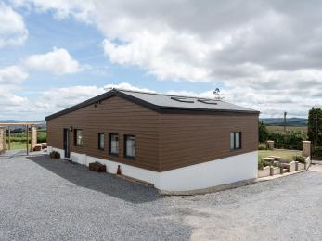
Parking is directly outside of The Dairy

Arrival

Path to main entrance
- From the street to the main entrance, there is level access.
- The path is 5500mm wide, or more.
- The path is sloped.

Main entrance
- The main entrance has level access.
- The door is 820mm wide.
- The main door is side hung and manual.
- When you arrive, we can help carry your luggage.
- We are happy to assist visitors with taking their luggage between their vehicle and the cottage.
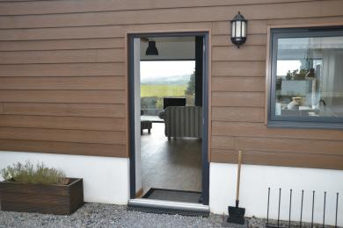
Front Entrance door of The Dairy

Getting around inside

Visual Impairment - General Information
- We have contrast markings on all glass doors and high colour contrast between walls and doorframes.

Bedrooms
- All bedrooms have windows.
- Bedrooms have ceiling lights, wall lights, bedside lamps, desk or table lamps and natural daylight.
- Lights are energy saving. TVs have subtitles.
- All bedrooms are non-smoking.
- We have non-allergic bedding.
- No bedrooms have fitted carpets.
- We do not allow pets in the cottages or the farm in order to minimise any allergic reactions for visitors.
- From the main entrance to this area, there is level access.
- The direction of transfer onto the toilet is to the front only.

Accessible bedrooms

Accessible bedroom Master Bedroom
- The route to the bedroom is 820mm wide, or more. The bedroom door is 730mm wide. There is 900mm at the side of the bed. The bed is 580mm high. There is 240mm under the bed.
- The bedroom is double. The bathroom is ensuite. The bathroom door is 740mm wide.
- The bathroom has a separate shower. The bathroom has a bath with an overhead shower. The bathroom has a bath.
- The direction of transfer onto the toilet is to the right. There is 240mm at the side of the toilet.
- There is 880mm in front of the toilet. The toilet seat is 440mm high.
- The basin is 830mm high. The taps are lever operated. There is no space under the basin.
- The walls and the bathroom fittings have high colour contrast.
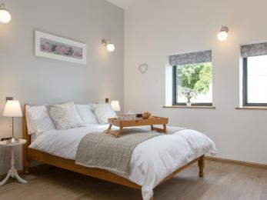
Master Bedroom
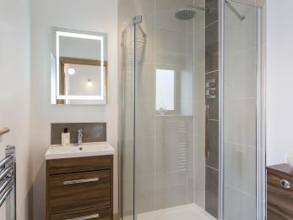
En-Suite Shower Room

Self catering kitchen

Kitchen Area
- We have an open plan kitchen.
- From the main entrance to the kitchen, there is level access.
- The route is 820mm wide, or more.
- The door is 820mm wide.
- The work surface is available with clear underspace.
- The oven is available at a height between 650mm and 900mm.
- The table and plates have high colour contrast.
- We have white and grey crockery and the table and worktops have a wood effect colour.

Lounge

Lounge Area
- From the main entrance to the lounge, there is level access. The route is 820mm wide, or more. The door is 820mm wide.
Front Entrance door into the Lounge/Kitchen/Dining area.

Getting around outside

Terrace

Decking Area
- From the main entrance to this area, there is level access. The route is 820mm wide, or more.
- The entrance is 1300mm wide.
- To get to a table, there are no steps.
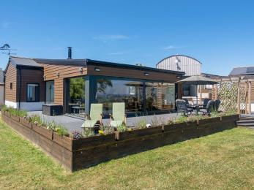
Decking Area

Lawn Area
- From the main entrance to this area, there is level access. There is a permanent ramp. The route is 1300mm wide, or more. The entrance is 1300mm wide.
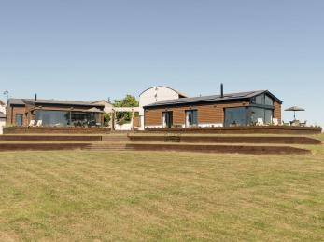
Lawn Area

Customer care support

Accessibility equipment
- For a list of more items, please go to http://www.nursingequipmenthiresouthwest.co.uk.
- The nearest toilet area for assistance dogs is approximately 100m away from the cottage in a field area, which is laid to permanent pasture. This area is up a slight slope from the cottage.
- You can hire mobility equipment from Nursing Equipment Hire by calling 01271 859144.

Emergency evacuation procedures
- We have emergency evacuation procedures for disabled visitors.

Customer care support
- Some staff have disability awareness training.

Guide last updated: 26 March 2021

