Accessibility Guide for Waterfoot Caravan Park
bookings@waterfootpark.co.uk, 01768425597, waterfootpark.co.uk
Contact for accessibility enquiries: Steven McAvoy, Manager
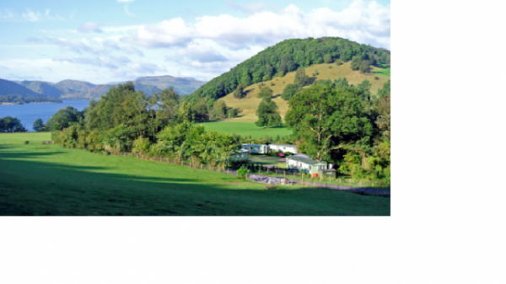

Welcome
Waterfoot Park is located just outside the village of Pooley Bridge, and a stone's throw from England's most beautiful lake, Ullswater. Our park is home to a collection of self-catering cottages, hive cabins, and glamping pods - many of which are dog-friendly - and with touring pitches for caravans, and holiday homes for sale, we are the perfect choice for both short and long-term stays in the Lake District.
Watch the video: Waterfoot Park, Pooley Bridge

At a Glance

Level Access
- The main entrance has level access with a ramp. The ramp is permanent.
- There is level access from the main entrance to:
  - Reception/Shop/office
  - Laundry
  - Mansion Bar
  - Waterfoot Shop/Reception
  - Play Park

Hearing
- The fire alarm has flashing lights.
- We have a hearing loop in located inside the reception/shop facility.
- Some staff have Next Generation Text and disability awareness training.

Visual
- Glass doors and full-height windows have contrast markings.
- The walls and the doors have high colour contrast.
- We have information in large print.

General
- Staff are available 24 hours a day.
- Some staff have disability awareness training.
- We have emergency evacuation procedures for disabled visitors.

Getting here
Lake District Estates Co. Ltd Waterfoot park
Soulby
Penrith
CA11 0JF

Travel by public transport
- You can get to Waterfoot Caravan Park by bus and train.
- The local bus route number is the 508 and the nearest bus stop to the park is 0.5 miles / 0.8 km located at the Ullswater Steamer Pier, Pooley Bridge. The walk to the site is either along A592 with no safe footpath or via a public footpath however please note that this path is uneven and not pushchair or wheelchair friendly. The bus stop is 0.5 miles / 0.8 km from Waterfoot Caravan Park.
- The nearest train station is Penrith. The train station is 5.2 miles / 8.4 km from Waterfoot Caravan Park.
- The nearest train station is Penrith which is 5.2 miles by car.

Travel by taxi
- You can get a taxi with bluebell Taxies by calling 07594 311421.

Parking
- We have a car park. There are accessible parking spaces. The parking is less than 50 metres from the main entrance. Parking is free.
- There is a drop-off point at the main entrance. The drop-off point has a dropped kerb.
- From the car park to the entrance, there is level access. There is a permanent ramp.
- The path is sloped.
- The route is 900mm wide, or more.
- The reception/shop is located at the main entrance.
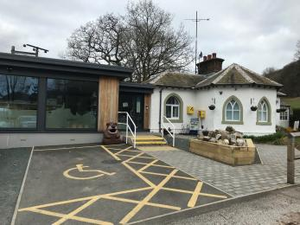
Waterfoot Reception/Shop parking and access ramp located beside main entrance

Arrival

Path to main entrance
- From the street to the main entrance, there is level access.
- There is a permanent ramp.
- The path is 1500mm wide, or more.
- The path is sloped.

Main entrance
- The main entrance has level access.
- There is a permanent ramp.
- The door is 900mm wide.
- The main door is side hung and manual.
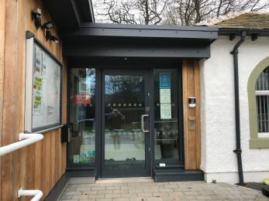
Reception/Shop main entrance

Getting around inside

Visual Impairment - General Information
- We have contrast markings on all glass doors, contrast markings on all full-height windows and high colour contrast between walls and doorframes.
- Watch the video: Waterfoot Park arrival and Good to go information

Reception/Shop/office
- From the main entrance to reception, there is level access. There is a permanent ramp.
- The door is 900mm wide.
- The check-in desk has a low section for wheelchair users. You can sit down at reception.

Site facilities
- We can help you with pitching.
- You can park next to your tent and caravan.
- We have showers, with a seat.
- We have showers, with a handrail.
- We have a level access shower.
- There is a shower chair available.
- The level access shower has handrails.
- The toilets have handrails.
- The direction of transfer onto the toilet is to the left.
- The taps are lever operated. There is space under the basin, with no pedestal or boxing.
- The bathroom has an emergency call system.

Laundry
- From the main entrance to the laundry, there is level access. There is a permanent ramp. We have an iron and ironing board. You can use the ironing board sitting down.
- Washing/Drying machines are stacked with dryer on top - access to which can be assisted if required.

Bar

Mansion Bar
- From the main entrance to the bar, there is level access. There is a permanent ramp.
- The main entrance to the mansion is up 3 steps of varying height.
There is an accessible entrance around the left side with a permanent ramp and level access. The door can be opened with a radar key and this is only accessible during bar hours.
There is an Accessible Toilet in the Mansion with grab rails, shelf, sink, and baby changing facility.

Shop

Waterfoot Shop/Reception
- From the main entrance to the shop, there is level access. There is a permanent ramp. The route is 900mm wide, or more. The door is 900mm wide.
- The route through the shop is 800mm wide, or more.

Getting around outside

Play Park
- From the main entrance to this area, there is level access. The route is 1000mm wide, or more. The entrance is 900mm wide.
- Please see the video for more information on the play park equipment but note that the play park is a large grassed area.

Customer care support

Accessibility equipment
- We have a hearing loop in located inside the reception/shop facility.
- magnifying glass if required is available in reception.
- For a list of more items, please go to https://lakedistrictmobility.org/accessibility.
- Waterfoot Park is surrounded by public footpaths and quiet country lanes with plenty dog walking areas and if necessary we have areas on park, please ask.
- We have an area to charge mobility scooters and battery powered wheelchairs.
- please ask at reception and we can arrange this for you
- You can hire mobility equipment from Lake District Mobility by calling 07843 754239.

Emergency evacuation procedures
- The fire alarm has flashing lights.
- Within self-catering facilities and public areas there is emergency lighing with flashing lights to assist evacuation.

Customer care support
- Some staff have disability awareness training.
- Some staff have Next Generation Text training.
- We have information in large print.
- Staff are available 24 hours a day.
- Staff are available 24/7 at reception either via emergency oncall phone system or inside during opening hours.

Guide last updated: 25 February 2022

