Accessibility Guide for Selly Manor Museum
sellymanor@bvt.org.uk, 0121 4720199, http://www.sellymanormuseum.org.uk/
Contact for accessibility enquiries: Nicki Lupton
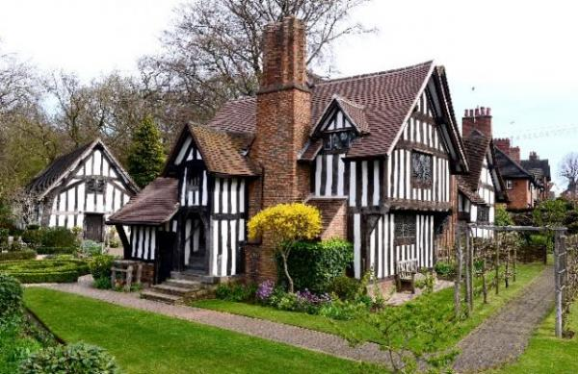

Welcome
Selly Manor Museum consists of two beautiful half-timbered buildings: a medieval hall house and a Tudor yeoman’s house. The buildings are home to a fantastic collection of furniture and objects, which make it possible for visitors to imagine that they have been transported to a time long ago.
Visitors can try on our stunning costumes, get to grips with our replica armour (if they’re feeling strong!), test their skills with our Tudor games and explore the museum with our family friendly hands-on activities.
We extend a warm welcome to all of our visitors and aim to provide a friendly, safe, accessible service to everyone.

At a Glance

Level Access
- There is level access from the main entrance to:
  - Minworth Greaves
  - Ticket desk
  - Toilets at Selly Manor
  - Selly Manor Museum shop
  - Selly Manor Museum garden

Access with steps
- There are steps from the main entrance to:
  - Selly Manor

Visual
- Some parts of the venue have low lighting.

General
- We have a concessionary rate for disabled visitors.
- We have a complimentary ticket policy for personal assistants.

Getting here
Maple Road
Bournville
Birmingham
B30 2AE

Travel by public transport
- You can get to Selly Manor Museum by bus and train.
- The number 11C and 11A bus stops by the village green on Linden Road, which is two or three minutes walk from Selly Manor Museum. For more information about travelling to Selly Manor by bus, please visit www.travelinemidlands.co.uk. The bus stop is 0.2 miles / 0.3 km from Selly Manor Museum.
- The nearest train station is Bournville Train Station. The train station is 1 miles / 1.6 km from Selly Manor Museum.
- There is an excellent train service from Birmingham New Street to Bournville. Trains run approximately every 10 minutes and the journey takes 12 minutes. The train station is approximately 20 minutes walk from Selly Manor Museum.

Parking
- There is parking near the venue. Parking is free.
- There is a drop-off point at the main entrance. The drop-off point does not have a dropped kerb.
- From the car park to the entrance, there is level access. The route is 1360mm wide, or more.
- Street parking is usually available at Selly Manor. It is very unusual not to be able to park on Maple Road where the museum is located. There is also the option of using the overflow car park for the Garden Centre which is behind us which offers level access to the pavement. If using the car park, visitors will need to navigate past a tree which is growing through the section of pavement between the car park and Selly Manor, which restricts access down to 53cm.
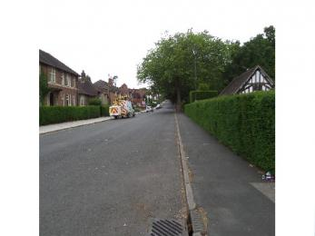
Maple Road

Arrival

Path to main entrance
- From the street to the main entrance, there is level access.
- The path is 950mm wide, or more.
- The path is sloped.

Main entrance
- The main entrance has level access.
- The door is 990mm wide.
- The main door is side hung and manual.
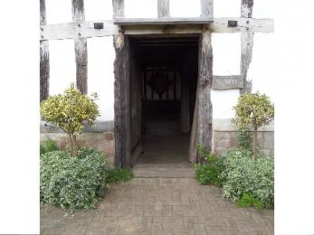
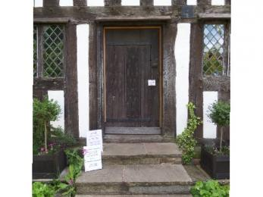
Main entrance to Selly Manor
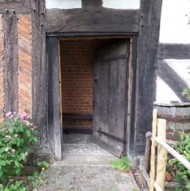

Getting around inside

Visual Impairment - General Information
- Some parts of the venue have low lighting.

Ticket/ information desk

Ticket desk
- From the main entrance to the desk, there is level access. The route is 990mm wide, or more.
- The door is 990mm wide, or more.
- The ticket desk stands 890mm high and is all the same height. The card machine is accessible and staff will be glad to help with any assistance or information that is needed.
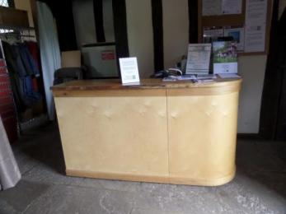
Ticket desk

Things to See and Do
- We have a concessionary rate for disabled visitors.
- We have a complimentary ticket policy for personal assistants.

Minworth Greaves
- From the main entrance to this area, there is level access. The route is 990mm wide, or more. The door is 990mm wide.
- Some display information is low, for wheelchair users. There are seats.
- Minworth Greaves is a medieval hall, there is not a great deal in this building, other than the building itself, which is a good example of a cruck-framed building. There is an information board that give details about the building's history and the furniture in the room, which can be viewed seated. There are usually staff in this building to welcome you and provide more information.
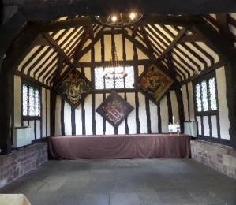
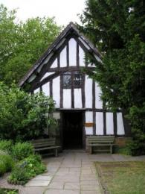
The exterior of Minworth Greaves

Public toilet

Toilets at Selly Manor
- From the main entrance to the public toilet, there is level access. The route is 880mm wide, or more.
- The toilet door is 880mm wide.
- The direction of transfer onto the toilet is to the left.
- There is 1900mm at the side of the toilet. There is 1310mm in front of the toilet. The toilet seat is 470mm high. The toilets have handrails.
- Selly Manor has two toilets, both of which are unisex and accessible. The toilets are large enough to accommodate a carer and can easily provide sufficient space for forward and side transfers to the toilets. Unfortunately, the horizontal grab rails on both toilet walls are positioned awkwardly, and are too far away to provide useful support. There is a pull down trombone support in each which is positioned correctly. There is no alarm in either toilet. The toilet on the left hand side has baby changing facilities. The toilet block will be replaced towards the end of 2017/beginning of 2018.
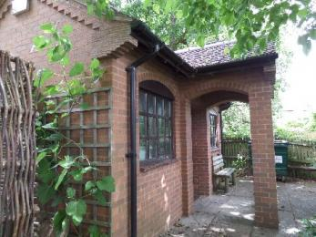
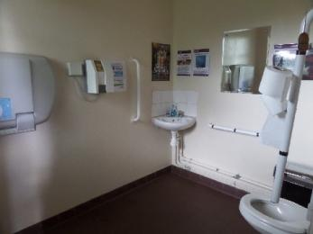

Shop

Selly Manor Museum shop
- From the main entrance to the shop, there is level access. The route is 990mm wide, or more. The route through the shop is 800mm wide, or more.
- There is a small shop in Minworth Greaves, which is opposite the ticket desk and sells mainly pencils, rubbers and other pocket money items.
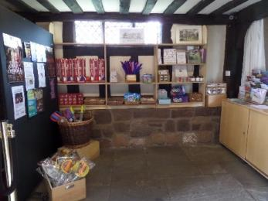

Selly Manor
- From the main entrance to this area, there are 4 steps. There is no lift and no ramp.
- The main entrance to Selly Manor has four steps. The alternative entrance has level access which is situated around the back of the building.
Main entrance to Selly Manor

Getting around outside

Selly Manor Museum garden
- From the main entrance to the gardens, there is level access.
- The route is 930mm wide, or more.
- There is a brick pathway that leads around the garden which is level and of a good width.
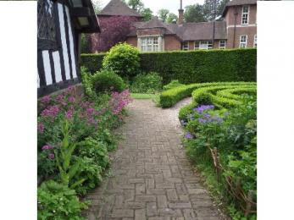
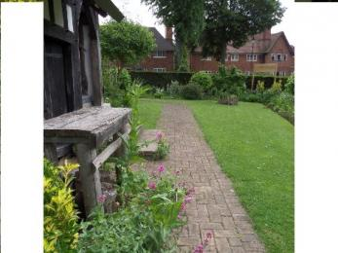
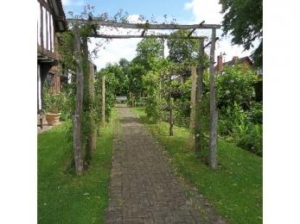

Picnic Area

Selly Manor garden
- The path is 920mm wide, or more.
- You can bring your own food to the picnic area.
- Visitors are very welcome to bring picnics to Selly Manor and enjoy them in the garden. There are several benches, but no picnic tables. The lawned area that visitors most frequently use for picnics is off the pathway, but there are no steps to navigate..
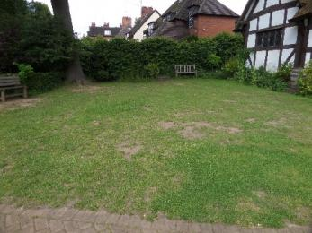

Customer care support

Accessibility equipment
- The upper floors of Selly Manor are accessed by steep stairs only. There is touchscreen which is located downstairs which offers 360 degree images of all the rooms which is useful for visitors that are not using the upper floors, together with further information relating to the museum and its history. There is a chair nearby so that visitors can use the screen in comfort. There is also a modern seat in most of the rooms of Selly Manor for visitors to use.
Most of the rooms include hands-on elements. These include costumes and armour to try on, games, a discovery box for younger children, spices to smell, a truckle bed to try out, a medicine chest, children's trail and clipboards and paper.
Information about the house and furniture is provided in books and boards in each room. All of the books and boards are in the same format to make them easily identifiable. They include images and easy to read print.
Tactile tours and audio descriptive tours can be arranged. Please contact us for further details. Assistance dogs are very welcome in both buildings.
During weekdays, there are usually school groups on site until 2:30pm. For visitors who prefer to enjoy the house at quieter times, we suggest visiting after 2:30pm. We always know if there will be a school group visiting as they book in advance, so if you would like to check prior to your visit, please call us and we will be happy to help.
- The nearest toilet area for assistance dogs is on Maple Road, and is a couple of minutes walk from Selly Manor.

Emergency evacuation procedures
- In the event of an emergency evacuation, staff will check both buildings, the garden and the toilet area to make sure that everyone is safely evacuated.
- We have other services for people with accessibility requirements.
- We can provide tactile tours or audio descriptive tours of Selly Manor. These will need to be booked approx. 4 weeks in advance. Our staff will do their very best to accomodate our visitors needs, please just let us know how we can help.

Guide last updated: 18 January 2019

