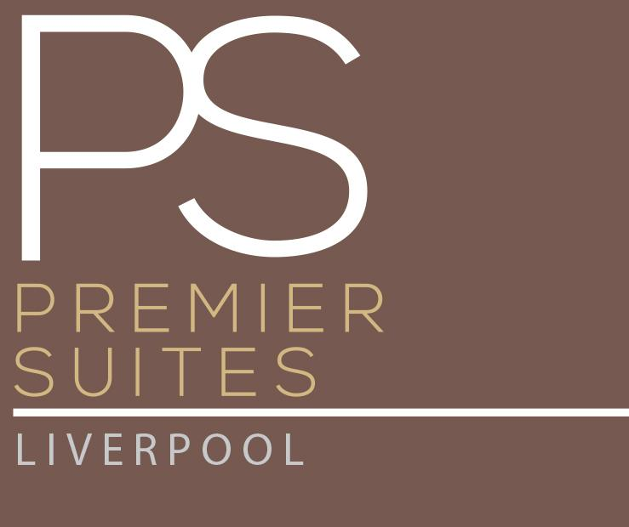

Accessibility Guide for PREMIER SUITES Liverpool
gm@premiersuitesliverpool.com, 01512279467, https://www.premiersuitesliverpool.com/
Contact for accessibility enquiries: Samantha Mcdermott
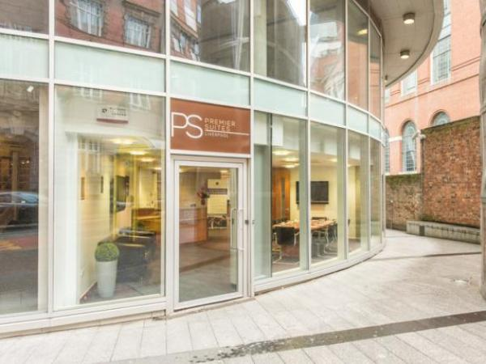

Welcome
Serviced apartments, suitable for both short and long term stays. PREMIER SUITES Liverpool are a fantastic alternative to traditional hotel stays giving you the space and convenience of your home from home in stylish setting. Available with a choice of 1 or 2 bedrooms our self-catering apartments are fully furnished with family-sized kitchens, comfortable lounges to relax and unwind, and dining-area with plenty of space to entertain. Secure car parking is available on-site.

At a Glance

Level Access
- There is level access from the main entrance to:
  - Open Plan Lounge
  - Smoking Area

Bedrooms
- We have non-allergic bedding.

Level access bedrooms
- From the main entrance to the bedroom, there is level access.
- The route to the bedroom is 750mm wide, or more.
- The bedroom door is 750mm wide, or more.

Hearing
- The (bedroom) TVs have subtitles.
- Some staff have disability awareness training.

General
- Some staff have disability awareness training.

Getting here
7 Hatton Garden
Liverpool
L3 2FE

Travel by public transport
- You can get to PREMIER SUITES Liverpool by bus and train.
- Hatton Garden The bus stop is 0.0 miles / 0.0 km from PREMIER SUITES Liverpool.
- The nearest train station is Lime Street Station. The train station is 0.5 miles / 0.8 km from PREMIER SUITES Liverpool.

Parking
- We have a car park. There are accessible parking spaces. The parking is less than 50 metres from the main entrance. Parking is not free.
- There is a drop-off point at the main entrance. The drop-off point has a dropped kerb.
- From the car park to the entrance, there is level access. There is a permanent ramp.
- There is a lift. The path is sloped.
- The route is 820mm wide, or more.

Arrival

Path to main entrance
- From the street to the main entrance, there is level access.
- There is a permanent ramp.
- The path is 820mm wide, or more.

Main entrance
- The main entrance has level access.
- The door is 102mm wide.
- The main door is side hung and manual.
- When you arrive, we can help carry your luggage.
- Our Limited opening hours we have staff than can help with luggage
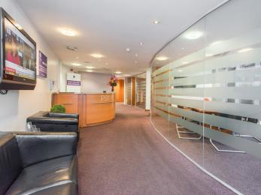
Reception

Getting around inside

Visual Impairment - General Information
Reception

Bedrooms
- All bedrooms have windows.
- Bedrooms have ceiling lights, floor standing lights, bedside lamps, desk or table lamps, spot lights and natural daylight.
- Lights are energy saving. TVs have subtitles.
- All bedrooms are non-smoking.
- We have non-allergic bedding.
- All bedrooms have fitted carpets.
- We can move the bedroom furniture, to improve accessibility.
- From the main entrance to this area, there is level access.
- The direction of transfer onto the toilet is to the front only.
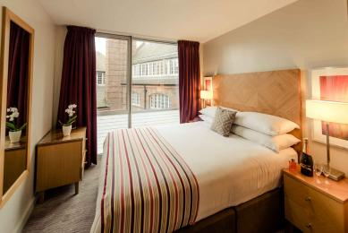
Bed room

Self catering kitchen

Open Plan Kitchen
- From the main entrance to the kitchen, there is level access.
- The route is 108mm wide, or more.
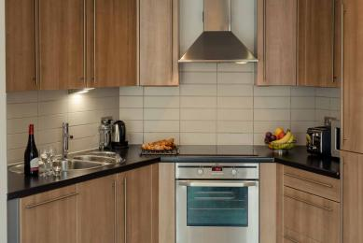
Kitchen

Lounge

Open Plan Lounge
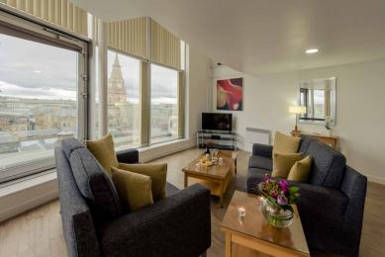
Lounge area
- From the main entrance to the lounge, there is level access. The route is 108mm wide, or more.

Getting around outside

Smoking Area
- From the main entrance to this area, there is level access. The route is 108mm wide, or more.

Customer care support

Emergency evacuation procedures
- We have emergency evacuation procedures for disabled visitors.
- We have emergency evacuation procedures for disabled visitors.
Outside office hours we are not able to assist customers with disabilities who require assistance in evacuating the building in the event of an emergency.

Customer care support
- Some staff have disability awareness training.
- All staff have disability awareness training.
• Staff are available every day with limited working hours.
• Outside office hours our staff are not on site so unable to assist customers with disabilities who require assistance in evacuating the building.

Guide last updated: 2 March 2021

