Accessibility Guide for Leopold Hotel
res.sheffield@leopoldhotels.com, 0114 252 4000, https://leopoldhotel.co.uk/
Contact for accessibility enquiries: Matthew Whittaker
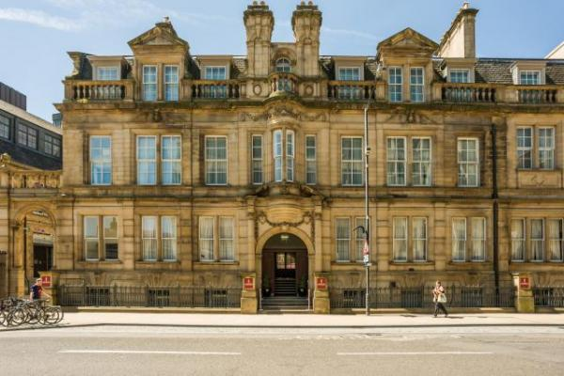

Welcome
Built on the former site of a Grade II listed Boys Grammar School this historic property offers a quirky yet luxurious place to stay situated centrally on Leopold Square amongst an array of upmarket bars and eateries.The imposing building has been sympathetically restored Each of the hotel’s 89 en-suite bedrooms is uniquely furnished, offering every modern amenity for the discerning traveller. our friendly staff are professional and efficient.Having originally been designed as a Grammar School, and latterly the city’s Central Technical School, the Leopold Hotel Sheffield reflects its past with the many images and photographs that have been kindly donated from its past pupils.
Watch the video: Welcome to Leopold Hotel

At a Glance

Level Access
- The main entrance has level access with a lift and a ramp. The ramp is permanent.
- There is level access from the main entrance to:
  - Dining Table

Hearing
- The fire alarm has a vibrating pillow pad and flashing lights.
- We have a hearing loop in Available from reception.
- Some staff have Next Generation Text and disability awareness training.

Visual
- Glass doors have contrast markings.
- The menu is in large print.

General
- Staff are available 24 hours a day.
- Some staff have disability awareness training.
- We have emergency evacuation procedures for disabled visitors.

Getting here
Leopold Square
2 Leopold Street
Sheffield
S1 2GZ

Travel by public transport
- You can get to Leopold Hotel by bus, train, metro and tram.
- There is a bust stop on West Street which is less than a 5 minute walk from the hotel. You would leave the hotel entrance and take a left, then walk along Leopold Street and take a left up West Street and it is approx. 3 minutes walk. For other buses you would take these from Arundel Gate this is approx. a 6 minute walk from the hotel. The bus stop is 0.3 miles / 0.5 km from Leopold Hotel.
- The nearest train station is Sheffield Train Station. The train station is 0.4 miles / 0.6 km from Leopold Hotel.
- The nearest tram station is Castle Sqaure. The tram station is 0.2 miles / 0.3 km from Leopold Hotel.
- Walk north-west on Leopold St towards Church St turn right onto Church St continue onto High St, Turn left onto Castle Square/High Ct, Turn right onto Castle Square/Market Pl, Destination will be on the right

Parking
- There is a drop-off point at the main entrance. The drop-off point does not have a dropped kerb.
- There is a slight kerb to the drop off point

Arrival

Path to main entrance
- From the street to the main entrance, there is level access.
- There is a permanent ramp.
- The path is 3000mm wide, or more.

Main entrance
- The main entrance has level access.
- There is a permanent ramp.
- There is a lift.
- The door is 1200mm wide.
- The main door is side hung and manual.
- we have a seperate accessible entrance which has a lift from this level to reception level.
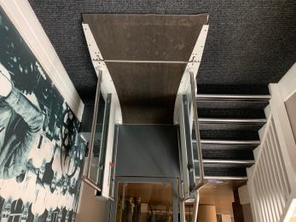
Accessible lift
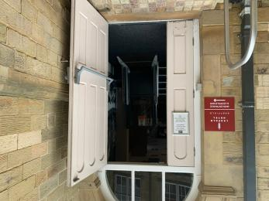
Accessible entrance

Getting around inside

Visual Impairment - General Information
- We have contrast markings on all glass doors.

Place to eat and drink

Lounge bar
- From the main entrance to the dining area, there is level access. There is a permanent ramp. There is a lift. From the lift to dining area, the route is 1060mm wide, or more. To get to a table, there are no steps.
- The menu is offered in large print.
- The route through the dining area is 800mm wide, or more.
- There is background music.
- We cater for sugar free (diabetic), vegetarian, gluten free (celiacs), lactose free (dairy free), nut free and vegan specific diets.

Customer care support

Accessibility equipment
- We have a hearing loop in Available from reception.
- We have 5 accessible rooms, an accessible lift from street level to reception, bar, lounge and bedrooms and a deaf guard for fire alarm is also available
- There is an area on west street where dogs can be taken which is less than a 5 minute walk from the hotel. Alternatively there are areas in the City Centre where dogs can be taken
- We have an area to charge mobility scooters and battery powered wheelchairs.
- we can provide this service in the hotel on request
- You can hire mobility equipment from Mobile Sheffield by calling 0114 273 8787.

Emergency evacuation procedures
- We have emergency evacuation procedures for disabled visitors.
- The fire alarm has a vibrating pillow pad.
- The fire alarm has flashing lights.
- A PEEP would also be completed with guests on arrival to confirm the procedure in case of emergency and where there refuge point would be

Customer care support
- Some staff have disability awareness training.
- Some staff have Next Generation Text training.
- Staff are available 24 hours a day.

Guide last updated: 2 March 2021

