Accessibility Guide for Tutors Lodge
stay@kidlandlee.co.uk, 01669 650472, www.kidlandlee.co.uk
Contact for accessibility enquiries: Mrs Teresa Stock
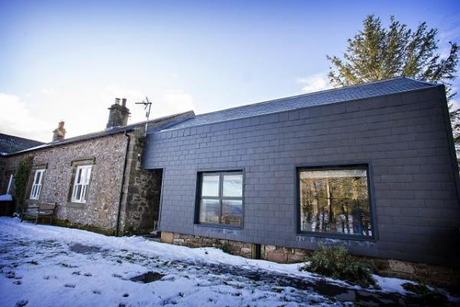

Welcome
Sitting 1400 feet above sea level deep in the heart of the Northumberland National Park, this is a place of big sky views and never-ending walking and cycling from the doorstep. Surrounded by the beautifully rugged hills of the Upper Coquet Valley, this really is a place to escape the crowds and get away from it all. An off-grid experience without compromising on luxury. Sustainable Tourism and a commitment to Improving our environmental impact is why we have been awarded Gold with Green Tourism. An executive escape, or a fun filled family holiday, the calm natural beauty of Kidlandlee will certainly send you home relaxed, refreshed and with plenty of fond holiday memories.
Watch the video: Tutors Lodge

At a Glance

Level Access
- The main entrance has 1 step. There is no lift and no ramp.
- There is level access from the main entrance to:
  - Tutors Lodge Gardens

Access with steps
- There are steps from the main entrance to:
  - Tutors lodge Lounge

Bedrooms
- We have non-allergic bedding.

Level access bedrooms
- From the main entrance to the bedroom, there is level access.
- The route to the bedroom is 750mm wide, or more.
- The bedroom door is 750mm wide, or more.

General
- Staff are available 24 hours a day.
- We have emergency evacuation procedures for disabled visitors.

Getting here
Tutors Lodge, Kidlandlee
Harbottle
Morpeth
NE65 7DA

Travel by public transport
- You can only get to Kidlandlee by car as we are quite remote and three miles from the main road. In the winter it is advisable to use a four wheel drive.

Parking
- We have a car park. The parking is less than 50 metres from the main entrance. Parking is not free.
- The Drop off point is Tutors lodge car park. You can walk from here along the path to the front door which has one step up or there is a path to the back door which does not have a step and is on one level. From the car park to the entrance, there is level access. The route is 750mm wide, or more.

Arrival

Path to main entrance
- From the street to the main entrance, there is level access.
- The path is 750mm wide, or more.

Main entrance
- The door is 750mm wide.
- The main entrance has 1 steps.
- The other entrance door is 750.00mm wide.
- This back door is to the rear of the property and can be accessed from the parking area. It is all on one level

Getting around inside

Bedrooms
- All bedrooms have windows.
- Bedrooms have ceiling lights, bedside lamps and natural daylight.
- Lights are LED and energy saving. All bedrooms are non-smoking.
- We have non-allergic bedding.
- No bedrooms have fitted carpets.
- We can move the bedroom furniture, to improve accessibility.
- From the main entrance to this area, there is level access.
- The direction of transfer onto the toilet is to the front only.
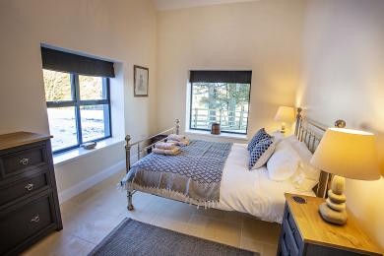
Master Bedroom

Self catering kitchen

Tutors Lodge Kitchen
- We have a separate kitchen and dining room. From the main entrance to the kitchen, there is 1 step. There is no lift and no ramp.
- From the main entrance to the dining room, there is 1 step. There is no lift and no ramp.
- There is one step up into the kitchen from the main entrance. Once in the kitchen the loung/ dinning area is one level.
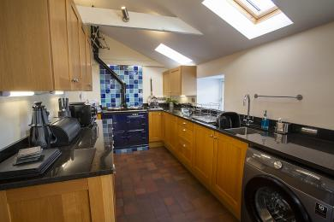
One step up into this kitchen from the main entrance, bedrooms and bathroom.

Lounge

Tutors lodge Lounge
- From the main entrance to the lounge, there is 1 step. There is no lift and no ramp.
- There is one step up from the mainentrance to the kitchen which then leads to the Lounge/ dinning area
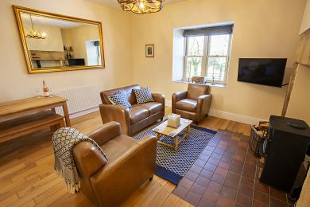
Lounge/ Dinning area from the kitchen.

Getting around outside

Tutors Lodge Gardens
- From the main entrance to this area, there is level access. The route is 750mm wide, or more. The entrance is 750mm wide.
- There is a rear enclosed garden with picninc area and BBQ. There is also a shared front garden with The School House. This does have a bank to access the main part of the garden.

Customer care support

Accessibility equipment
- Tutors Lodge is dog friendly and has an enclosed garden. There is a field directly opposite Chaffinch Cottage for doggies to run around and there are dog bins at the entrance. We provide towels, bowls, dog bags and a little treat for doggies. Also a map of walks around the estate and places to wash muddy paws.
- You can hire mobility equipment from British Red Cross by calling 0191 273 7961.

Customer care support
- Staff are available 24 hours a day.

Guide last updated: 18 April 2023

