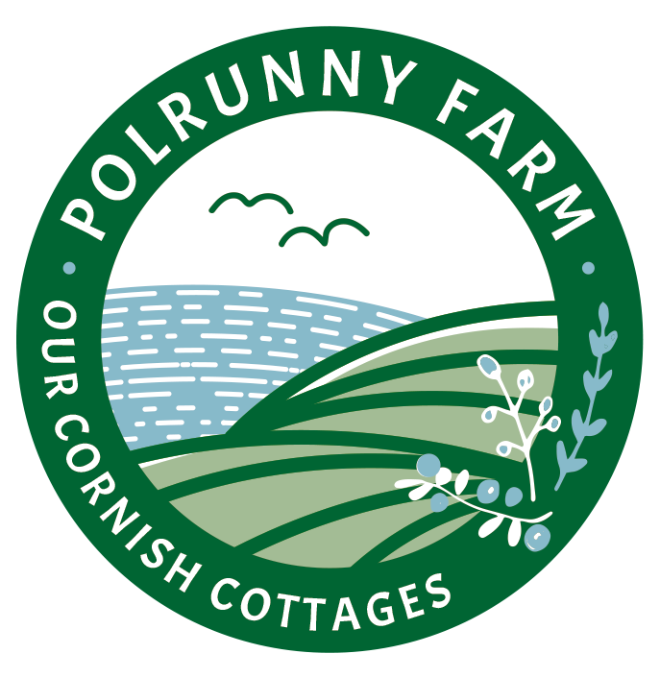

Accessibility Guide for Polrunny Farm - Seaberry Cottage
stay@polrunnyfarm.com, 01840250049, www.polrunnyfarm.com
Contact for accessibility enquiries: Adam Benjamin
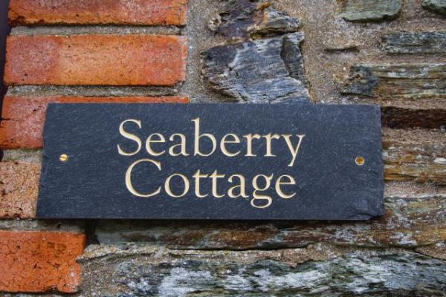

Welcome
Polrunny Farm and Holiday Cottages are situated an area of outstanding natural beauty in the hills above the picturesque harbour village of Boscastle on North Cornwall's spectacular North coast.
SeaberryCottage is one of four self-catering cottages on the farm. With its' stunning sea and countryside views, this one-bed single-level cottage is a popular choice for a romantic escape.
We hope that the information within this guide will help you judge for yourselves whether it meets your particular accessibility needs.
Watch the video: Introduction to Polrunny Farm

At a Glance

Level Access
- The main entrance has 1 step. There is no lift and no ramp.
- There is level access from the main entrance to:
  - Seaberry Lounge
  - Courtyard seating
  - Sea-view breakfast area

Access with steps
- There are steps from the main entrance to:
  - Farm Garden

Bedrooms
- We have non-allergic bedding.

Level access bedrooms
- From the main entrance to the bedroom, there is level access.

Hearing
- The (bedroom) TVs have subtitles.
- All staff have disability awareness training.

Visual
- The walls and the doors have high colour contrast.

General
- Staff are available 24 hours a day.
- All staff have disability awareness training.
- We have emergency evacuation procedures for disabled visitors.

Getting here
Polrunny Farm
Minster
Boscastle
PL35 0EL

Travel by public transport
- You can get to Polrunny Farm - Seaberry Cottage by bus and train.
- The nearest bus stop is down the hill from our farm, outside the Doctor's surgery in Boscastle. The bus stop is 0.7 miles / 1.1 km from Polrunny Farm - Seaberry Cottage.
- The nearest train station is Bodmin Parkway. The train station is 18 miles / 29.0 km from Polrunny Farm - Seaberry Cottage.

Travel by taxi
- Whilst it is possible to reach Polrunny Farm through a combination of train, bus and walking or taxi, most people that stay here have access to a car.

Parking
- We have a car park. The parking is less than 50 metres from the main entrance. Parking is free.
- There is a drop-off point at the main entrance. The drop-off point has a dropped kerb.
- From the car park to the entrance, there is level access. The path is sloped.
- The route is 2000mm wide, or more.
- Seaberry Cottage is accessed from the main gravel and concrete courtyard.
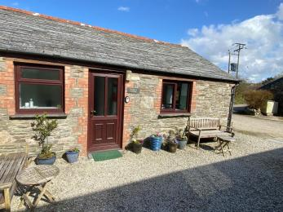
Seaberry Cottage at Polrunny Farm, taken from across the courtyard garden.

Arrival

Path to main entrance
- From the street to the main entrance, there is level access.
- The path is 2000mm wide, or more.
- The path is sloped.

Main entrance
- The door is 720mm wide.
- The main entrance has 1 steps.
- The main door is side hung and manual.
- When you arrive, we can help carry your luggage.
- There is one small step at the doorway to enter Seaberry Cottage. Once inside, the cottage is all on one level.

Getting around inside

Visual Impairment - General Information
- We have high colour contrast between walls and doorframes.
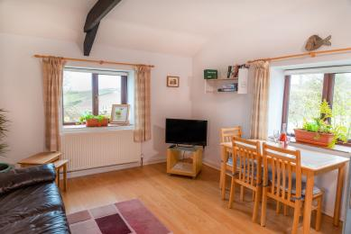
Seaberry @Polrunny Farm is a bright and airy property with windows on three sides.
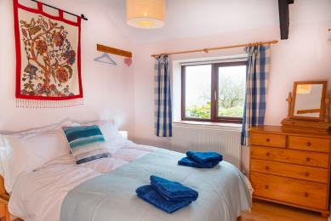
Seaberry's bright double bedroom.

Bedrooms
- All bedrooms have windows.
- Bedrooms have ceiling lights, bedside lamps and natural daylight.
- Some lights can be controlled independently.
- TVs have subtitles.
- All bedrooms are non-smoking.
- We have non-allergic bedding.
- All of Polrunny Farm's linen and cleaning products are purchased with the needs of our holiday-makers with asthma and allergies in mind.
- We can move the bedroom furniture, to improve accessibility.
- From the main entrance to this area, there is level access.

Self catering kitchen

Seaberry Kitchen
- We have an open plan kitchen.
- From the main entrance to the kitchen, there is level access.
- The route is 730mm wide, or more.
- The door is 730mm wide.
- The work surface is available with clear underspace and available at a height between 650mm and 900mm.
- The hob is available at a height between 650mm and 900mm.
- The sink is available at a height between 650mm and 900mm.
- The oven is available at a height between 650mm and 900mm.
- The table and plates have high colour contrast.
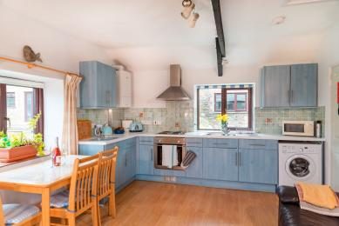
The sky-blue kitchen at Seaberry Cottage, Polrunny Farm.

Lounge

Seaberry Lounge
- From the main entrance to the lounge, there is level access. The route is 730mm wide, or more.

Getting around outside

Courtyard seating
- From the main entrance to this area, there is level access. The route is 2000mm wide, or more. The entrance is 2000mm wide.
- The courtyard,area consisting of tables and chairs is directly accessible from Seaberry Cottage. It's a real sun trap in the mornings.
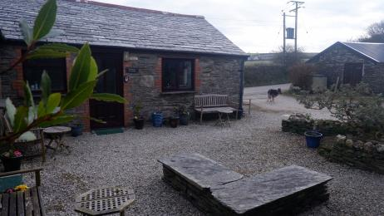
Polrunny Farm's courtyard garden - a sheltered gravel area containing garden furniture and pot plants

Sea-view breakfast area
- From the main entrance to this area, there is level access. The route is 2000mm wide, or more. The entrance is 2000mm wide.
- The grassed breakfast garden with spectacular sea and countryside views is accessed through a farm gate opposite Seaberry Cottage. There is accessible seating in the breakfast garden.
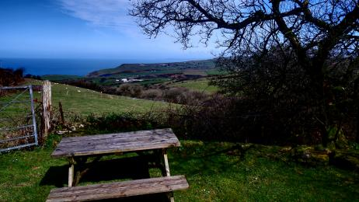
Stunning sea views from Polrunny Farm's breakfast garden
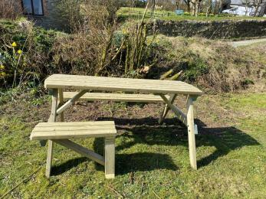
There is room for everyone around our accessible seating in the breakfast garden at Polrunny Farm

Farm Garden
- From the main entrance to the area, there are 10 steps.
- The expansive farm gardens and play equipment are accessed via stone steps. The farm gardens are grassed, and are gently sloping.
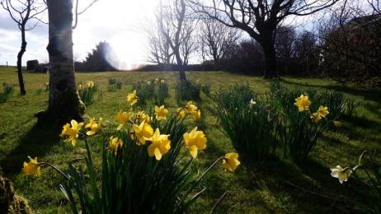
Daffodils in abundance in Polrunny Farm's farm garden
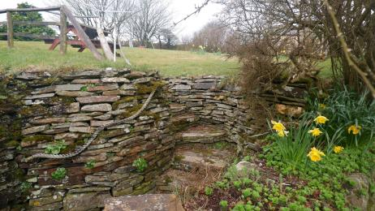
Stone steps leading to Polrunny Farm's farm garden.

Customer care support

Accessibility equipment
- A dedicated 'dog run' is provided approximately 75 metres from Seaberry Cottage. The owners are happy to provide any guests with a thorough tour of the premises.
- We have an area to charge mobility scooters and battery powered wheelchairs.

Emergency evacuation procedures
- We have emergency evacuation procedures for disabled visitors.

Customer care support
- All staff have disability awareness training.
- Staff are available 24 hours a day.

Guide last updated: 25 March 2021

