Accessibility Guide for The Old Shippen
hello@kerswellfarm.uk, 01237 452352, www.kerswellfarm.uk
Contact for accessibility enquiries: Elaine Arnold
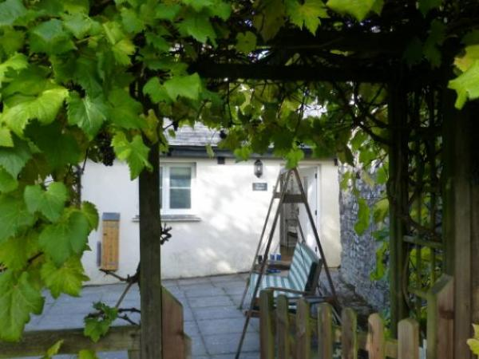

Welcome
A bright and sunny ‘upside down’ barn conversion, The Old Shippen is south-facing and flooded with light. There are two spacious bedrooms downstairs, a king with an en-suite bathroom, a twin and a further shower room. Upstairs the lovely sitting room with log burner overlooks the woodland and the lakes and is cosily furnished with Harris tweed sofas and beautiful fabrics. A spacious dining kitchen awaits keen cooks or those who prefer an easy life on holiday, with granite worktops, induction hob, dishwasher and all mod cons!

At a Glance

Access with steps
- There are steps from the main entrance to:
  - Bedroom
  - The Old Shippen sitting room
  - The Old Shippen garden

Bedrooms
- We have non-allergic bedding.

Hearing
- The (bedroom) TVs have subtitles.

General
- Staff are available 24 hours a day.
- We have emergency evacuation procedures for disabled visitors.

Getting here
Kerswell Farm
Parkham Ash
Bideford
EX39 5PR

Travel by public transport
- We are very rural and there is no public transport available sadly

Parking
- We have a car park. The parking is less than 50 metres from the main entrance. Parking is free.
- There is a drop-off point at the main entrance. The drop-off point has a dropped kerb.
- From the parking to the main entrance, there is 1 step. There is no ramp and no lift. There is a large paved patio between the gravelled parking area and the front door. There is one long step between levels.
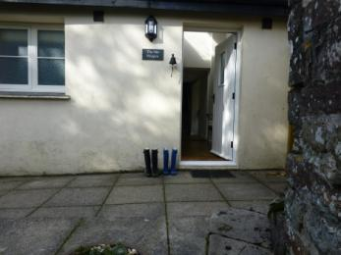
Leading to the front door from the parking area
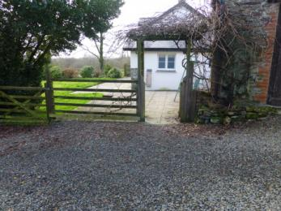
Private parking area

Arrival

Path to main entrance
- From the street to the main entrance, there is 1 step. There is no ramp and no lift.

Main entrance
- The main entrance has level access.
- The door is 780mm wide.
- The main door is side hung and manual.
- When you arrive, we can help carry your luggage.
- As the cottage is self-catering cottage, guests would normally manage their own luggage, but we are on hand to help if required
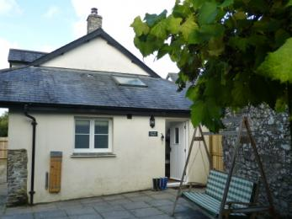
The path to the front door

Getting around inside

Bedrooms
- All bedrooms have windows.
- Bedrooms have ceiling lights and bedside lamps.
- Lights are energy saving. TVs have subtitles.
- All bedrooms are non-smoking.
- We have non-allergic bedding.
- All bedrooms have fitted carpets.
- All pillows and duvets are pure wool.
- We can move the bedroom furniture, to improve accessibility.
- The bedroom nearest the main entrance has 1 steps.
- We have bathrooms with a separate shower.
- We have bathrooms with a bath and overhead shower. The shower has a handrail.
- The walls and the fittings have high colour contrast.
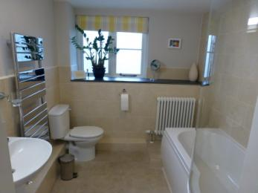
En-suite bathroom to double bedroom with bath and shower over
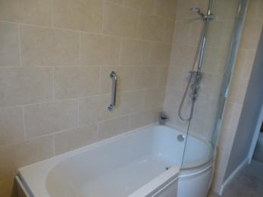
En-suite bath with shower over
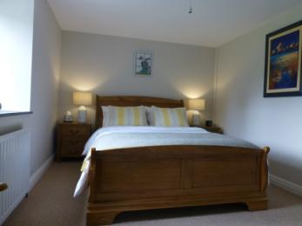
Double bedroom with king-sized bed
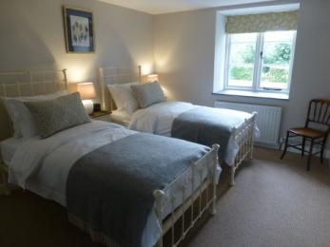
Old Shippen twin bedroom
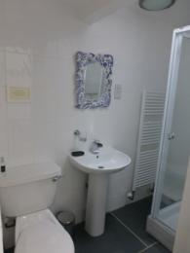
Shower room for twin bedroom

Self catering kitchen

The Old Shippen kitchen
- We have an open plan kitchen.
- From the main entrance to the kitchen, there are 12 steps. There is no lift and no ramp.
- The work surface is available at a height between 650mm and 900mm.
- The hob is available at a height between 650mm and 900mm.
- The sink is available at a height between 650mm and 900mm.
- The oven is available at a height between 650mm and 900mm.
- The table and plates have high colour contrast.
- As the cottage is 'upside down', the bedrooms are on the ground floor and the kitchen-diner and sitting room are upstairs
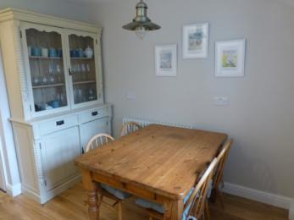
Dining area of The Old Shippen kitchen
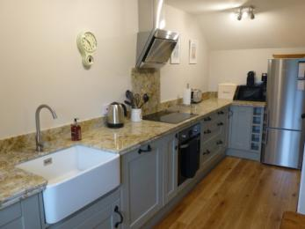
The Old Shippen kitchen

Lounge

The Old Shippen sitting room
- From the main entrance to the lounge, there are 12 steps. There is no lift and no ramp.
- The living room and kitchen are upstairs in this 'upside-down' barn conversion
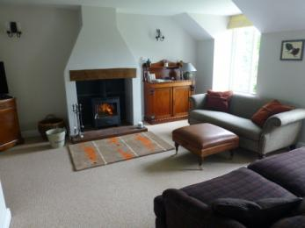
The Old Shippen sitting room

Getting around outside

The Old Shippen garden
- From the main entrance to the gardens, there is 1 step. There is no lift and no ramp.
- There is one step from the front door onto a level patio area that leads around the property to a further level paved patio with BBQ and dining and lounging areas. There is also a covered arbour for sitting overlooking our lake, accessed across grass
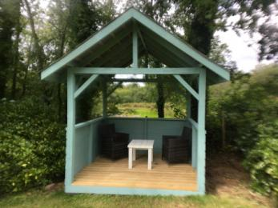
Arbour overlooking top lake
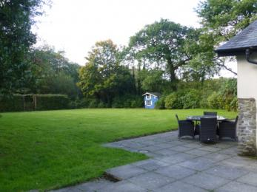
Patio area of Old Shippen garden

Customer care support

Accessibility equipment
- We do have a raised toilet seat that is available on request
- The enclosed garden is for the sole use of guests of The Old Shippen and any resident assistance dogs
- We have an area to charge mobility scooters and battery powered wheelchairs.
- In the garage adjacent to the private parking area there is a power source under cover that may be used to charge a mobility scooter
- You can hire mobility equipment from A M Care by calling 01237479553.
- You can hire mobility equipment from Essential Mobility by calling 01237237172.

Emergency evacuation procedures
- The Old Shippen is a converted farm building and the conversion did not take place with guests with disabilities in mind. We do our best to accommodate all requirements, but the property has not been designed for wheelchair access or for those with severely limited mobility.

Customer care support
- Staff are available 24 hours a day.
- The owners live in the farmhouse next door to The Old Shippen and will help with any emergency or assist guests in any way they can.

Guide last updated: 26 February 2021

