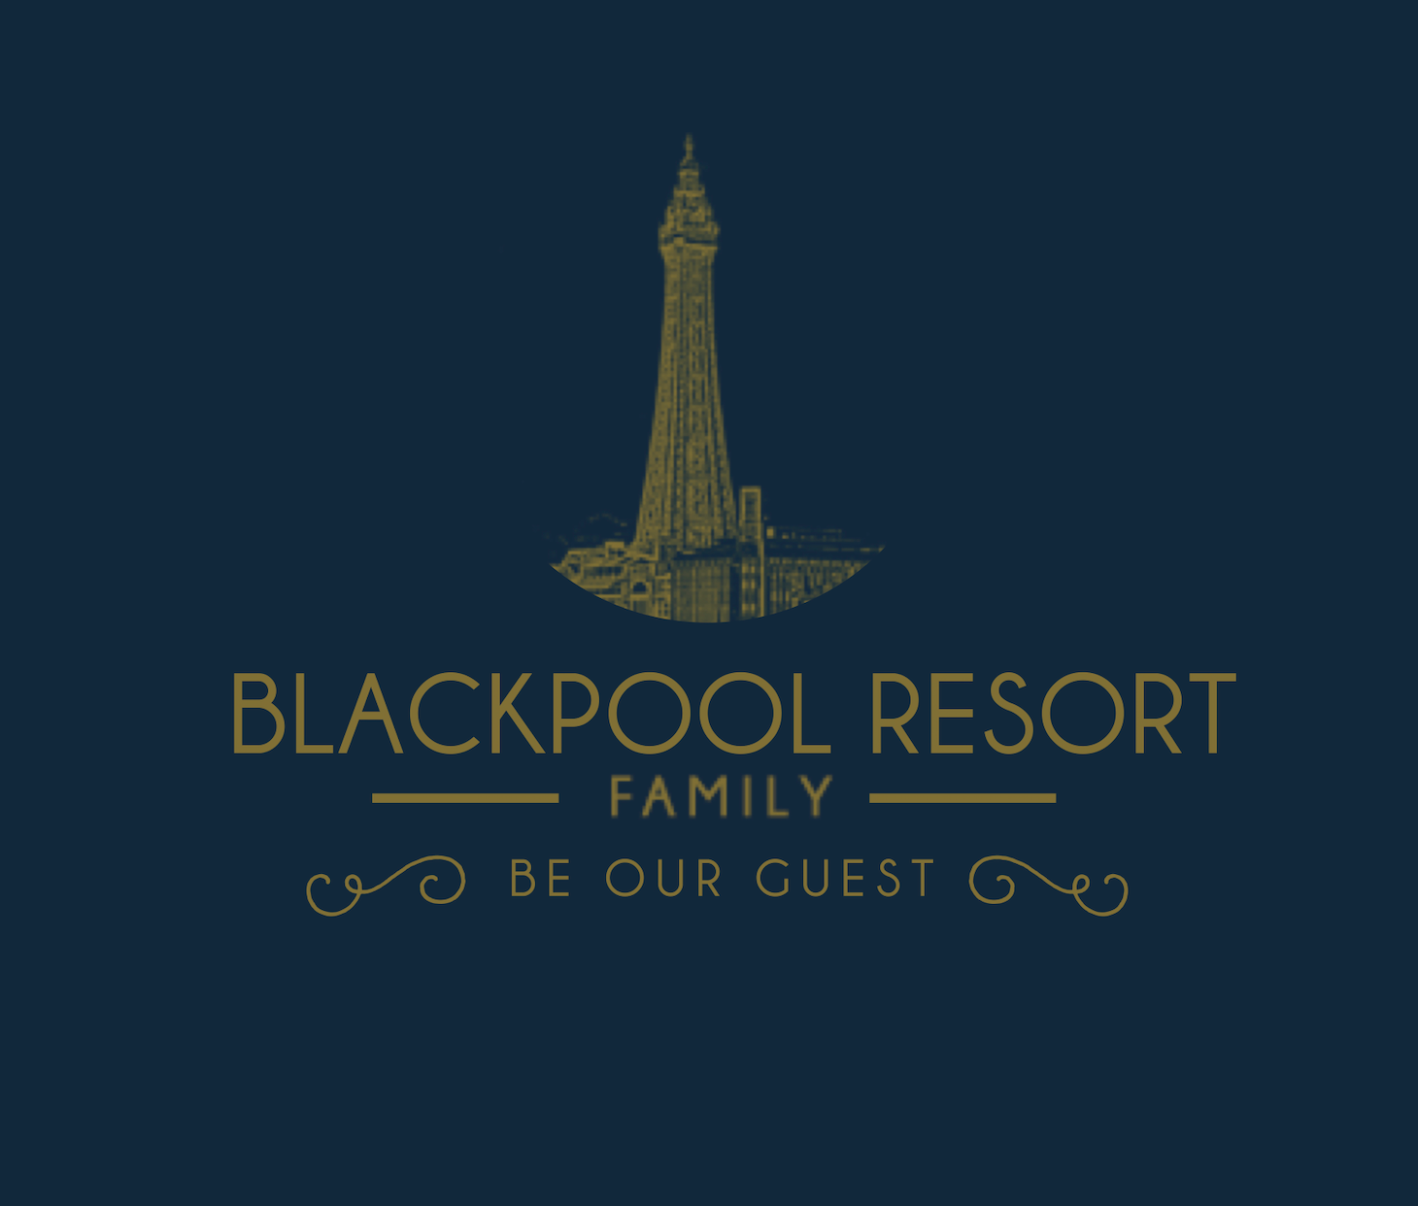

Accessibility Guide for Palatine House Holiday Home
hello@blackpoolresort.co.uk, 01253621005, www.blackpoolresort.co.uk
Contact for accessibility enquiries: Milly Glaister

Welcome
Totally self contained house close to Blackpool Victoria Hospital and Whitegate Urgent Care centre. Fully disinfected at change over, Visit England Good to Go & AA COVID Accreditation in place, book with confidence.
This 1920’s built ‘home from home’ is welcoming, warm, clean and comfortable; ensuring your stay in central Blackpool is enjoyable. The entire house and enclosed patio garden is yours only for the duration of your stay.
Neutrally painted and decorated throughout with fitted carpets.

At a Glance

Level Access
- The main entrance has 3 steps. There is no lift and no ramp.
- There is level access from the main entrance to:
  - Living room

Access with steps
- There are steps from the main entrance to:
  - Bedroom
  - Large private garden

Bedrooms
- We have non-allergic bedding.

Hearing
- The (bedroom) TVs have subtitles.
- Some staff have BSL and disability awareness training.

General
- Staff are available 24 hours a day.
- Some staff have disability awareness training.
- We have emergency evacuation procedures for disabled visitors.

Getting here
210 Palatine Road
BLACKPOOL
FY1 4DU

Travel by public transport
- You can get to Palatine House Holiday Home by bus, train and tram.
- Turn left out of Palatine House and walk 300 yards to the end of Palatine Road. Turn left onto Central Drive. Bus stop is on Central Drive in about 100 yards. The bus stop is 0.2 miles / 0.3 km from Palatine House Holiday Home.
- The nearest train station is Blackpool North Train Station. The train station is 0.5 miles / 0.8 km from Palatine House Holiday Home.
- The nearest tram station is Central Pier. The tram station is 0.3 miles / 0.5 km from Palatine House Holiday Home.

Travel by taxi
- You can get a taxi with Premier Taxis by calling 01253 401000. The taxi company has a wheelchair accessible vehicle.
- You can get a taxi with Blackpool 24 7 Taxis by calling 01253 777222. The taxi company has a wheelchair accessible vehicle.
- You can get a taxi with C Cabs by calling 01253 292929. The taxi company has a wheelchair accessible vehicle.

Parking
- We have a car park. The parking is less than 50 metres from the main entrance. Parking is free.
- There is a drop-off point at the main entrance. The drop-off point does not have a dropped kerb.
- From the car park to the entrance, there is level access. The path is sloped.
- The route is 1000mm wide, or more.
- Parking for 1 vehicle outside the property. A car park for other vehicles is across the road.

Arrival

Path to main entrance
- From the street to the main entrance, there is level access.
- The path is 750mm wide, or more.
- The path is sloped.

Main entrance
- The door is 800mm wide.
- The main entrance has 3 steps.
- The main door is side hung and manual.

Getting around inside

Bedrooms
- All bedrooms have windows.
- Bedrooms have ceiling lights, bedside lamps and natural daylight.
- Lights are energy saving and traditional filament. TVs have subtitles.
- All bedrooms are non-smoking.
- We have non-allergic bedding.
- All bedrooms have fitted carpets.
- We can give details of our cleaning products on request
- We can move the bedroom furniture, to improve accessibility.
- The bedroom nearest the main entrance has 15 steps.
- We have bathrooms with a separate shower.
- We have bathrooms with a bath.
- The direction of transfer onto the toilet is to the front only.

Self catering kitchen

Main kitchen
- We have a separate kitchen and dining room. From the main entrance to the kitchen, there is level access.
- The route is 750mm wide, or more.
- The door is 750mm wide.
- The oven is available at a height between 650mm and 900mm.
- From the main entrance to the dining room, there is level access. The route is 750mm wide, or more. The door is 750mm wide.

Lounge

Living room
- From the main entrance to the lounge, there is level access. The route is 750mm wide, or more. The door is 750mm wide.

Getting around outside

Large private garden
- From the main entrance to the area, there is 1 step.
- 1 step down into the garden

Customer care support

Accessibility equipment
- We provide wheelchairs. There is a charge for wheelchairs.
- Large garden comes as part of the property
- We have an area to charge mobility scooters and battery powered wheelchairs.
- Plug points inside the house
- You can hire mobility equipment from Millercare Blackpool by calling 01253 764054.

Customer care support
- Some staff have disability awareness training.
- Some staff have BSL training.
- Staff are available 24 hours a day.
- Duty Manager is available by phone 24 hours a day

Guide last updated: 14 December 2020

