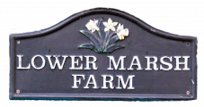

Accessibility Guide for Orchard Cottage, Lower Marsh Farm
bookings@lowermarshfarm.com, 07894 567918, lowermarshfarm.com
Contact for accessibility enquiries: Olivia Stewart
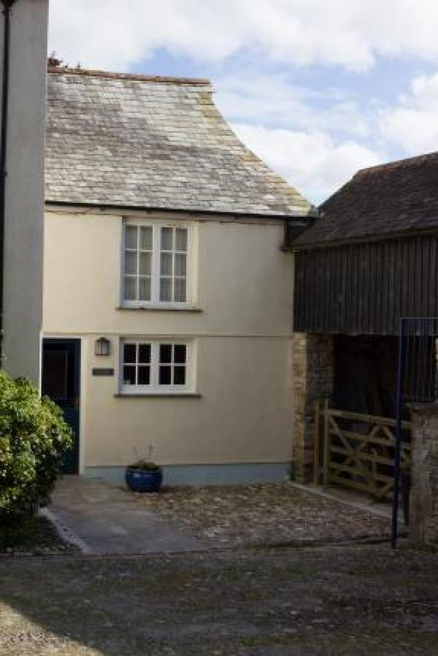

Welcome
Orchard Cottage is a Victorian Gothic style attached property which provides romantic cosy accommodation for 2-3 people. Set all on the ground floor, it has been fully refurbished in 2016 with a modern eat-in kitchen, stylish bathroom, comfortable living and sleeping area with oak flooring and a wood burner.
Outside there’s a private garden area overlooking the orchard with your own hot tub, table, chairs and bbq.
Guests have full access to all of our amenities – including tennis court, games room, orchard, basketball hoop, woodland and private shingle river beach.The cottage comes complete with a flat screen satellite television and DVD player.

At a Glance

Level Access
- The main entrance has level access with a ramp. The ramp is permanent.
- There is level access from the main entrance to:
  - Bedroom: Bedroom / living area
  - Cottage kitchen washing machine & separate Boot Room (for dryer)
  - Orchard Cottage lounge

Access with steps
- There are steps from the main entrance to:
  - Orchard Cottage garden
  - Orchard

Bedrooms
- We have non-allergic bedding.

Level access bedrooms
- From the main entrance to the bedroom, there is level access.
- The route to the bedroom is 750mm wide, or more.
- The bedroom door is 750mm wide, or more.
- There is unobstructed floor space 1200mm by 900mm, or more.

Hearing
- The (bedroom) TVs have subtitles.

Visual
- We have information in large print.

General
- Staff are available 24 hours a day.
- We have emergency evacuation procedures for disabled visitors.

Getting here
Orchard Cottage, Lower Marsh Farm
Landulph
Saltash
Cornwall
PL12 6NG

Travel by public transport
- Car is the best way to get to Lower Marsh Farm, although visitors can get a bus or train to Plymouth or Saltash. Then you would need to get a taxi to the property. A taxi from Plymouth will cost around £25 – £30 and take approximately 30 minutes. A taxi from Saltash will cost around £20 and take approximately 15 minutes.

Travel by taxi
- You can get a taxi with Double Two Taxis by calling 01752 848 422.
- You can get a taxi with ESSA cabs by calling 01752 905 905.
- You can get a taxi with Plymouth Taxis Limited by calling 01752 606060. The taxi company has a wheelchair accessible vehicle.

Parking
- We have a car park. The parking is less than 50 metres from the main entrance. Parking is free.
- There is a drop-off point at the main entrance. The drop-off point has a dropped kerb.
- From the car park to the entrance, there is level access. There is a permanent ramp.
- The route is 680mm wide, or more.
- Parking is directly outside the cottage main entrance in the cobbled courtyard. From the car to the cottage is over approximately a metre of cobbles and then up a level slate paved ramp into the cottage.

Arrival

Path to main entrance
- From the street to the main entrance, there is level access.
- There is a permanent ramp.
- The path is 3000mm wide, or more.
- The path is sloped.

Main entrance
- The main entrance has level access.
- There is a permanent ramp.
- The door is 680mm wide.
- The main door is side hung and manual.
- When you arrive, we can help carry your luggage.

Getting around inside

Visual Impairment - General Information
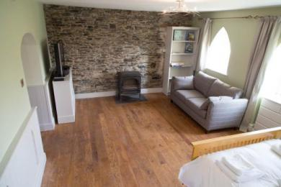
Main living room

Bedrooms
- All bedrooms have windows.
- Bedrooms have ceiling lights, bedside lamps and natural daylight.
- Lights are energy saving. TVs have subtitles.
- All bedrooms are non-smoking.
- We have non-allergic bedding.
- No bedrooms have fitted carpets.
- We can move the bedroom furniture, to improve accessibility.
- We have bed blocks.
- From the main entrance to this area, there is level access.

Accessible bedrooms

Accessible bedroom Bedroom / living area
- The route to the bedroom is 920mm wide, or more. The bedroom door is 920mm wide. There is 580mm at the side of the bed. The bed is 500mm high. There is 240mm under the bed.
- The bedroom is flexible (either double or twin). The bathroom is separate. It is not an ensuite.
- The bathroom door is 680mm wide.
- The bathroom has a separate shower. The shower has a handrail.
- The toilets have handrails. The direction of transfer onto the toilet is to the right. There is 300mm at the side of the toilet.
- There is 1010mm in front of the toilet. The toilet seat is 430mm high.
- The basin is 850mm high. There is no space under the basin.
- The shower entrance is 690mm wide.
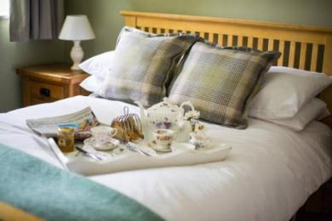
King size bed with bedside tables and lights on both sides
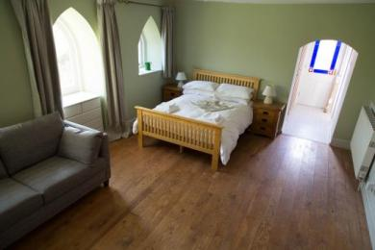
Bedroom area and view to garden door (bathroom is on right just before garden door)
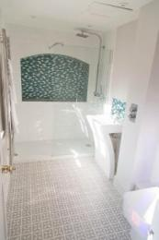
Bathroom (shower tray is very low profile and controls are outside shower next to the sink)
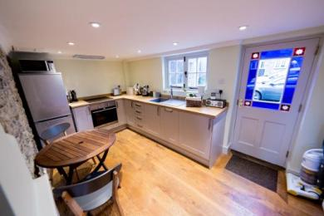
Kitchen and main entrance door
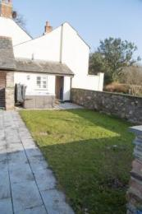
Garden area with hot tub, level paving allows access around garden and out into Orchard (grassy but reasonably level)

Cottage kitchen washing machine & separate Boot Room (for dryer)
- From the main entrance to the laundry, there is level access. The route is 920mm wide, or more. We have an iron and ironing board. You can use the ironing board sitting down.

Self catering kitchen

Orchard Cottage kitchen
- We have an open plan kitchen.
- From the main entrance to the kitchen, there is level access.
- The route is 920mm wide, or more.
- The work surface is available at a height between 650mm and 900mm.
- The hob is available at a height between 650mm and 900mm.
- The sink is available at a height between 650mm and 900mm.
- The oven is available at a height between 650mm and 900mm.
- The table and plates have high colour contrast.
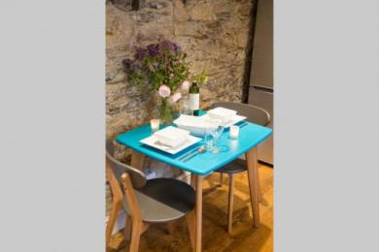
Dining table in kitchen
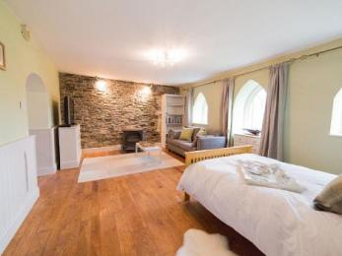
View of living and sleeping area

Lounge

Orchard Cottage lounge
- From the main entrance to the lounge, there is level access. The route is 680mm wide, or more. The door is 920mm wide.
- Width of the main entrance is 680mm, once through there the lounge doorway is 920mm.
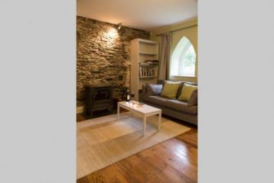
Main living room

Getting around outside

Orchard Cottage garden
- The route is 680mm wide, or more.
- From the main entrance to the gardens, there is 1 step. There is no lift and no ramp.
- The door out to the garden has a small step down of approximately 5 cm - we can provide a ramp for this if required.

Orchard
- The route is 680mm wide, or more. From the main entrance to the area, there is 1 step.
- Access to the orchard is via the garden and across a grassy path and wooden flat bridge.
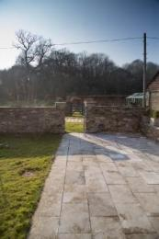
View from garden towards orchard and tennis court

Customer care support

Accessibility equipment
- The nearest toilet area for assistance dogs is in the garden of Orchard Cottage.
- We have an area to charge mobility scooters and battery powered wheelchairs.
- There is a car port where a wheelchair or mobility scooter can be charged.
- You can hire mobility equipment from Plymouth Mobility Centre (www.plymouthmobilitycentre.co.uk) by calling 01752 546222.

Customer care support
- We have information in large print.
- Staff are available 24 hours a day.
- The proprieters live on site. On rare occasions the farm may be unstaffed.

Guide last updated: 10 November 2023

