Accessibility Guide for Raikes Parade Traditional Victorian Holiday Home
hello@blackpoolresort.co.uk, 01253 621005, www.blackpoolresort.co.uk
Contact for accessibility enquiries: Milly Glaister
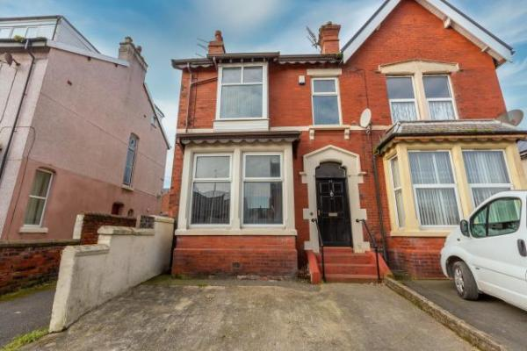

Welcome
Raikes parade, part of the Blackpool Resort family, is a large Victorian town house which is situated very close to the town centre and other major tourist attractions. This home from home has 5 bedrooms, a beautiful spacious lounge with tradtional fireplace, a large through dining/kitchen area and 1 bathroom with separate toilet. Raikes parade has been welcoming guests and their pets since 2018 and also has the benefit of two car parking spaces and an enclosed rear courtyard perfect for a summer BBQ.

At a Glance

Level Access
- The main entrance has 3 steps. There is no lift and no ramp.
- There is level access from the main entrance to:
  - Bedroom: Ground Floor Bedroom
  - Washine machine in the kitchen
  - Main living room

Access with steps
- There are steps from the main entrance to:
  - Private garden in the holiday home

Bedrooms
- We have non-allergic bedding.

Level access bedrooms
- From the main entrance to the bedroom, there is level access.
- The route to the bedroom is 750mm wide, or more.
- The bedroom door is 750mm wide, or more.
- There is unobstructed floor space 1200mm by 900mm, or more.

Hearing
- The (bedroom) TVs have subtitles.
- Some staff have BSL and disability awareness training.

General
- Staff are available 24 hours a day.
- Some staff have disability awareness training.
- We have emergency evacuation procedures for disabled visitors.

Getting here
22 Raikes Parade
Blackpool
FY1 4EX

Travel by public transport
- You can get to Raikes Parade Traditional Victorian Holiday Home by bus and train.
- Turn right out of Raikes Parade Holiday Home and walk 200 yards to the end of Raikes Parade. Turn right onto Hornby Road. Walk 50 yards, then turn right onto Park Road. Bus stop is 25 yards along Park Road. The bus stop is 0.3 miles / 0.5 km from Raikes Parade Traditional Victorian Holiday Home.
- The nearest train station is Blackpool North Train Station. The train station is 0.3 miles / 0.5 km from Raikes Parade Traditional Victorian Holiday Home.

Travel by taxi
- You can get a taxi with C Cabs by calling 01253 292929. The taxi company has a wheelchair accessible vehicle.
- You can get a taxi with Blackpool 24 7 Taxis by calling 01253 777222. The taxi company has a wheelchair accessible vehicle.
- You can get a taxi with Premier Taxi by calling 01253 401000. The taxi company has a wheelchair accessible vehicle.

Parking
- We have a car park. The parking is less than 50 metres from the main entrance. Parking is free.
- There is a drop-off point at the main entrance. The drop-off point has a dropped kerb.
- From the parking to the main entrance, there are 3 steps. There is no ramp and no lift.
- Cars can park on the drive outside the house. The drive is on a slope. There are 3 steps from the drive into the property.

Arrival

Path to main entrance
- From the street to the main entrance, there are 3 steps. There is no ramp and no lift.
- The path is sloped.

Main entrance
- The door is 900mm wide.
- The main entrance has 3 steps.
- The main door is side hung and manual.

Getting around inside

Bedrooms
- All bedrooms have windows.
- Bedrooms have ceiling lights, bedside lamps and natural daylight.
- Lights are energy saving and traditional filament. TVs have subtitles.
- All bedrooms are non-smoking.
- We have non-allergic bedding.
- Some bedrooms have fitted carpets.
- We can give details of all of our cleaning products on request, We use non-allergenic pillows and duvets in all bedrooms, Guests are welcome to bring things from home and We endeavour to cater for all specific requirements if the guest contacts us prior to arrival
- We can move the bedroom furniture, to improve accessibility.
- From the main entrance to this area, there is level access.
- The direction of transfer onto the toilet is to the front only.

Accessible bedrooms

Accessible bedroom Ground Floor Bedroom
- The route to the bedroom is 800mm wide, or more. The bedroom door is 800mm wide. There is 1000mm at the side of the bed. The bed is 800mm high. There is 500mm under the bed.
- The bedroom is double. The bathroom is separate. It is not an ensuite.
- The bathroom door is 750mm wide.
- The direction of transfer onto the toilet is to the front only. There is 600mm at the side of the toilet.
- There is 1000mm in front of the toilet. The toilet seat is 650mm high.
- The basin is 850mm high. There is no space under the basin.
- The bathroom is on the first floor, up a full flight of steps. There are no bathroom facilities on the ground floor.
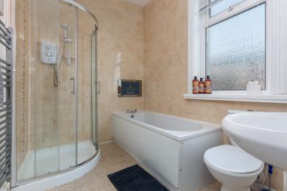
Bathroom First Floor

Washine machine in the kitchen
- From the main entrance to the laundry, there is level access. The route is 800mm wide, or more. The door is 800mm wide.
- We have an iron and ironing board.

Self catering kitchen

Main kitchen on the ground floor
- We have an open plan kitchen.
- From the main entrance to the kitchen, there is level access.
- The route is 800mm wide, or more.
- The door is 800mm wide.
- The work surface is available with clear underspace.
- The oven is available at a height between 650mm and 900mm.
- The table and plates have high colour contrast.
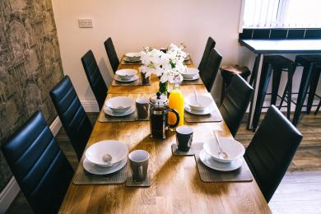
Dining table
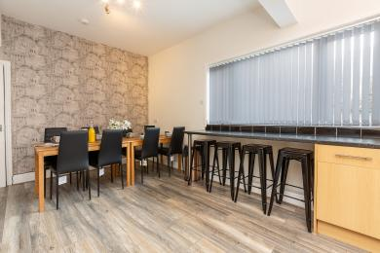
Open plan kitchen and dining area
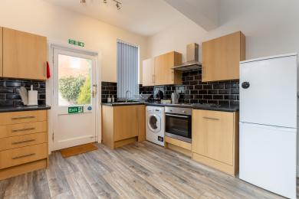
Open plan kitchen

Lounge

Main living room
- From the main entrance to the lounge, there is level access. The route is 900mm wide, or more. The door is 900mm wide.
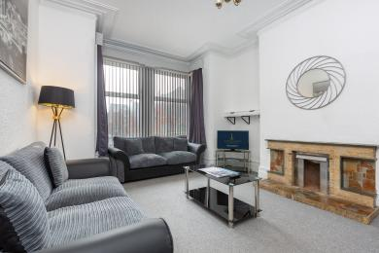
Living room at Raikes Parade Victorian Home

Getting around outside

Private garden in the holiday home
- From the main entrance to the gardens, there is 1 step. There is no lift and no ramp.
- One step down from back door into garden. Garden is gravel on the floor, can be uneven.
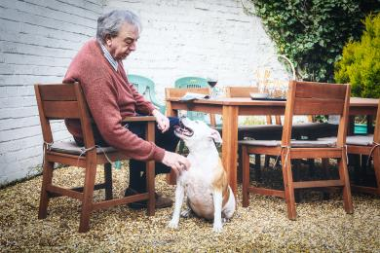
Back garden

Customer care support

Accessibility equipment
- We provide wheelchairs. There is a charge for wheelchairs.
- Private garden where assistance dogs can toilet.
- We have an area to charge mobility scooters and battery powered wheelchairs.
- Plug sockets available in all rooms.
- You can hire mobility equipment from Millercare Blackpool by calling 01253 764054.
- You can hire mobility equipment from Blackpool Mobility by calling 01253 405457.

Customer care support
- Some staff have disability awareness training.
- Some staff have BSL training.
- Staff are available 24 hours a day.
- We have other services for people with accessibility requirements.
- We endeavour to assist our guests in any way we can. If it is possible for us to do something, we will! Guests can contact us in advance to make specific arrangements.

Guide last updated: 3 December 2020

