Accessibility Guide for The Clifton
reception@thecliftonshanklin.co.uk, 01983863015, https://www.thecliftonshanklin.co.uk/
Contact for accessibility enquiries: Denis Dyer
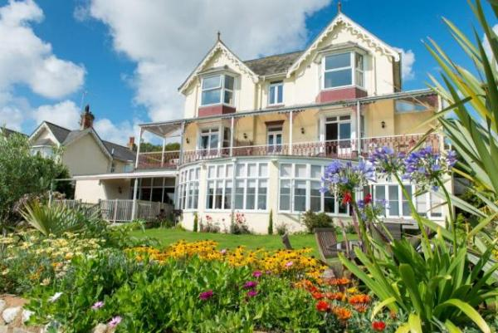

Welcome
The Clifton is perched high on the cliffs, overlooking sparkling blue waters and out to Culver Cliffs.
We warmly welcome all of our guests to The Clifton. However due to the historic nature and inherited design features of the building we are aware that some of our guests need as much information about our facilities as possible, in order to ensure it is suitable to make their holiday the perfect experience.
Watch the video: The Clifton Video

At a Glance

Level Access
- There is level access from the main entrance to:
  - Garden

Access with steps
- There are steps from the main entrance to:
  - Bedroom
  - Dining Table

Bedrooms
- We have non-allergic bedding.

Hearing
- The (bedroom) TVs have subtitles.

General
- Staff are available 24 hours a day.
- We have emergency evacuation procedures for disabled visitors.

Getting here
1 Queens Road
Shanklin
PO37 6AN

Travel by public transport
- You can get to The Clifton by bus, train and boat or ferry.
- The nearest bus stop is 50 yards down the road The bus stop is 0.0 miles / 0.0 km from The Clifton.
- The nearest train station is Shanklin Train Station. The train station is 0.5 miles / 0.8 km from The Clifton.
- The nearest port is Fishbourne. The port is 10.5 miles / 16.9 km from The Clifton.

Parking
- We have a car park. There are accessible parking spaces. The parking is less than 50 metres from the main entrance. Parking is free.
- There is a drop-off point at the main entrance. The drop-off point has a dropped kerb.
- From the car park to the entrance, there is level access. There is a permanent ramp.
- The path is sloped.
- The route is 4000mm wide, or more.

Arrival

Path to main entrance
- From the street to the main entrance, there is level access.
- The path is sloped.

Main entrance
- The main entrance has level access.
- The door is 1400mm wide.
- The main door is side hung and manual.

Getting around inside

Bedrooms
- All bedrooms have windows.
- Bedrooms have ceiling lights, bedside lamps and natural daylight.
- Lights are LED. TVs have subtitles.
- All bedrooms are non-smoking.
- We have non-allergic bedding.
- All bedrooms have fitted carpets.
- The bedroom nearest the main entrance has 14 steps.
- All bedrooms are ensuite.
- We have bathrooms with a bath and overhead shower.

Place to eat and drink
- From the main entrance to the dining area, there is 1 step. There is no lift and no ramp.
- To get to a table, there is 1 step.
- The route through the dining area is 800mm wide, or more.
- There is background music.
- We cater for vegetarian, gluten free (celiacs) and lactose free (dairy free) specific diets.

Getting around outside

Garden
- From the main entrance to this area, there is level access. There is a permanent ramp. The route is 1400mm wide, or more. The entrance is 1400mm wide.

Customer care support

Accessibility equipment
- We have an area to charge mobility scooters and battery powered wheelchairs.

Emergency evacuation procedures
- We have emergency evacuation procedures for disabled visitors.

Customer care support
- Staff are available 24 hours a day.

Guide last updated: 1 December 2020

