Accessibility Guide for The Sewing Room
info@coquetcottages.co.uk, 01665 710700,
Contact for accessibility enquiries: Reservations Team
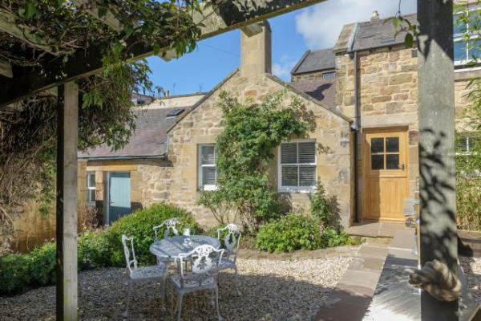

Welcome
This gorgeous holiday cottage in Alnmouth has been lovingly renovated to create an idyllic retreat, nestled in a secluded courtyard offering a relaxing hidden bolthole, positioned to the rear of the main street. Internally, original features have been retained, including internal beams and timbers, and external original stonework. The sympathetically designed interior has a light, contemporary coastal styling in keeping with the architecture. The open-plan living space creates a homely, sociable vibe.
The Sewing Room sleeps 4 guests in 2 bedrooms and welcomes 1 well-behaved dog.

At a Glance

Level Access
- The main entrance has 1 step. There is no lift and no ramp.
- There is level access from the main entrance to:
  - Washing machine

Access with steps
- There are steps from the main entrance to:
  - Bedroom
  - Open plan living area including lounge, kitchen & dining
  - Enclosed patio

Bedrooms
- We have non-allergic bedding.

Hearing
- The (bedroom) TVs have subtitles.

Getting here
7a Northumberland Street
Alnmouth
NE66 2RS

Travel by public transport
- You can get to The Sewing Room by bus and train.
- The nearest bus stop is located on the B1338 just before the bridge in/out of Alnmouth approx. 0.3 miles / 0.5 km away. The bus stop is 0.3 miles / 0.5 km from The Sewing Room.
- The nearest train station is Alnmouth Train Station. The train station is 1.2 miles / 1.9 km from The Sewing Room.

Travel by taxi
- You can get a taxi with J L Taxis by calling 01665 713800.

Parking
- There is parking near the venue. Parking is free.
- There is no designated parking for The Carriage House. Parking is on the main street of Alnmouth Village or down towards the golf club. From the parking to the main entrance, there are 3 steps. There is no ramp and no lift.
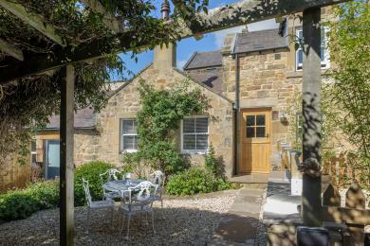
Photo of the entrance to The Sewing Room showingr

Arrival

Path to main entrance
- From the street to the main entrance, there are 3 steps. There is no ramp and no lift.

Main entrance
- The door is 850mm wide.
- The main entrance has 1 steps.
- The main door is side hung and manual.

Getting around inside

Bedrooms
- All bedrooms have windows.
- Bedrooms have ceiling lights, wall lights, bedside lamps and natural daylight.
- Lights are LED. TVs have subtitles.
- All bedrooms are non-smoking.
- We have non-allergic bedding.
- All bedrooms have fitted carpets.
- The bedroom nearest the main entrance has 12 steps.
- We have bathrooms with a separate shower.
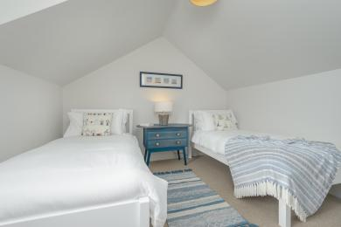
Bedroom 2
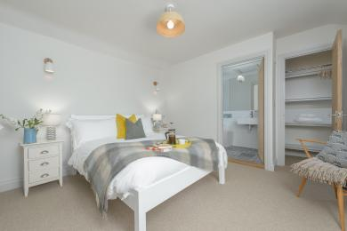
Bedroom 1
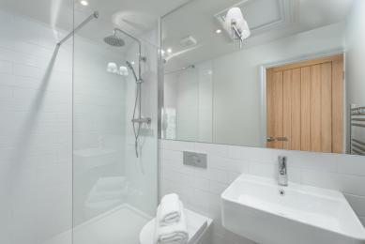
Bedroom 1 Ensuite

Washing machine
- From the main entrance to the laundry, there is level access. The route is 1000mm wide, or more. We have an iron and ironing board.

Self catering kitchen

Open plan living area including kitchen, dining & lounge
- We have an open plan kitchen.
- From the main entrance to the kitchen, there is level access.
- The route is 1000mm wide, or more.
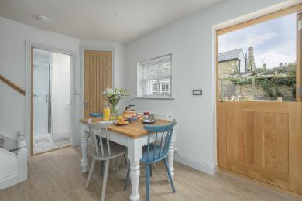
Kitchen
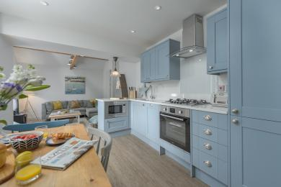
Kitchen
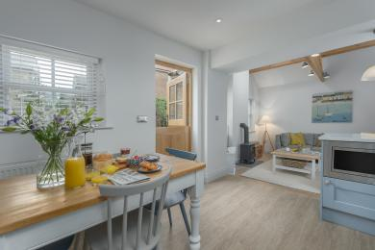
Kitchen
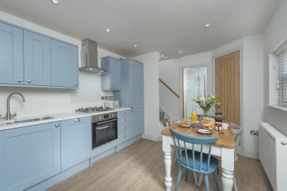
Kitchen

Lounge

Open plan living area including lounge, kitchen & dining
- From the main entrance to the lounge, there is 1 step. There is no lift and no ramp.
- The kitchen & dining area is level access form the main entrance. There is 1 step into the lounge area.
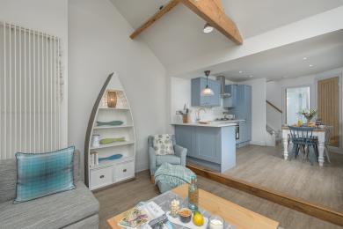
Lounge area showing the step
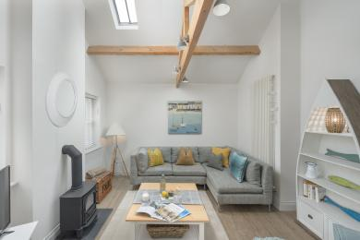
Lounge

Getting around outside

Enclosed patio
- From the main entrance to the gardens, there are 2 steps. There is no lift and no ramp.
- The patio area is gravelled.
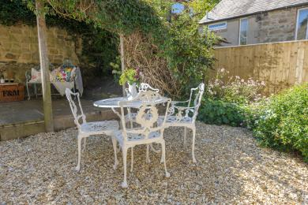
Patio area
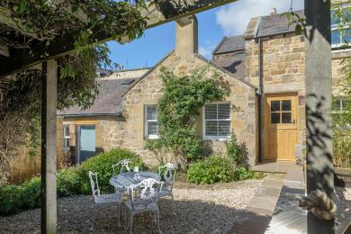
Patio area

Customer care support

Accessibility equipment
- For a list of more items, please go to https://www.redcross.org.uk/get-help/borrow-a-wheelchair.
- The nearest toilet for assistance dogs is the patio area.

Guide last updated: 20 November 2020

