Accessibility Guide for Morridge View at Lane Head Barns
kate@laneheadbarns.co.uk, 07960598258, www.laneheadbarns.co.uk
Contact for accessibility enquiries: Kate Beresford
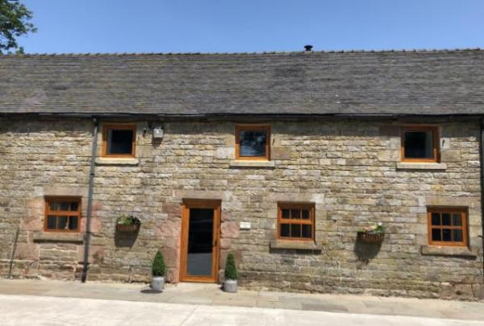

Welcome
Morridge View is a luxury self-catering barn conversion in the Peak District National Park sleeping 10 in five double / twin bedrooms. One ground floor double bedroom with en-suite step-free wet room is suitable for wheelchair users and those with access needs. The extensive ground floor living area is open plan with oak flooring. There is level access from a flat car parking area right next to the front door. Ramped access leads to a level patio at the rear where there are beautiful views over farmland. Morridge View works well for family gatherings and reunions where one or two members of the group have access needs. The owners provide information about accessible walks and attractions in the area.
Watch the video: Morridge View Ground Floor

At a Glance

Level Access
- There is level access from the main entrance to:
  - Bedroom: Ground floor bedroom
  - Lounge
  - Dining area
  - Patio

Bedrooms
- We have non-allergic bedding.

Level access bedrooms
- From the main entrance to the bedroom, there is level access.
- The route to the bedroom is 750mm wide, or more.
- The bedroom door is 750mm wide, or more.
- There is unobstructed floor space 1200mm by 900mm, or more.
- The bathroom has a level access shower.

Visual
- The walls and the doors have high colour contrast.

Getting here
Lane Head Farm
Onecote
LEEK
ST13 7SJ

Travel by public transport
- The nearest train station is 15 miles away in Stoke-on-Trent.

Travel by taxi
- You can get a taxi with Leek Link by calling 01538 399999. The taxi company has a wheelchair accessible vehicle.
- Taxis from Leek Link need to be booked in advance (ideally the day before) as wheelchair accessible vehicles are not available at all times.

Parking
- We have a car park. The parking is less than 50 metres from the main entrance. Parking is free.
- Car parking is immediately outside main entrance. From the car park to the entrance, there is level access. The car parking area is a large open plan concrete area right next to the entrance. There is no loose stone or gravel.
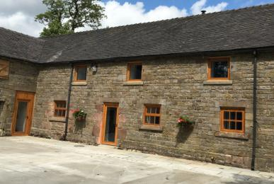
CarParking

Arrival

Path to main entrance
- From the street to the main entrance, there is level access.
- The path is 1000mm wide, or more.

Main entrance
- The main entrance has level access.
- The door is 790mm wide.
- The main door is side hung and manual.
- When you arrive, we can help carry your luggage.

Getting around inside

Visual Impairment - General Information
- We have high colour contrast between walls and doorframes.

Bedrooms
- All bedrooms have windows.
- Bedrooms have ceiling lights, bedside lamps and natural daylight.
- Lights are LED. All bedrooms are non-smoking.
- We have non-allergic bedding.
- No bedrooms have fitted carpets.
- We can move the bedroom furniture, to improve accessibility.
- From the main entrance to this area, there is level access.
- The direction of transfer onto the toilet is to the right.

Accessible bedrooms

Accessible bedroom Ground floor bedroom
- The route to the bedroom is 1000mm wide, or more. The bedroom door is 790mm wide. There is 800mm at the side of the bed. The bed is 560mm high. There is 250mm under the bed.
- The bedroom is double. The bathroom is ensuite. The bathroom door is 790mm wide.
- The bathroom has a separate shower. The shower has a seat. The shower has a handrail.
- The bathroom has a level access shower. The level access shower has a seat. There is a shower chair available. The level access shower has handrails.
- The toilets have handrails. The direction of transfer onto the toilet is to the right. There is 460mm at the side of the toilet.
- There is 930mm in front of the toilet. The toilet seat is 490mm high.
- The basin is 730mm high. There is space under the basin, with no pedestal or boxing.
- The walls and the bathroom fittings have high colour contrast.
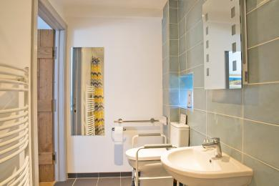
wet room toilet end
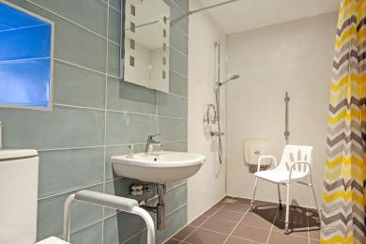
Wet room shower end

Self catering kitchen

Kitchen area
- We have an open plan kitchen.
- From the main entrance to the kitchen, there is level access.
- The route is 1000mm wide, or more.
- The table and plates have high colour contrast.
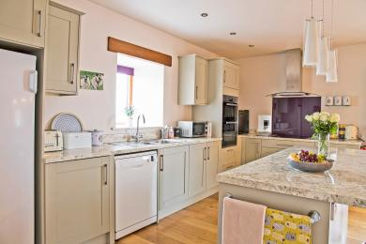
Kitchen

Lounge

Lounge
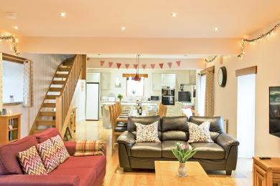
Lounge towards kitchen
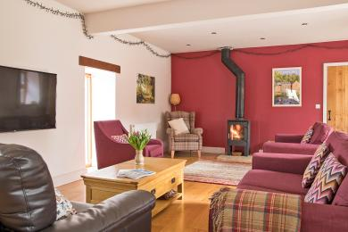
Lounge towards downstairs bedroom
- From the main entrance to the lounge, there is level access. The route is 1000mm wide, or more.

Dining area
- From the main entrance to this area, there is level access. The route is 1000mm wide, or more.
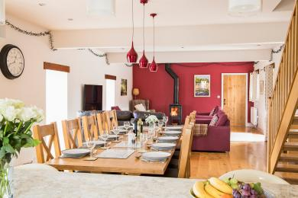
Dining area

Getting around outside

Patio
- From the main entrance to this area, there is level access. There is a portable ramp. The route is 1000mm wide, or more. The entrance is 1560mm wide.
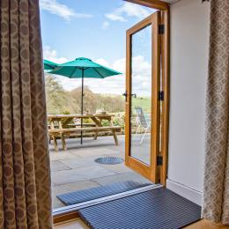
Ramp to patio
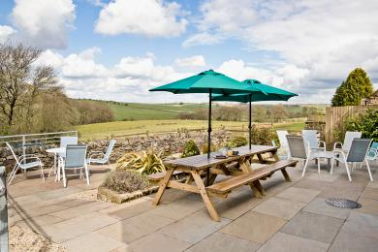
Patio

Customer care support

Accessibility equipment
- Free standing shower chair and toilet frame
- We have an area to charge mobility scooters and battery powered wheelchairs.
- Guests have access to a secure garage where they may store and charge mobility scooters and battery powered wheelchairs.

Guide last updated: 18 July 2023

