Accessibility Guide for Pleasure Holiday Apartments
contact@pleasureholiday.co.uk, 01244646165, www.pleasureholiday.co.uk
Contact for accessibility enquiries: Sonia Paget
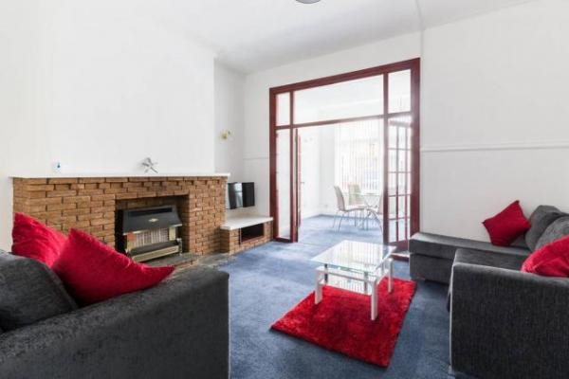

Welcome
Pleasure Holiday Apartments offers accommodation in Blackpool. Blackpool Pleasure Beach Amusement Park is just a 4 min walk away. Free WiFi is provided throughout the property and free private parking is available on site.
The accommodation has a flat-screen TV. Units have a sitting and/or dining area. There is also a kitchen, fitted with an oven, microwave and toaster. A refrigerator and stovetop are also available, as well as a kettle. Towels and bed linen are provided.
Coral Island is 1.3 miles from Pleasure Holiday Apartments, and Blackpool Tower is 1.4 miles from the property. The nearest airport is Liverpool John Lennon Airport, 33 miles from Pleasure Holiday Apartments.

At a Glance

Level Access
- The main entrance has 4 steps. There is no lift and no ramp.
- There is level access from the main entrance to:
  - Bedroom: Two-Bedroom Apartment Ground Floor
  - Lounge

Bedrooms
- We have non-allergic bedding.

Level access bedrooms
- From the main entrance to the bedroom, there is level access.
- The route to the bedroom is 750mm wide, or more.
- The bedroom door is 750mm wide, or more.
- There is unobstructed floor space 1200mm by 900mm, or more.

Hearing
- The (bedroom) TVs have subtitles.

General
- Staff are available 24 hours a day.
- We have emergency evacuation procedures for disabled visitors.

Getting here
26 Withnell Rd
Blackpool
FY4 1HF

Travel by public transport
- You can get to Pleasure Holiday Apartments by bus, train and tram.
- The nearest bus stop is on Bond Street just round the corner on the left. Just in front of the National Tyres and Autocare. The bus stop is called Withnell Road. The bus stop is 0.0 miles / 0.0 km from Pleasure Holiday Apartments.
- The nearest train station is Blackpool South. The train station is 0.5 miles / 0.8 km from Pleasure Holiday Apartments.
- The nearest tram station is Pleasure Beach. The tram station is 0.2 miles / 0.3 km from Pleasure Holiday Apartments.

Travel by taxi
- You can get a taxi with Blacktax by calling 01253 596596.
- You can get a taxi with C Cabs by calling 01253 292929.
- You can get a taxi with Premier Taxis by calling 01253 401000.

Parking
- We have a car park. The parking is less than 50 metres from the main entrance. Parking is free.
- There is a drop-off point at the main entrance. The drop-off point does not have a dropped kerb.
- From the parking to the main entrance, there are 4 steps. There is no ramp and no lift.
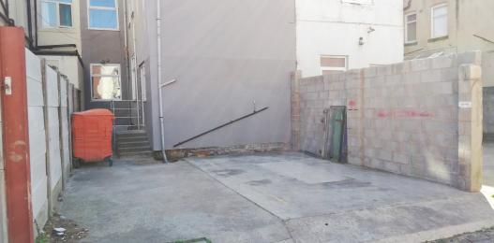
Back of 26 Withnell Rd. Showing car parking space for 2 cars.

Arrival

Path to main entrance
- From the street to the main entrance, there are 4 steps. There is no ramp and no lift.

Main entrance
- The door is 762mm wide.
- The main entrance has 4 steps.
- The main door is side hung and manual.
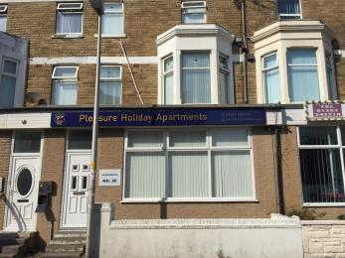
Front entrance to Pleasure Holiday Apartments

Getting around inside

Visual Impairment - General Information
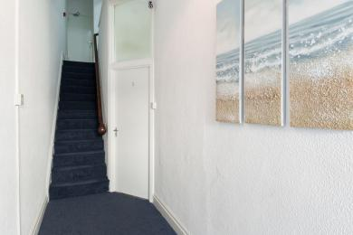
Entry to apartment 1

Bedrooms
- All bedrooms have windows.
- Bedrooms have ceiling lights, bedside lamps and natural daylight.
- Lights are LED and traditional filament. Some lights can be controlled independently.
- TVs have subtitles.
- All bedrooms are non-smoking.
- We have non-allergic bedding.
- All bedrooms have fitted carpets.
- From the main entrance to this area, there is level access.
- The direction of transfer onto the toilet is to the left.
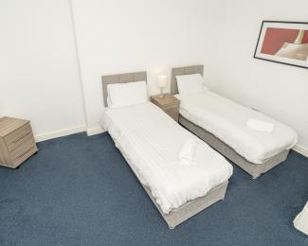
Bedroom one
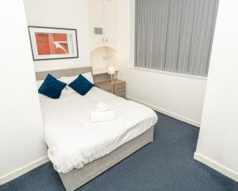
Bedroom two

Accessible bedrooms

Accessible bedroom Two-Bedroom Apartment Ground Floor
- The route to the bedroom is 762mm wide, or more. The bedroom door is 762mm wide. The bedroom is flexible (either double or twin). The bathroom is separate. It is not an ensuite.
- The bathroom door is 762mm wide.
- The direction of transfer onto the toilet is to the left. The taps are lever operated. There is space under the basin, with no pedestal or boxing.
- The walls and the bathroom fittings have high colour contrast.
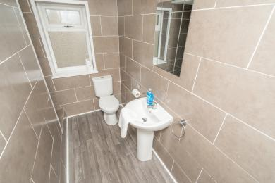
Toilet in bathroom
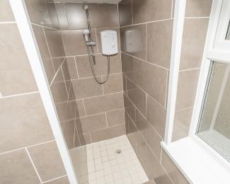
Shower in bathroom
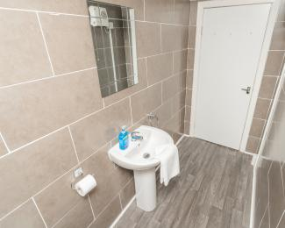
Door to bathroom

Self catering kitchen

Kitchen
- We have a separate kitchen and dining room. From the main entrance to the kitchen, there is level access.
- The route is 762mm wide, or more.
- The door is 762mm wide.
- The table and plates have high colour contrast.
- From the main entrance to the dining room, there is level access. The route is 762mm wide, or more. The door is 762mm wide.
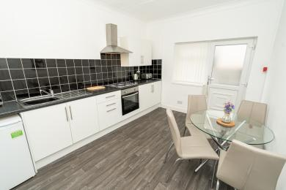
Kitchen
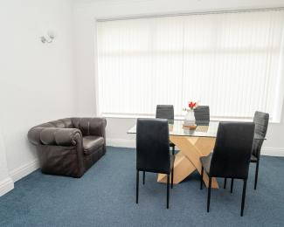
Dinning room
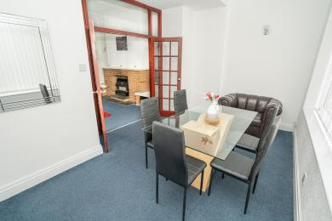
Dinning room

Lounge

Lounge
- From the main entrance to the lounge, there is level access. The route is 762mm wide, or more. The door is 762mm wide.
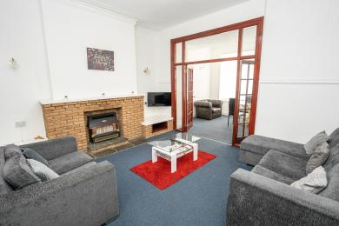
Lounge
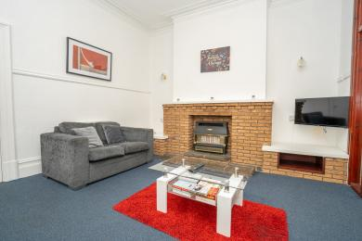
Lounge

Customer care support

Emergency evacuation procedures
- We have fire alarms that issue a sound alarm when activated. We also have a house warden onsite to assist guests.

Customer care support
- Staff are available 24 hours a day.
- We have a house warden onsite available 24/7.

Guide last updated: 6 November 2020

