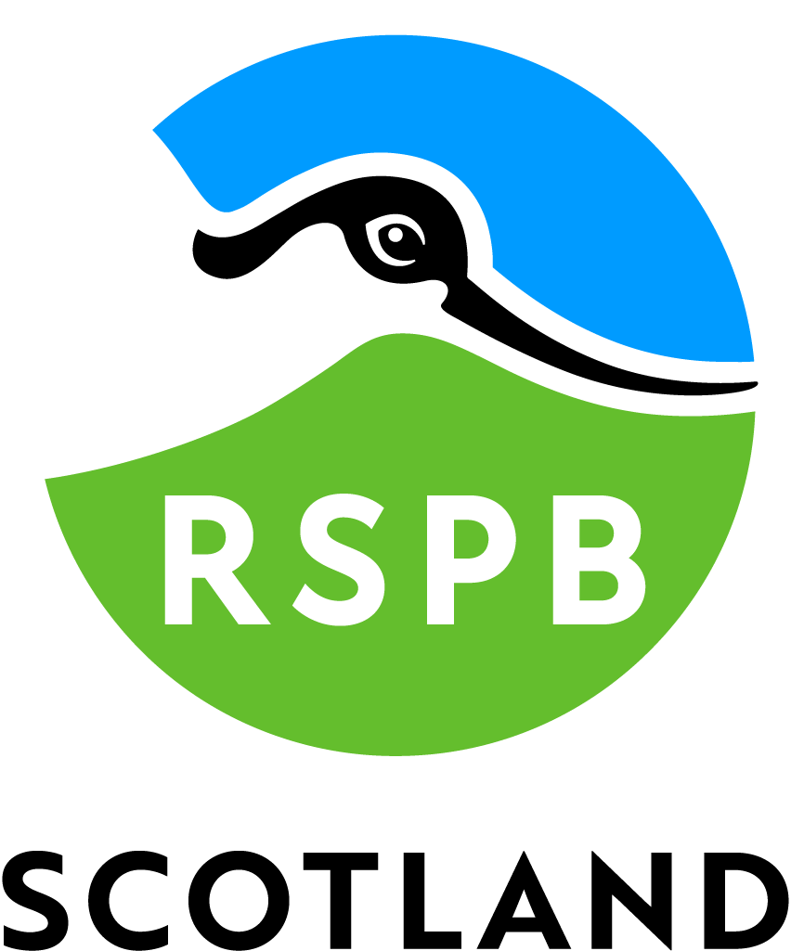

Accessibility Guide for RSPB Scotland Insh Marshes
insh@rspb.org.uk, https://www.rspb.org.uk/reserves-and-events/reserves-a-z/insh-marshes/
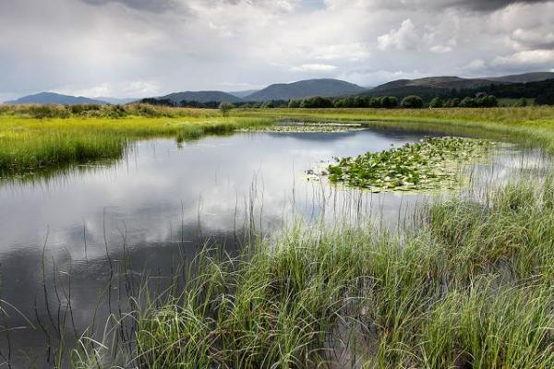

Welcome
RSPB Scotland Insh Marshes is a vast, important wetland and a haven for wildlife throughout the year. The bird hide gives views across the Marshes, where in spring and summer waders and wildfowl are breeding, whilst in winter, whooper swans and geese can be seen. A number of trails lead you to explore beautiful birch and aspen woodlands and a stunning wildflower meadow, where in summer hundreds of orchids grow.

At a Glance

Level Access
- The main entrance has 25 steps. There is no lift and no ramp.
- There is level access from the car park to:

Visual
- Some parts of the venue have low lighting.

Getting here
RSPB Scotland Insh Marshes
Ivy Cottage
Insh
PH21 1NT

Travel by public transport
- You can get to RSPB Scotland Insh Marshes by bus and train.
- The nearest bus stop is Kingussie. The bus stop is 1.5 miles / 2.4 km from RSPB Scotland Insh Marshes.
- The nearest train station is Kingussie. The train station is 1.5 miles / 2.4 km from RSPB Scotland Insh Marshes.
- Walking from Kingussie takes approx 1hr. It is on the road initially but once you reach Ruthven Barracks you can use the Speyside Way footpath.

Travel by taxi
- You can get a taxi with Aviemore Taxis by calling 01479811111.

Parking
- We have a car park. There are accessible parking spaces. The parking is less than 50 metres from the main entrance. Parking is free.
- The nearest drop-off is within the car park area and is approx. 25 metres from the entrance to the hide.

Arrival

Path to main entrance
- The path is sloped.

Main entrance
- The door is 1020mm wide.
- The main entrance has 25 steps.
- The main door is side hung and manual.

Getting around inside

Visual Impairment - General Information
- Some parts of the venue have low lighting.

Getting around outside

Designated Walking Trail

Invertromie Trail
- The trail is 4500metres long. Some of the trail has a loose surface. Some of the trail has cobbles.
- narrow path, narrow gates, steps, boggy areas, slopes The trail is sloped. The trail has seats. There are bird hides along the trail.
- The path follows a gully with a descent down to the hide via a narrow and uneven path.

Invertromie Hide
- The hide entrance has 25 steps. There is no lift and no ramp.

Picnic Area
- From the car park to the picnic area, there is level access. The path is 1800mm wide, or more.
- The entrance is 1800mm wide.
- Some tables have space for wheelchair users. You can bring your own food to the picnic area.

Customer care support

Accessibility equipment
- We do not have a designated toilet area for assistance dogs

Guide last updated: 16 June 2022

