Accessibility Guide for Portland Basin Museum
portland.basin@tameside.gov.uk, 0161 343 2878, www.tameside.gov.uk/portlandbasin
Contact for accessibility enquiries: Rachel Cornes
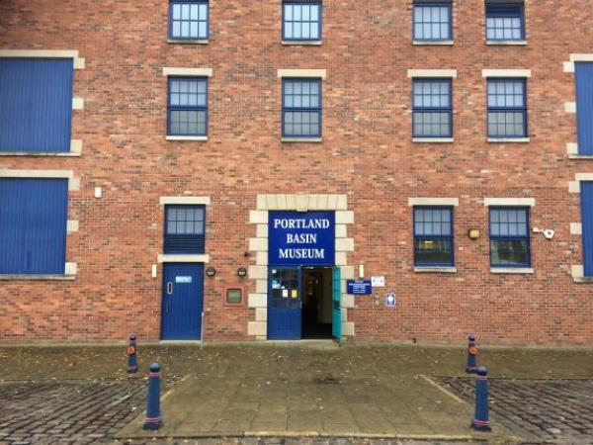

Welcome
Portland Basin Museum is housed within the restored nineteenth century Ashton Canal Warehouse in Ashton-under-Lyne. The museum combines a lively modern interior with a peaceful canal side setting. It is an exciting family friendly museum, with something for all the family.
Enjoy our temporary exhibition, and step back in time on our 1920s street, as the sights and sounds of bygone Tameside are brought to life. Take a look into our kitchen and parlour to find out how we used to live. Visitors can explore the area's industrial heritage and discover what life was like down the mines, or on the farm. Find out more about local crafts and industries and marvel at our historic machines.

At a Glance

Level Access
- There is level access from the main entrance to:
  - 1920s Street
  - Reception desk
  - Main entrance toilets
  - Museum shop
  - Industrial Gallery
- There is level access from the car park to:
  - Wharf picnic area

Hearing
- Some staff have BSL and disability awareness training.

Visual
- We have display information in large print.

General
- There is at least 1 public toilet for disabled visitors.
- Some staff have disability awareness training.

Getting here
Portland Basin Museum
Portland Place
Ashton-under-Lyne
OL7 0QA

Travel by public transport
- You can get to Portland Basin Museum by bus, train and tram.
- Ashton-under-Lyne interchange is located on Wellington Road in Ashton town centre , which is approximately 1 mile away from the museum. The bus stop is 1.0 miles / 1.6 km from Portland Basin Museum.
- The nearest train station is Ashton-under-Lyne. The train station is 1 miles / 1.6 km from Portland Basin Museum.
- The nearest tram station is Ashton-under-Lyne. The tram station is 1 miles / 1.6 km from Portland Basin Museum.
- The train station, bus interchange and tram stop are all located in the centre of Ashton, approximately one mile from the museum.

Travel by taxi
- You can get a taxi with Stamford Cars by calling 0161 3394411.
- You can get a taxi with Radio Cabs by calling 0161 330 2090.

Parking
- We have a car park. There are accessible parking spaces. The parking is less than 50 metres from the main entrance. Parking is free.
- There is a drop-off point at the main entrance. The drop-off point has a dropped kerb.
- From the car park to the entrance, there is level access. The car park has an old fashioned cobbled surface which means it is uneven in places, but the car park is flat with no steps or ramps.
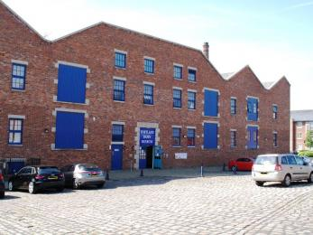
Portland Basin Museum car park and entrance

Arrival

Path to main entrance
- From the street to the main entrance, there is level access.
- The path is 1920mm wide, or more.

Main entrance
- The main entrance has level access.
- The door is 1920mm wide.
- The main door is side hung and manual.
- The entrance doors are wooden double doors with one side propped open during opening hours. Staff are available to open the doors fully and assist if required. These doors lead to a foyer space and straight ahead there is a second set of double doors that lead to the museum. Access is level and these doors are open.
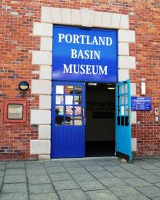
Portland Basin Museum main entrance
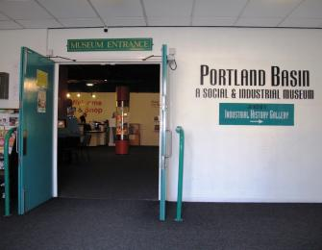
Portland Basin Museum museum doors

Getting around inside

Lift
- We have 1 lift.
- You can get a lift to all floors.

Lift to all floors
- The lift door is 880mm wide.
- The lift is 880mm wide. The lift is 1400mm deep.
- The lift says the floor number at each floor.
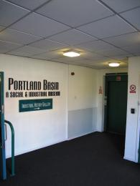
Portland Basin Museum lift entrance
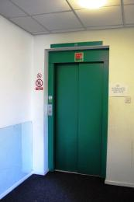
Portland Basin Museum lift door

Ticket/ information desk

Reception desk
- From the main entrance to the desk, there is level access. The route is 1500mm wide, or more.
- The door is 1500mm wide, or more.
- The desk has a low section.
- The desk currently has perspex screening all around it due to Covid-19
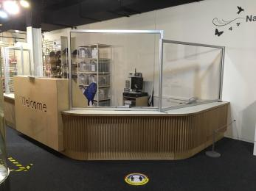
Portland Basin Museum reception desk

Things to See and Do
- We have display information in: large print.

1920s Street
- From the main entrance to this area, there is level access. There is a permanent ramp. The route is 1900mm wide, or more. Some display information is low, for wheelchair users. There are seats.
- The 1920s Street has a series of room sets, some that visitors can go in, some that are viewable through a barrier. The flooring is an old-fashioned style flagstone floor that can be uneven in parts. The street is sloped, and is two metres wide with handrails on either side
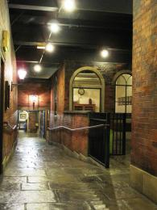
1920s street
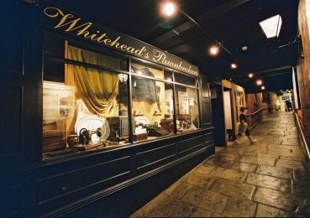
1920s street

Public toilet

Main entrance toilets
- There is a public toilet for disabled visitors.
- From the main entrance to the public toilet, there is level access. The route is 820mm wide, or more.
- The toilet door is 820mm wide.
- The direction of transfer onto the toilet is to the front only.
- There is 1400mm in front of the toilet. The toilet seat is 480mm high. The toilets have handrails.
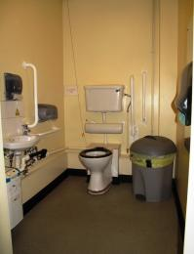
Main entrance disabled toilet
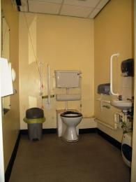
Lower ground floor disabled toilet

Shop

Museum shop
- From the main entrance to the shop, there is level access. The route is 1600mm wide, or more. The route through the shop is 800mm wide, or more.
- The museum shop currently has a one way system in place due to Covid-19, which is marked out with floor arrows and barriers. Products are displayed on shelves at various heights and there is a low level display point in the middle of the shop. The shop counter is at a low level.
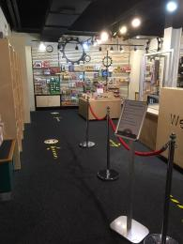
Portland Basin Museum shop

Industrial Gallery
- From the main entrance to this area, there is level access. There is a lift.
- From the lift to this area, the route is 880mm wide, or more. The door is 1480mm wide.
- The Industrial Gallery is on the lower ground floor and is accessible via a lift or from the canal wharf side at the back of the building at lower ground level. The floor in the Industrial Gallery is flagstones, which can be uneven in places.
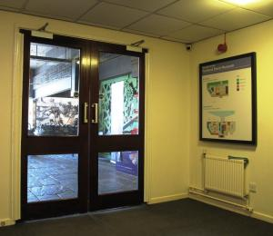
Doors to the Industrial Gallery
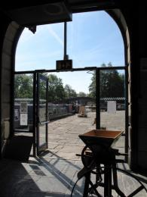
Doors out to the canal wharf
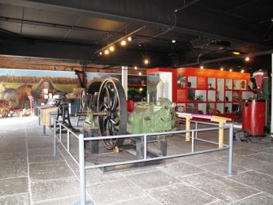
Industrial Gallery

Getting around outside

Picnic Area

Wharf picnic area
- From the car park to the picnic area, there is level access. There is a permanent ramp. The path is 2000mm wide, or more.
- The entrance is 7300mm wide.
- You can bring your own food to the picnic area.
- There are 3 picnic bench tables on the canal-side wharf at the back of the museum which visitors are able to use to eat their own food. The indoor picnic area at the museum is currently unavailable due to Covid-19.
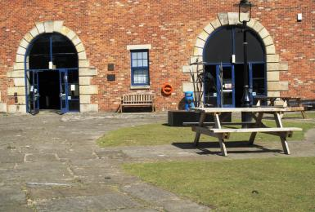
Outdoor picnic tables

Customer care support

Accessibility equipment
- We provide wheelchairs. Wheelchairs are free.
- We have one wheelchair available for free use. We have large print versions of our text panels for the 1920s street and the Industrial Gallery.
- We have an area to charge mobility scooters and battery powered wheelchairs.
- Please ask at the reception desk if you need to charge a mobility scooter or require any other assistance.
- You can hire mobility equipment from Tameside Healthcare by calling 0161 330 1446.
- You can hire mobility equipment from World of Scooters by calling 0161 330 5544.

Emergency evacuation procedures
- We have emergency evacuation procedures for disabled visitors.
- Staff are trained in emergency evacuation procedures including the safe evacuation of all visitors.

Customer care support
- Some staff have disability awareness training.
- Some staff have BSL training.
- We have information in large print.

Guide last updated: 26 October 2020

