Accessibility Guide for Rosedale Cottage
hello@highoaksgrage.co.uk, 01751 469351, www.highoaksgrange.co.uk
Contact for accessibility enquiries: Rebecca Palmer-Bunting
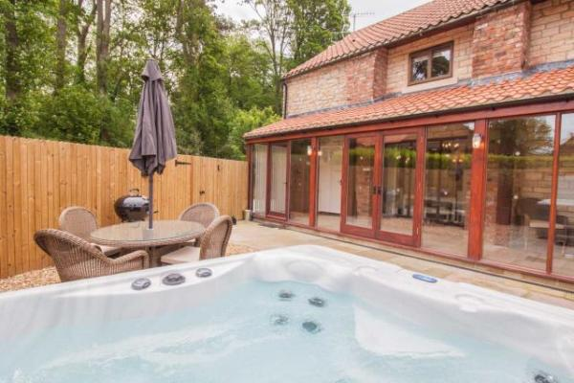

Welcome
We have a range of lodges and cottages at High Oaks Grange, please note we have many slopes, steps and split levels in and around the accommodation. The Grange, lodges and cottages are accessed by a tarmacked driveway half a mile long. We are 1 mile away from the town of Pickering with a variety of amenities including grocery shops, butchers, banks, post office, newsagents, tea shops, pubs, restaurants, doctors and dentist. We aim to provide you with a detailed statement but if you would like further information please call us on 01751 469351 or email us at the address above.
We look forward to welcoming you!
Watch the video: Visit Rosedale Cottage

At a Glance

Level Access
- The main entrance has 1 step. There is no lift and no ramp.
- There is level access from the main entrance to:

Access with steps
- There are steps from the main entrance to:
  - Bedroom

Bedrooms
- We have non-allergic bedding.

Hearing
- The (bedroom) TVs have subtitles.
- Some staff have disability awareness training.

Visual
- Glass doors have contrast markings.

General
- Staff are available 24 hours a day.
- Some staff have disability awareness training.
- We have emergency evacuation procedures for disabled visitors.

Getting here
Thornton Road
Pickering
YO18 7JX

Travel by public transport
- You can get to Rosedale Cottage by bus and train.
- Bus stops are available in Thornton-le-Dale (1.3 miles / 2.1 km from entrance) and Pickering Industrial Estate (0.4 miles / 2.1 km from entrance) with buses to Scarborough, Malton and Helmsley. The nearest train station is Malton . The train station is 8.00 miles / 2.1 km from Rosedale Cottage.

Travel by taxi
- You can get a taxi with Kappa Cars by calling 01653 699999. The taxi company has a wheelchair accessible vehicle.

Parking
- We have a car park. The parking is less than 50 metres from the main entrance. Parking is free.
- From the car park to the entrance, there is level access. Keys can be collected from reception. If arriving after 8pm, please contact us on 01751 469351 to arrange alternative key collection.
Reception has an inward opening door, hinged to the right measuring 78cm with a small door lip measuring 12cm high and 15cm deep
Rosedale Cottage has room for one car to be parked alongside. All parking is free of charge. Please contact us for alternative parking arrangements if you have more than one car.
The reception area is well lit. Each cottage has its own outside light with the switch being located just inside the front door.
The path to Rosedale Cottage is loose stone chip

Arrival

Path to main entrance
- From the street to the main entrance, there is 1 step. There is no ramp and no lift.

Main entrance
- The door is 8100mm wide.
- The main entrance has 1 steps.
- The main door is side hung and manual.
- Entrance Porch
Stoned external area leads to a glass porch to the entrance of the cottage with a step of 15cm, depth 15cm. Two inward opening doors. One with single door (width 81cm), hinged opening to the left and one with double door (width 164cm). Handles 121cm from the stone flooring.
Free space of 640cm x 100cm in the porch area when inward opening doors are closed. Laminate flooring.
A door (width 85cm) with step of 10cm height and 14cm depth leads into the cottage.

Getting around inside

Visual Impairment - General Information
- We have contrast markings on all glass doors.

Bedrooms
- All bedrooms have windows.
- Bedrooms have ceiling lights, wall lights and bedside lamps.
- Lights are LED and energy saving. TVs have subtitles.
- All bedrooms are non-smoking.
- We have non-allergic bedding.
- All bedrooms have fitted carpets.
- The bedroom nearest the main entrance has 13 steps.
- We have bathrooms with a bath and overhead shower. The walls and the fittings have high colour contrast.
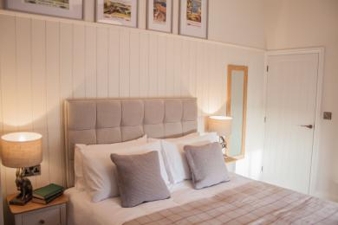
Main Bedroom Rosedale Cottage
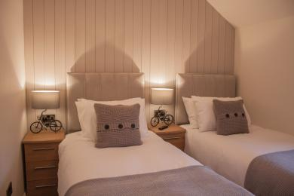
Twin Bedroom Rosedale Cottage

Self catering kitchen
- We have an open plan kitchen.
- From the main entrance to the kitchen, there is level access.
- The table and plates have high colour contrast.
- Kitchen/dining area
The entrance leads directly into the fully integrated kitchen area with:
Worktop and kitchen island height at 91cm
Single oven/grill, drop down door, height of lowest shelf is 38cm, accessible
from both sides
Ceramic hob with touchpad control
Extractor fan
Wall mounted microwave at 150cm high
Kettle and toaster – on worktop
Dishwasher
Washer Drier
Undercounter fridge with freezer compartment with door hinged to the right
Wine cooler with door hinged on the right
Stainless steel sink and right-hand drainer with twist turn mixer tap
Drawers x 3 under counter housing cutlery and equipment
Knife block on the worktop
Most storage is at worktop height with 3 wall mounted cupboards at 134cm high and 2 above the sink at 155cm high. A step stool can be provided to assist
At least 100cm x 250cm free space in the kitchen area
Dining table – 135cm x 80cm. Height 75cm with 2 chairs, seat height 46cm and fitted bench seating measuring 108cm in length, 30cm depth and 46.5cm high
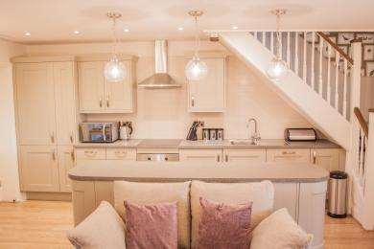
Rosedale Cottage Kitchen

Lounge
- From the main entrance to the lounge, there is level access.
- The lounge area is open to the kitchen, dining area and staircase
2 x two-seater sofa with removable cushions, space for 4 people. Seat height 48cm
Nest of 3 portable coffee tables with heights of 39cm, 48cm and 58cm
SMART TV with DVD.
Free space of at least 360cm x 210cm clear of doors and furniture
Woodburning stove – hearth is 116cm x 33cm x 5cm
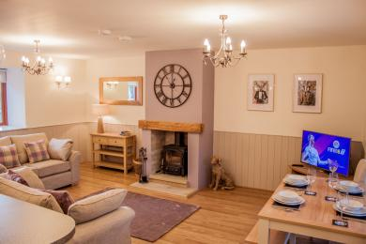
Relax in Rosedale Cottage, High Oaks Grange

Getting around outside
- From the main entrance to the area, there is 1 step.
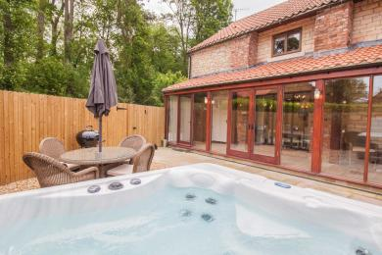
Rosedale Cottage, High Oaks Grange

Customer care support

Accessibility equipment
- For a list of more items, please go to https://www.scarboroughshopmobility.co.uk.
- You can hire mobility equipment from Scarborough Shop Mobility by calling 01723 369910.

Emergency evacuation procedures
- We have emergency evacuation procedures for disabled visitors.

Customer care support
- Some staff have disability awareness training.
- Staff are available 24 hours a day.

Guide last updated: 27 September 2020

