Accessibility Guide for The Lynhurst
info@thelynhurst.com, 07838270926, http://www.thelynhurst.com
Contact for accessibility enquiries: Kate Holland, Richard Holland
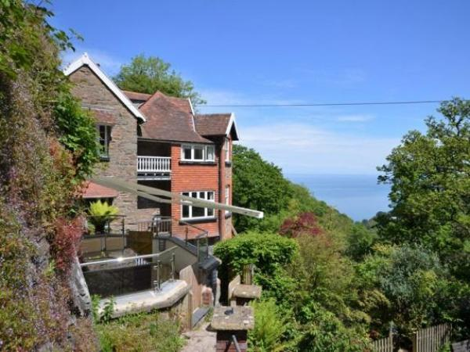

Welcome
The Lynhurst is a large beautiful distinguished property perched just a short walk from the historic village of Lynton. It ideally suited to large groups of friends and family wanting a unique location for that special occasion.
It has 10 bedrooms, two lounges, a large dining area and a modern kitchen.
Nestled within lovely gardens and stunning natural woodland and close to Exmoor National Park it is an ideal place for walkers and for exploring North Devons attractions

At a Glance

Level Access
- There is level access from the main entrance to:
  - garden
  - Garden

Access with steps
- There are steps from the main entrance to:
  - Bedroom
  - Lounge 1
  - Lounge 2

Hearing
- Some staff have disability awareness training.

General
- Some staff have disability awareness training.

Getting here
The Lynhurst
Lynway
Lynton
EX35 6AX

Travel by public transport
- You can get to The Lynhurst by bus.
- The nearest bus stop is in Bottom Meadow car park a few hundred metres from the entrance to the property. Buses to this stop are from Barnstaple. The bus stop is 0.1 miles / 0.2 km from The Lynhurst.

Travel by taxi
- You can get a taxi with Lyn Valley Taxi by calling 07907161666.
- You can get a taxi with Riverside Taxis by calling 01598 753 442.

Parking
- There is parking near the venue. Parking is not free.
- Parking for the property is in Bottom Meadow car park, from here it is a short walk (approximately 200m) up to the property. The path is slightly sloped upwards and there are 23 long steps towards the start of the path. From the parking to the main entrance, there are 23 steps. There is no ramp and no lift.
- The path is on a slight slope at the beginning and then it flattens out
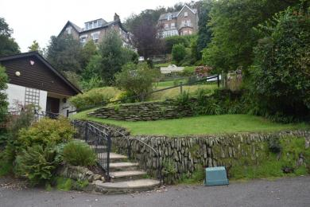
View of way up from carpark
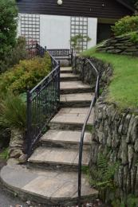
First run of steps
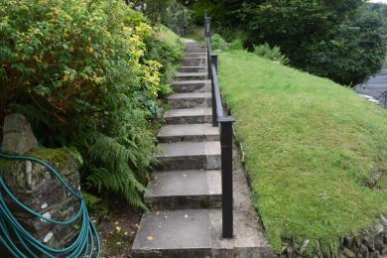
Second run of steps
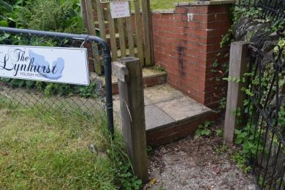
Step to path
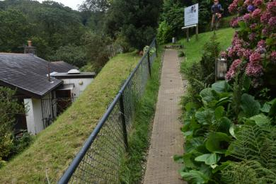
Path
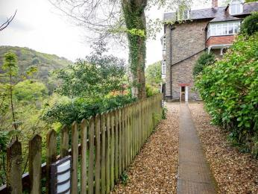
Path to entrance

Arrival

Path to main entrance
- From the street to the main entrance, there are 23 steps. There is no ramp and no lift.
- The path is sloped.

Main entrance
- The door is 690mm wide.
- The main entrance has 1 steps.
- When you arrive, we can help carry your luggage.
- We can arrange to meet guests on arrival if requested and may be able to assist with luggage.

Getting around inside

Bedrooms
- All bedrooms have windows.
- Bedrooms have ceiling lights, bedside lamps and natural daylight.
- Lights are energy saving. All bedrooms are non-smoking.
- All bedrooms have fitted carpets.
- We can move the bedroom furniture, to improve accessibility.
- The bedroom nearest the main entrance has 16 steps.
- We have bathrooms with a separate shower.
- We have bathrooms with a bath and overhead shower.

Self catering kitchen

kitchen
- We have a separate kitchen and dining room. From the main entrance to the kitchen, there is level access.
- The route is 690mm wide, or more.
- The door is 690mm wide.
- The table and plates have high colour contrast.
- From the main entrance to the dining room, there is level access. The route is 770mm wide, or more. The door is 770mm wide.

Lounge

Lounge 1
- From the main entrance to the lounge, there are 16 steps. There is no lift and no ramp.

Lounge 2
- From the main entrance to this area, there are 16 steps. There is no lift and no ramp.

Getting around outside

garden
- From the main entrance to the gardens, there is level access.
- The route is sloped. The route is 1000mm wide, or more.
- Access to the garden area through a gate
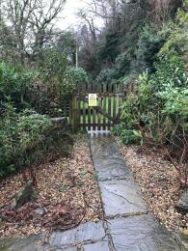
Garden access

Garden
- From the main entrance to this area, there is level access. The route is 1000mm wide, or more. The entrance is 1000mm wide.
- The garden is accesed from the main entrace round a wide path that leads to a seating area then onto a paved area and then on the the lawned area of the garden.

Customer care support

Customer care support
- Some staff have disability awareness training.
- We are only 10 minutes away from the property and can usually be contacted to provide assistance if required, although we could not guarentee to provide a 24 hours service as this is a self catering propery.

Guide last updated: 30 January 2021

