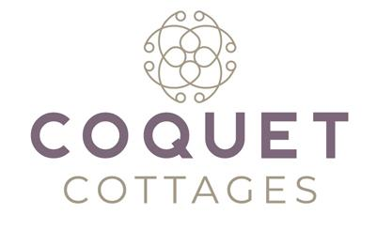
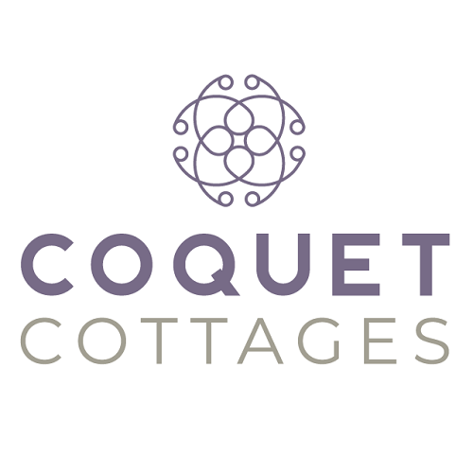

Accessibility Guide for Hedgehog House
info@coquetcottages.co.uk, 01665 710700, https://coquetcottages.co.uk/northumberland-holiday-cottages/hedgehog-house/
Contact for accessibility enquiries: Reservations Team
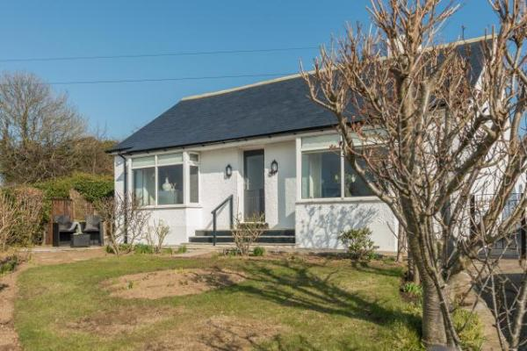

Welcome
Beautifully restored, this stylish holiday cottage in Embleton has been completely refurbished to a very high standard and is now a luxurious holiday home on the coast for up to five guests.Hedgehog House is a single storey holiday cottage right in the centre of pretty Embleton Village, just 10 minutes walk from the golden sands of Embleton beach. Hedgehog House sleeps five guests and welcomes two well-behaved dogs. The luxury decor is to a 5 star standard and there is private parking and an enclosed patio which is a sun trap in the mornings.

At a Glance

Level Access
- The main entrance has 4 steps and a handrail. There is no lift and no ramp.
- There is level access from the main entrance to:
  - Washing machine
  - Lounge
  - Garden

Bedrooms
- We have non-allergic bedding.

Level access bedrooms
- From the main entrance to the bedroom, there is level access.

Getting here
Hedgehog House (formerly 'Redesdale')
Embleton
NE66 3XS

Travel by public transport
- You can get to Hedgehog House by bus.
- The nearest bus stop is located 1 minute walk from the cottage. Once at the end of the drive, turn right and you will see the bus stop ahead of you. The bus stop is 0.0 miles / 0.0 km from Hedgehog House.

Travel by taxi
- You can get a taxi with Wizard Taxis by calling 01665 663709.

Parking
- We have a car park. The parking is less than 50 metres from the main entrance. Parking is free.
- There is a drop-off point at the main entrance. The drop-off point has a dropped kerb.
- From the car park to the entrance, there is level access. The path is sloped.
- The route is 900mm wide, or more.
- Parking for 2 large and 1 small car is available on the private driveway.
There are steps from the driveway into the cottage.
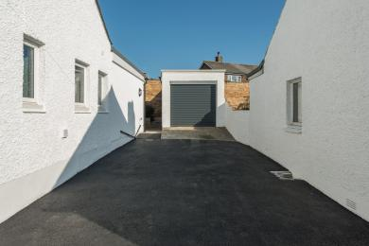
Driveway
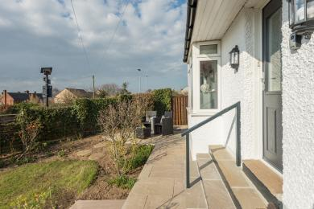
Steps into cottage

Arrival

Path to main entrance
- From the street to the main entrance, there is level access.
- The path is 900mm wide, or more.
- The path is sloped.

Main entrance
- The main entrance has 4 steps.
- This entrance has a handrail.
- The main door is side hung and manual.
Steps into cottage
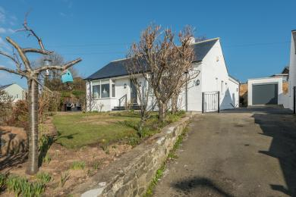
Sloped driveway up to cottage

Getting around inside

Bedrooms
- All bedrooms have windows.
- Bedrooms have ceiling lights, bedside lamps, desk or table lamps and natural daylight.
- Lights are LED. All bedrooms are non-smoking.
- We have non-allergic bedding.
- No bedrooms have fitted carpets.
- From the main entrance to this area, there is level access.

Washing machine
- From the main entrance to the laundry, there is level access. The route is 900mm wide, or more. We have an iron and ironing board.
- There are 4 steps into the cottage but once inside, it's all on one level.

Self catering kitchen

Kitchen/diner
- We have an open plan kitchen.
- From the main entrance to the kitchen, there is level access.
- The route is 900mm wide, or more.
- There are 4 steps into the cottage but once inside, it's all on one level.
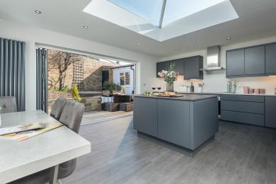
Kitchen
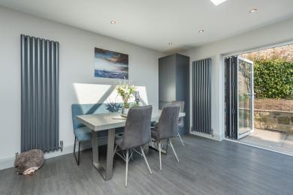
Dining

Lounge

Lounge
- From the main entrance to the lounge, there is level access. The route is 900mm wide, or more.
- There are 4 steps into the cottage but once inside, it's all on one level.
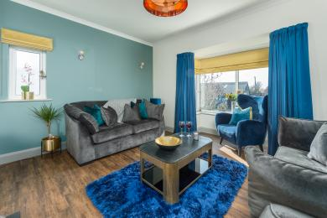
Lounge
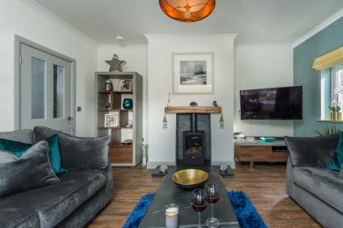
Lounge

Getting around outside

Garden
- From the main entrance to the gardens, there is level access.
- The route is 900mm wide, or more.
- At the front there is the west-facing garden which captures the gorgeous afternoon and evening sun. At the back there is a smart patio with furniture to seat 5 guests. The back patio is east facing and accessed from the kitchen, making the most of the morning sun.
There are 4 steps into the cottage but once inside, it's all on one level.
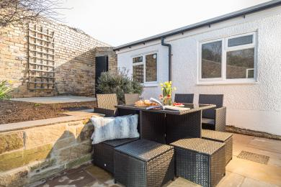
Back garden
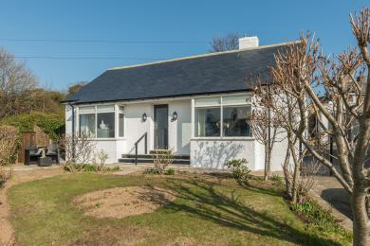
Front garden

Customer care support

Accessibility equipment
- For a list of more items, please go to https://www.redcross.org.uk/get-help/borrow-a-wheelchair?gclid=EAIaIQobChMI7O....
- The nearest toilet area for dogs is the garden area.
- You can hire mobility equipment from Red Cross Newcastle by calling 0191 273 7961.

Guide last updated: 21 July 2020

