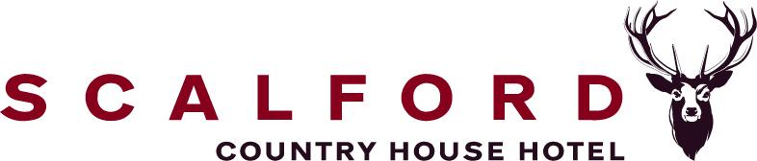

Accessibility Guide for Scalford Country House Hotel
info@scalfordcountryhouse.com, 01664 444654, www.scalfordcountryhouse.com
Contact for accessibility enquiries: Amanda Burton
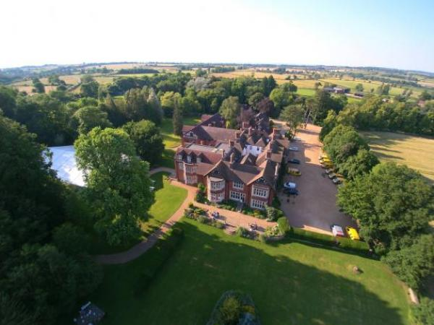

Welcome
Scalford Country House Hotel is a stunning former hunting lodge built in 1908 and set in the beautiful Leicestershire countryside, the former home of Colonel and Mrs Colman of Colmans Mustards. Relax in our recently refurbished lounge and bar with a wide range of bar snacks and drinks or enjoy Afternoon tea in the Drawing Room whilst taking in the surrounding gardens and woodlands. Meet friends for coffee and cake, enjoy Sunday lunch with the family, stay over for business or a relaxing weekend away. We have 25 bedrooms, including 2 suites and 3 accessible en-suite bedrooms.

At a Glance

Level Access
- The main entrance has 2 steps. There is no lift and no ramp.
- There is level access from the main entrance to:
  - Reception office
  - Dining Table
  - Main Lounge
  - Lounge bar
  - Reception toilets
  - Terrace
  - Patio and fish pond

Level access bedrooms
- From the main entrance to the bedroom, there is level access.
- The route to the bedroom is 750mm wide, or more.
- There is unobstructed floor space 1200mm by 900mm, or more.

Hearing
- The (bedroom) TVs have subtitles.
- All staff have disability awareness training.

Visual
- Glass doors have contrast markings.
- The walls and the doors have high colour contrast.
- The menu is in large print.

General
- There is at least 1 public toilet for disabled visitors.
- Staff are available 24 hours a day.
- All staff have disability awareness training.
- We have emergency evacuation procedures for disabled visitors.

Getting here
Melton Road
Melton Mowbray
LE14 4UB

Travel by public transport
- You can get to Scalford Country House Hotel by bus.
- The nearest bus stop is at the end of our drive, on Melton Road. The bus stop is 0.3 miles / 0.5 km from Scalford Country House Hotel.

Travel by taxi
- You can get a taxi with Elaines Taxis by calling 01664 656565.
- You can get a taxi with Garrett Taxis by calling 0758401559.
- You can get a taxi with Paulas by calling 0795 0474552.

Parking
- We have a car park. There are accessible parking spaces. The parking is less than 50 metres from the main entrance. Parking is free.
- There is a drop-off point at the main entrance. The drop-off point does not have a dropped kerb.
- From the car park to the entrance, there is level access. The route is 1300mm wide, or more.
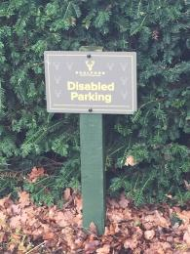
5 Disabled parking spaces
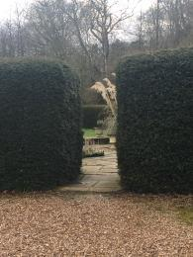
Walkway from car park to ramp

Arrival

Path to main entrance
- From the street to the main entrance, there is level access.
- The path is 1300mm wide, or more.

Main entrance
- The door is 1050mm wide.
- The main entrance has 2 steps.
- The main door is side hung and manual.
- The main door is sliding and automatic.
- The other entrance door is 1200.00mm wide.
- Park in one of the disabled parking bays. go through the yew hedge to the left of the Hall. There is a ramp leading up to double doors straight into the bar.
- These doors are kept locked, please notify reception when you wish to use them
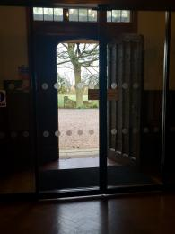
Automatic front doors
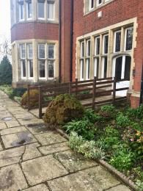
Alternative ramped entrance

Getting around inside

Visual Impairment - General Information
- We have contrast markings on all glass doors and high colour contrast between walls and doorframes.

Reception office
- From the main entrance to reception, there is level access. The door is 1000mm wide.
- From the main entrance to reception, there are 2 steps. There is no lift and no ramp.
- The check-in desk has a low section for wheelchair users. You can sit down at reception.
- Ramped access via bar door
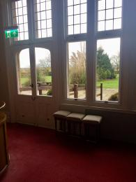
Bar out to ramp

Bedrooms
- All bedrooms have windows.
- Bedrooms have ceiling lights, wall lights, bedside lamps and natural daylight.
- Lights are energy saving. TVs have subtitles.
- All bedrooms have fitted carpets.
- We can give details of our cleaning products on request
- We can move the bedroom furniture, to improve accessibility.
- From the main entrance to this area, there is level access.

Lounge

Main Lounge
- From the main entrance to the lounge, there is level access. The route is 1000mm wide, or more.
- Ramped access via bar door
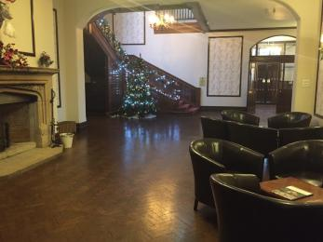
Main lounge

Bar

Lounge bar
- From the main entrance to the bar, there is level access. The route is 1000mm wide, or more.
- From the main entrance to the bar, there are 2 steps. There is no lift and no ramp.
- Ramped entrance via bar door

Public toilet

Reception toilets
- There is a public toilet for disabled visitors.
- From the main entrance to the public toilet, there is level access. There is a permanent ramp.
- The route is 800mm wide, or more.
- The toilet door is 800mm wide.
- The direction of transfer onto the toilet is to the front only.
- There is 1000mm in front of the toilet. The toilet seat is 400mm high. The toilets have handrails.
- Emergency pull cord
Lowered sink and mirror

Place to eat and drink

Colman Room
- From the main entrance to the dining area, there is level access. The route is 1000mm wide, or more. The door is 1000mm wide.
- To get to a table, there are no steps.
- The menu is offered in large print.
- The route through the dining area is 800mm wide, or more.
- There is background music sometimes.
- We cater for sugar free (diabetic), vegetarian, gluten free (celiacs), lactose free (dairy free), nut free, low fat, low potassium, low sodium, high fibre, vegan, kosher and halal specific diets.
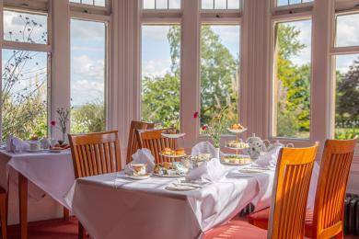
Colman dining room

Getting around outside

Terrace
- From the main entrance to the gardens, there is level access.
- There is a permanent ramp.
- The route is 1200mm wide, or more.
- Exit via bar door ramp
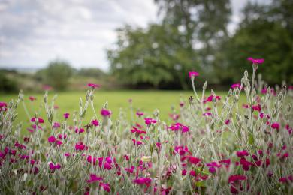
Gardens
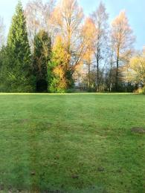
Lawns

Terrace

Patio and fish pond
- From the main entrance to this area, there is level access. The route is 800mm wide, or more.
- The entrance is 800mm wide.
- To get to a table, there are no steps.

Customer care support

Accessibility equipment
- For a list of more items, please go to https://mobilityandlifestyle.co.uk/.
- We have 8 acres of gardens, lawns and woods.
- We have an area to charge mobility scooters and battery powered wheelchairs.
- Feel free to plug into our electric anywhere in the lounge
- You can hire mobility equipment from Shopmobility Melton by calling 07927356384.

Emergency evacuation procedures
- We have emergency evacuation procedures for disabled visitors.
- Please inform reception on arrival if , in the event of an emergency, you require our system of assisted evacuation.

Customer care support
- All staff have disability awareness training.
- Staff are available 24 hours a day.
- Reception desk manned 24hours

Guide last updated: 15 March 2020

