Accessibility Guide for The Cart Shed
Info@Luxuryinthecotswolds.co.uk, 01608683740, Www.luxuryinthecotswolds.co.uk
Contact for accessibility enquiries: Laura Bowden
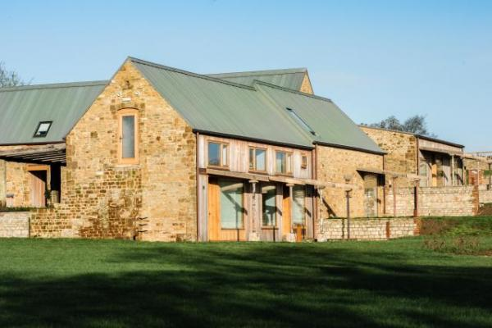

Welcome
Luxury In The Cotswolds offers un-complicated luxury in the heart of The Cotswolds. Providing luxury self-catering breaks in the most sought after setting in The Cotswolds - Great Tew, Oxfordshire. Catering for guests seeking solace; guests needing a little indulgence & guests simply enjoying time together.

At a Glance

Level Access
- The main entrance has 1 step. There is no lift and no ramp.

Access with steps
- There are steps from the main entrance to:
  - The Cart Shed - Living Room
  - The Cart Shed - Garden

Bedrooms
- We have non-allergic bedding.

Level access bedrooms
- From the main entrance to the bedroom, there is level access.
- There is unobstructed floor space 1200mm by 900mm, or more.

Hearing
- The (bedroom) TVs have subtitles.

Visual
- Full-height windows have contrast markings.
- The walls and the doors have high colour contrast.

General
- Staff are available 24 hours a day.
- We have emergency evacuation procedures for disabled visitors.

Getting here
Tew Farmhouse & Barns
Enstone Road
Great Tew
OX7 4AB

Travel by public transport
- You can get to The Cart Shed by train.
- The nearest train station is Charlbury Station or Banbury Station. The train station is 6 miles / 9.7 km from The Cart Shed .
- Charlbury Station is on the Paddington Line and is 6 miles away.
Banbury Station is on the Chiltern Main Line and is 9 miles away.

Travel by taxi
- You can get a taxi with A1 Taxis by calling 07528133960. The taxi company has a wheelchair accessible vehicle.
- You can get a taxi with Excelsior Taxis by calling 01608642721.

Parking
- There is parking near the venue. The parking is less than 50 metres from the main entrance. Parking is free.
- Access to the property is via a slabbed walkway through the communal courtyard, there are shallow slopes, minimum of 130cm throughout. From the car park to the entrance, there is level access. The path is sloped.
- The route is 1300mm wide, or more.
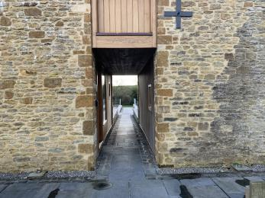
The Cart Shed - Access from car park
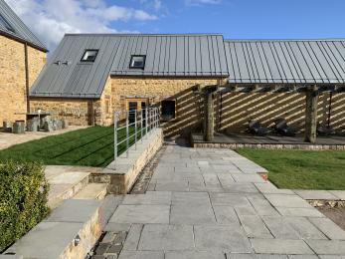
The Cart Shed - Journey through communal courtyard with gentle slope
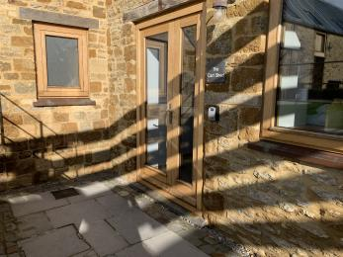
The Cart Shed - Entrance

Arrival

Path to main entrance
- From the street to the main entrance, there is level access.
- The path is 1300mm wide, or more.
- The path is sloped.

Main entrance
- The door is 720mm wide.
- The main entrance has 1 steps.
- When you arrive, we can help carry your luggage.
- Luggage assistance can be provided by request.
Step into main entrance is 20cm.
The Cart Shed - Main Entrance with step

Getting around inside

Visual Impairment - General Information
- We have contrast markings on all full-height windows and high colour contrast between walls and doorframes.
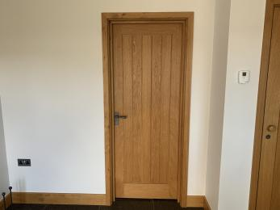
The Cart Shed - Wall & Door frames contrast

Bedrooms
- All bedrooms have windows.
- Bedrooms have ceiling lights, wall lights and bedside lamps.
- Lights are LED and energy saving. TVs have subtitles.
- All bedrooms are non-smoking.
- We have non-allergic bedding.
- No bedrooms have fitted carpets.
- There are no wi-fi free bedrooms, however we can disable the boosters in the bedroom. All of our bedding is hypoallergenic. We can provide details of our cleaning products on request, and where possible use alternative products if required.
- We can move the bedroom furniture, to improve accessibility.
- From the main entrance to this area, there is level access.
- The direction of transfer onto the toilet is to the left.
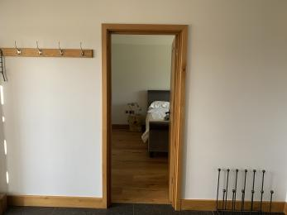
The Cart Shed - Doorway into ground floor bedroom
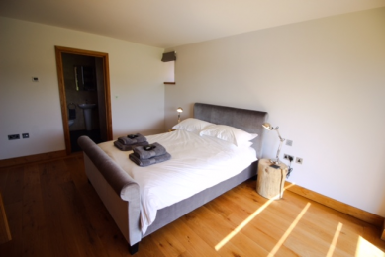
The Cart Shed - Ground floor bedroom
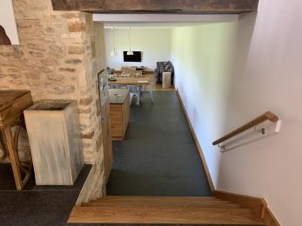
The Cart Shed - Stairs to kitchen and living area

Self catering kitchen

The Cart Shed - Kitchen & Dining
- We have an open plan kitchen.
- From the main entrance to the kitchen, there are 5 steps. There is no lift and no ramp.
- The work surface is available at a height between 650mm and 900mm.
- The hob is available at a height between 650mm and 900mm.
- The sink is available at a height between 650mm and 900mm.
- The oven is available at a height between 650mm and 900mm.
- The table and plates have high colour contrast.
- There is a minimum of 100cm around the kitchen island & dining table.
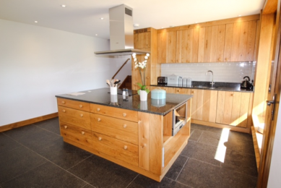
The Cart Shed - Kitchen
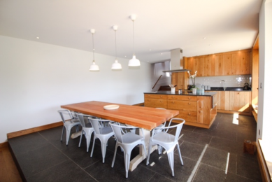
The Cart Shed - Dining

Lounge

The Cart Shed - Living Room
- From the main entrance to the lounge, there are 6 steps. There is no lift and no ramp.
- There are 5 steps into the kitchen/dining area, there is an additional step into the living area of 20cm, there is a contrast in flooring slab to wood. Furniture can be re-arranged by request.
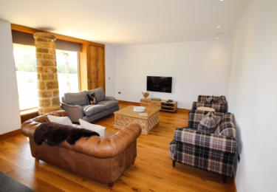
The Cart Shed - Living area

Getting around outside

The Cart Shed - Garden
- From the main entrance to the gardens, there is 1 step. There is no lift and no ramp.
- There is 1 step from the kitchen door to the garden area, this is at a height of 18cm, please bear in mind the 5 internal kitchen steps to get to the kitchen.
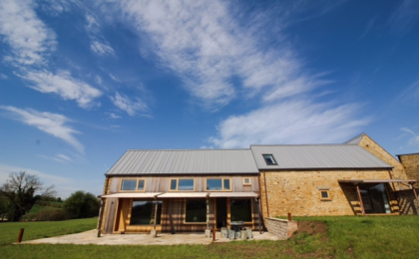
The Cart Shed - Garden View
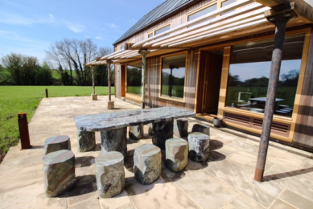
The Cart Shed - Access to garden

Customer care support

Accessibility equipment
- Grab rail for shower available by request.
- The nearest toilet area for assistant employees dogs are located through the main entrance onto grass or located out of the kitchen side door onto the open landscaped field.
- Sockets within property only, however we can accommodate charging within our commercial building away from the properties by arrangement.
- You can hire mobility equipment from Cotswold Mobility Hire by calling 01608658899.

Emergency evacuation procedures
- We have emergency lighting throughout the property.

Customer care support
- Staff are available 24 hours a day.
- We are a family run business, a member of the management team lives on location and is available 24 hours a day, the rest of the management team live 1.5 miles away.

Guide last updated: 2 March 2020

