Accessibility Guide for Joss Bay
visitorinformation@thanet.gov.uk, 01843 577577, https://www.visitthanet.co.uk/attractions/joss-bay-2186/
Contact for accessibility enquiries: Thanet Visitor Information Centre
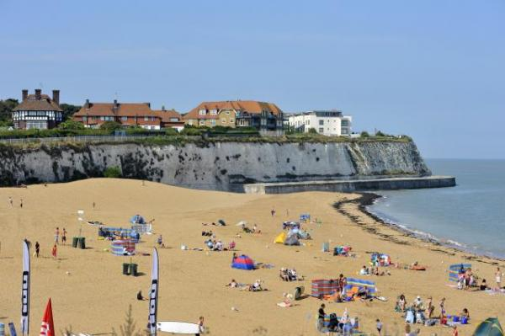

Welcome
Joss Bay, Broadstairs is a popular 200-metre long bay, known as the best surfing beach in Thanet. It's surrounded by fields and a golf course.
The surf school hires boards and wet suits. Deck chair/lounger hire available, a beach shop and cafe.There is plenty of exposed sand when the tide is in, but take care walking, as the beach gets cut off at both ends.
-Toilets (Seasonal)
-Seasonal lifeguards
-Disabled access to the beach
-Parking
-Kiddies Corner with bouncy castle and trampolines
-Dog ban in place from 1st May-30th September, dogs not permitted from 10am-6pm.
Bay inspectors in season assist the RNLI with minor first aid. The RNLI provide a 7 day service between 23 May - 6 September.

At a Glance
There is level access from the car park to:
- Beach

Visual
- We have information in audio, braille and large print.

Getting here
Joss Gap Road
Broadstairs
CT10 3PG

Travel by public transport
- The bay is fairly secluded from public transport links. The nearest train station is Broadstairs, 1.8 miles from the beach.

Travel by taxi
- You can get a taxi with Central Cars by calling 01843 888888.
- You can get a taxi with Thanet Cars by calling 01843 333333.
- You can get a taxi with United Cars by calling 01843 581581.
- Please contact the Thanet Visitor Information Service for information on accessible taxis in the area.
01843 577577

Parking
- We have a car park. There are accessible parking spaces. The parking is less than 50 metres from the main entrance. Parking is not free.
- There is no official dedicated drop-off point but visitors are welcome to drop off in the car park. There is a dropped curb to the slope down to the beach. Please note, the slope is on the road side and opposite a junction so it is unsafe to stop on the road, but the car park is less than 20 metres to the slope. The car park is immeditely next to the beach and has 200 spaces, including 4 accessbile spaces.

Arrival

Getting around inside

Getting around outside

Beach
- The beach access point is 20.00meters from the nearest car park.
- From the nearest car park to the beach, there is level access. The path is 3000mm wide, or more.
- The entrance is 1700mm wide.
- There are sun loungers.
- There is a First Aid Station.
- RNLI available to assist with minor First Aid during operating dates and hours only.
Sun loungers and deckchairs available to hire.
The width of the entrance tothe beach is 3000mm slipway and 1700mm access beside barrier.

Customer care support

Accessibility equipment
- For a list of more items, please go to https://www.visitthanet.co.uk/plan-your-visit/accessibility-information/.

Customer care support
- We have information in audio, braille and large print.

Guide last updated: 4 March 2020

