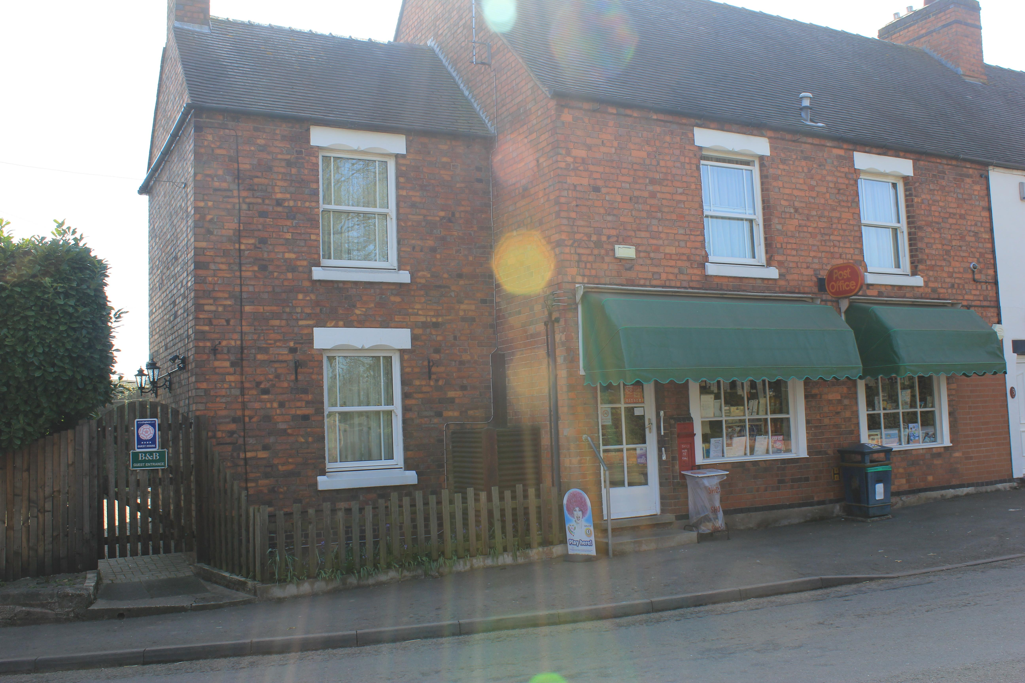

Accessibility Guide for Harlaston Post Office Bed & Breakfast
info@harlastonpostoffice.co.uk, 07548 271678, www.harlastonpostoffice.co.uk
Contact for accessibility enquiries: Tony Palmer or Rachel Rowe
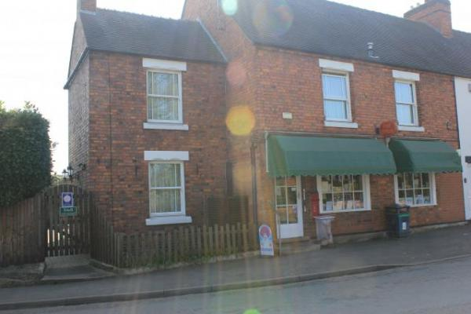

Welcome
Harlaston Post Office offers superb guest accommodation with 3 en-suite bedrooms. We offer a warm friendly welcome & a relaxed atmosphere. We do not have a downstairs bedroom or a stairlift. We are centrally located between Tamworth, Lichfield & Burton on Trent with good road links to Birmingham and Nottingham. We are ideally situated for visiting the National Memorial Arboretum and The National Forest. We serve a traditional english breakfast, or if you prefer something lighter or have special dietary needs we will be happy to accommodate if advised on booking. There is a pub in the village, The White Lion which is a 2 minute walk away that offers a superb evening meal, however booking is advisable.

At a Glance

Level Access
- The main entrance has 1 step. There is no lift and no ramp.
- There is level access from the main entrance to:
  - Dining Table
  - Post Office Cottage garden

Access with steps
- There are steps from the main entrance to:
  - Conservatory
  - Bedroom
  - Village Post Office & Stores
  - Conservatory

Bedrooms
- We have non-allergic bedding.

Hearing
- The (bedroom) TVs have subtitles.

General
- Staff are available 24 hours a day.
- We have emergency evacuation procedures for disabled visitors.

Getting here
Harlaston Post Office Bed & Breakfast
Main Road, Harlaston
Tamworth
B79 9JU

Travel by public transport
- The bus stop is 0.0 miles / 0.0 km from Harlaston Post Office Bed & Breakfast.

Travel by taxi
- You can get a taxi with Tamworth Taxis by calling 01827 62222.
- You can get a taxi with Bennetts Taxis by calling 01827 54444. The taxi company has a wheelchair accessible vehicle.

Parking
- We have a car park. There are accessible parking spaces. The parking is less than 50 metres from the main entrance. Parking is free.
- There is a drop-off point at the main entrance. The drop-off point has a dropped kerb.
- From the car park to the entrance, there is level access. The path is sloped.
- The route is 660mm wide, or more.
- Not applicable, the parking is at the back of the Post Office
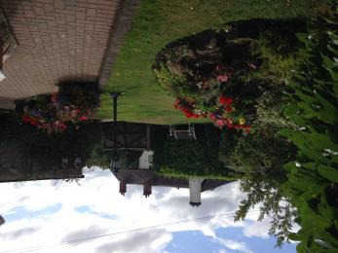
Parking is outside the church opposite the Post Office or if availability parking can be at the back of the post office

Arrival

Path to main entrance
- From the street to the main entrance, there is 1 step. There is no ramp and no lift.
- The path is sloped.

Main entrance
- The door is 1524mm wide.
- The main entrance has 1 steps.
- The main door is side hung and manual.
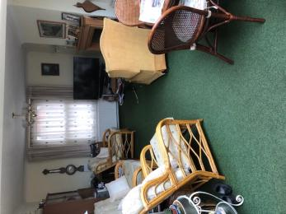
Conservatory where guests are met from the main entrance

Getting around inside

Conservatory
- From the main entrance to reception, there is 1 step. There is no lift and no ramp.
- The check-in desk has a low section for wheelchair users. You can sit down at reception.
This is the reception room

Bedrooms
- All bedrooms have windows.
- Bedrooms have ceiling lights, wall lights, bedside lamps and desk or table lamps.
- Lights are LED and energy saving. TVs have subtitles.
- All bedrooms are non-smoking.
- We have non-allergic bedding.
- All bedrooms have fitted carpets.
- We can move the bedroom furniture, to improve accessibility.
- The bedroom nearest the main entrance has 12 steps.
- All bedrooms are ensuite.
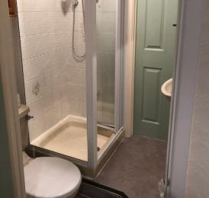
Room 2 - double has a small bathroom with a shower
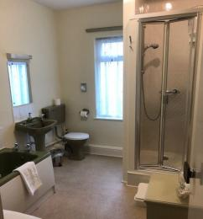
Room 3 twin has a bath and a separate shower
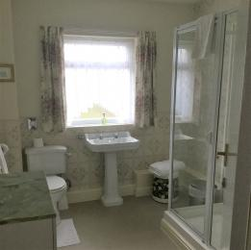
Room 1 family room bathroom with a shower

Shop

Village Post Office & Stores
- From the main entrance to the shop, there are 2 steps. There is no lift and no ramp.

Place to eat and drink

Dining room
- From the main entrance to the dining area, there is level access. The route is 762mm wide, or more. To get to a table, there are no steps.
- If you need table service, staff can help you.
- There is no background music.
- We cater for vegetarian, gluten free (celiacs) and lactose free (dairy free) specific diets.
- Any diet can be catered for as long as advised on booking
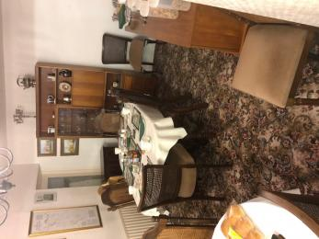
The dining room has 2 tables

Conservatory
- From the main entrance to this area, there is 1 step. There is no lift and no ramp.
- Guests are welcomed in the conservatory where they are asked to register. There is seating with arms and the flooring is carpet tiles and is well lit. We are happy for guests to sit in the Conservatory.
Conservatory is the room from the main entrance

Getting around outside

Post Office Cottage garden
- From the main entrance to the gardens, there is level access.
- The route is sloped. The route is 2794mm wide, or more.
- There is block paving up the path from the front gate and all around the main entrance and up the back to the rear parking
view coming up the path from the front gate
- From the main entrance to the area, there is 1 step.
- The Post Office has a lovely garden and a small fish pond. Guests are welcome to sit outside
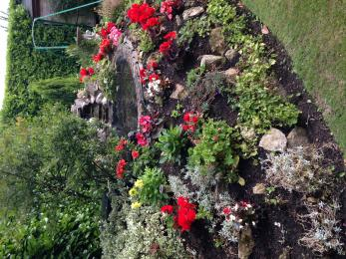
Lovely garden with small fish pond

Customer care support

Accessibility equipment
- Walking stick

Emergency evacuation procedures
- Smoke alarms are fitted.

Customer care support
- Staff are available 24 hours a day.

Guide last updated: 16 February 2020

