Accessibility Guide for Jacksons at Jedburgh
jas@jacksonsatjedburgh.co.uk, 07720891981, https://www.jacksonsatjedburgh.co.uk
Contact for accessibility enquiries: Jasmine Jackson
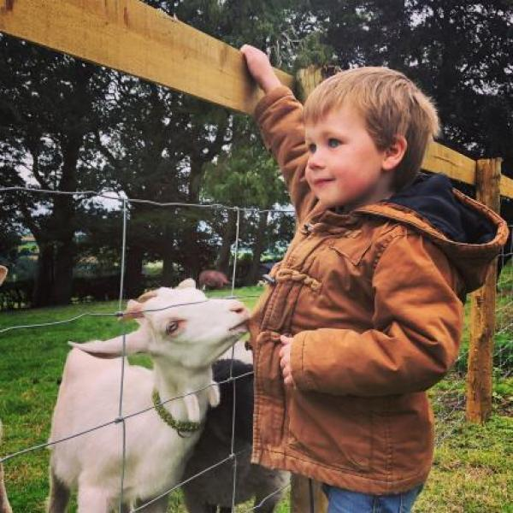

Welcome
​Jacksons at Jedburgh is a family friendly outdoor venue in the Scottish Borders offering farm tours, family days out, birthday parties and seasonal events.
​Nestled in the countryside, just south of Jedburgh in the Scottish Borders is Kersheugh Farm: 435 acres of farmland, the place we call home and where the daily routines of work and raising kids blend into our family’s way of life.

At a Glance

Level Access
- There is level access from the main entrance to:
  - Welcome Shed
  - Toilets
  - Outdoor paddock
- There is level access from the car park to:

Hearing
- All staff have disability awareness training.

Visual
- Some parts of the venue have low lighting.

General
- We have a complimentary ticket policy for personal assistants.
- There is at least 1 public toilet for disabled visitors.
- All staff have disability awareness training.

Getting here
Kersheugh Farm
Jedburgh
TD8 6QT

Travel by public transport
- The venue is accessible in all vehicles however there is no public transport directly to the farm. You can access Jedburgh by public transport and the farm by taxi if you wish.

Travel by taxi
- You can get a taxi with 1st Taxis Jedburgh by calling 01835 862377. The taxi company has a wheelchair accessible vehicle.

Parking
- We have a car park. There are accessible parking spaces. The parking is less than 50 metres from the main entrance. Parking is free.
- There is a drop-off point at the main entrance. The drop-off point has a dropped kerb.
- From the car park to the entrance, there is level access. The path is sloped.
- The route is 1000000mm wide, or more.
- The carpark is open and relatively level but is stoney and on a slight slope. Help is always available if required.
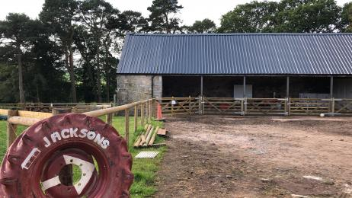
Picture of car park. Grass verge, stoney and hard soil ground. concrete inside shed.

Arrival

Path to main entrance
- From the street to the main entrance, there is level access.
- The path is sloped.

Main entrance
- The main entrance has level access.

Getting around inside

Visual Impairment - General Information
- Some parts of the venue have low lighting.
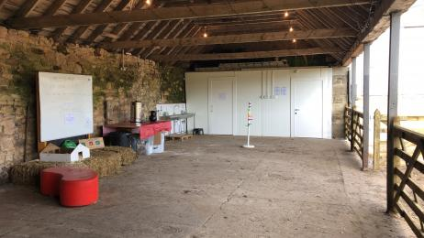
A picture of the inside of the shed. Concrete floor, toilets at one end.

Things to See and Do
- We have a complimentary ticket policy for personal assistants.

Welcome Shed
- From the main entrance to this area, there is level access. The route is 10000mm wide, or more. The door is 10000mm wide.
The inside of our shed has a concrete floor. toilets and hand washing facilities are at one end.
- Some display information is low, for wheelchair users.

Public toilet

Toilets
- There is a public toilet for disabled visitors.
- From the main entrance to the public toilet, there is level access. The direction of transfer onto the toilet is to the left.
- The toilets have handrails.

Outdoor paddock
- From the main entrance to this area, there is level access.
- Access to the paddock is directly from the shed. Surface is good and grass is well kept.
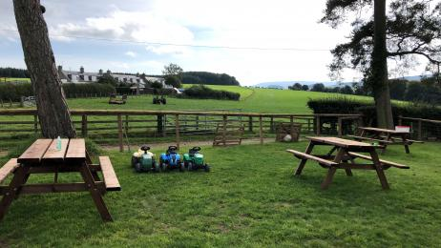
picture shows grass paddock and picnic benches

Getting around outside

Picnic Area
- From the car park to the picnic area, there is level access. Some tables have space for wheelchair users. You can bring your own food to the picnic area.
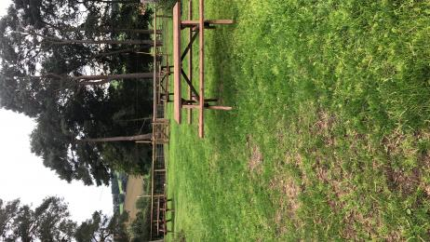
picture shows picnic bench

Customer care support

Emergency evacuation procedures
- We have emergency evacuation procedures for disabled visitors.

Customer care support
- All staff have disability awareness training.
- We have other services for people with accessibility requirements.
- We offer private visits, lots of pre planning help if required and are always available to discuss your needs.

Guide last updated: 21 September 2020

