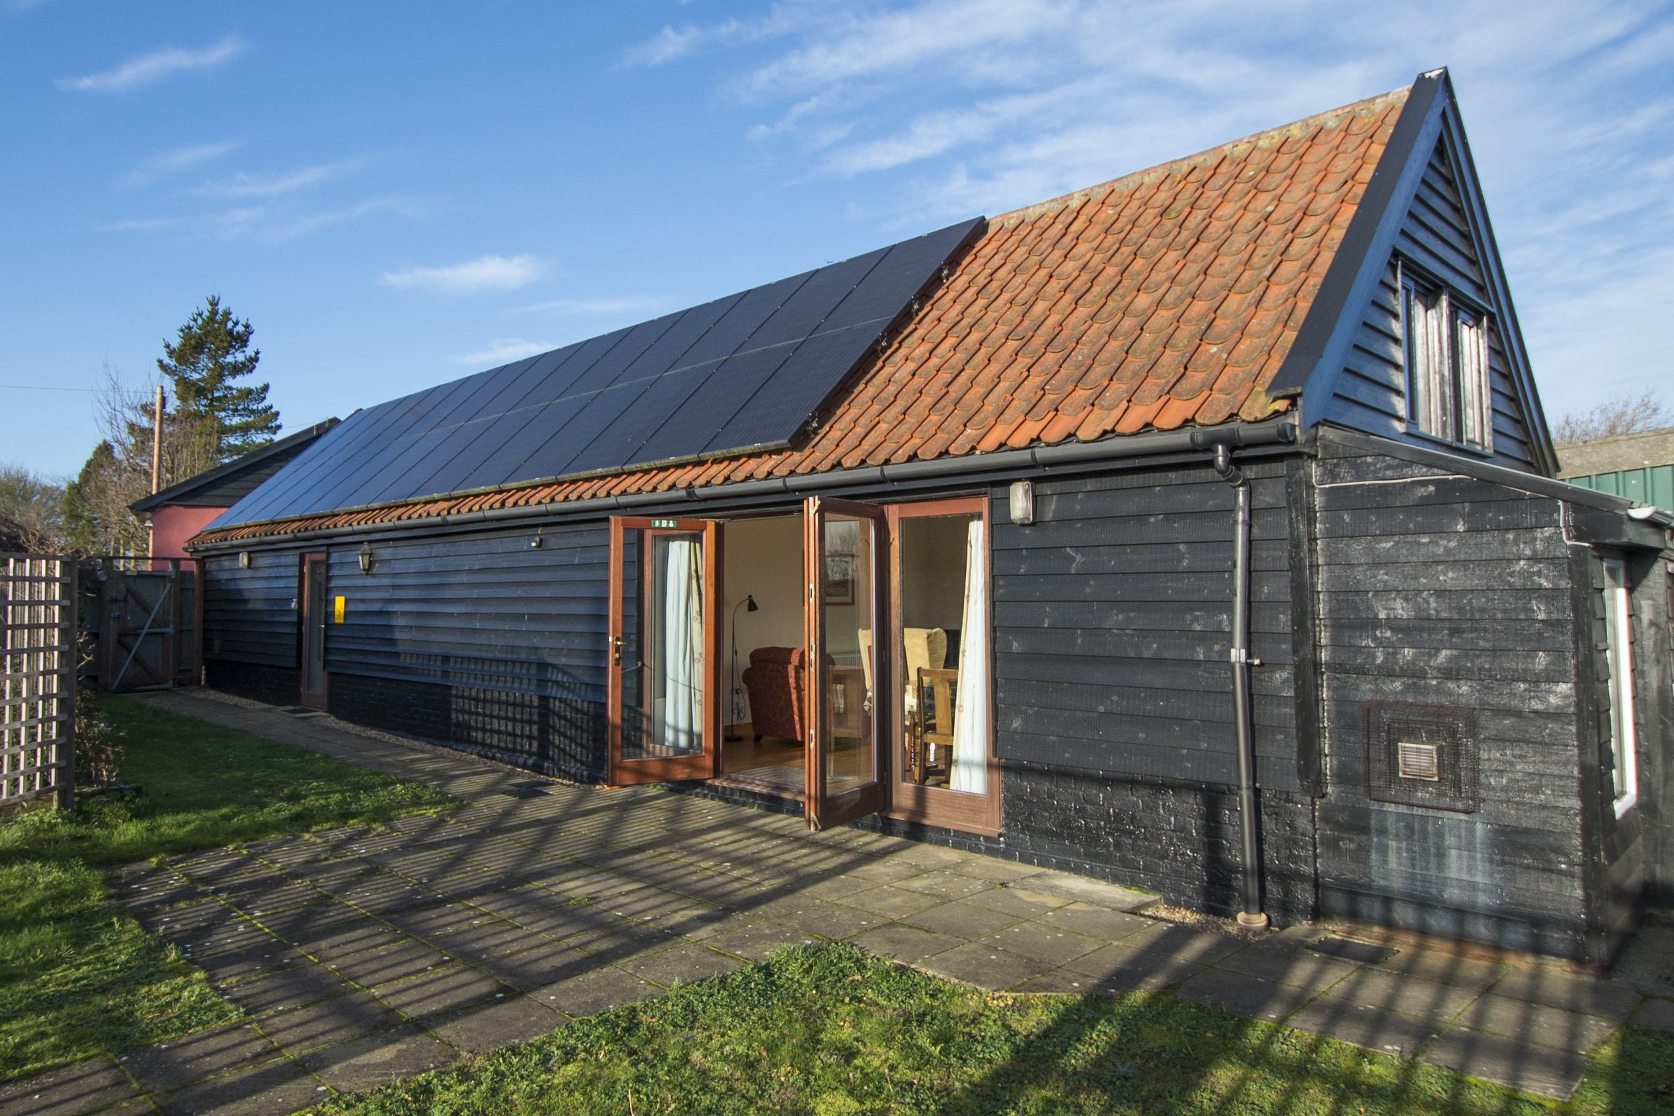

Accessibility Guide for Stable Cottage
enquiries@redhousefarmhaughley.co.uk, 01449 673323, www.redhousefarmhaughley.co.uk
Contact for accessibility enquiries: John Noy
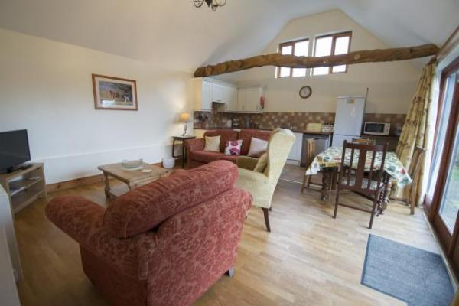

Welcome
The old farm stables converted into a comfortable cottage for up to four people. All the accommodation is on the ground floor making it perfect for the less mobile. It has a large kitchen/living area which is comfortably furnished and well equipped. The main bedroom has double or twin beds. It has an en-suite wet room which has been specially converted with wheelchair users in mind. The second bedroom has twin beds or double beds. There is also a fully fitted second bathroom.

At a Glance

Level Access
- There is level access from the main entrance to:
  - Bedroom: Main bedroom
  - Lounge
  - 2nd Bedroom
  - 2nd Bathroom
  - Garden

Bedrooms
- We have non-allergic bedding.

Level access bedrooms
- From the main entrance to the bedroom, there is level access.
- The route to the bedroom is 750mm wide, or more.
- The bedroom door is 750mm wide, or more.
- There is unobstructed floor space 1200mm by 900mm, or more.
- The bathroom has a level access shower.

General
The accommodation is rated by the National Accessible Scheme as suitable for:
- Part-time wheelchair users

Getting here
Red House Farm
Station Road
Haughley
IP14 3QP

Travel by public transport
- You can get to Stable Cottage by bus.
- The nearest Bus Stop is 100m walk from Red House Farm. The bus stop is 0.1 miles / 0.2 km from Stable Cottage.

Travel by taxi
- You can get a taxi with Stowmarket Cab Co by calling 01449 677777.
- You can get a taxi with Gold Star Taxis by calling 01449 676767.
- You can get a taxi with Superb Travel Suffolk by calling 01449 507775. The taxi company has a wheelchair accessible vehicle.

Parking
- We have a car park. The parking is less than 50 metres from the main entrance. Parking is free.
- There is a drop-off point at the main entrance. The drop-off point has a dropped kerb.
- From the car park to the entrance, there is level access. The route is 900mm wide, or more.

Arrival

Path to main entrance
- From the street to the main entrance, there is level access.
- The path is 900mm wide, or more.

Main entrance
- The main entrance has level access.
- The door is 810mm wide.
- The main door is side hung and manual.
- We can help with luggage if someone is available at the time of arrival but we can't guarantee it.

Getting around inside

Bedrooms
- All bedrooms have windows.
- Bedrooms have ceiling lights, bedside lamps and natural daylight.
- Lights are LED. Some lights can be controlled independently.
- All bedrooms are non-smoking.
- We have non-allergic bedding.
- All bedrooms have fitted carpets.
- We can move the bedroom furniture, to improve accessibility.
- From the main entrance to this area, there is level access.
- The direction of transfer onto the toilet is to the right.
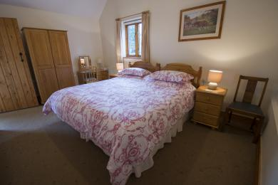
Stable Cottage Main Bedroom

Accessible bedrooms

Accessible bedroom Main bedroom
- The route to the bedroom is 820mm wide, or more. The bedroom door is 820mm wide. There is 1200mm at the side of the bed. The bed is 600mm high. There is 40mm under the bed.
- The bedroom is flexible (either double or twin). The bathroom is ensuite. The bathroom door is 910mm wide.
- The shower has a seat. The shower has a handrail.
- The bathroom has a level access shower. There is a shower chair available. The level access shower has handrails.
- The toilets have handrails. The direction of transfer onto the toilet is to the right. There is 1850mm at the side of the toilet.
- There is 1400mm in front of the toilet. The toilet seat is 480mm high.
- The basin is 790mm high. The taps are lever operated. There is space under the basin, with no pedestal or boxing.
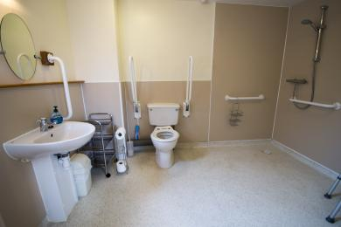
en suite Toilet Wet Room Shower

Self catering kitchen

Kitchen
- We have an open plan kitchen.
- From the main entrance to the kitchen, there is level access.
- The route is 780mm wide, or more.
- The door is 780mm wide.
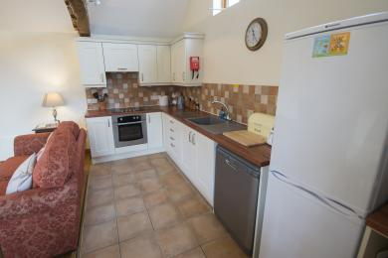
Stabel Cottage Kitchen

Lounge

Lounge
- From the main entrance to the lounge, there is level access. The route is 780mm wide, or more. The door is 780mm wide.
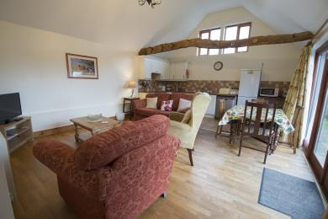
Stable Cottage Lounge

2nd Bedroom
- From the main entrance to this area, there is level access. The route is 790mm wide, or more.
- The door is 790mm wide.
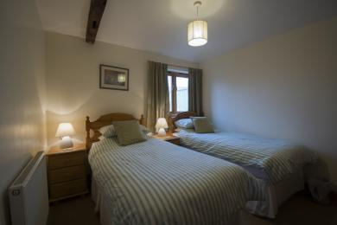
Stable Cottage 2nd Bedroom

2nd Bathroom
- From the main entrance to this area, there is level access. The route is 760mm wide, or more.
- The door is 760mm wide.
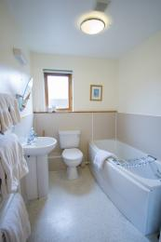
Stable Cottage Bathroom

Getting around outside

Garden
- From the main entrance to this area, there is level access. The route is 900mm wide, or more. The entrance is 900mm wide.

Customer care support

Accessibility equipment
- Stable Cottage Garden
- We have an area to charge mobility scooters and battery powered wheelchairs.

Guide last updated: 30 January 2020

