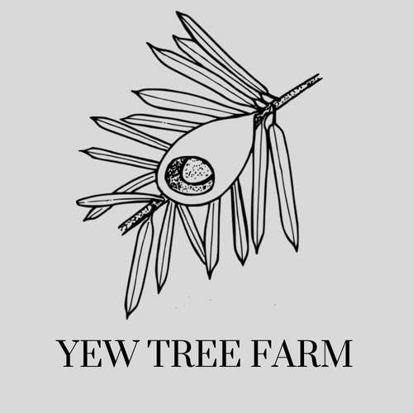

Accessibility Guide for Self catering cottages at Yew Tree Farm Holidays
info@yewtreefarmholidays.com, 01829770311, www.yewtreefarmholidays.com
Contact for accessibility enquiries: rachel whittingham
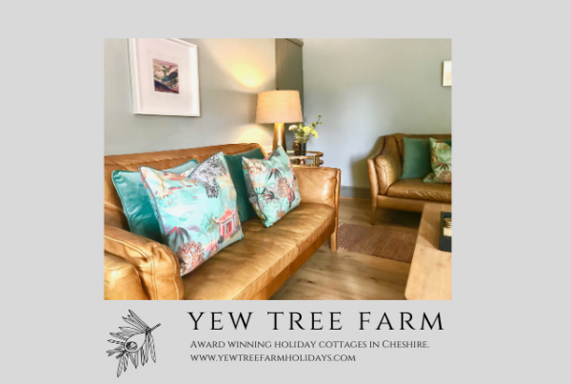

Welcome
Award winning holiday cottages situated on a quiet farm near the villages of Tattenhall & Tarporley, Cheshire.
The Stable is a boutique style two bedroom cottage for four people with a king size bedroom and a pretty twin.
The Cottage sleeps five in a king, a twin and a single room along with a comfortable dining kitchen.
The cottages are ideal for families, couples or friends for a relaxing stay in the country and we're very happy to have your dogs as our guests.
Both cottages have their own gardens with seating areas and we are ideally situated close to some amazing rural walks and super pubs.

At a Glance

Level Access
- The main entrance has 1 step. There is no lift and no ramp.

Access with steps
- There are steps from the main entrance to:
  - Bedroom
  - Sitting room in both cottages
  - Gardens and patio area

Hearing
- The (bedroom) TVs have subtitles.

Visual
- The walls and the doors have high colour contrast.

General
- Staff are available 24 hours a day.
- We have emergency evacuation procedures for disabled visitors.

Getting here
Yew Tree Farm, Newton Lane
Tattenhall
Chester
CH3 9NE

Travel by public transport
- Due to the rural aspect ans ituation of the property then a car is needed.
There is a bus stop situated 1 mile from the property which has regular stops for Chester.

Travel by taxi
- You can get a taxi with Pegasus Taxi by calling 07576661008.

Parking
- We have a car park. The parking is less than 50 metres from the main entrance. Parking is free.
- There is a drop-off point at the main entrance. The drop-off point has a dropped kerb.
- From the car park to the entrance, there is level access. The route is 3000mm wide, or more.
- The entrance to both cottages is from a tarmac courtyard. There is one step into the The Stable cottage and two steps into The Cottage.
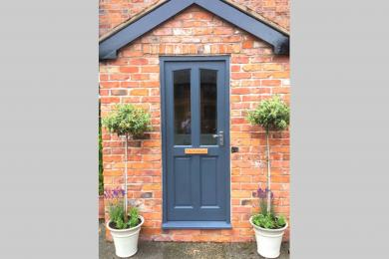
Entrance to The Cottage
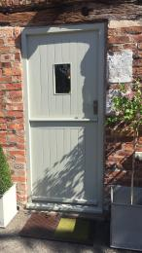
Entrance to The Stable

Arrival

Path to main entrance
- From the street to the main entrance, there is level access.
- The path is 3000mm wide, or more.

Main entrance
- The door is 762mm wide.
- The main entrance has 1 steps.
- The main door is side hung and manual.
- When you arrive, we can help carry your luggage.

Getting around inside

Visual Impairment - General Information
- We have high colour contrast between walls and doorframes.

Bedrooms
- All bedrooms have windows.
- Bedrooms have ceiling lights, wall lights, floor standing lights, bedside lamps and natural daylight.
- Lights are halogen, LED and energy saving. TVs have subtitles.
- All bedrooms are non-smoking.
- All bedrooms have fitted carpets.
- All cleaners used to clean cottages are eco friendly and some are asthma friendly. We can give details of cleaning products on request.
- The bedroom nearest the main entrance has 12 steps.
- We have bathrooms with a bath and overhead shower. The walls and the fittings have high colour contrast.
- The direction of transfer onto the toilet is to the left.

Self catering kitchen
- We have a separate kitchen and dining room. From the main entrance to the kitchen, there is level access.
- The route is 800mm wide, or more.
- The door is 762mm wide.
- The work surface is available at a height between 650mm and 900mm.
- The hob is available at a height between 650mm and 900mm.
- The sink is available at a height between 650mm and 900mm.
- The oven is available at a height between 650mm and 900mm.
- The table and plates have high colour contrast.
- From the main entrance to the dining room, there is 1 step. There is no lift and no ramp.

Lounge

Sitting room in both cottages
- From the main entrance to the lounge, there is 1 step. There is no lift and no ramp.

Getting around outside

Gardens and patio area
- From the main entrance to the gardens, there are 2 steps. There is no lift and no ramp.

Customer care support

Accessibility equipment
- We have an area to charge mobility scooters and battery powered wheelchairs.
- Can be charged in a farm buuilding and returned to user.

Customer care support
- Staff are available 24 hours a day.
- We have other services for people with accessibility requirements.
- We are very happy to assist people with accessibilty requirements in any way we can.

Guide last updated: 28 May 2023

