Accessibility Guide for Jeremy Fisher Cottage
info@northhaynefarmcottages.co.uk, 01769 550807, https://www.northhaynefarmcottages.co.uk/
Contact for accessibility enquiries: Cheryl Dixon, Roger Dixon
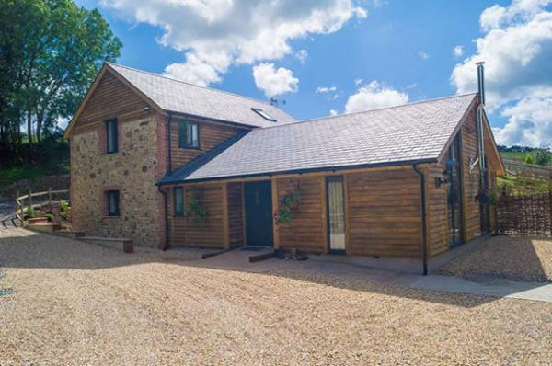

Welcome
Jeremy Fisher is a cottage of large proportions sleeping 10 and is comprised of 2 master bedroom on the ground floor each with ensuite, on the 1st floor a further double bedroom with ensuite, twin and bunk bedroom plus a family bathroom. An open plan kitchen/dining room and lounge are all on the ground floor with spacious hallways and access around the kitchen. A private slabbed patio with furniture and hot tub is accessed via ramp from the lounge on the ground floor.

At a Glance

Level Access
- The main entrance has level access with a ramp. The ramp is permanent.
- There is level access from the main entrance to:
  - Bedroom: Back ground floor bedroom with accessible wet room
  - Jeremy Fisher lounge
  - Ground floor bedroom 2
  - All Shared Gardens
  - Gated private slabbed patio with hot tub
  - Children's Farm

Access with steps
- There are steps from the main entrance to:
  - Main Reception
  - 1st floor double bedroom with ensuite
  - 1st floor twin bedroom configurable as a double
  - 1st floor bunk bedroom
  - 1st floor family bathroom
  - Games room/Play barn

Bedrooms
- We have non-allergic bedding.

Level access bedrooms
- From the main entrance to the bedroom, there is level access.
- The route to the bedroom is 750mm wide, or more.
- The bedroom door is 750mm wide, or more.
- There is unobstructed floor space 1200mm by 900mm, or more.
- The bathroom has a level access shower.

Hearing
- The (bedroom) TVs have subtitles.
- Some staff have disability awareness training.

Visual
- Some parts of the venue have low lighting.
- We have information in large print.

General
- Staff are available 24 hours a day.
- Some staff have disability awareness training.
- We have emergency evacuation procedures for disabled visitors.

Getting here
North Hayne Farm
Bishops Nympton
South Molton
EX36 3QR

Travel by public transport
- We benefit from the seclusion of being part of the natural rural landscape of North Devon. Access to the site is possible by public transport with the addition of a taxi, however, the use of a car whilst not essential would be a better option for travelling around the area.

Travel by taxi
- You can get a taxi with South Molton Taxis by calling 01769 573636. The taxi company has a wheelchair accessible vehicle.
- You can get a taxi with A & L Taxis by calling 01769 572169.
- We are always happy to help organise taxis so please speak to us if you require any help.

Parking
- We have a car park. There are accessible parking spaces. The parking is less than 50 metres from the main entrance. Parking is free.
- From the car park to the entrance, there is level access. There is a permanent ramp.
- The path is sloped.
- The route is 3000mm wide, or more.
- Guests with limited mobility are able to park their car outside their cottage. Please be sure to discuss your requirements with us before booking your cottage as we will be able to help provide additional information which may help with your choice of cottage. When you arrive/depart we are happy to help you with your bags should you need assistance.
Please let us know if you wish to order your shopping using an online grocery service and we will put it away in your cottage ready for your arrival.
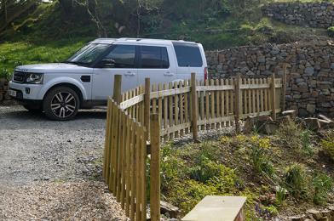
Own car parking area to side of cottage

Arrival

Path to main entrance
- From the street to the main entrance, there is level access.
- There is a permanent ramp.
- The path is 1500mm wide, or more.
- The path is sloped.

Main entrance
- The main entrance has level access.
- There is a permanent ramp.
- The door is 870mm wide.
- The main door is side hung and manual.
- When you arrive, we can help carry your luggage.
- Guests with limited mobility are welcome to park their car very near their cottage. We will always offer to help with baggage both when you arrive and depart.
We will also put away your online grocery order (please let us know in advance) ready for your arrival.
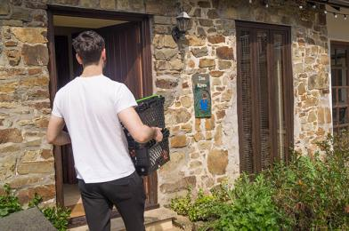
Putting your online grocery away

Getting around inside

Visual Impairment - General Information
- Some parts of the venue have low lighting.

Main Reception
- From the main entrance to reception, there are 6 steps. There is no lift and no ramp.
- You can sit down at reception.
- Our reception has 3 steps to the door where there are 2 door bells, one at 1.2m from ground level (accessible without using steps) and one at 1.4m from the top step.
Once inside there are a further 3 steps before entering the main reception area.
We will be happy to speak to you outside if you are unable to access our reception or we will come to your cottage if you wish to call us on the land line.
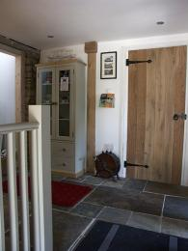
Our Main Reception Area

Bedrooms
- All bedrooms have windows.
- Bedrooms have ceiling lights, bedside lamps, spot lights and natural daylight.
- Lights are LED. TVs have subtitles.
- All bedrooms are non-smoking.
- We have non-allergic bedding.
- Some bedrooms have fitted carpets.
- Please let us know before your arrival if we need to carry out additional cleaning and remove loose furnishings that may cause an allergic reaction.
- We can move the bedroom furniture, to improve accessibility.
- From the main entrance to this area, there is level access.

Accessible bedrooms

Accessible bedroom Back ground floor bedroom with accessible wet room
- The route to the bedroom is 1300mm wide, or more. The bedroom door is 800mm wide. There is 1300mm at the side of the bed. The bed is 550mm high. There is 170mm under the bed.
- There is a low clothes rail. You can use the rail sitting down.
- The bedroom is flexible (either double or twin). The bathroom is ensuite. The bathroom door is 800mm wide.
- The bathroom has a level access shower. There is a shower chair available. The level access shower has handrails.
- The toilets have handrails. The direction of transfer onto the toilet is to the left. There is 1000mm at the side of the toilet.
- There is 2000mm in front of the toilet. The basin is 760mm high. The taps are lever operated. There is space under the basin, with no pedestal or boxing.
- The walls and the bathroom fittings have high colour contrast.
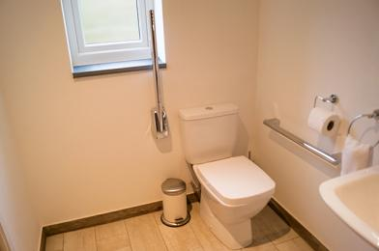
Support handles
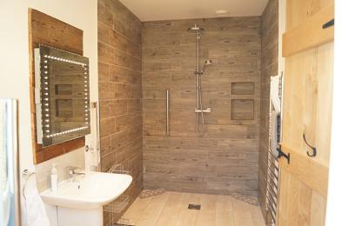
Ensuite wet room

Self catering kitchen

Jeremy Fisher kitchen
- We have an open plan kitchen.
- From the main entrance to the kitchen, there is level access.
- The route is 1200mm wide, or more.
- The work surface is available with clear underspace.
- The table and plates have high colour contrast.
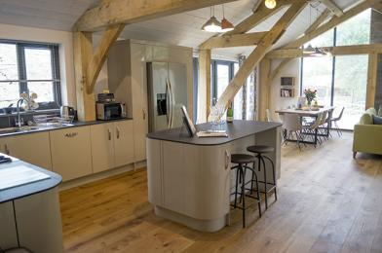
Island with under counter space
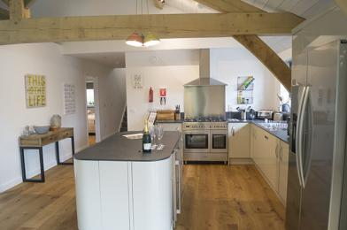
Open plan kitchen
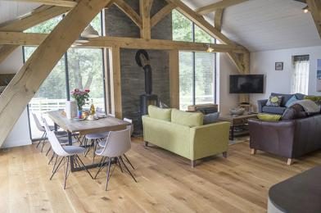
Open plan dining area

Lounge

Jeremy Fisher lounge
- From the main entrance to the lounge, there is level access. The route is 2000mm wide, or more.
- The lounge is a large open space made up of three settees. These can be move if required to create improved access.
Lounge area

Ground floor bedroom 2
- From the main entrance to this area, there is level access. The route is 1200mm wide, or more.
- The door is 800mm wide.
- Bedroom 2 also has an ensuite with bath and separate walk-in wetroom shower.
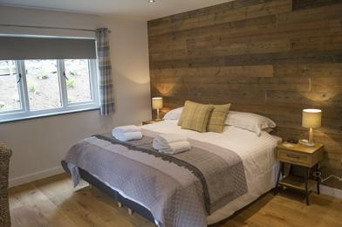
Bedroom 2 with ensuite
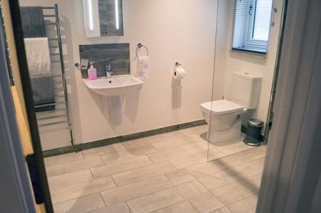
Bedroom 2 ensuite with walk-in wetroom shower
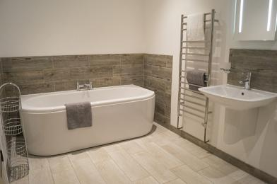
Bedroom 2 ensuite with bath

1st floor double bedroom with ensuite
- From the main entrance to this area, there are 14 steps. There is no lift and no ramp.
- This bedroom is located on the 1st floor via internal full turn stairs with landing on turn and again at top of stairs.
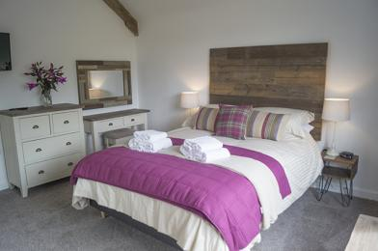
1st floor double bedroom with ensuite
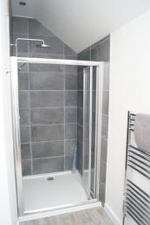
Ensuite shower with toilet and basin

1st floor twin bedroom configurable as a double
- From the main entrance to this area, there are 14 steps. There is no lift and no ramp.
- Located just off the main 1st floor landing.
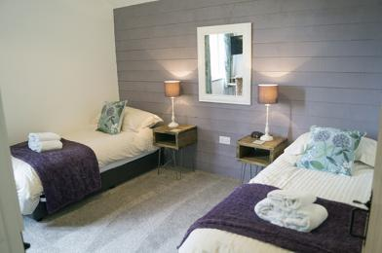
1st floor twin bedroom

1st floor bunk bedroom
- From the main entrance to this area, there are 14 steps. There is no lift and no ramp.
- Located just off the main 1st floor landing next door to the twin bedroom.
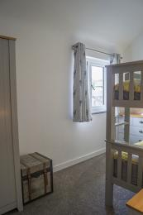
1st floor bunk bedroom

1st floor family bathroom
- From the main entrance to this area, there are 14 steps. There is no lift and no ramp.
- Located just off the main 1st floor landing.
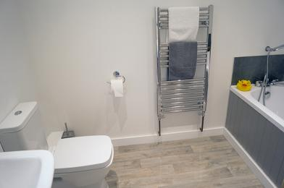
1st floor family bathroom

Getting around outside

All Shared Gardens
- From the main entrance to the gardens, there is level access.
- The route is 2000mm wide, or more.
- There are two lawned gardens. Both are undulating and may have tree roots in places. One of the garden areas is on a slope with access via 16 steps or via a high gradient 2 meter wide path leading from the car park.
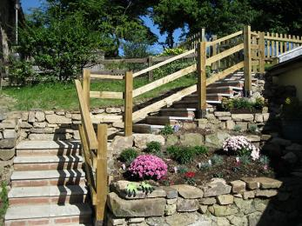
Access to Additional Gardens

Gated private slabbed patio with hot tub
- From the main entrance to this area, there is level access. There is a permanent ramp. The entrance is 900mm wide.
- Access to the patio area is from the open plan dining area through patio doors.
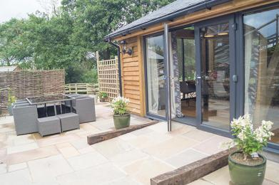
Access to private patio and hot tub
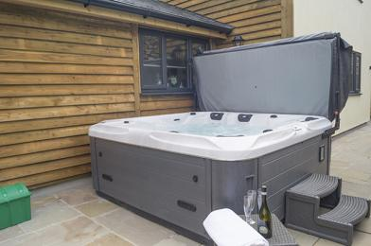
Private hot tub

Games room/Play barn
- From the main entrance to the area, there are 3 steps.
- Three 2 meter wide steps with handrail lead up to the games room/play barn. A door with threshold gives access to both rooms. Once in the games room a further 4 steps provides access to the pool table room.
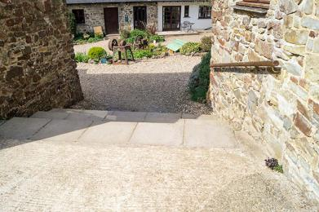
Steps leading to games room
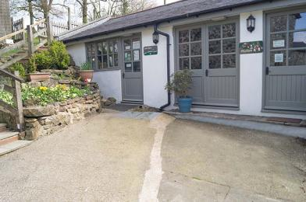
Access to games room via either of two doors
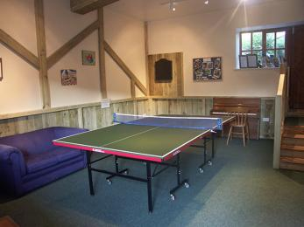
Games room with access via 4 steps to pool table room
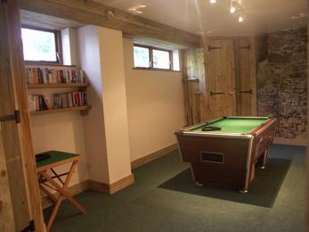
Pool table room
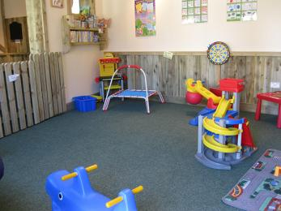
Under 7's play barn

Children's Farm
- From the main entrance to this area, there is level access. The route is 1300mm wide, or more. The entrance is 1300mm wide.
- The children's farm has been built to provide good access, safe and clean areas and undercover space from the elements. All paths and open spaces are of concrete with the exception of the riding area which is of sand.
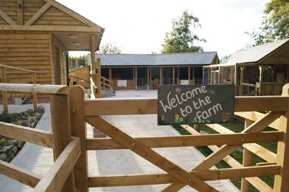
Our Children's Farm
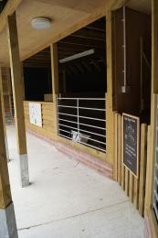
Covered Feeding Areas
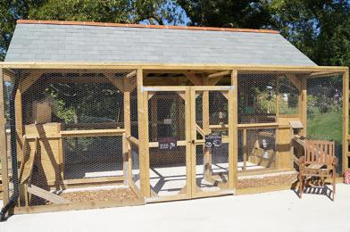
Covered Feeding Areas
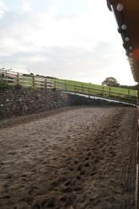
Sand Donkey Riding Area
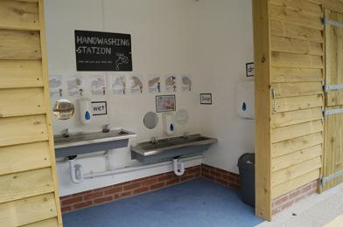
Hand Washing Area
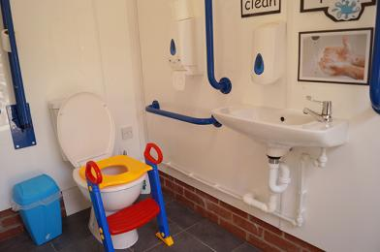
Ambulant Toilet
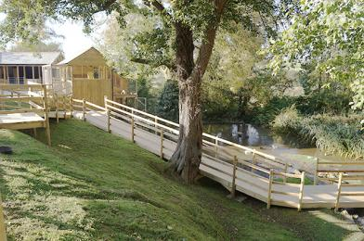
Access To Pond

Treatment Room
- Our beauty and holistic therapy treatment room is situated approx 30m just off the main court yard. Access is via a flat gravelled 2m wide path.
The entrance to the room is over a low threshold strip of 10mm height.
The main door is 770mm wide but can be opened further to enable a 1230mm wide entrance. Internal doors are all 820mm wide.
The reception/beauty area is 1700 x 2080 and has dimable lighting
An ambulant toilet facility is located off the reception. 1700 x 1000.
The main treatment room is off the reception and is 3200 x 3400 and has dimable lighting. There is clear space from the door to the treatment couch of 1700.
A stepup is available to help with getting on to the massage couch.
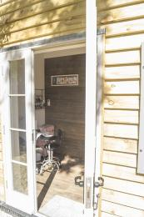
Main entrance to the treatment room
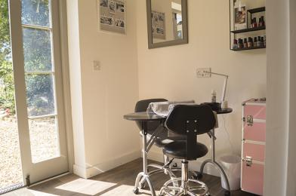
Reception area incorporating beauty treatment area
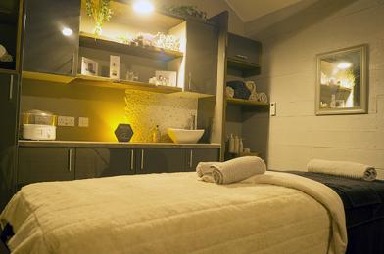
Treatment room

Customer care support

Accessibility equipment
- We recommend hiring mobility equipment to ensure it meets your requirements correctly. We are happy to receive such equipment on the day of your arrival.
- For a list of more items, please go to https://www.brauntonmobility.co.uk/.
- All assistance dogs may use the private lawned area belonging to the business owners. We will happily clear up after your dog.
- We have an area to charge mobility scooters and battery powered wheelchairs.
- We can provide access for charging batteries via either indoor or outdoor socket.
- You can hire mobility equipment from Braunton Mobility by calling 01271 814577.

Emergency evacuation procedures
- We have emergency evacuation procedures for disabled visitors.
- All cottages have wired fire detectors and are connected back to our farm house which is situated on site. This alerts us to any potential incident alowing us to attend to the specific cottage within minutes. We will let ourselves in to the cottage as required to determine the reason for the alarm and assist with your evacuation if required.

Customer care support
- Some staff have disability awareness training.
- We have information in large print.
- Staff are available 24 hours a day.
- We live on site and are available to assist as the need arises.

Guide last updated: 16 January 2020

