Accessibility Guide for Katies Corner Cottage
info@northhaynefarmcottages.co.uk, 01769 550807, https://www.northhaynefarmcottages.co.uk/
Contact for accessibility enquiries: Cheryl Dixon, Roger Dixon
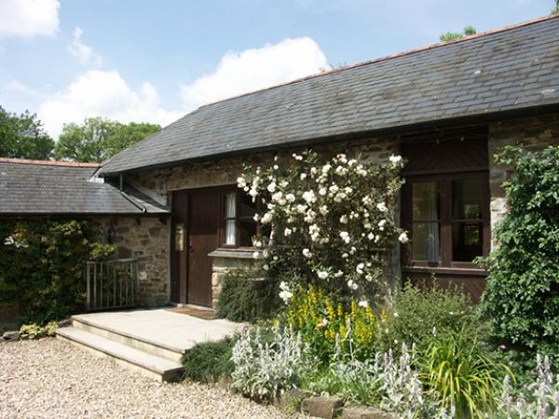

Welcome
Katies Corner cottage is a cottage sleeping up to 3 plus a trundle bed. The cottage is accessed by 2 steps to the front door and additionally 2 steps to the kitchen door from the patio area and private garden. From the front door you enter directly in to the lounge. The main and second bedroom both lead off the lounge with the main bedroom on the same level but the second being down 2 steps. The bathroom and kitchen both lead off the lounge and are both via separate steps (2 for the bathroom and 3 for the kitchen). The kitchen and dining area are open plan. Outside off the patio is your own private hot tub. Steps are available if required.

At a Glance

Level Access
- The main entrance has 2 steps. There is no lift and no ramp.
- There is level access from the main entrance to:
  - All Shared Gardens
  - Children's Farm

Access with steps
- There are steps from the main entrance to:
  - Main Reception
  - Guest laundry
  - Second bedroom
  - Private patio
  - Private hot tub
  - Games room/Play barn

Bedrooms
- We have non-allergic bedding.

Level access bedrooms
- From the main entrance to the bedroom, there is level access.

Hearing
- Some staff have disability awareness training.

Visual
- We have information in large print.

General
- Staff are available 24 hours a day.
- Some staff have disability awareness training.
- We have emergency evacuation procedures for disabled visitors.

Getting here
North Hayne Farm
Bishops Nympton
South Molton
EX36 3QR

Travel by public transport
- We benefit from the seclusion of being part of the natural rural landscape of North Devon. Access to the site is possible by public transport with the addition of a taxi, however, the use of a car whilst not essential would be a better option for travelling around the area.

Travel by taxi
- You can get a taxi with South Molton Taxis by calling 01769 573636. The taxi company has a wheelchair accessible vehicle.
- You can get a taxi with A & L Taxis by calling 01769 572169.
- We are always happy to help organise taxis so please speak to us if you require any help.

Parking
- We have a car park. There are accessible parking spaces. Parking is free.
- There is a drop-off point at the main entrance. The drop-off point does not have a dropped kerb.
- From the parking to the main entrance, there are 2 steps. There is no ramp and no lift.
- Guests with limited mobility are able to park their car outside their cottage. Please be sure to discuss your requirements with us before booking your cottage as we will be able to help provide additional information which may help with your choice of cottage. When you arrive/depart we are happy to help you with your bags should you need assistance.
Please let us know if you wish to order your shopping using an online grocery service and we will put it away in your cottage ready for your arrival.
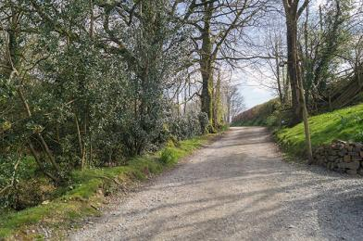
Access from car parking area

Arrival

Path to main entrance
- From the street to the main entrance, there are 2 steps. There is no ramp and no lift.

Main entrance
- The door is 800mm wide.
- The main entrance has 2 steps.
- The main door is side hung and manual.
- When you arrive, we can help carry your luggage.
- Guests with limited mobility are welcome to park their car outside (or near) their cottage. We will always offer to help with baggage both when you arrive and depart.
We will also put away your online grocery order (please let us know in advance) ready for your arrival.
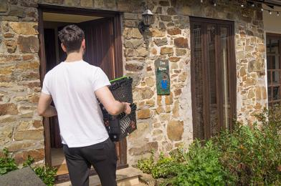
Putting your online grocery away

Getting around inside

Main Reception
- From the main entrance to reception, there are 6 steps. There is no lift and no ramp.
- You can sit down at reception.
- Our reception has 3 steps to the door where there are 2 door bells, one at 1.2m from ground level (accessible without using steps) and one at 1.4m from the top step.
Once inside there are a further 3 steps before entering the main reception area.
We will be happy to speak to you outside if you are unable to access our reception or we will come to your cottage if you wish to call us on the land line.
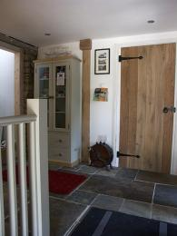
Our Main Reception Area

Bedrooms
- All bedrooms have windows.
- Bedrooms have ceiling lights, bedside lamps and natural daylight.
- Lights are LED and traditional filament. All bedrooms are non-smoking.
- We have non-allergic bedding.
- All bedrooms have fitted carpets.
- Please let us know before your arrival if we need to carry out additional cleaning and remove loose furnishings that may cause an allergic reaction.
- We can move the bedroom furniture, to improve accessibility.
- From the main entrance to this area, there is level access.
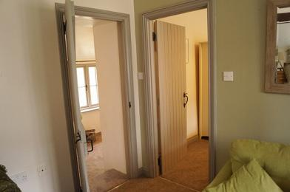
Katies Corner access to main and second bedrooms
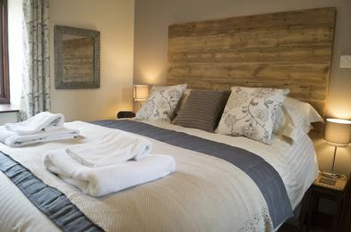
Master bedroom
- We have bathrooms with a bath and overhead shower.

Guest laundry
- From the main entrance to the laundry, there are 3 steps. There is no lift and no ramp.
- The guest laundry has 2 front loading washing machines and 1 front loading tumble dryer. Each cottage has it's own ironing board/iron. Tom Kitten, Samuel Whiskers, Squirrel Nutkin and Jeremy Fisher all have their own washing machine. Jeremy Fisher also has it's own tumble dryer. Bio/Non Bio washing products can be bought from reception if required.
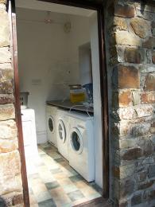
Guest laundry

Self catering kitchen

Katies Corner Kitchen
- We have an open plan kitchen.
- From the main entrance to the kitchen, there are 3 steps. There is no lift and no ramp.
- The table and plates have high colour contrast.
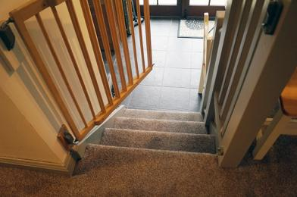
Katies Corner access down to kitchen
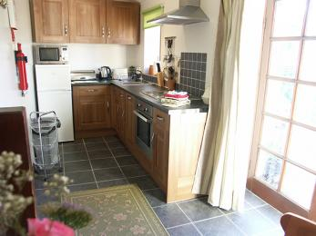
Katies Corner open plan kitchen

Lounge

Katies Corner Lounge
- There is a threshold at the front door.
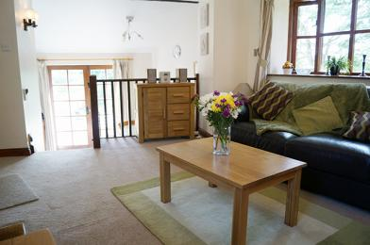
Lounge with access down steps to kitchen, bathroom and second bedroom

Second bedroom
- From the main entrance to this area, there are 2 steps. There is no lift and no ramp.
- A second bedroom is accessed off the lounge down 2 steps. Normally setup as a single room, a trundle bed can be setup for use by a child or a cot can be setup instead.
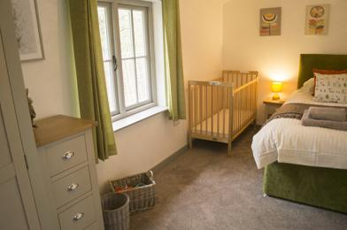
Second bedroom

Getting around outside

All Shared Gardens
- From the main entrance to the gardens, there is level access.
- The route is 2000mm wide, or more.
- There are two lawned gardens. Both are undulating and may have tree roots in places. One of the garden areas is on a slope with access via 16 steps or via a high gradient 2 meter wide path leading from the car park.
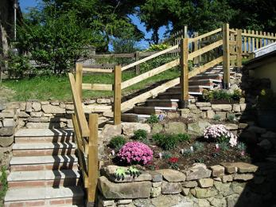
Access to Additional Gardens

Private patio
- From the main entrance to the area, there are 2 steps.
- Access to the private patio is via the kitchen.
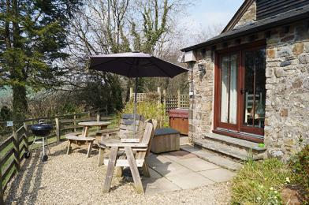
Katies Corner private patio

Private hot tub
- From the main entrance to the area, there is 1 step.
- The private hot tub is accessed off the patio area. A small change in surface exists.
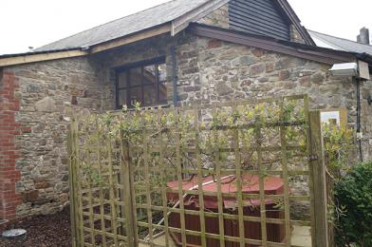
Katies Corner private hot tub

Games room/Play barn
- From the main entrance to the area, there are 3 steps.
- Three 2 meter wide steps with handrail lead up to the games room/play barn. A door with threshold gives access to both rooms. Once in the games room a further 4 steps provides access to the pool table room.
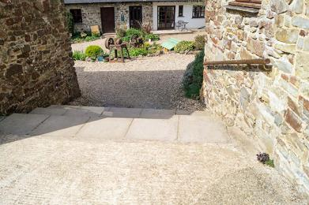
Steps leading to games room
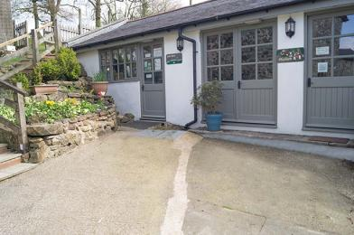
Access to games room via either of two doors
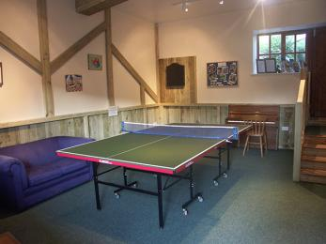
Games room with access via 4 steps to pool table room
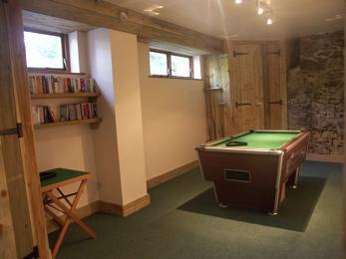
Pool table room
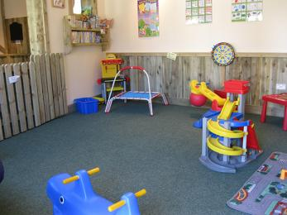
Under 7's play barn

Children's Farm
- From the main entrance to this area, there is level access. The route is 1300mm wide, or more. The entrance is 1300mm wide.
- The children's farm has been built to provide good access, safe and clean areas and undercover space from the elements. All paths and open spaces are of concrete with the exception of the riding area which is of sand.
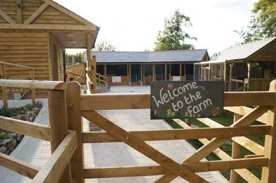
Our Children's Farm
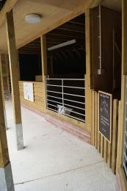
Covered Feeding Areas
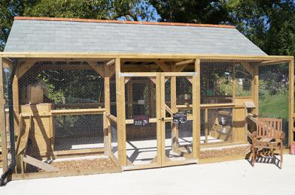
Covered Feeding Areas
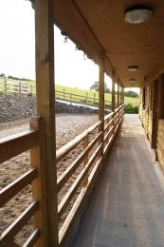
Sand Donkey Riding Area
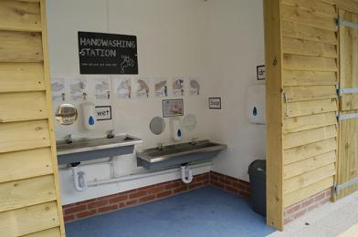
Hand Washing Area
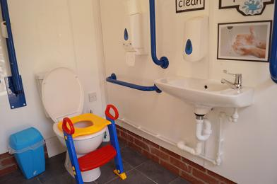
Ambulant Toilet
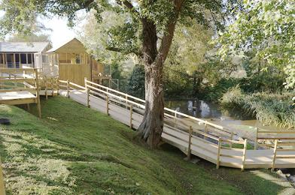
Access To Pond

Treatment Room
- Our beauty and holistic therapy treatment room is situated approx 30m just off the main court yard. Access is via a flat gravelled 2m wide path.
The entrance to the room is over a low threshold strip of 10mm height.
The main door is 770mm wide but can be opened further to enable a 1230mm wide entrance. Internal doors are all 820mm wide.
The reception/beauty area is 1700 x 2080 and has dimable lighting
An ambulant toilet facility is located off the reception. 1700 x 1000.
The main treatment room is off the reception and is 3200 x 3400 and has dimable lighting. There is clear space from the door to the treatment couch of 1700.
A stepup is available to help with getting on to the massage couch.
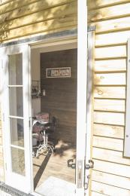
Main entrance to the treatment room
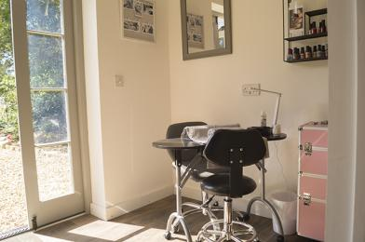
Reception area incorporating beauty treatment area
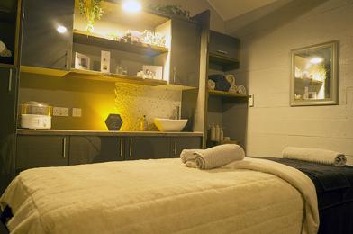
Treatment room

Customer care support

Accessibility equipment
- For a list of more items, please go to https://www.brauntonmobility.co.uk/.
- All assistance dogs may use the private lawned area belonging to the business owners. We will happily clear up after your dog.
- We have an area to charge mobility scooters and battery powered wheelchairs.
- We can provide access for charging batteries via either indoor or outdoor socket.
- You can hire mobility equipment from Braunton Mobility by calling 01271 814577.

Emergency evacuation procedures
- We have emergency evacuation procedures for disabled visitors.
- All cottages have wired fire detectors and are connected back to our farm house which is situated on site. This alerts us to any potential incident alowing us to attend to the specific cottage within minutes. We will let ourselves in to the cottage as required to determine the reason for the alarm and assist with your evacuation if required.

Customer care support
- Some staff have disability awareness training.
- We have information in large print.
- Staff are available 24 hours a day.
- We live on site and are available to assist as the need arises.

Guide last updated: 16 January 2020

