Accessibility Guide for Glasgow Science Centre
contact.us@gsc.org.uk, 0141 420 5000, https://www.glasgowsciencecentre.org
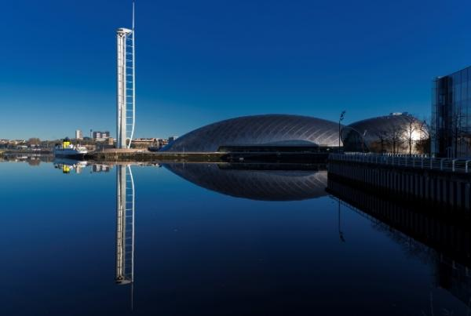

Welcome
Glasgow Science Centre is one of Scotland’s must-see visitor attractions – presenting concepts of science and technology in unique and inspiring ways.
The main experiences include Glasgow Tower, an IMAX Theatre, Planetarium and Science Mall.
The gleaming titanium crescent that overlooks the Clyde has three floors packed with hundreds of interactive exhibits that will fascinate you. The Science Mall also plays host to our interactive workshops, Science Show Theatre, the Lab and the state-of-the-art Planetarium! Our science communicators are here to help you to explore and make your experience memorable.

At a Glance

Level Access
- There is level access from the main entrance to:
  - Dining Table
  - Science Mall Floor 1
  - Science Mall - Floor 3
  - Ticket Desk
  - Ground Floor
  - Floor 2 Toilet
  - Floor 3 - Toilet
  - IMAX Toilet
  - Changing Places Toilet - Ground Floor
  - Ground Floor Toilet - Locker area
  - GSC Gift Shop
  - Smoking Area - Front of Building
- There is level access from the car park to:
  - Riverside
- We have a viewing area for wheelchair users.

Hearing
- The fire alarm has flashing lights.
- We have a hearing loop in The Planetarium, Main Ticket Desk and Science Show Theatre.
- Some staff have disability awareness, BSL and Next Generation Text training

Visual
- The walls and the doors have high colour contrast.
- Some parts of the venue have low lighting.

General
- We have a complimentary ticket policy for personal assistants.
- There is at least 1 public toilet for disabled visitors.At least one toilet is a Changing Places toilet.
- Some staff have disability awareness training.

Getting here
50 Pacific Quay
Glasgow
G51 1EA

Travel by public transport
- You can get to Glasgow Science Centre by bus, train and metro.
- The nearest bus stop is at Festival Park on Pacific Drive. It is around a 4-minute walk. McGill's buses number 23 and 24. Glasgow Sightseeing bus also stops at the SEC which is a 5 minute walk away from Glasgow Science Centre - Stop 11. The bus stop is 0.2 miles / 0.3 km from Glasgow Science Centre.
- The nearest train station is Exhibition Centre. The train station is 0.5 miles / 0.8 km from Glasgow Science Centre.
- The nearest underground station is Cessnock Subway. The underground station is 0.9 miles / 1.4 km from Glasgow Science Centre.
- Ibrox Subway station is also a short distance away from Glasgow Science Centre.

Parking
- We have a car park. There are accessible parking spaces. Parking is not free.
- There is a drop-off point at the main entrance. The drop-off point does not have a dropped kerb.
- From the car park to the entrance, there is level access. The route is 1300mm wide, or more.
- Glasgow Science Centre has a tarrif system in operation. Please see our website for full details.

Arrival

Path to main entrance
- From the street to the main entrance, there is level access.
- There is a permanent ramp.
- The path is 1600mm wide, or more.

Main entrance
- The main entrance has level access.
- The door is 1600mm wide.
- The main door is side hung and automatic.
- The main entrances and exit to Glasgow Science Centre are wheelchair accessible. The area is also well lit with natural lighting and overhead lights. The main entrance has easy access wth automatic doors. Doorways measure 160x220cm. Staff are located at the main doors and are on hand to assist anyone who requires assistance.
The exit is in the Link Building next to the Gift Shop and IMAX cinema, this doorway measures 130x238cm. Please note that there is a small moat area that is filled with water to the left of the doorway as you approach the door.
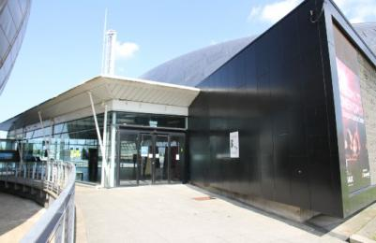
Exit via the link building
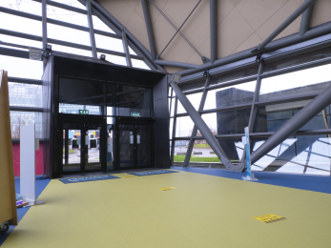
Entrance - Atrium
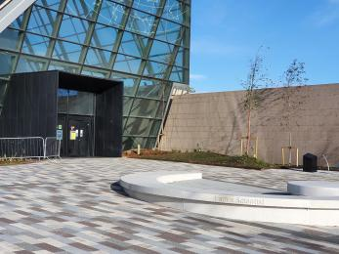
Main entrance to GSC

Getting around inside

Visual Impairment - General Information
- We have high colour contrast between walls and doorframes.
- Some parts of the venue have low lighting.

Lift
- We have 3 lifts.
- You can get a lift to all floors.

Science Mall large lift
- The lift door is 2080mm wide.
- The lift is 2540mm wide. The lift is 3640mm deep.
- The lift buttons have raised numbers or letters.
- The lift shows the floor number, at each floor.
- We have a very large multi-person lift near the ticket desk that can carry up to 66 people, the doorway opening is 2080mm and the depth is 3640mm. This provides excellent access for those with mobility aids and parents with buggies. This lift gives access to all three floors of the Science Mall at Glasgow Science Centre.
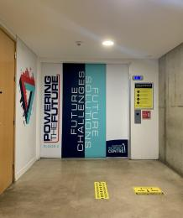
Entrance to Science Mall large lift

Science Mall small lift
- The lift door is 800mm wide.
- The lift is 1150mm wide. The lift is 1500mm deep.
- A smaller lift is also available with a door opening of 800mm, and a depth of 1500mm. This lift is located between the escalators to Floor 1 from the Ground Floor and the entrance to Glasgow Tower. The small lift gives access to all three floors of the Science Mall at Glasgow Science Centre.
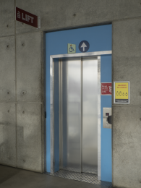
Small lift - access to all floors

IMAX lift
- The lift door is 1000mm wide.
- The lift is 1300mm deep.
- This lift is located in the foyer of the IMAX and gives access to the rear of the auditorium with a door opening of 1000mm, and a depth of 1300mm.

Ticket/ information desk

Ticket Desk
- From the main entrance to the desk, there is level access. The desk has a low section.
- Access to the main ticket desk is straight ahead of the main entrance doors and is completely level. All of our tills are at an accessible height.
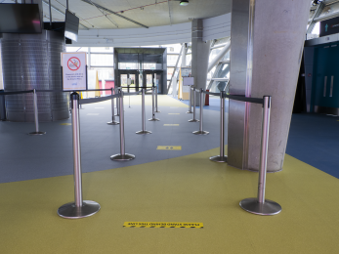
Access to main ticket desk
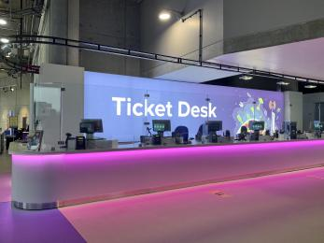
GSC ticket desk

Things to See and Do
- We have a complimentary ticket policy for personal assistants.

Science Mall Floor 1
- From the main entrance to this area, there is level access. There is a lift.
- Some display information is low, for wheelchair users. There are seats.
- Some videos have subtitles.

Science Mall - Floor 3
- From the main entrance to this area, there is level access. There is a lift.
- Some display information is low, for wheelchair users. There are seats.
- Floor 3 is also home to The Live Lab where wheelchair users have access to workshops and activities.

Spectator/ Audience viewing areas
- There are stewards to help disabled visitors.
- We have a viewing area for wheelchair users.

Science Show Theatre
- From the main entrance to the viewing area, there is level access. The route is 940.00 wide, or more. The door is 940 wide.
- Personal assistants and friends can sit with wheelchair users.
- There is space for wheelchair users and their carers at the rear of the Science Show Theatre.
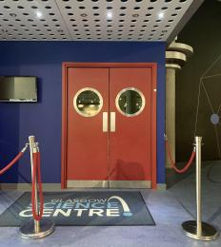
Entrance to Science Show Theatre

Planetarium
- From the main entrance to the viewing area, there is level access. There is a lift.
- From the lift to the viewing area, the route is 940 wide, or more. The door is 940 wide.
- The wheelchair spaces are sheltered. Personal assistants and friends can sit with wheelchair users.
- Wheelchair users can sit with their own fans.
- The spaces for wheelchair users are at the rear of the Planetarium.
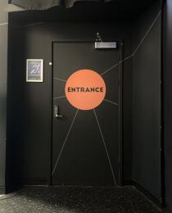
Entrance to Planetarium
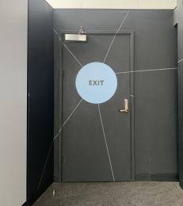
Planetarium exit

IMAX Theatre
- From the main entrance to the viewing area, there is level access. There is a lift.
- The wheelchair spaces are sheltered. Personal assistants and friends can sit with wheelchair users.
- Wheelchair users can sit with their own fans.
- Stewards can bring food and drink to wheelchair users.
- Please check our bookings page for latest film schedule IMAX | Glasgow Science Centre

Public toilet

Ground Floor
- There is a public toilet for disabled visitors.
- From the main entrance to the public toilet, there is level access. The route is 920mm wide, or more.
- The toilet door is 920mm wide.
- The direction of transfer onto the toilet is to the right.
- There is 840mm at the side of the toilet. There is 1470mm in front of the toilet. The toilet seat is 450mm high. The toilets have handrails.
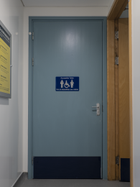
Toilet door - width 920mm
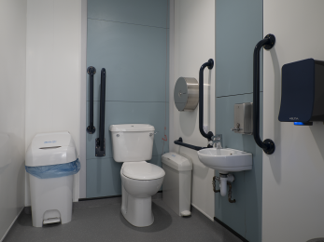
Ground Floor Accessible toilet

Public toilet

Floor 2 Toilet
- There is a public toilet for disabled visitors.
- From the main entrance to the public toilet, there is level access. There is a lift.
- From the lift to the public toilet, the route is 920mm wide, or more.
- The toilet door is 920mm wide.
- The direction of transfer onto the toilet is to the front only.
- There is 1117mm in front of the toilet. The toilet seat is 435mm high. The toilets have handrails.
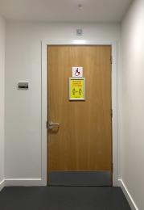
Entrance to Floor 2 accessible toilet
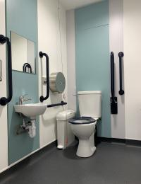
Floor 2 Accessible toilet

Public toilet

Floor 3 - Toilet
- There is a public toilet for disabled visitors.
- From the main entrance to the public toilet, there is level access. There is a lift.
- From the lift to the public toilet, the route is 940mm wide, or more.
- The toilet door is 940mm wide.
- The direction of transfer onto the toilet is to the front only.
- There is 1720mm in front of the toilet. The toilet seat is 420mm high. The toilets have handrails.
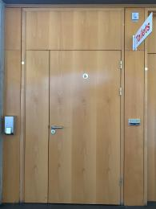
Entrance - Floor 3 Accessible toilet
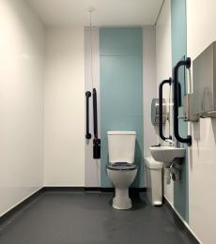
Floor 3 Accessible toilet

Public toilet

IMAX Toilet
- There is a public toilet for disabled visitors.
- From the main entrance to the public toilet, there is level access. The toilet door is 920mm wide.
- The direction of transfer onto the toilet is to the front only.
- There is 1370mm in front of the toilet. The toilet seat is 450mm high. The toilets have handrails.

Public toilet

Changing Places Toilet - Ground Floor
- There is a public toilet for disabled visitors.
- The toilet is a Changing Places toilet.
- From the main entrance to the public toilet, there is level access. The route is 800mm wide, or more.
- The toilet door is 880mm wide.
- The direction of transfer onto the toilet is to the right.
- There is 1000mm at the side of the toilet. There is 3000mm in front of the toilet. The toilet seat is 470mm high. The toilets have handrails.
- Glasgow Science Centre has a Changing Places Toilet located on the Ground Floor of the Science Mall, on the right-hand side, next to the escalators.
The CPT has the following items of equipment
Moving and Handling and Changing Equipment supplied by W Munro (Rehab) Ltd. Tel:
Guldmann cover overhead hoisting equipment (www.guldmann.com) . The Hoist serial number is GH3200 110 HS
Shower trolley by Chiltrern Invadex (UK) Ltd
Peninsular Toilet
Washbasin Height Adjustable
Non-Slip Floor
Floor Space 13.5m2
Emergency Alarms
Managed/controlled access
Additional Information
Before using the hoisting system clients should be familiar with the operation of the hoist and rail system. Only competent and trained people should use the hoist system.
The access code for the CPT can be obtained from the main ticket desk.
GSC will be registered as a destination and will be added to the changing places map. Therefore, anyone wishing to use the CPT do not have to be a GSC customer.
However, access to the Changing Places Toilet will be only be during normal operational hours or during corporate events in the evening. Please see opening hours for details https://www.glasgowsciencecentre.org/visit/our-opening-hours
The Safe working load of the hoist is a maximum nominal load 200 kgs (440IIbs) - 375kg (825IIbs) respectively must not be exceeded.
Changing places toilets are in addition to standard accessible toilets within GSC
Please note that GSC staff are not accountablee for the following:
Undertaking a risk assessment for individual disabled people and their assistants
Providing physical assistance to a disabled person using the Changing Places Facilities
Providing slings for use with the hoist.
If you require any further information or support prior to your visit please contact – contact.us@glasgowsciencecentre.org 0141 420 5000
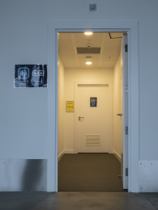
Access door to CPT
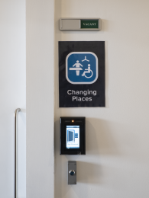
Controlled access
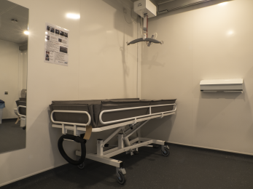
Guldmann cover overhead hoisting equipment and shower trolley
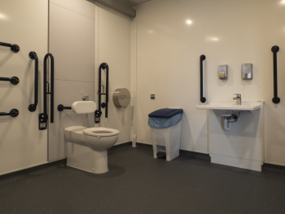
Peninsular Toilet, Washbasin Height Adjustable, Non-Slip Floor

Public toilet

Ground Floor Toilet - Locker area
- There is a public toilet for disabled visitors.
- From the main entrance to the public toilet, there is level access. The route is 800mm wide, or more.
- The toilet door is 900mm wide.
- The direction of transfer onto the toilet is to the right.
- There is 900mm at the side of the toilet. There is 1300mm in front of the toilet. The toilet seat is 450mm high. The toilets have handrails.
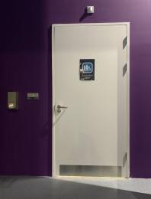
Entrance to Accessible toilet
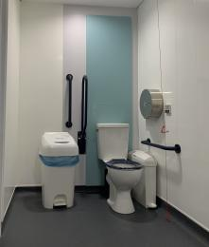
Ground floor Accessible toilet - locker area

Shop

GSC Gift Shop
- From the main entrance to the shop, there is level access. The route through the shop is 800mm wide, or more.
- A low level counter is available at the shop counter. Staff are happy to assist customers if required.
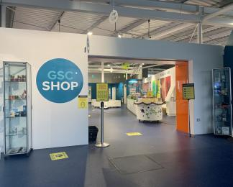
Entrance to GSC Gift Shop

Place to eat and drink

Taste Cafe
- From the main entrance to the dining area, there is level access. To get to a table, there are no steps.
- If you need table service, staff can help you.
- The route through the dining area is 800mm wide, or more.
- There is background music sometimes.
- We cater for vegetarian, gluten free (celiacs), lactose free (dairy free), nut free, vegan and halal specific diets.
- Please niote that our Taste Cafe is curently closed however the Coffee Shop in the IMAX Theatre is open Wed - Friday and the main cafe is open weekends in the Clyde Suire on the grounfd floor of the Science Mall.

Getting around outside

Picnic Area

Riverside
- From the car park to the picnic area, there is level access. Some tables have space for wheelchair users. You can bring your own food to the picnic area.
- Picnic benches are available outdoors alongside a grass area with a lovely view of the Clyde (on a nice day)

Smoking

Smoking Area - Front of Building
- From the main entrance to the smoking area, there is level access. The smoking area has a shelter.
- The smoking area is located outside at the fornt of the main building, beside the bicycle rack. It is sheltered by a canopy.

Customer care support

Accessibility equipment
- We provide wheelchairs. Wheelchairs are free.
- We have a hearing loop in The Planetarium, Main Ticket Desk and Science Show Theatre.
- Walking stick chairs available on request.
- As part of Euan's Guide we supply water and poo bags for assistance dogs. A rest area is available. We have a grassed area outside the building.
- We have an area to charge mobility scooters and battery powered wheelchairs.
- Mobility scooters can be charged provided visitors can supply their own charger.

Emergency evacuation procedures
- We have emergency evacuation procedures for disabled visitors.
- The fire alarm has flashing lights.
- All areas within the building are well equipped to deal with the evacuation of mobility impaired visitors should the need arise. Refuge areas are located in each of the Science Mall floors. Evac-chairs are also positioned in both Mall and IMAX buildings.

Customer care support
- Some staff have disability awareness training.
- Some staff have Next Generation Text training.
- Some staff have BSL training.
- We have a mobile app that features British Sign Language versions of interpretation for some of our exhibits, we are working to make this available for all of our exhibits in the near future. You can find this in the app store on your mobile device, please ask a member of staff if you need help to download it.
10 individual hearing neckloops are available on request for visitors in the Planetarium.
First Aid trained staff.
We weclome assisted dogs.
We accept the Access card.
We are a member of the Hidden Disabilities Sunflower Scheme.
Trained staff on 'A Sense of blindness and sight loss'.
Trained staff on 'Sense of deafness and hearing loss'.
We offer autism-friendly hours. Visitors with autism do not have to queue during busy periods. Please speak to a member of staff on arrival and they will be happy to assist you. We can arrange a quiet space for visitors who require it. Autism Friendly Hours are back from 27/11/22 and will run weekly on Sundays 10am-1pm

Guide last updated: 10 November 2022

