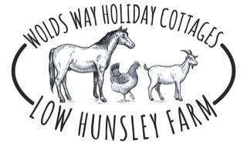

Accessibility Guide for Milking Parlour
07880410928, www.woldswayholidaycottages.com
Contact for accessibility enquiries: Rachel Adamson
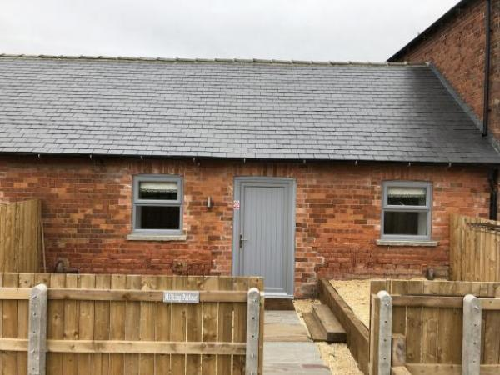

Welcome
At Low Hunsley Farm, we have converted our range of traditional brick and tile barns into beautifully appointed 1, 2 & 3 bedroom holiday accommodation. Set in the middle of our 330 acre arable farm, all of our apartments are equiped with dishwasher, washer / tumbler, fridge, microwave, coffee machine, toaster and kettle. The super king beds can also be split into singles to accommodate family parties

At a Glance

Level Access
- There is level access from the main entrance to:
  - Milking Parlour

Level access bedrooms
- From the main entrance to the bedroom, there is level access.

Hearing
- The (bedroom) TVs have subtitles.

General
- Staff are available 24 hours a day.
- We have emergency evacuation procedures for disabled visitors.

Getting here
Low Hunsley Farm
Little Weighton
Cottingham
HU20 3UP

Travel by public transport
- We have no public transport nearby so a car is a must. The nearest railway stations are based in Cottingham and Brough

Travel by taxi
- You can get a taxi with Willerby Cars by calling 01482 659659.
- You can get a taxi with South Cave Taxis by calling 01430 422218.

Parking
- We have a car park. The parking is less than 50 metres from the main entrance. Parking is free.
- There is a drop-off point at the main entrance. The drop-off point does not have a dropped kerb.
- From the car park to the entrance, there is level access. The path is sloped.
- The route is 900mm wide, or more.
- Vehicle can be parked at entrance for loading / unloading
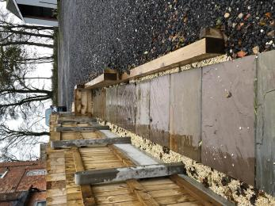
Path to cottage
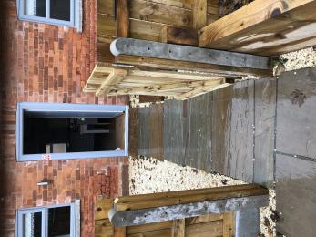
Garden path to door
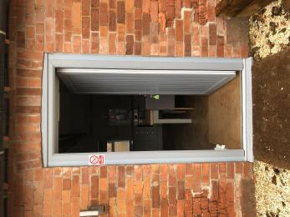
Entrance door

Arrival

Path to main entrance
- From the street to the main entrance, there is level access.
- The path is 980mm wide, or more.

Main entrance
- The main entrance has level access.
- The door is 860mm wide.
- The main door is side hung and manual.
- When you arrive, we can help carry your luggage.
Entrance door

Getting around inside

Bedrooms
- All bedrooms have windows.
- Bedrooms have ceiling lights, wall lights, bedside lamps and natural daylight.
- Lights are LED and energy saving. TVs have subtitles.
- All bedrooms are non-smoking.
- No bedrooms have fitted carpets.
- From the main entrance to this area, there is level access.
- The direction of transfer onto the toilet is to the left.
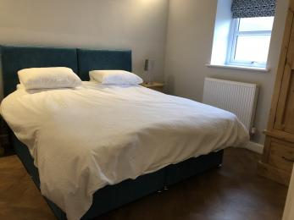
Bed
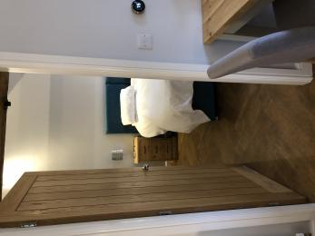
Bedroom door

Self catering kitchen

The Milking Parlour
- We have an open plan kitchen.
- From the main entrance to the kitchen, there is level access.
- The route is 980mm wide, or more.
- The table and plates have high colour contrast.
- Plates are white
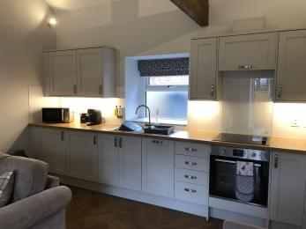
Kitchen area

Lounge

Milking Parlour
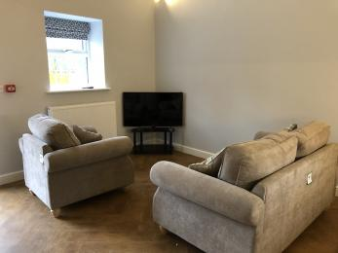
Lounge area

Getting around outside

Milking Parlour
- From the main entrance to the gardens, there is level access.
- The route is 900mm wide, or more.
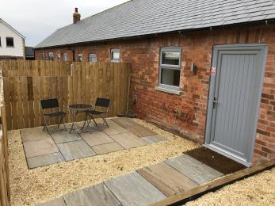
Garden Area

Customer care support

Customer care support
- Staff are available 24 hours a day.
- Proprietors live on site

Guide last updated: 15 November 2023

