Accessibility Guide for Yorkshire Museum & Garden
access@ymt.org.uk, 01901 687 687, https://www.yorkshiremuseum.org.uk/
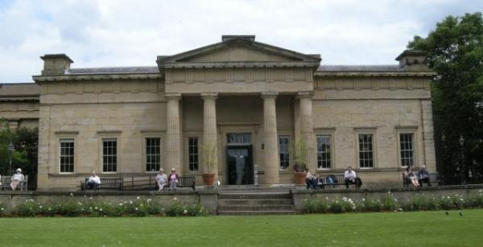

Welcome
The Yorkshire Museum is set in ten acres of botanical gardens, both of which were founded in the 1830s by the Yorkshire Philosophical Society. The museum currently houses a number of archaeological, geological and natural history artefacts from our extensive collections. Within the Museum Gardens are the ruins of the 13th century St Mary’s Abbey, a medieval Hospitium and guest lodge, and a 19th century Observatory. All of the buildings are listed and the gardens are a registered Garden of Special Scientific Interest.

At a Glance

Level Access
- The main entrance has level access with a ramp. The ramp is permanent.
- There is level access from the main entrance to:
  - museum galleries
  - Main entrance
  - museum shop
  - Museum Gardens

Hearing
- The fire alarm has flashing lights.
- Some staff have disability awareness training.

Visual
- Glass doors and full-height windows have contrast markings.
- Some parts of the venue have low lighting.

General
- We have a concessionary rate for disabled visitors.
- We have a complimentary ticket policy for personal assistants.
- Some staff have disability awareness training.

Getting here
Museum Gardens,
Museum Street,
York,
YO1 7FR

Travel by public transport
- You can get to Yorkshire Museum & Garden by bus and train.
- The nearest bus stop is on Museum Street where the number 2 bus stops. It is then a short, slightly sloped walk to the museum entrance. There are several other bus stops nearby. For more information visit www.itravelyork.info/buses. The bus stop is 0.1 miles / 0.2 km from Yorkshire Museum & Garden.
- The nearest train station is York. The train station is 0.5 miles / 0.8 km from Yorkshire Museum & Garden.

Parking
- There is a drop-off point at the main entrance. The drop-off point does not have a dropped kerb.
- Cars can drop off at the front of the museum by prior arrangement. The closest parking is a five minute walk and has 350 spaces. The Marygate car park, Frederick Street, York, YO30 7DT.
Marygate is off Bootham, the A19, which is the main road into York from the north.
Free parking for blue badge holders is available immediately outside the car park, located between the entry and exit points. For further car parking information please click here.

Arrival

Path to main entrance
- From the street to the main entrance, there is level access.
- There is a permanent ramp.
- The path is sloped.

Main entrance
- The main entrance has level access.
- There is a permanent ramp.
- The door is 760mm wide.
- The main door is side hung and manual.
- There are two manual opening doors at the main entrance.
To operate them manuallly; pull on entry and push on exit.

Getting around inside

Visual Impairment - General Information
- We have contrast markings on all glass doors and contrast markings on all full-height windows.
- Some parts of the venue have low lighting.

Lift
- We have 1 lift.
- You can get a lift to all floors.

lift to all floors
- The lift is 1100mm wide. The lift is 2050mm deep.
- The lift shows the floor number, at each floor.
- Instead of announcing the floor numbers, the lift does say the floor level at teach floor, for example 'ground floor' and 'first floor',

Ticket/ information desk

Main entrance
- From the main entrance to the desk, there is level access. The desk has a low section.

Things to See and Do
- We have a concessionary rate for disabled visitors.
- We have a complimentary ticket policy for personal assistants.

museum galleries
- From the main entrance to this area, there is level access. There is a lift.
- Some display information is low, for wheelchair users. There are seats.
- Some videos have subtitles.
- The library and bookable lunch room are only available via steps.

Shop

museum shop
- From the main entrance to the shop, there is level access. The route through the shop is 800mm wide, or more.

Getting around outside

Museum Gardens
- From the main entrance to the gardens, there is level access.
- There is a permanent ramp.
- The route is sloped.
- The gardens have a network of tarmac paths. The majority of the paths are situated on easy or moderate slopes.
Access into the gardens is via Museum Street and Marygate. Both entrances are level with no doors.

Customer care support

Accessibility equipment
- We provide wheelchairs. Wheelchairs are free.

Emergency evacuation procedures
- We have emergency evacuation procedures for disabled visitors.
- The fire alarm has flashing lights.

Customer care support
- Some staff have disability awareness training.
- We have other services for people with accessibility requirements.
- Low Sensory Experiences once every three months where light levels are static, sounds and smells are turned off for the last hour and a half of our opening times.

Guide last updated: 15 February 2023

