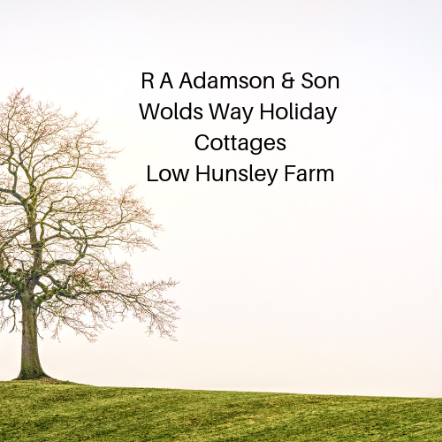

Accessibility Guide for The Dairy
rachel@woldswayholidaycottages.com, 07889410928, www.woldswayholidaycottages.com
Contact for accessibility enquiries: Rachel Adamson
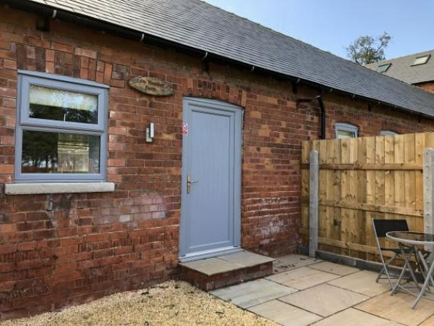

Welcome
At Low Hunsley Farm, we have converted our range of traditional brick and tile barns into beautifully appointed 1, 2 & 3 bedroom holiday accommodation. Set in the middle of our 330 acre arable farm, all of our apartments are equiped with dishwasher, washer / tumbler, fridge, microwave, coffee machine, toaster and kettle. The super king beds can also be split into singles to accommodate family parties.

At a Glance

Level Access
- The main entrance has 1 step. There is no lift and no ramp.
- There is level access from the main entrance to:
  - Bedroom: This is a studio apartment
  - Dairy Lounge

Access with steps
- There are steps from the main entrance to:
  - Dairy Garden

Level access bedrooms
- From the main entrance to the bedroom, there is level access.
- The route to the bedroom is 750mm wide, or more.
- The bedroom door is 750mm wide, or more.
- There is unobstructed floor space 1200mm by 900mm, or more.

Hearing
- The (bedroom) TVs have subtitles.

Getting here
Low Hunsley Farm
Little Weighton
Cottingham
Hu20 3UP

Travel by public transport
- We have no public transport nearby so a car is a must. The nearest railway stations are based in Cottingham and Brough

Travel by taxi
- You can get a taxi with Willerby Cars by calling 01482 659659.
- You can get a taxi with South Cave Taxis by calling 01430 422218.

Parking
- We have a car park. The parking is less than 50 metres from the main entrance. Parking is free.
- There is a drop-off point at the main entrance. The drop-off point does not have a dropped kerb.
- From the car park to the entrance, there is level access. The route is 820mm wide, or more.
- The site is not suitable for wheelchair access
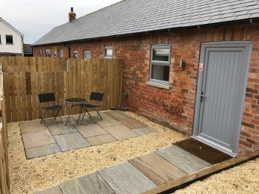
All of the properties have steps into them
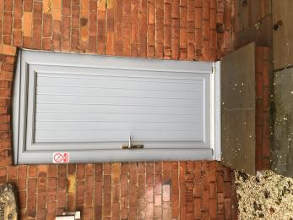
Door has step at 860MM access
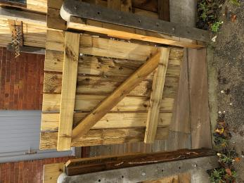
Gate width is 820mm

Arrival

Path to main entrance
- From the street to the main entrance, there are 3 steps. There is no ramp and no lift.

Main entrance
- The door is 1000mm wide.
- The main entrance has 1 steps.
- When you arrive, we can help carry your luggage.
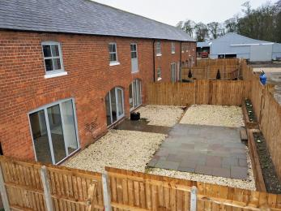
Steps drop down into all of the gardens

Getting around inside

Bedrooms
- All bedrooms have windows.
- Bedrooms have ceiling lights, bedside lamps and natural daylight.
- Lights are halogen and energy saving. TVs have subtitles.
- All bedrooms are non-smoking.
- No bedrooms have fitted carpets.
- From the main entrance to this area, there is level access.
- The direction of transfer onto the toilet is to the front only.

Accessible bedrooms

Accessible bedroom This is a studio apartment
- The route to the bedroom is 1000mm wide, or more. The bedroom door is 1000mm wide. There is 450mm at the side of the bed. The bed is 620mm high. There is 5mm under the bed.
- The bedroom is flexible (either double or twin). The bathroom is ensuite. The bathroom door is 780mm wide.
- The bathroom has a separate shower. The direction of transfer onto the toilet is to the front only. There is 500mm at the side of the toilet.
- There is 3000mm in front of the toilet. The toilet seat is 430mm high.
- The basin is 840mm high. The taps are lever operated. There is space under the basin, with no pedestal or boxing.
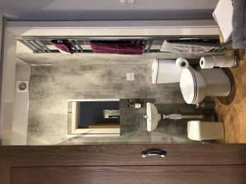
Toilet and sink
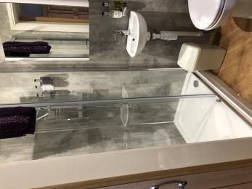
Shower cubicle Step into shower is 200 mm

Self catering kitchen

The Dairy Kitchen
- We have an open plan kitchen.
- From the main entrance to the kitchen, there is level access.
- The route is 860mm wide, or more.
- From the main entrance to the kitchen, there is 1 step. There is no lift and no ramp.
- The table and plates have high colour contrast.
- White plates
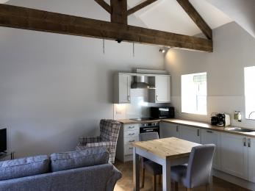
Kitchen area

Lounge

Dairy Lounge
- From the main entrance to the lounge, there is level access. The route is 860mm wide, or more. From the main entrance to the lounge, there is 1 step. There is no lift and no ramp.
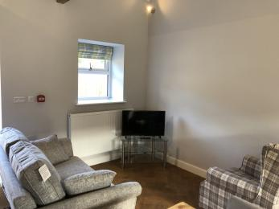
Lounge area

Getting around outside

Dairy Garden
- From the main entrance to the gardens, there is 1 step. There is no lift and no ramp.
- Step from garden into the property is 200 mm
Entrance step 200 mm

Customer care support

Guide last updated: 12 November 2019

