Accessibility Guide for Standard 3 bed Caravan
holidays@glen-nevis.co.uk, 01397 702191, https://www.glen-nevis.co.uk/
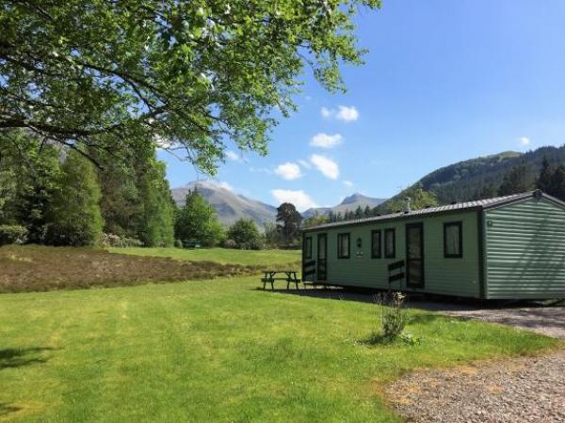

Welcome
Set in well landscaped grounds at the foot of Ben Nevis mountain range, and enjoying superb views these 3 bed standard Caravans offer everything a small family needs for a happy highland holiday. WIFI and TV are included and parking is right next to the caravan. Situated within a peaceful, quiet park with magical views of Glen Nevis, surrounded by mountains and forest these caravans provide the perfect base for exploring the Scottish Highlands.

At a Glance

Level Access
- The main entrance has 2 steps and a handrail. There is no lift and no ramp.
- There is level access from the main entrance to:
  - Self Catering Reception Office
  - Standard 3 bedroomed caravan open plan Lounge Diner

Access with steps
- There are steps from the main entrance to:
  - Outdoor seating and parking

Bedrooms
- We have non-allergic bedding.

Level access bedrooms
- From the main entrance to the bedroom, there is level access.

Hearing
- The fire alarm has flashing lights.
- The (bedroom) TVs have subtitles.

Getting here
Glen Nevis Holidays
Glen Nevis
PH33 6SX

Travel by public transport
- You can get to Standard 3 bed Caravan by bus.
- You can get to the Holiday Caravans by bus. The nearest bus stop is outside Glen Nevis Youth Hostel, which is 50m from our Self-catering Reception building. The bus stop is 100 yards from the Holiday caravans. The bus stop is 0.20 miles / 4.8 km from Standard 3.0 bed Caravan.
- The bus stops at the entrance to the Self Catering Park and the Caravans are the first units you come to as you leave the bus.

Travel by taxi
- You can get a taxi with Ace Taxis by calling 01397 704400 . The taxi company has a wheelchair accessible vehicle.
- You can get a taxi with Speeders Cabs by calling 01397 704000.
- You can get a taxi with Jusef's Taxis by calling 01397 701234.

Parking
- We have a car park. The parking is less than 50 metres from the main entrance. Parking is free.
- There is a drop-off point at the main entrance. The drop-off point has a dropped kerb.
- From the car park to the entrance, there is level access. The route is 1800mm wide, or more.
- We have a transport service, to take visitors from the car park to the main entrance. Depending upon availability Housekeeping staff can give Guests and their luggage a lift up to their property.
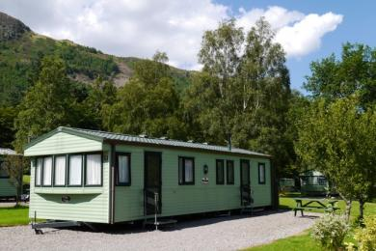
There is flat, level gravel for generous car parking next to the caravan

Arrival

Path to main entrance
- From the street to the main entrance, there is level access.
- The path is 1800mm wide, or more.

Main entrance
- The door is 710mm wide.
- The main entrance has 2 steps.
- This entrance has a handrail.
- The main door is side hung and manual.
- Depending on availability Housekeeping staff are happy to give Guests and their luggage a lift up to their property
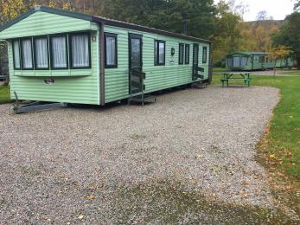
3 bed standard caravan showing access to unit and parking area

Getting around inside

Self Catering Reception Office
- From the main entrance to reception, there is level access. There is a permanent ramp.
- The door is 850mm wide.
- The check-in desk has a low section for wheelchair users. You can sit down at reception.
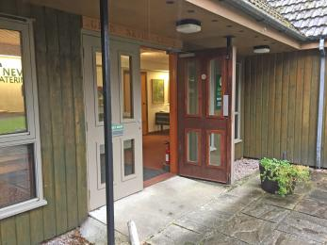
Self Catering Reception Main Entrance
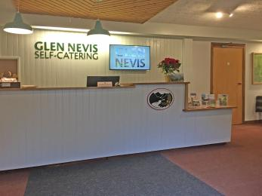
Self Catering Reception showing low section of the check in desk for wheelchair users
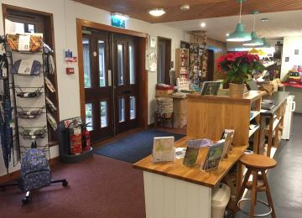
Self Catering Reception showing low section of the check in desk for wheelchair users
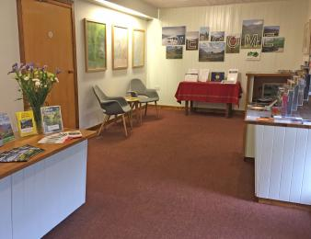
Self Catering Reception with seated area for guests

Bedrooms
- All bedrooms have windows.
- Bedrooms have ceiling lights.
- Lights are energy saving. TVs have subtitles.
- All bedrooms are non-smoking.
- We have non-allergic bedding.
- All bedrooms have fitted carpets.
- All bedding is Hypoallergenic (no feathers) and We can give details of our cleaning products on request.
- From the main entrance to this area, there is level access.
- The direction of transfer onto the toilet is to the left and right.
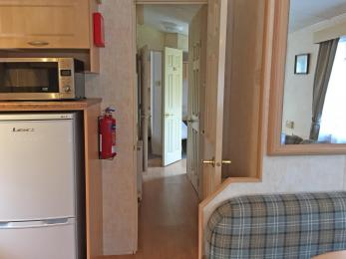
Standard 3 bedroomed caravan showing internal hallway to bedrooms

Self catering kitchen

Standard 3 bedroomed caravan open plan Kitchen Diner
- We have an open plan kitchen.
- From the main entrance to the kitchen, there is level access.
- The route is 890mm wide, or more.
- All kitchen units, surfaces and worktops are of normal height
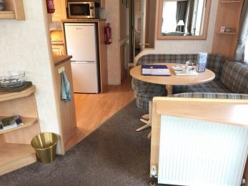
Standard 3 bedroomed caravan open plan Kitchen Diner access
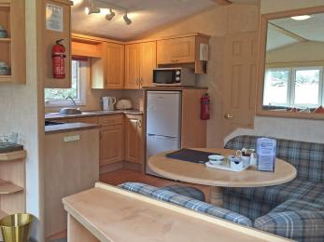
Standard 3 bedroomed caravan open plan Kitchen, all kitchen units, surfaces and worktops are of normal height

Lounge

Standard 3 bedroomed caravan open plan Lounge Diner
- From the main entrance to the lounge, there is level access. The route is 710mm wide, or more. The door is 710mm wide.
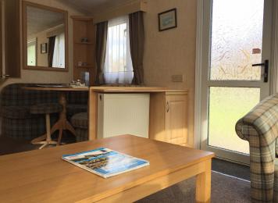
Standard 3 bedroomed caravan open plan Lounge access
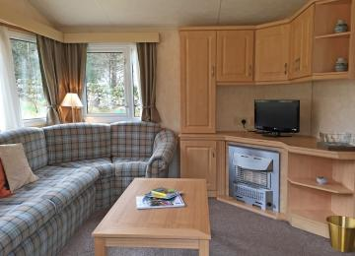
Standard 3 bedroomed caravan open plan Lounge

Getting around outside

Outdoor seating and parking
- From the main entrance to the area, there is 1 step.
- There is generous gravelled parking next to the caravan plus a picnic bench
Standard 3 bed caravan showing level gravelled parking plus picnic bench next to caravan
Standard 3 bed caravan showing typical level gravelled parking area beside each caravan

Customer care support

Accessibility equipment
- Lochaber Action on Disability and Shopmobility Lochaber provide a good range of mobility equipment available for loan or hire. Guests will need to organise their equipment requirements directly with these service providers. We can store equipment at our Reception Office for collection or place it in your unit for your arrival. For a list of items please go to www.lad.org.uk
- For a list of more items, please go to https://www.lad.org.uk/.
- Due to our rural location there are numerous green areas for assistance dogs to use. Our nearby caravan and camping park also has two dedicated dog exercise areas.
- You can hire mobility equipment from Lochaber Action on Disability by calling Shopmobility Lochaber on 01397 701171
- You can hire mobility equipment from https://www.shopmobilitylochaber.co.uk/ by calling 01397 701171.

Emergency evacuation procedures
- We have emergency evacuation procedures for disabled visitors.
- The fire alarm has flashing lights.

Guide last updated: 9 December 2019

