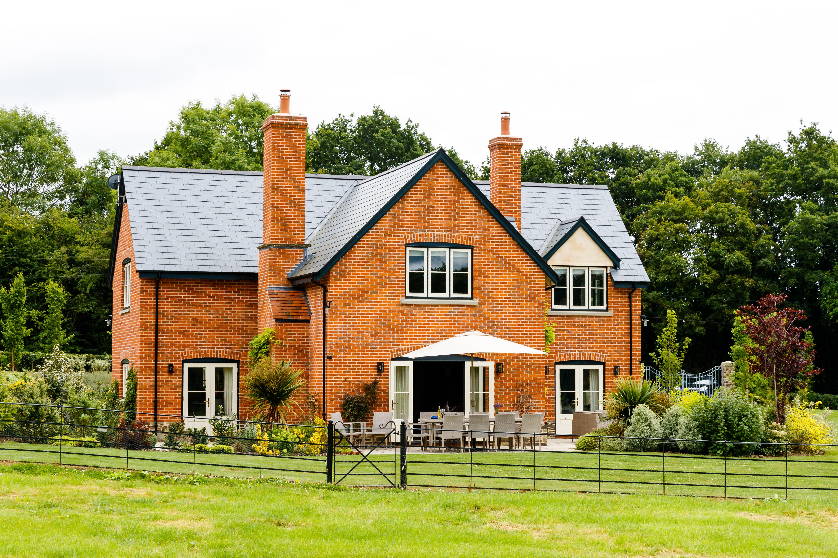

Accessibility Guide for Sharpnage House
info@sharpnagehouse.co.uk, 07922431817, www.sharpnagehouse.co.uk
Contact for accessibility enquiries: Andrea Krizan
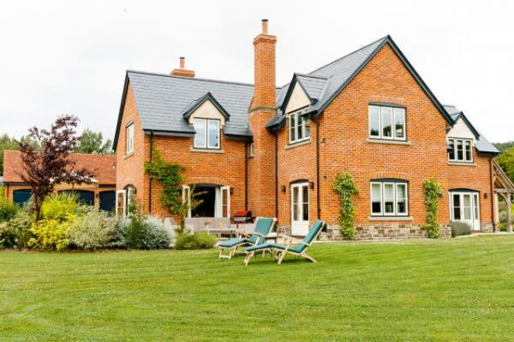

Welcome
At Sharpnage House we want to make everyone's stay as enjoyable as possible, and are committed to providing suitable access for all our guests, whatever their individual needs. We aim to accurately describe our facilities and services to give you the confidence to book the right property for your specific requirements.
All our properties are rated by VisitEngland under the National Accessible Scheme.
The accommodation is rated by the National Accessible Scheme as suitable for: Older and less mobile guests

At a Glance

Level Access
- There is level access from the main entrance to:
  - Bedroom: Downstairs bedroom
  - External grounds and gardens
  - Patio

Bedrooms
- We have non-allergic bedding.
- There is an emergency call system next to the bed.

Level access bedrooms
- From the main entrance to the bedroom, there is level access.
- The route to the bedroom is 750mm wide, or more.
- The bedroom door is 750mm wide, or more.
- There is unobstructed floor space 1200mm by 900mm, or more.
- The bathroom has a level access shower.

Hearing
- The (bedroom) TVs have subtitles.
- Some staff have disability awareness training.

General
The accommodation is rated by the National Accessible Scheme as suitable for:
- Older and less mobile guests
- Staff are available 24 hours a day.
- Some staff have disability awareness training.
- We have emergency evacuation procedures for disabled visitors.

Getting here
Sharpnage House
Little Canwood
Checkley
HR14NF

Travel by public transport
- You can get to Sharpnage House by bus.
- The nearest bus stop is in Woolhope. The bus stop is 1.1 miles / 1.8 km / 1.8 km / 1.7 km from Sharpnage House. The nearest train station is Hereford. The train station is 7.9 miles / 1.8 km / 1.8 km / 12.7 km from Sharpnage House. The bus stop is 1.1 miles / 1.8 km / 1.8 km from Sharpnage House .

Travel by taxi
- You can get a taxi with Blue Line by calling 01432343435. The taxi company has a wheelchair accessible vehicle.

Parking
- We have a car park. The parking is less than 50 metres from the main entrance. Parking is not free.
- There is a drop-off point at the main entrance. The drop-off point has a dropped kerb.
- From the car park to the entrance, there is level access. There is a permanent ramp.
- The path is sloped.
- The route is 1080mm wide, or more.
- The main entrance has level access with a ramp from the car park. The ramp is permanent. The ramp is 1080mm wide, or more.
The area is well lit at night by several motion sensors.
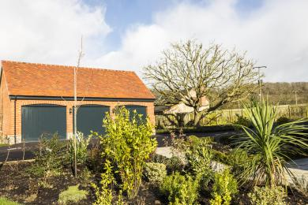
Ramp leading from the car park to the footpath around the house

Arrival

Path to main entrance
- From the street to the main entrance, there is level access.
- There is a permanent ramp.
- The path is 1080mm wide, or more.
- The path is sloped.

Main entrance
- The main entrance has level access.
- The door is 915mm wide.
- The main door is side hung and manual.
- When you arrive, we can help carry your luggage.
- The main entrance has level access.
The main door is side hung and manual.
The front door is 915mm (36ins) wide. This gives access to the main entrance door into the hallway. The door is 720mm (28.5 inches) wide
When you arrive, we can help carry your luggage.
There is level access from the main entrance to:
Bedroom: King size bed
En-suite wet room
Lounge
Kitchen/dining area
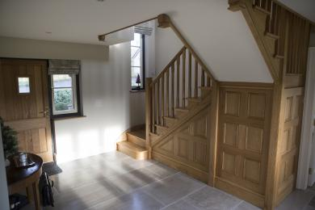
Sharpnage House main hallway

Getting around inside

Bedrooms
- All bedrooms have windows.
- Bedrooms have ceiling lights, wall lights, floor standing lights, bedside lamps and natural daylight.
- Lights are halogen, LED and energy saving. Some lights can be controlled independently.
- TVs have subtitles.
- All bedrooms are non-smoking.
- We have non-allergic bedding.
- Some bedrooms have fitted carpets.
- All our bedding is non-allergic. If visitors suffer from allergies, please contact us.
- We can move the bedroom furniture, to improve accessibility.
- From the main entrance to this area, there is level access.
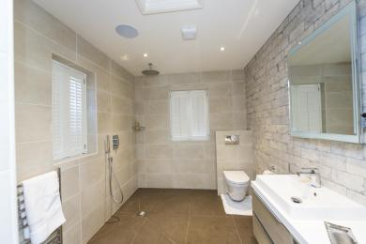
Downstairs wet room

Accessible bedrooms

Accessible bedroom Downstairs bedroom
- The route to the bedroom is 900mm wide, or more. The bedroom door is 775mm wide. There is 900mm at the side of the bed. The bed is 635mm high. There is 0mm under the bed.
- There is a low clothes rail. You can use the rail sitting down.
- There is an emergency call system next to the bed.
- The bedroom is double. The bathroom is ensuite. The bathroom door is 860mm wide.
- The bathroom has a level access shower. There is a shower chair available. The level access shower has handrails.
- The toilets have handrails. The direction of transfer onto the toilet is to the left. There is 1200mm at the side of the toilet.
- There is 1000mm in front of the toilet. The toilet seat is 450mm high.
- The basin is 800mm high. The taps are lever operated. There is no space under the basin.
- • The shower is fixed thermostatic lever turn shower and there is no tray, door or a curtain.
• There is under floor heating in the bathroom, but the temperature can be adjusted manually by thermostat.
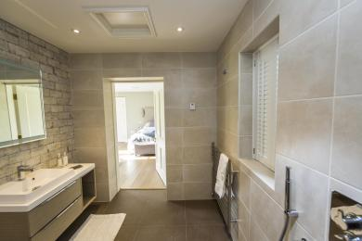
Downstairs wet room

Getting around outside

External grounds and gardens
- From the main entrance to the gardens, there is level access.
- The route is 600mm wide, or more.
- There is a footpath (tarmac) that goes on one side of the garage that is 950mm wide (37.5 inches).
Footpath around the house is made of natural stone and it is 950mm (37.5 inches) wide at the narrowest point on the left from main door but it reduces to 600mm (24 inches) around the corners of the house.
There is a pathway that allows you to take a wheelchair down to the house from the driveway and there is a single step of 50mm (2 inches) between the tarmac driveway and the natural stone path.
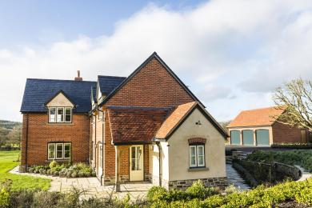
Footpath around the property

Terrace

Patio
- From the main entrance to this area, there is level access. The route is 900mm wide, or more.
- The entrance is 915mm wide.
- To get to a table, there are no steps.
- From the main entrance to the gardens, there is level access.
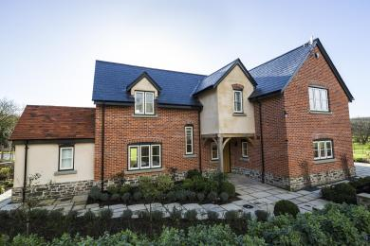
Levelled footpath around the property

Customer care support

Accessibility equipment
- Shower chair, toilet seat riser
- We have an area to charge mobility scooters and battery powered wheelchairs.
- There are outside sockets
- You can hire mobility equipment from Hirers of Equipment TPG Disabled Aids by calling 01432 351666.

Customer care support
- Some staff have disability awareness training.
- Staff are available 24 hours a day.
- The hospitality manager has NVQ L2 in Health and Social Care and is available 24 hours a day in case of emergency

Guide last updated: 12 October 2019

