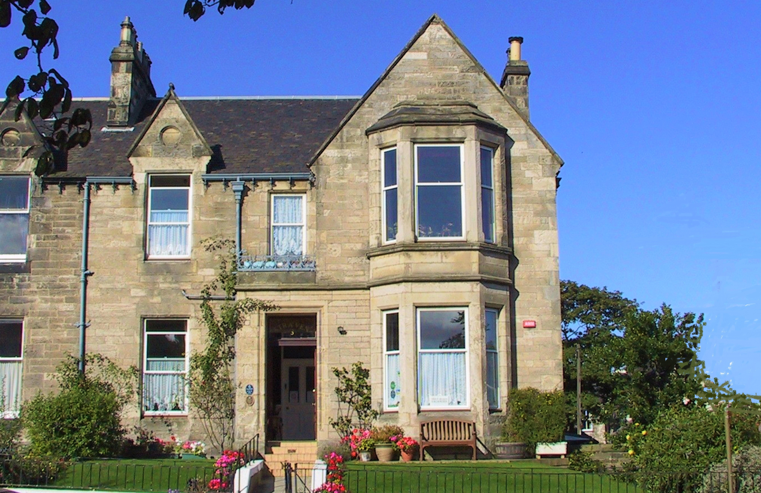
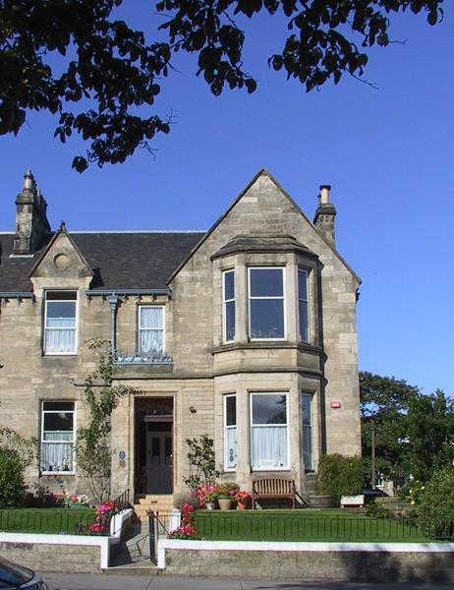

Accessibility Guide for Straven Guesthouse
book@stravenguesthouse.com, 01316695580, www.stravenguesthouse.com
Contact for accessibility enquiries: Sinead and Chris Watson
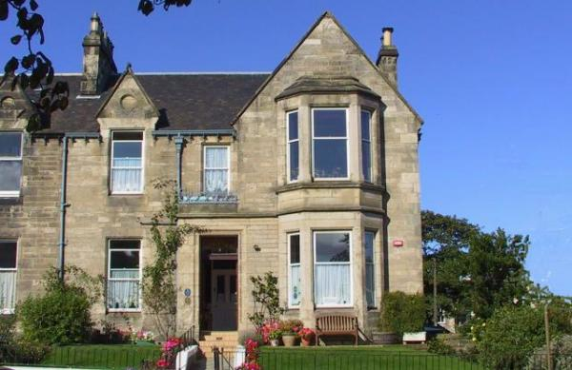

Welcome

Straven Guesthouse provides high quality bed and breakfast in Edinburgh. You will find comfortable en suite rooms with Wifi, TV and USB charge points. Wake up to a hearty breakfast menu with local produce. We are a homely bed and breakfast with no staff, so a personal service is always guaranteed.
Explore the rich heritage of Edinburgh by day, relax in the evening with a quiet stroll along the flat beachfront promenade which is less than 50m from our door.
Whether you want a peaceful break, historical sites, theatre, shopping, dining; Edinburgh has it all.

At a Glance

Level Access
- The main entrance has 6 steps and a handrail. There is no lift and no ramp.
- There is level access from the main entrance to:
  - Dining Table

Access with steps
- There are steps from the main entrance to:
  - Guest Lounge

Bedrooms
- We have non-allergic bedding.

Hearing
- The (bedroom) TVs have subtitles.

Getting here
3 Brunstane Rd North
Joppa
Edinburgh
EH15 2DL

Travel by public transport
- You can get to Straven Guesthouse by bus and train.
- The nearest bus stop is on Abercorn Terrace and is called Brunstane Rd North. This is about 70 metres from us all on the pavement. There is a pedestrian crossing at the bus stop for the direction of travel into the city centre and no roads to cross for travelling to East Lothian. This is served by the Lothian bus no 26, the Lothian bus no 49 and the East Coast bus no 124 and the night bus N26. The bus stop is 0.0 miles / 0.0 km from Straven Guesthouse.
- The nearest train station is Brunstane Station. The train station is 0.5 miles / 0.8 km from Straven Guesthouse.
- Brunstane Station is 05. miles away at the top of our street on Brunstane Rd South. This train line goes to and from Waverley Station in Edinburgh city centre and Tweedbank in the Scottish Borders every half an hour during the day.

Travel by taxi
- You can get a taxi with Central Taxis by calling 01312292468. The taxi company has a wheelchair accessible vehicle.

Parking
- We have a car park. The parking is less than 50 metres from the main entrance. Parking is free.
- There is a drop-off point at the main entrance. The drop-off point does not have a dropped kerb.
- From the parking to the main entrance, there are 6 steps. There is no ramp and no lift.
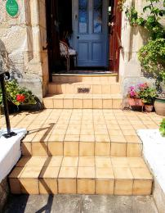
Steps to front entrance

Arrival

Path to main entrance
- From the street to the main entrance, there are 6 steps. There is no ramp and no lift.
- The path is sloped.

Main entrance
- The door is 900mm wide.
- The main entrance has 6 steps.
- This entrance has a handrail.
- The main door is side hung and manual.
- From the pavemnet to our front hallway there are a total of 6 steps. One single step onto our path which gently slopes uphill to our front door. There are then 2 sets of steps. One pair of steps then a level ground then 3 steps into the hallway. There are rails at these steps. The entrance door is secure and requires a code to entre and is kept locked for guests security and peace of mind.
front entrance

Getting around inside

Bedrooms
- All bedrooms have windows.
- Bedrooms have ceiling lights, wall lights and natural daylight.
- Lights are LED and energy saving. TVs have subtitles.
- All bedrooms are non-smoking.
- We have non-allergic bedding.
- All bedrooms have fitted carpets.
- There are no pets or smoking allowed throughout the premsies. We occassionally have assistance dogs for guests. All cleaning products are eco and so low chemical and odour as we have Gold award with Green Tourism.
- All bedrooms are ensuite.
- We have bathrooms with a separate shower.
- Some showers have a seat.
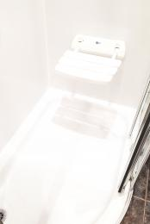
Shower seat
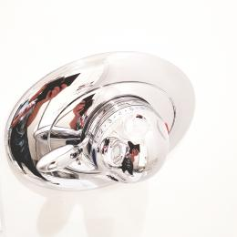
east turn shower controls
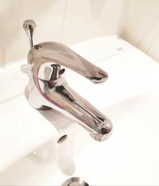
east lift taps

Lounge

Guest Lounge
- From the main entrance to the lounge, there are 21 steps. There is no lift and no ramp.
- the staircase leading up to the first floor is carpetted and has a rail. The staircase has a turn in it as it is an old Vicotrian house which means the stairs get narrow on the inside at the side of the handrail. Please see the pictures for details
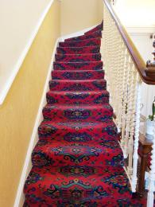
Stairs to first floor
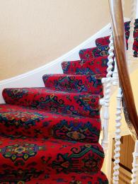
Turn in stairs
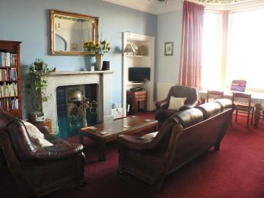
Guest Lounge

Place to eat and drink

Guest Dining Room
- From the main entrance to the dining area, there is level access. The route is 90mm wide, or more. The door is 90mm wide.
- To get to a table, there are no steps.
- If you need table service, staff can help you.
- The route through the dining area is 800mm wide, or more.
- There is background music.
- The table and plates have high colour contrast.
- We cater for vegetarian, gluten free (celiacs), lactose free (dairy free) and vegan specific diets.
- We have menus available on request for gluten free, vegan and vegetarian diets. Please state at time of reservation any dietary requirements as we are a small guest house and buy and prepare food especially.
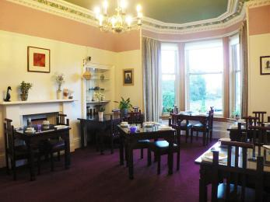
Dining room

Customer care support

Accessibility equipment
- Closeby there are wheelchairs that can be borrowed to access the beach.
There are the options of wheelchair hire in Edinburgh.
Find out more at the weblinks.
- For a list of more items, please go to http://portobellobeach.com/wheelchairs/.
- You can hire mobility equipment from Mobility Equipment hire Direct by calling 08006226000.
- You can hire mobility equipment from Portobell beach wheelchairs by calling 03006660990.

Customer care support
- We have no staff at Straven guesthouse. This means that although we live there we do go out at times and sleep overnight so there is no 24 hour staff. We ask that guests checking in let us know an arrival time so we can be in to greet them and show them round. After that there is no curfew and guests have their own access to their bedroom to come and go.

Guide last updated: 25 July 2019

