Accessibility Guide for The Hepworth Wakefield
hello@hepworthwakefield.org, +44 (0)1924 247360 , www.hepworthwakefield.org
Contact for accessibility enquiries: Visitor Experience Team
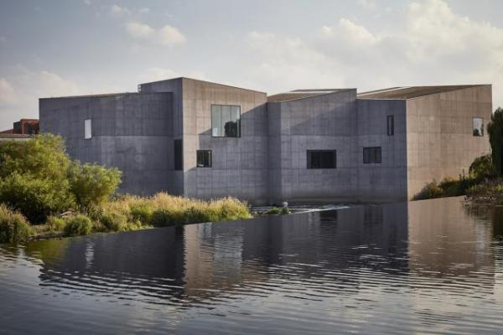

Welcome
The Hepworth Wakefield is an award-winning art gallery in the heart of Yorkshire, set within Wakefield’s historic waterfront overlooking the River Calder. Designed by the acclaimed David Chipperfield Architects, the gallery opened in May 2011.
Named after Barbara Hepworth, one of the most important artists of the 20th century who was born and brought up in Wakefield, the gallery presents major exhibitions of the best international modern and contemporary art and has dedicated galleries exploring Hepworth’s art and working process.
The Hepworth Wakefield is home to Wakefield’s art collection – an impressive compendium of modern British art, as well as work by significant contemporary artists.

At a Glance

Level Access
- There is level access from the main entrance to:
  - Foyer
  - Welcome Desk
  - Gallery Spaces
  - Café
  - Shop
  - Garden

Hearing
- We have a hearing loop in Welcome Desk, Café and in our Auditorium.
- All staff have disability awareness training. Some staff have BSL training

Visual
- Glass doors have contrast markings.
- Some parts of the venue have low lighting.
- We have display information in large print.
- We have information in audio and large print.

General
- We have a concessionary rate for disabled visitors.
- We have a complimentary ticket policy for personal assistants.
- All staff have disability awareness training.

Getting here
The Hepworth Wakefield
Gallery Walk
Wakefield
WF1 5AW

Travel by public transport
- You can get to The Hepworth Wakefield by bus and train.
- The gallery is on the FreeCityBus route operated Monday – Friday between 7.30am & 6.33pm, and Saturday between 8.30am & 5pm. The service does not run on Sundays. The bus route includes Wakefield Westgate and Kirkgate train stations, Wakefield bus station, Ridings Shopping Centre, Trinity Walk and other city centre drop offs and is every 10 minutes. The Hepworth Wakefield bus stop is adjacent to the Wakefield Waterfront on A61 Barnsley Road and the gallery. All journeys on the bus are free of charge and each FreeCityBus is accessible and can carry one wheelchair at a time. Wakefield bus station is located on Union Street, Wakefield WF1 3AG. The bus stop is 0.1 miles / 0.2 km from The Hepworth Wakefield.
- The nearest train station is Wakefield Kirkgate . The train station is 0.3 miles / 0.5 km from The Hepworth Wakefield.
- The gallery is 0.3 miles from Wakefield Kirkgate train station (approximately 8 minutes walk)
and 1 mile from Westgate train station (approximately 20 minutes walk).
For train timetable information and tickets visit our travel partner Grand Central or National Rail and Northern Railway

Parking
- We have a car park. There are accessible parking spaces. Parking is not free.
- There is a drop-off point at the main entrance. The drop-off point has a dropped kerb.
- From the car park to the entrance, there is level access. There is a permanent ramp.
- The route is 200mm wide, or more.
- There are 85 spaces for cars in our car park, including larger accessible bays and space for motorcycles and bicycles.
For blue badge holders, we have six disabled spaces on Gallery Walk next to the gallery. Sat Nav: WF1 5AW
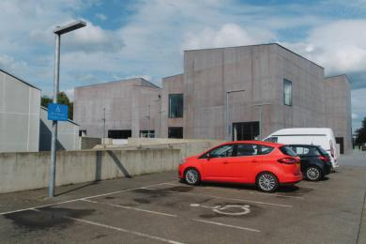
Five accessible parking spaces next to the gallery on Gallery Walk.
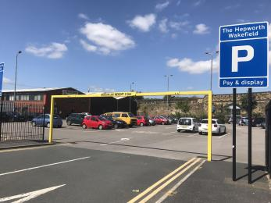
The Hepworth Wakefield main visit car park on Thornes Lane, WF1 5QJ

Arrival

Path to main entrance
- From the street to the main entrance, there is level access.
- There is a permanent ramp.

Main entrance
- The main entrance has level access.
- The main door is sliding and automatic.
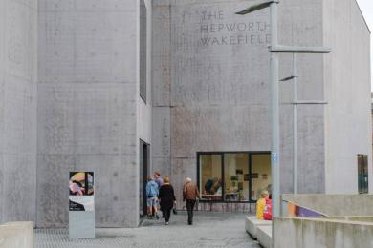
This is the entrance to The Hepworth Wakefield
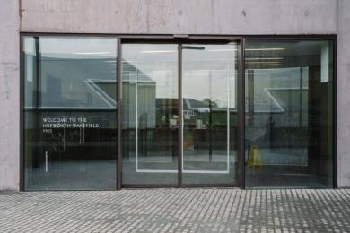
These are the main doors to The Hepworth Wakefield

Getting around inside

Visual Impairment - General Information
- We have contrast markings on all glass doors.
- Some parts of the venue have low lighting.
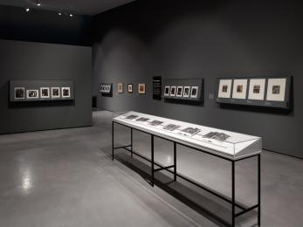
Henry Moore and Bill Brandt Exhibition extended until 1st November 2020
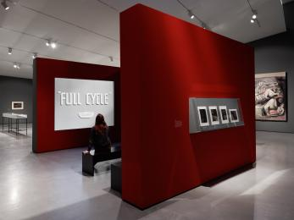
Henry Moore and Bill Brandt Exhibition extended until 1st November 2020

Lift
- We have 1 lift.
- You can get a lift to all floors.

Ticket/ information desk

Welcome Desk
- From the main entrance to the desk, there is level access. The desk has a low section.

Things to See and Do
- We have a concessionary rate for disabled visitors.
- We have a complimentary ticket policy for personal assistants.
- We have display information in: large print.

Foyer
- From the main entrance to this area, there is level access. Some display information is low, for wheelchair users. There are seats.
- There is a hearing loop.
- Videos have subtitles.
- The Welcome Desk is a short distance from the main entrance and is medium height. Part of the desk is lower level for easy access to wheelchair users. There is an induction loop. Lighting levels are bright.
The main public toilets are on the ground floor to the right hand side of the Welcome Desk at the rear of the foyer. This area of public toilets includes standard toilets plus accessible facilities and a baby change area.
The gallery has a Changing Places toilet that is located within the gallery’s Clore Learning Studios on the ground floor, an area of the building used primarily by families and schools. The facility has a height adjustable adult sized changing bench, a tracking hoist system and adequate space in the changing area for the person with additional needs and up to two carers.
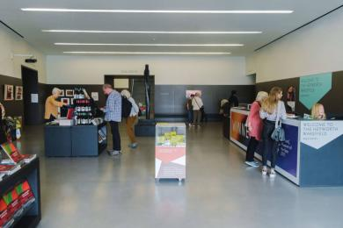
The Hepworth Wakefield's foyer
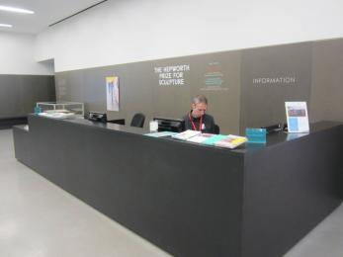
The Welcome Desk is a short distance from the main entrance and is medium height. Part of the desk is lower level for easy acces

Public toilet
- There is a public toilet for disabled visitors.
- From the main entrance to the public toilet, there is level access.

Gallery Spaces
- From the main entrance to this area, there is level access. There is a lift.
- There are ten interlinked gallery spaces on the first floor; all gallery spaces have level access and double doors. There is an accessible toilet in Gallery 6.
Artworks have wall mounted labels next to each work in 16 point text along with introductory text panels in each gallery space in 58 point text size.
Gallery spaces have sculptures displayed on large low level and high level plinths. Extra care should be taken when manoeuvring around these.
Gallery 4 presents objects, photographs and tools from Hepworth’s studio in glass cabinets with drawers at 70cm high. Large print versions of the text panels are available.
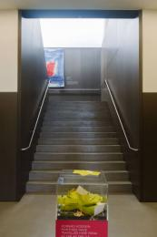
The Hepworth Wakefield's gallery spaces are all upstairs
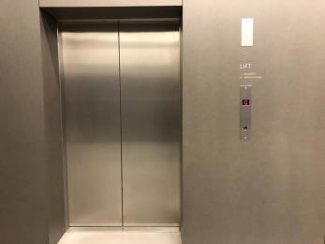
The Hepworth Wakefield's gallery spaces can be accessed by lift.
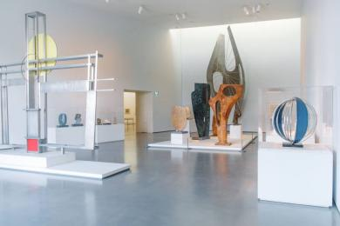
The Hepworth Wakefield has ten interlinked gallery spaces on the first floor; all gallery spaces have level access.

Café
- From the main entrance to this area, there is level access.
- The café is located on the ground floor and has level access from the foyer or via its own entrance from the café terrace at the end of the pedestrian bridge. From the foyer, the café can be accessed through double glass doors that are locked open. From the outside, the café can be accessed by a single width automatic door. There is room for a wheelchair user to manoeuvre around the café and furniture is not fixed. There is an induction loop in the café. Due to cornoavirus restrictions, the cafe is not currently serving food and drink. Visitors are welcome to use the cafe seating area to consume their own food and drink, or use the area to eat street food which can be purchased from vendors located in the Hepworth Wakefield Garden.
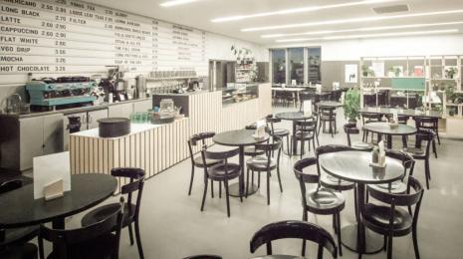
The Hepworth Café

Shop
- From the main entrance to this area, there is level access.
- The shop is located to the left of the main entrance and has level access. The doors are locked open. There is room for a wheelchair user to manoeuvre. Some merchandise may be out of reach for wheelchair users but staff members are on hand to help.
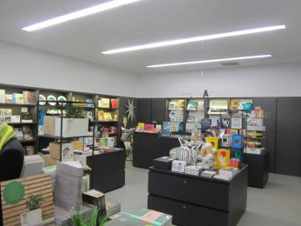
The Hepworth Wakefield shop

Getting around outside

Garden
- From the main entrance to the gardens, there is level access.
- The route is sloped.
- The Hepworth Wakefield Garden, designed by internationally acclaimed landscape architect Tom Stuart-Smith, is free for all to enjoy.
Tom Stuart-Smith’s design draws inspiration from its unusual setting between 19th-century red-brick mills and a 21st-century art gallery, edged by the River Calder. It echos the striking, angular shapes of the David Chipperfield-designed gallery while harnessing a naturalism that reflects Barbara Hepworth’s deep connection to the landscape.
As well as Stuart-Smith’s distinctive planting, there are outdoor sculptures by Sir Michael Craig-Martin, Barbara Hepworth and Kim Lim.
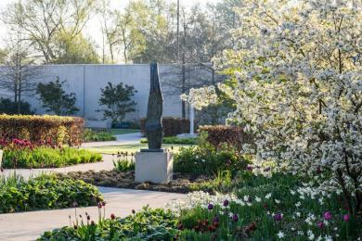
A photo of The Hepworth Wakefield Garden with sculpture and level access paths

Customer care support

Accessibility equipment
- We provide wheelchairs. Wheelchairs are free.
- We have a hearing loop in Welcome Desk, Café and in our Auditorium.
- Large print guides
- For a list of more items, please go to https://hepworthwakefield.org/your-visit/access/.

Emergency evacuation procedures
- We have emergency evacuation procedures for disabled visitors.
- Refuge point in gallery 3 and gallery 6 fire exits. Evac chairs available in gallery 3 and gallery 6 fire exits.

Customer care support
- All staff have disability awareness training.
- Some staff have BSL training.
- We have information in audio and large print.
- Visitor information in audio format is available on our website - https://hepworthwakefield.org/your-visit/access/
- We have other services for people with accessibility requirements.
- The gallery has a Changing Places toilet that is located within the gallery’s Clore Learning Studios on the ground floor, an area of the building used primarily by families and schools. The facility has a height adjustable adult sized changing bench, a tracking hoist system and adequate space in the changing area for the person with additional needs and up to two carers.
There are three accessible toilets throughout the building, one on the ground floor, one in Gallery 6 and another in the Learning Studios. All accessible toilets have a functional emergency alarm, coat hooks and wall mounted rails.
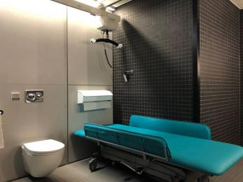
Changing Places toilet at The Hepworth Wakefield

Guide last updated: 15 December 2023

