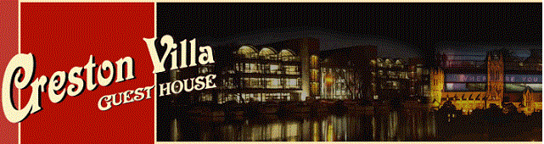

Accessibility Guide for Creston Villa Guest House
info@crestonvilla.co.uk, 01522872511, www.crestonvilla.co.uk
Contact for accessibility enquiries: Iain Brown
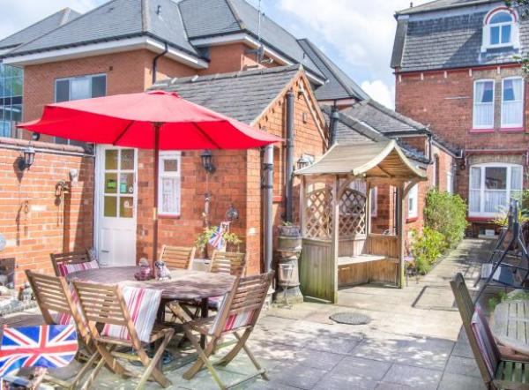

Welcome
This traditional Victorian town house is an excellent alternative to a hotel or Travel Inn. It was built in circa 1874, it offers a degree of luxury and elegance that will make your visit to Lincoln both pleasurable and memorable.
Anna and Iain believe in the old fashioned values of courtesy and consideration. We invite you to make Creston Villa Guest House your Bed and Breakfast accommodation of choice for your next visit to the beautiful city of Lincoln.
Creston Villa Guest House is the ideal base for your stay when visiting Lincoln’s many attractions. It overlooks the attractive South Common, yet is only a fifteen minute walk to the train station in the city centre.

At a Glance

Level Access
- The main entrance has 1 step. There is no lift and no ramp.
- There is level access from the main entrance to:
  - Dining Table

Access with steps
- There are steps from the main entrance to:
  - The Breakfast Room
  - The Guest Day Room
  - Guest Patio

Bedrooms
- We have non-allergic bedding.

Level access bedrooms
- From the main entrance to the bedroom, there is level access.
- The bedroom door is 750mm wide, or more.
- There is unobstructed floor space 1200mm by 900mm, or more.

Hearing
- The (bedroom) TVs have subtitles.
- All staff have disability awareness training.

Visual
- Glass doors have contrast markings.
- The walls and the doors have high colour contrast.
- Some parts of the venue have low lighting.
- The menu is in large print.

General
- Staff are available 24 hours a day.
- All staff have disability awareness training.
- We have emergency evacuation procedures for disabled visitors.

Getting here
27 St Catherines
Lincoln
LN5 8LW

Travel by public transport
- You can get to Creston Villa Guest House by bus and train.
- There are four services that leave from the bus station in the centre of Lincoln. The bus stops are directly across the road. The bus stop is 0.1 miles / 0.2 km from Creston Villa Guest House.
- The nearest train station is Lincoln Central Station. The train station is 1 miles / 1.6 km from Creston Villa Guest House.

Travel by taxi
- You can get a taxi with Direct Cars by calling 01522 567567. The taxi company has a wheelchair accessible vehicle.

Parking
- There is a drop-off point at the main entrance. The drop-off point does not have a dropped kerb.
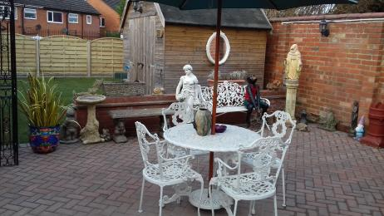
Patio Beside Entrance Door

Arrival

Path to main entrance
- From the street to the main entrance, there is 1 step. There is no ramp and no lift.

Main entrance
- The door is 750mm wide.
- The main entrance has 1 steps.
- The main door is side hung and manual.
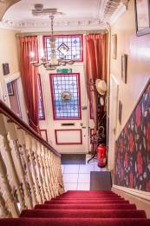
Front Door From The Stairs Inside

Getting around inside

Visual Impairment - General Information
- We have contrast markings on all glass doors and high colour contrast between walls and doorframes.
- Some parts of the venue have low lighting.
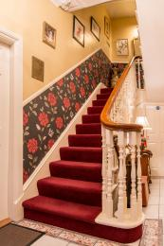
Stairs with low level lighting

Bedrooms
- All bedrooms have windows.
- Bedrooms have ceiling lights, wall lights, floor standing lights, bedside lamps and natural daylight.
- Lights are halogen, LED and traditional filament. Some lights can be controlled independently.
- TVs have subtitles.
- All bedrooms are non-smoking.
- We have non-allergic bedding.
- All bedrooms have fitted carpets.
- All surfaces are damp dusted every day. and All carpets and floors are vacuumed daily.
- From the main entrance to this area, there is level access.
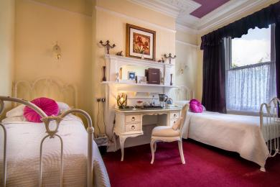
The Garden Room

Lounge

The Guest Day Room
- From the main entrance to the lounge, there is 1 step. There is no lift and no ramp.
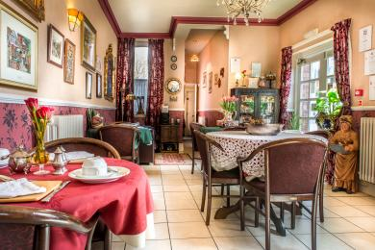
The Guest Day Room

Place to eat and drink

The Breakfast Room
- From the main entrance to the dining area, there is 1 step. There is no lift and no ramp.
- To get to a table, there are no steps.
- The menu is offered in large print.
- The route through the dining area is 800mm wide, or more.
- There is background music.
- The table and plates have high colour contrast.
- We cater for vegetarian, gluten free (celiacs), lactose free (dairy free), nut free and vegan specific diets.
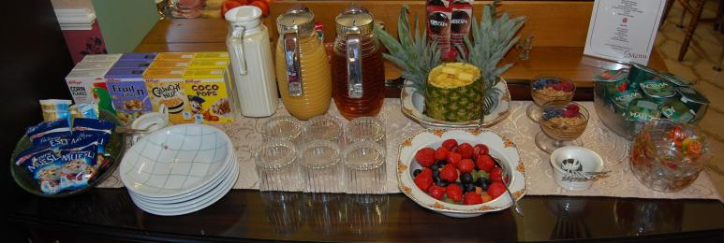
Continental buffet either self service or table service on request.
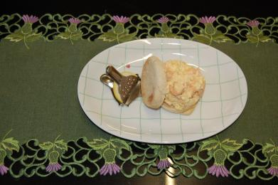
Fish options are available.
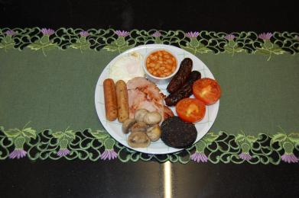
Full English breakfast.

Getting around outside

Guest Patio
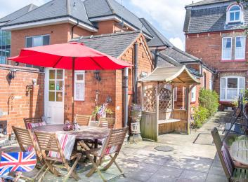
Guest Patio
- From the main entrance to the gardens, there is 1 step. There is no lift and no ramp.

Smoking

The Guest Patio
- The route is 2000mm wide, or more.
- The entrance is 750mm wide.
- The smoking area has a shelter.

Terrace
- To get to a table, there are 1steps steps.

Customer care support

Accessibility equipment
- There is a lawned area next to the guest patio outside the back door.
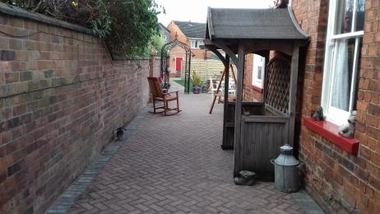
Smoking area and shelter
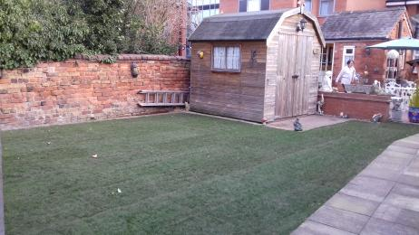
Assistance dogs toilet area.

Customer care support
- All staff have disability awareness training.
- Staff are available 24 hours a day.
- We have other services for people with accessibility requirements.
- Public area furniture will be moved to provide safe access. Asistance will be offered at breakfast to ensure all guests have access to everything on offer.

Guide last updated: 14 July 2023

