Accessibility Guide for St Andrews Coach Houses - Priory Lodge
info@standrewscoachhouses.co.uk, 07855 779092, www.standrewscoachhouses.co.uk
Contact for accessibility enquiries: Maggie Picken
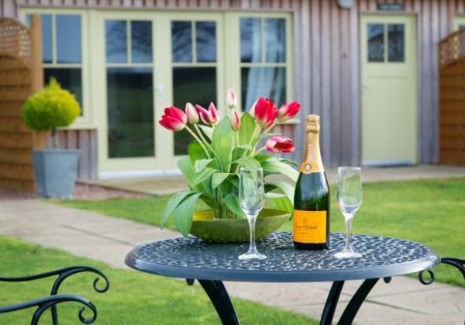

Welcome
This newly refurbished five star self catering lodge has stunning views and provides luxury accommodation with a focus on contemporary style and design. With high quality furnishings and boutique style interiors, super comfy beds with Egyptian cotton sheets, a fully equipped kitchen and a cosy wood-burning stove in the lounge, you’re sure to have a wonderful relaxing holiday!

At a Glance

Level Access
- The main entrance has 1 step. There is no lift and no ramp.
- There is level access from the main entrance to:
  - Lounge
  - Courtyard

Level access bedrooms
- From the main entrance to the bedroom, there is level access.
- The route to the bedroom is 750mm wide, or more.
- The bedroom door is 750mm wide, or more.

Hearing
- The (bedroom) TVs have subtitles.
- Some staff have disability awareness training.

General
- Some staff have disability awareness training.

Getting here
St Andrews Coach Houses
Priorletham
St Andrews
KY16 8NP

Travel by taxi
- You can get a taxi with St Andrews Taxis by calling 01334 477272. The taxi company has a wheelchair accessible vehicle.

Parking
- We have a car park. There are accessible parking spaces. The parking is less than 50 metres from the main entrance. Parking is free.
- From the car park to the entrance, there is level access. The path is sloped.
- The route is 1500mm wide, or more.

Arrival

Path to main entrance
- From the street to the main entrance, there is level access.
- The path is 1500mm wide, or more.
- The path is sloped.

Main entrance
- The door is 770mm wide.
- The main entrance has 1 steps.
- The main door is side hung and manual.

Getting around inside

Bedrooms
- All bedrooms have windows.
- Bedrooms have ceiling lights, wall lights, bedside lamps and natural daylight.
- Lights are energy saving and traditional filament. TVs have subtitles.
- All bedrooms are non-smoking.
- All bedrooms have fitted carpets.
- We can move the bedroom furniture, to improve accessibility.
- From the main entrance to this area, there is level access.
- The direction of transfer onto the toilet is to the right.

Self catering kitchen

Kitchen
- We have an open plan kitchen.
- From the main entrance to the kitchen, there is level access.
- The route is 750mm wide, or more.
- The oven is available at a height between 650mm and 900mm.
- The table and plates have high colour contrast.

Lounge

Lounge
- From the main entrance to the lounge, there is level access. The route is 750mm wide, or more. The door is 750mm wide.

Getting around outside

Courtyard
- From the main entrance to this area, there is level access. The route is 750mm wide, or more. The entrance is 750mm wide.
- From the main entrance to the area, there is 1 step.

Customer care support

Accessibility equipment
- We have an area to charge mobility scooters and battery powered wheelchairs.

Customer care support
- Some staff have disability awareness training.

Guide last updated: 1 July 2019

