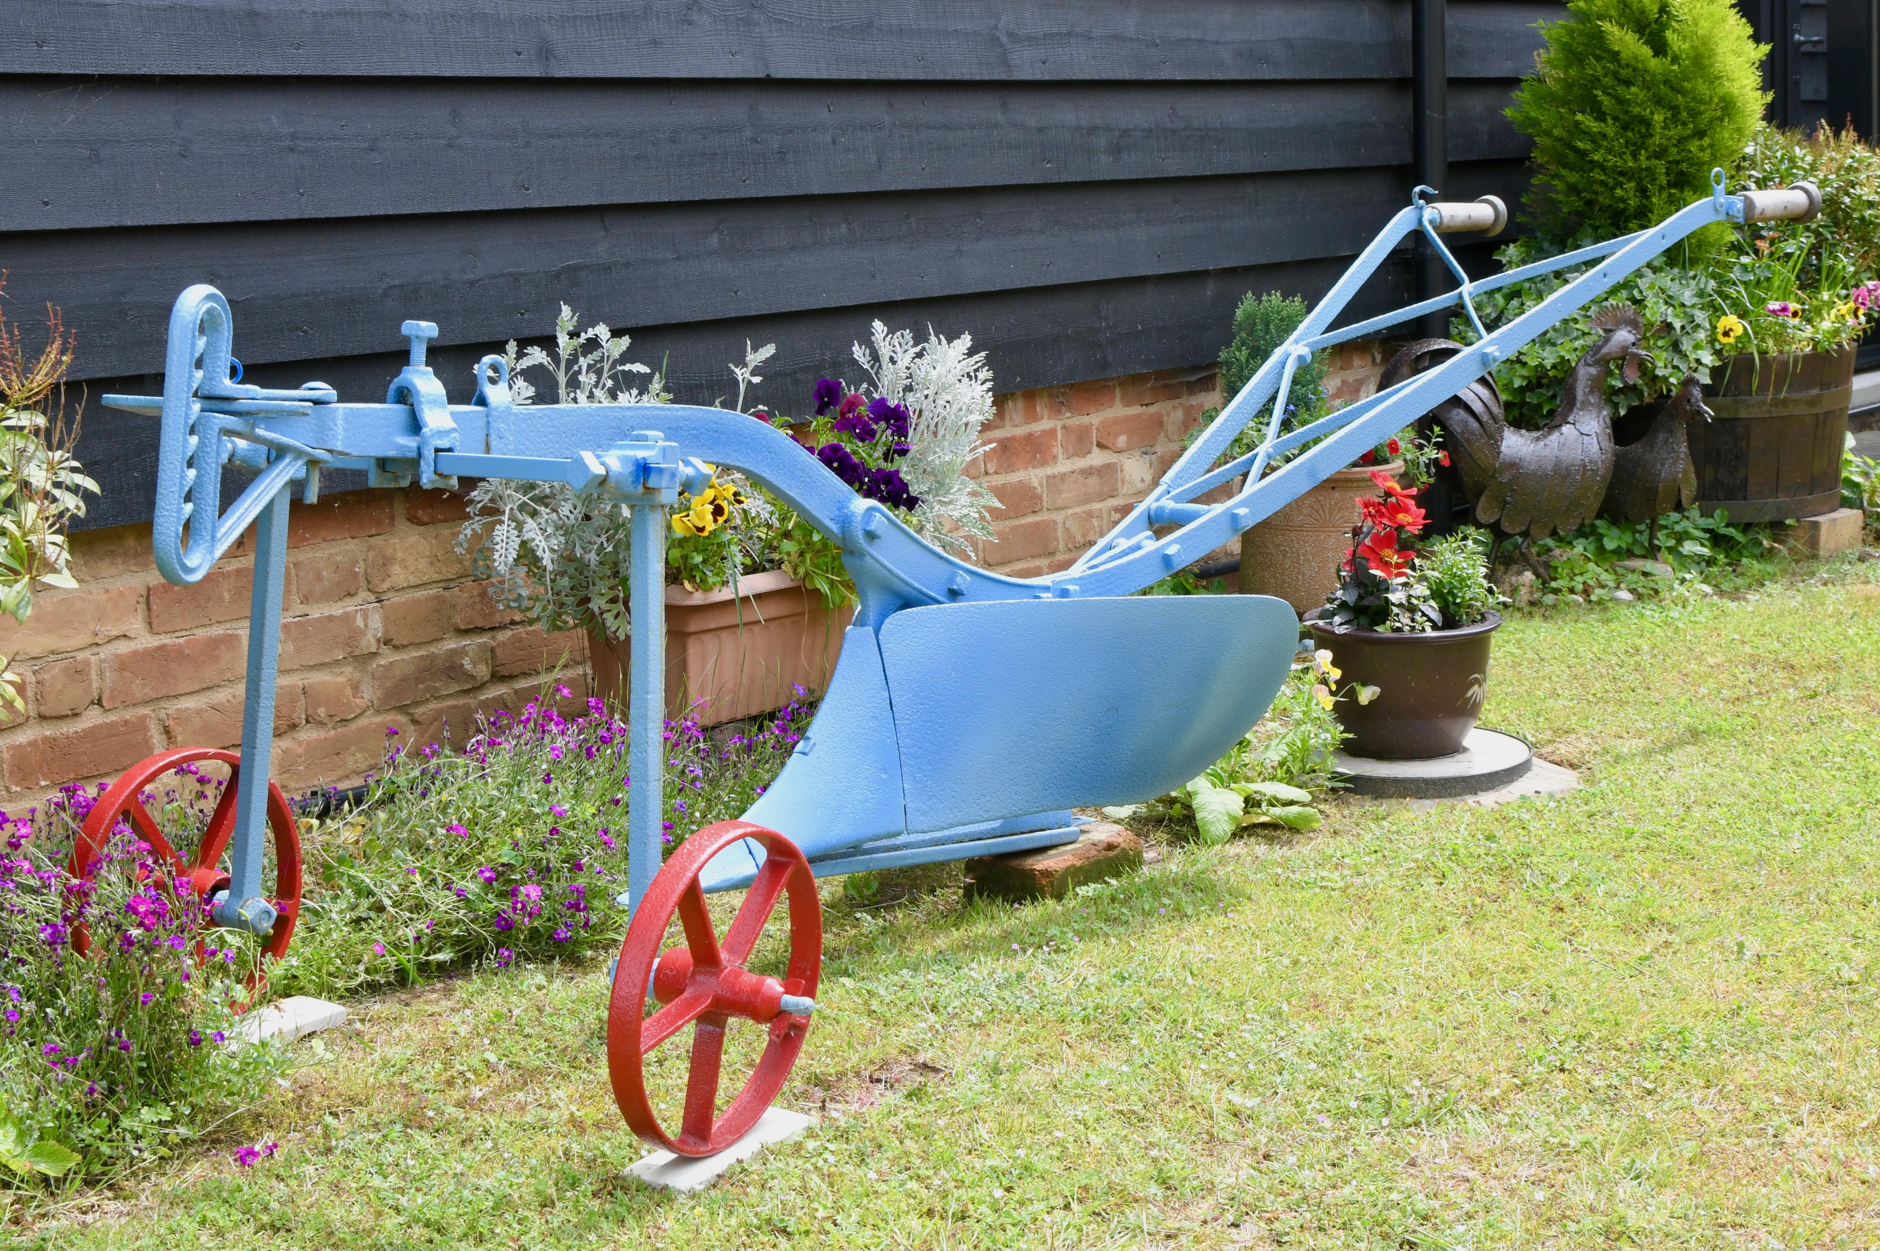

Accessibility Guide for Buffs Old Barn at Woodside Barn Cottages
jeannie@woodsidebarncottages.co.uk, 01728688217, www.woodsidebarncottages.co.uk
Contact for accessibility enquiries: Jeannie Wright.
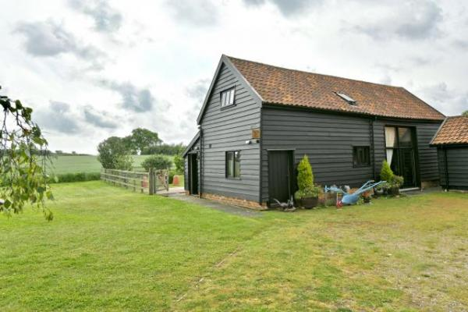

Welcome

At Buffs Old Barn we want to make our guests stay as enjoyable as possible. The accommodation is a Grade 2 Listed building & we have worked with our local council planners to create as much ease of use as possible. We aim to accurately describe Buffs Old Barn to give you the confidence to book, should our facility meet your particular needs.
Buffs Old Barn accommodates six in three double-bedrooms & is rated four star by Visit England with a Gold Award. The accommodation design makes Buffs Old Barn a great place for families, couples, or groups of friends to stay in a super location close to the Suffolk Heritage Coast and the Suffolk Coast and Heaths Area of Outstanding Natural Beauty.
Watch the video: Woodside Barn Cottages - Buffs Old Barn - Friston

At a Glance

Level Access
- There is level access from the main entrance to:
  - Open plan Lounge with Dining Room
  - Reading room
  - Enclosed garden
  - Garden patio

Access with steps
- There are steps from the main entrance to:
  - Main 1st Floor bedroom and shower room
  - Second 1st Floor Bedroom

Bedrooms
- We have non-allergic bedding.

Level access bedrooms
- From the main entrance to the bedroom, there is level access.
- The route to the bedroom is 750mm wide, or more.
- The bedroom door is 750mm wide, or more.

Hearing
- Some staff have disability awareness training.

General
- Some staff have disability awareness training.

Getting here
Buffs Old Barn, Church Road
Friston
Saxmundham, Suffolk.
IP17 1PU

Travel by public transport
- You can get to Buffs Old Barn at Woodside Barn Cottages by bus and train.
- You can get to Buffs Old Barn by bus and train The nearest bus stop is in the village of Friston. The bus stop is under 0.5 mile/ 0.5km from Buffs Old Barn. The nearest train Station is in Saxmundham. The train station is 3 miles / 0.8 km / 0.8 km/ 4.8 km from Buffs Old Barn. The bus stop is 0.5 miles / 0.8 km / 0.8 km from Buffs Old Barn at Woodside Barn Cottages.
- The nearest train station is Saxmundham. The train station is 3 miles / 4.8 km from Buffs Old Barn at Woodside Barn Cottages.
- The bus service to Friston Is infrequent and travel by taxi is recommended.

Travel by taxi
- You can get a taxi with NKS Private Hire by calling 01502450276 and Mob 07449145467 . The taxi company has a wheelchair accessible vehicle.
- You can get a taxi with Coastal Accessible Transport Services (CATS) Connecting Communities by calling 01728635938. The taxi company has a wheelchair accessible vehicle.
- You can get a taxi with Hawk Express Cabs by calling 01473222222. The taxi company has a wheelchair accessible vehicle.
- After leaving Church Road Friston, access to Buffs Old Barn is by a short country lane, which is also a public footpath.
Transport has access right up to the Main door.

Parking
- We have a car park. There are accessible parking spaces. The parking is less than 50 metres from the main entrance. Parking is free.
- There is a drop-off point at the main entrance. The drop-off point has a dropped kerb.
- From the car park to the entrance, there is level access. The route is 1000mm wide, or more.
- We have a transport service, to take visitors from the car park to the main entrance. Our transport service is wheelchair accessible.
- From the car park to the main entrance there is level access.
There is hard standing parking space with ample room for unloading and manoeuvring to the main entrance door.
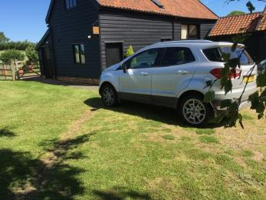
Parking close to the main entrance of the accommodation
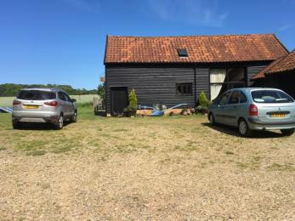
Parking at the Barn
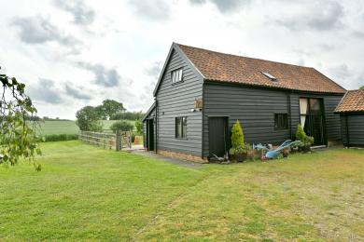
The front access to Buffs Old Barn

Arrival

Path to main entrance
- From the street to the main entrance, there is level access.
- The path is 1000mm wide, or more.

Main entrance
- The main entrance has level access.
- The door is 800mm wide.
- The main door is side hung and manual.
- When you arrive, we can help carry your luggage.
- Guests are met on arrival and help can be given with luggage.
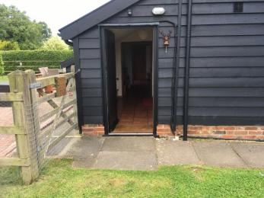
Main entrance to Barn and enclosed garden.

Getting around inside

Visual Impairment - General Information
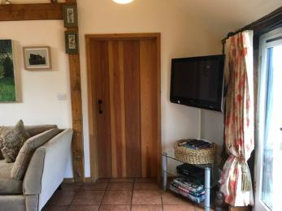
Internal doors & door frames are natural wood. Walls are magnolia emulsion.
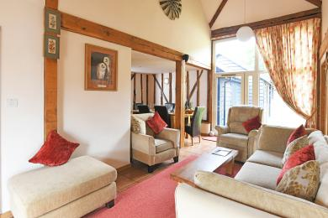
Natural light in all rooms including spot lights, ceiling lights and touch lamps.

Bedrooms
- All bedrooms have windows.
- Bedrooms have ceiling lights, bedside lamps, spot lights and natural daylight.
- Lights are halogen, LED and energy saving. All bedrooms are non-smoking.
- We have non-allergic bedding.
- Some bedrooms have fitted carpets.
- We can give details of our cleaning products on request.
- We can move the bedroom furniture, to improve accessibility.
- From the main entrance to this area, there is level access.
- The direction of transfer onto the toilet is to the left.
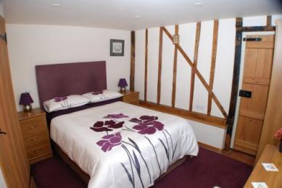
Easy access bedroom with usual furniture in place. The wardrobe clothes rail is 1450mm high. The divan bed is 600mm high.
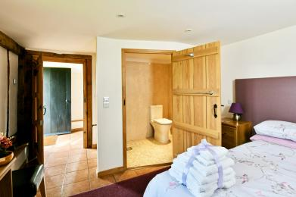
Easy access bedroom with furniture moved showing entrance & access to wet room.
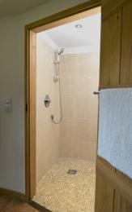
The wet-room is en-suite. The wet-room door is 800mm wide. A shower stool is available. The comfort toilet seat is 490mm high.

Self catering kitchen

Self catering kitchen.
- We have a separate kitchen and dining room. From the main entrance to the kitchen, there is level access.
- The route is 760mm wide, or more.
- The door is 760mm wide.
- The work surface is available at a height between 650mm and 900mm.
- The hob is available at a height between 650mm and 900mm.
- The sink is available at a height between 650mm and 900mm.
- The oven is available at a height between 650mm and 900mm.
- The table and plates have high colour contrast.
- From the main entrance to the dining room, there is level access. The door is 760mm wide.
- The cutlery is kept in the sideboard drawers. The crockery is kept in the base units of the sideboard.
The table cloth and place mats are kept in the sideboard drawers.
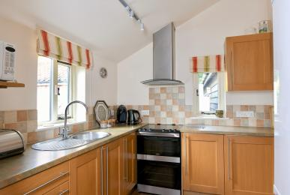
Kitchen work surface height is 900mm.
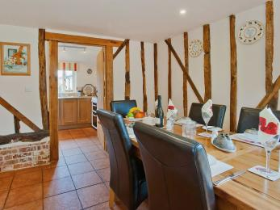
Dining room access to the kitchen
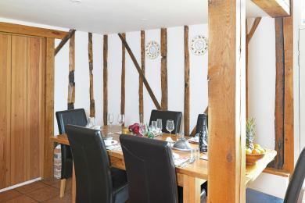
Dining room with Kitchen door closed.

Lounge

Open plan Lounge with Dining Room
- From the main entrance to the lounge, there is level access. The route is 760mm wide, or more. The door is 760mm wide.
- The Lounge area is open plan with the dining room. There is a three seat sofa that splits at the corner unit and an arm chair. The seating is 450mm from the floor. A second armchair is an electric riser/recliner. Its seat is 500 mm from the floor. Furniture can be arranged to suit individual needs.
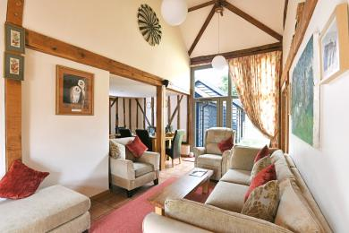
Ground floor lounge with dining room on the left.
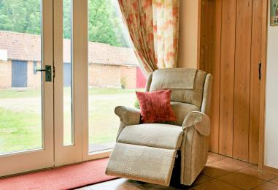
Electric riser/recliner chair in lounge

Reading room
- From the main entrance to this area, there is level access. The route is 760mm wide, or more.
- The door is 760mm wide.
- The Reading room has level access from the main entrance and through the Lounge. There is a double sofa bed with the seat 480mm from the floor. There is a ‘Serious Reader standard lamp with a flexible neck. A door opens into a small shower room, with toilet & washhand basin.
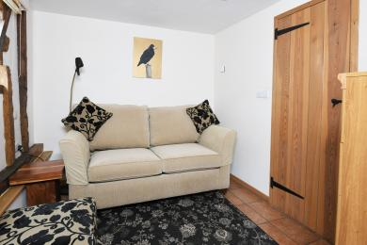
Reading room with sofa bed and Serious Reader Lamp.

Main 1st Floor bedroom and shower room
- From the main entrance to this area, there are 11 steps. There is no lift and no ramp.
- This 1st Floor bedroom and shower room are self-contained, with their own staircase. This room has a Tallboy wardrobe & drawers and there is more hanging space in the landing built in cupboard. The double bed is 600 mm high.
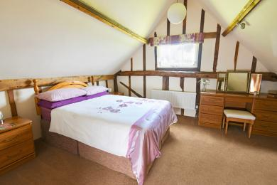
Accessed by its own staircase with bannisters either side of the stairs.
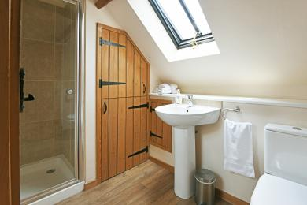
1st Floor Shower room with wash hand basin and toilet.

Second 1st Floor Bedroom
- From the main entrance to this area, there are 10 steps. There is no lift and no ramp.
- This bedroom has its own staircase with bannisters either side of the stairs. Its shower room has a shower, toilet and washhand basin located at the bottom of the stairs. The hanging space is in a built in cupboard over the staircase. The WiFi unit is located in this room.
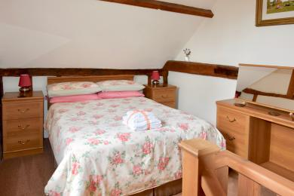
Second 1st Floor double bedroom.

Getting around outside

Enclosed garden
- From the main entrance to the gardens, there is level access.
- The route is 1500mm wide, or more.
- From the entrance path to this area a gate leads to the enclosed garden with level access. The gate is 1500mm wide. The garden is fenced and safely contains pets. From the Lounge to the garden there is a doorstep 40mm high and one step 55 mm high to the patio area.
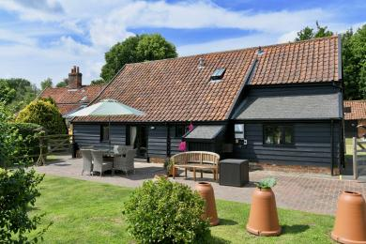
The enclosed garden
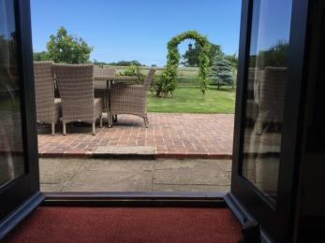
Access from the lounge into the enclosed garden.
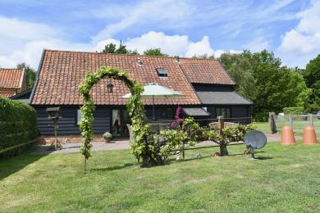
The enclosed garden and patio

Terrace

Garden patio
- From the main entrance to this area, there is level access. The route is 1420mm wide, or more.
- The entrance is 1420mm wide.
- To get to a table, there are no steps.
- The table is 760 mm high with clear under-space 720mm from floor to table edge. Garden chairs have a seat height of 420mm
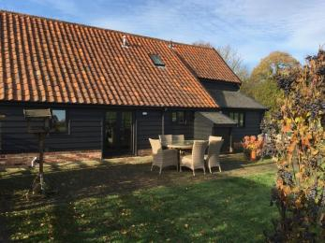
Garden Patio with access from main entrance and lounge.

Customer care support

Accessibility equipment
- There is a permanent grab rail by the toilet in the easy access wetroom. Two further grab rails are available that are suitable for the shower area. A shower stool is available.
- Assistance dogs nearest toilet area is the grass area in the enclosed garden which is accessed by the patio door. The grass area directly opposite the entrance door can also be used.
- We have an area to charge mobility scooters and battery powered wheelchairs.
- In the Barn access hall way or alternatively at the Farnhouse external electric socket.
- You can hire mobility equipment from Hadleigh Mobility Centre Ltd by calling 01473823235.

Emergency evacuation procedures
- We have emergency evacuation procedures for disabled visitors.

Customer care support
- Some staff have disability awareness training.
- The House book gives details of local medical services and emergency procedures. Mobile phone reception is variable in this area depending on your network.

Guide last updated: 2 July 2019

