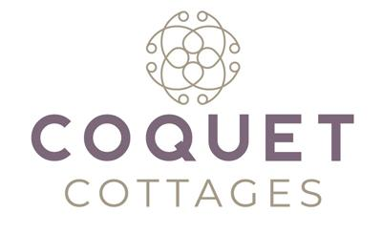
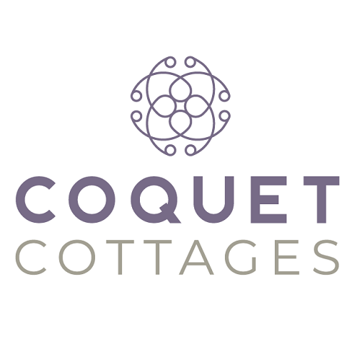

Accessibility Guide for The Atrium
01665 710700, https://www.coquetcottages.co.uk/northumberland-holiday-cottages/the-atrium-in-alnwick/
Contact for accessibility enquiries: Reservations Team
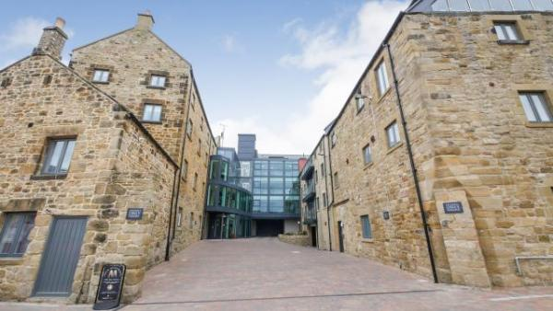

Welcome
The Atrium is just as modern and cool as the name suggests, yet built for comfortable living in the town of Alnwick, teeming with history. The apartment sleeps up to 4 guests but is perfect for a couple who enjoy modern living, relaxing and a bright and airy living space. Every area has been thought of in The Atrium and the west-facing balcony is the ‘cherry on the cake’ after a day out exploring, to indulge in the afternoon and evening sun with a glass of something cool, of course. No pets are permitted at The Atrium, but children are welcome. There’s a private parking space and free Wi-Fi too.

At a Glance

Level Access
- There is level access from the main entrance to:
  - Washer/dryer
  - Lounge
  - Balcony

Bedrooms
- We have non-allergic bedding.

Level access bedrooms
- From the main entrance to the bedroom, there is level access.

Hearing
- The (bedroom) TVs have subtitles.

Getting here
The Atrium
18 The Maltings
Alnwick
NE66 1LN

Travel by public transport
- You can get to The Atrium by bus.
- The nearest bus stop is located in the Alnwick Bus Station, next to Morrison's approx. 0.1 miles / 0.2 km away. The bus stop is 0.1 miles / 0.2 km from The Atrium.

Travel by taxi
- You can get a taxi with AA Taxis by calling 01665 606060.

Parking
- There is parking near the venue. Parking is free.
- There is a drop-off point at the main entrance. The drop-off point has a dropped kerb.
- From the car park to the entrance, there is level access. There is private parking space for one car in an allocated bay outside the apartment building. Additional, on-street parking can be found very close-by. There are no ‘guest’ spaces in the apartment parking area.

Arrival

Path to main entrance
- From the street to the main entrance, there is level access.

Main entrance
- The main entrance has level access.
- There is a lift.
- The main door is side hung and manual.
- The main door is side hung and automatic.

Getting around inside

Lift
- We have 1 lift.
- You can get a lift to all floors.

Lift to all floors
- The lift says the floor number at each floor.
- The lift shows the floor number, at each floor.

Bedrooms
- All bedrooms have windows.
- Bedrooms have ceiling lights, bedside lamps and natural daylight.
- TVs have subtitles.
- All bedrooms are non-smoking.
- We have non-allergic bedding.
- All bedrooms have fitted carpets.
- From the main entrance to this area, there is level access.

Washer/dryer
- From the main entrance to the laundry, there is level access. There is a lift.
- We have an iron and ironing board.

Self catering kitchen

Kitchen
- We have an open plan kitchen.
- From the main entrance to the kitchen, there is level access.
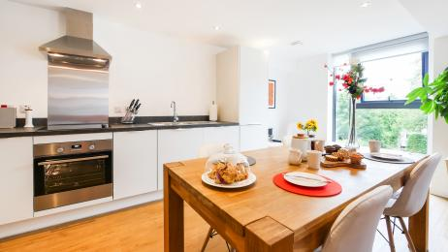
Kitchen
- There is a lift.

Lounge

Lounge
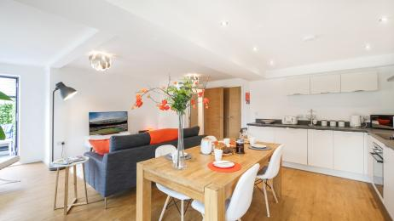
Lounge
- From the main entrance to the lounge, there is level access. There is a lift.

Getting around outside

Terrace

Balcony
- From the main entrance to this area, there is level access. There is a lift.
- To get to a table, there are no steps.
- The west-facing balcony can be accessed from both the lounge and the master bedroom. The balcony has a bench seat for 2. There are lovely walks in and around Alnwick Castle to enjoy on foot too from the apartment.
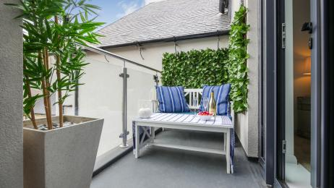
Balcony

Customer care support

Accessibility equipment
- For a list of more items, please go to http://www.redcross.org.uk/Where-we-work/HealthandSupport?loc=ne65+0xp&r=50&s....
- The nearest toilet area for assistance dogs is outside the main building.
- You can hire mobility equipment from Red Cross Newcastle by calling 0191 2737961.

Guide last updated: 11 June 2019

