Accessibility Guide for Orchard House Barn
info@coquetcottages.co.uk, 01665 710700, https://www.coquetcottages.co.uk/northumberland-holiday-cottages/orchard-house-barn/
Contact for accessibility enquiries: Reservations Team
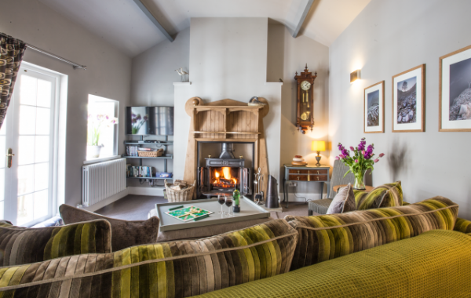

Welcome
Orchard House Barn is cosy in the winter with it’s deep, squashy Knoll sofa and huge range-style wood burning stove, yet colourful and bright in the summer with the pretty, flowered patio which is a sun trap. This luxury self-catering cottage is well position for discovering the historic village of Corbridge. You can walk into the village in around 45 minutes as it’s 2.1 miles away, although driving takes just 5 minutes. Corbridge is an upmarket village with a concentrated selection of divine deli’s, gorgeous pubs and restaurants and boutique shops. Orchard House Barn sleeps 2 guests in 1 bedroom and welcomes 1 small dog.

At a Glance

Level Access
- The main entrance has 5 steps. There is no lift and no ramp.

Access with steps
- There are steps from the main entrance to:
  - Bedroom
  - Washing machine & tumble dryer
  - Lounge
  - Courtyard

Bedrooms
- We have non-allergic bedding.

Hearing
- The (bedroom) TVs have subtitles.

Getting here
Orchard House Barn
Sanhoe
Corbridge
NE46 4LU

Travel by public transport
- The nearest bus stop is located in Corbridge, which is over a mile away, so we would recommend driving via car.

Travel by taxi
- You can get a taxi with Corbridge Private Hire by calling 01434 303995.

Parking
- There is parking near the venue. Parking is free.
- There is a drop-off point at the main entrance. The drop-off point does not have a dropped kerb.
- From the parking to the main entrance, there are 5 steps. There is no ramp and no lift.
- There is private, off-road parking for one car just outside the courtyard to the Barn. Further car parking can be made available if required.

Arrival

Path to main entrance
- From the street to the main entrance, there are 5 steps. There is no ramp and no lift.

Main entrance
- The main entrance has 5 steps.
- The main door is side hung and manual.

Getting around inside

Bedrooms
- All bedrooms have windows.
- Bedrooms have ceiling lights, wall lights, desk or table lamps and natural daylight.
- TVs have subtitles.
- All bedrooms are non-smoking.
- We have non-allergic bedding.
- All bedrooms have fitted carpets.
- The bedroom nearest the main entrance has 5 steps.
- All bedrooms are ensuite.
- We have bathrooms with a bath and overhead shower.

Washing machine & tumble dryer
- From the main entrance to the laundry, there are 5 steps. There is no lift and no ramp.
- We have an iron and ironing board.

Self catering kitchen

Kitchen
- We have an open plan kitchen.
- From the main entrance to the kitchen, there are 5 steps. There is no lift and no ramp.
- The table and plates have high colour contrast.
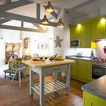
Kitchen

Lounge

Lounge
- From the main entrance to the lounge, there are 5 steps. There is no lift and no ramp.
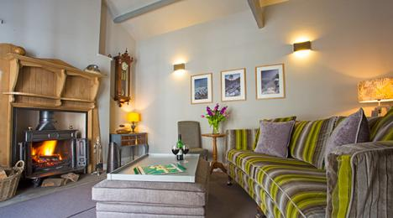
Lounge

Getting around outside

Courtyard
- From the main entrance to the gardens, there are 5 steps. There is no lift and no ramp.
- Directly outside the door to Orchard House Barn is a pretty courtyard area with seating for two. Although adjacent to the owner’s house, this south-facing courtyard is not overlooked and for your use only, is well-stocked with attractive plants.
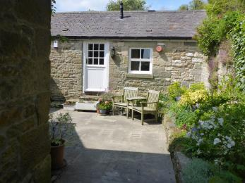
Courtyard

Customer care support

Accessibility equipment
- For a list of more items, please go to http://www.redcross.org.uk/Where-we-work/HealthandSupport?loc=ne65+0xp&r=50&s....
- The nearest toilet area for assistance dogs is the courtyard.
- You can hire mobility equipment from Red Cross Newcastle by calling 0191 2737961.

Guide last updated: 21 May 2019

