Accessibility Guide for Longstone
info@coquetcottages.co.uk, 01665 710700, https://www.coquetcottages.co.uk/northumberland-holiday-cottages/longstone-cottage/
Contact for accessibility enquiries: Reservations Team
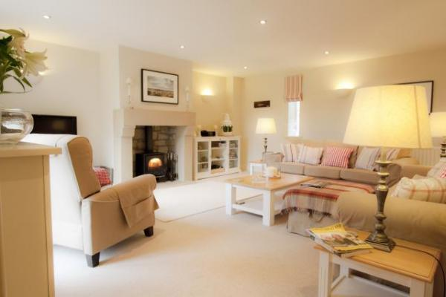

Welcome
Perfect for small families, couples holidaying together or for a romantic weekend, Longstone Cottage near Seahouses is furnished and equipped to a luxurious 4 star GOLD award standard, so is perfect for discerning guests who wish to stay on the Northumberland coast, near the sea, without compromising on quality. Decorated in a gorgeous ‘coastal chic’ style, there are artworks by renowned local artists and designer fabrics are used throughout the cottage.It’s a short walk to the gorgeous St Aidens beach at Seahouses and there is a lovely newly refurbished restaurant and bar called The Longstone House serving gorgeous food just around 100yds from Longstone.

At a Glance

Level Access
- There is level access from the main entrance to:
  - Washing/Dryer Machine
  - Longstone Lounge
  - Longstone Ground Floor WC
  - Longstone Garden

Access with steps
- There are steps from the main entrance to:
  - Bedroom

Hearing
- The (bedroom) TVs have subtitles.

Getting here
10 Village Farm
North Sunderland
NE68 7TE

Travel by public transport
- You can get to Longstone by bus.
- The nearest bus stop is a 2 minute walk away from Longstone, the bus stop is at St Paul's Church. The bus stop is 0.2 miles / 0.3 km from Longstone.

Travel by taxi
- You can get a taxi with Sovereign Taxis by calling 01665 602200.

Parking
- There is a drop-off point at the main entrance. The drop-off point does not have a dropped kerb.
- There is private parking for up to 2 cars, one on a private driveway in front of the cottage and one adjacent.

Arrival

Path to main entrance
- From the street to the main entrance, there is level access.
- The path is 900mm wide, or more.

Main entrance
- The main entrance has level access.
- The door is 900mm wide.
- The main door is side hung and manual.
- The main door is revolving and manual.

Getting around inside

Bedrooms
- All bedrooms have windows.
- Bedrooms have ceiling lights, bedside lamps and natural daylight.
- Lights are LED. TVs have subtitles.
- All bedrooms are non-smoking.
- All bedrooms have fitted carpets.
- The bedroom nearest the main entrance has 14 steps.
- All bedrooms are ensuite.
- We have bathrooms with a separate shower.
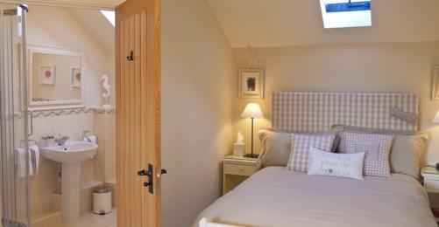
Longstone Master Bedroom
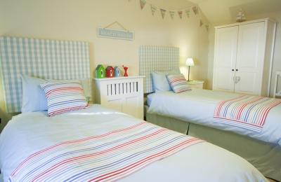
Longstone Second Bedroom
- We have bathrooms with a bath and overhead shower.

Washing/Dryer Machine
- From the main entrance to the laundry, there is level access. The route is 900mm wide, or more. The door is 900mm wide.
- From the main entrance to the laundry, there is 1 step. There is no lift and no ramp.
- We have an iron and ironing board.

Self catering kitchen

Longstone Kitchen
- We have an open plan kitchen.
- From the main entrance to the kitchen, there is level access.
- The route is 900mm wide, or more.
- The door is 900mm wide.
- The kitchen is well equipped and beautifully finished, with luxury cabinets and granite work surfaces. There’s a stainless steel range cooker with electric oven and induction hob, fridge, freezer, dishwasher, washer/dryer, microwave, kettle and toaster. There’s also a radio/hi-fi. The oak dining table comfortably seats up to 4 and can be extended for up to 6 guests if you had visitors.
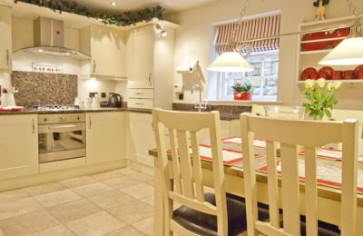
Longstone Kitchen

Lounge

Longstone Lounge
- From the main entrance to the lounge, there is level access. The route is 900mm wide, or more. The door is 900mm wide.
- The lounge is beautifully furnished and very spacious, with a real wood-burning stove set in a gorgeous sandstone fire place. An initial supply of logs are supplied between October and April and you can purchase more sacks upon booking. Large flat screen TV and DVD/CD player. French windows face onto the private patio garden.
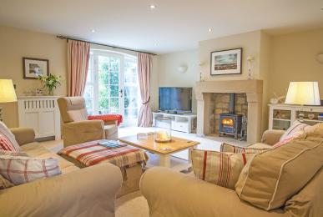
Longstone Lounge

Longstone Ground Floor WC
- From the main entrance to this area, there is level access. The route is 900mm wide, or more.
- The door is 900mm wide.

Getting around outside

Longstone Garden
- From the main entrance to the gardens, there is level access.
- The route is 900mm wide, or more.
- Longstone has a very attractive landscaped patio garden. A table and chairs are provided for fine days and there’s a barbecue. Fully enclosed, it’s sunny and quite private.
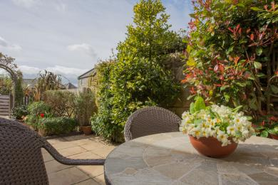
Longstone Garden

Customer care support

Accessibility equipment
- For a list of more items, please go to http://www.redcross.org.uk/Where-we-work/HealthandSupport?loc=ne65+0xp&r=50&s....
- The nearest toilet area for assistance dogs is in the garden.
- You can hire mobility equipment from Red Cross Newcastle by calling 0191 2737961.

Guide last updated: 7 May 2019

