Accessibility Guide for Nursery Cottage
info@coquetcottages.co.uk, 01665 710 700, https://www.coquetcottages.co.uk/northumberland-holiday-cottages/nursery-cottage/
Contact for accessibility enquiries: Coquet Cottages
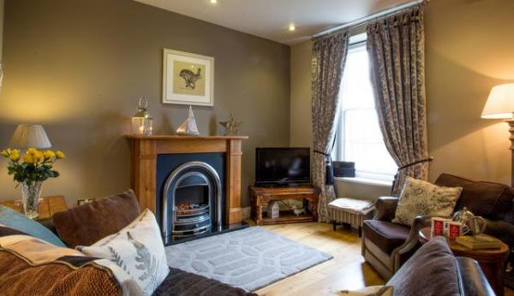

Welcome
Nursery Cottage at Alnwick has been lovingly restored from a former gardener’s cottage on the site of the old Clive Nurseries. Situated within the bounds of the town itself, the cottage is in a very quiet residential area. With the benefit of a private, secluded front garden and patio area, with stunning views of Alnwick Castle with the Moors beyond from the floor-to-ceiling master bedroom window, this little cottage is a real gem.

At a Glance

Level Access
- The main entrance has 1 step. There is no lift and no ramp.
- There is level access from the main entrance to:
  - Washer/Dryer Machine available for use.
  - Nursery Cottage Lounge

Access with steps
- There are steps from the main entrance to:
  - Bedroom
  - Nursery Cottage Garden

Bedrooms
- We have non-allergic bedding.

Hearing
- Some (bedroom) TVs have subtitles.

Getting here
1 Clive Nurseries
Alnwick
NE66 1LH

Travel by public transport
- You can get to Nursery Cottage by bus.
- The nearest bus stop is a 5 minute walk away on Clayport Street. The bus stop is 0.3 miles / 0.5 km from Nursery Cottage.
- Alnwick's main bus station is 0.4 miles away from Nusery Cottage. This is a 7-10 minute walk.

Travel by taxi
- You can get a taxi with JL Taxis by calling 01665 713800.

Parking
- We have a car park. The parking is less than 50 metres from the main entrance. Parking is free.
- There's private parking for one car in front of the garage (garage not in use). Additional free parking is just 30 yards away from here. From the parking to the main entrance, there is 1 step. There is no ramp and no lift.

Arrival

Path to main entrance
- From the street to the main entrance, there is 1 step. There is no ramp and no lift.

Main entrance
- The door is 900mm wide.
- The main entrance has 1 steps.
- The main door is side hung and manual.

Getting around inside

Bedrooms
- All bedrooms have windows.
- Bedrooms have bedside lamps and spot lights.
- Lights are LED. Some TVs have subtitles.
- All bedrooms are non-smoking.
- We have non-allergic bedding.
- All bedrooms have fitted carpets.
- The bedroom nearest the main entrance has 15 steps.
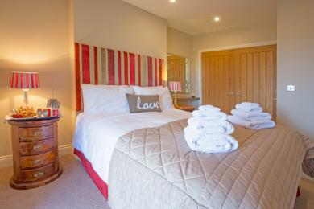
Nursery Cottage Master Bedroom
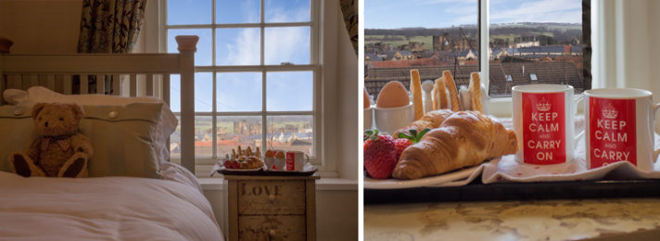
Nursery Cottage Second Bedroom

Washer/Dryer Machine available for use.
- From the main entrance to the laundry, there is level access. The route is 900mm wide, or more. The door is 900mm wide.
- We have an iron and ironing board.

Self catering kitchen

Nursery Cottage Kitchen Diner
- We have an open plan kitchen.
- From the main entrance to the kitchen, there is level access.
- The route is 900mm wide, or more.
- The door is 900mm wide.
- The spacious kitchen has a dining table and chairs for up to 4 people and is well equipped with all the usual appliances, including electric fan oven, gas hob, microwave, Nespresso coffee machin, integrated large fridge/freezer, washing machine and slimline dishwasher. There is a glazed door leading directly to the pretty patio outside.
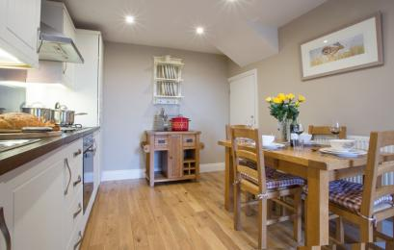
Nursery Cottage Kitchen

Lounge

Nursery Cottage Lounge
- From the main entrance to the lounge, there is level access. The route is 900mm wide, or more. The door is 900mm wide.
- A cosy lounge with a large original Georgian sash window looking out to the pretty garden and not overlooked. 43″ HD Smart TV (not shown in photo below) with full access to Netflix, DVD player, Hi-fi with iPod dock. Free Wi-fi and PlayStation 2 games console with a small selection of games. There is a feature fireplace with attractive electric fire, a selection of books, DVD’s and games.
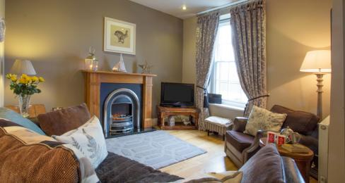
Nursery Cottage Lounge

Getting around outside

Nursery Cottage Garden
- From the main entrance to the gardens, there is 1 step. There is no lift and no ramp.
- 1 step from the gardens patio into the main entrance of Nursery Cottage
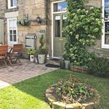
Nursery Cottage Garden

Customer care support

Accessibility equipment
- For a list of more items, please go to http://www.redcross.org.uk/Where-we-work/HealthandSupport?loc=ne65+0xp&r=50&s....
- The nearest toilet area for assistance dogs is in the garden/patio area at the main entrance of the property.
- You can hire mobility equipment from Red Cross by calling 0191 2737961.

Guide last updated: 7 May 2019

