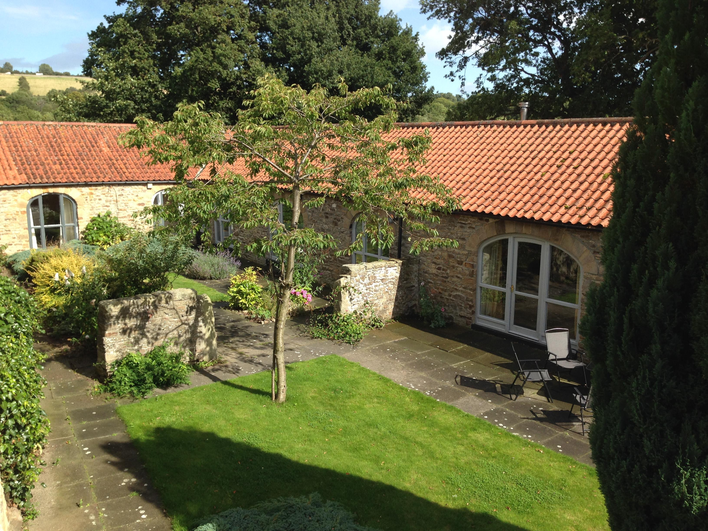

Accessibility Guide for Edge Knoll Holiday Cottages
vacationfarm@hotmail.com, +44 7971883431, https://edgeknollfarm.co.uk
Contact for accessibility enquiries: Michael Edmonds
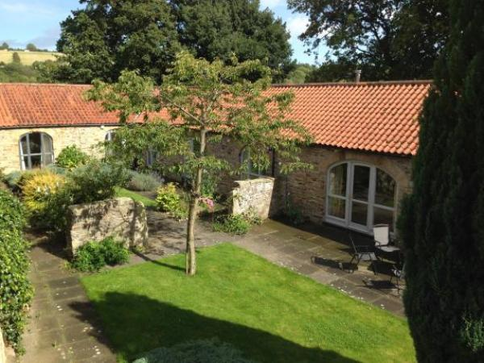

Welcome
Two cottages set in open countryside. Both are converted 17th century farm buildings set around a peaceful courtyard and open country views all round outside of the courtyard. No longer a working farm the cottages are approached along a one kilometer unpaved farm road. The courtyard is paved with grassy areas for relaxing and the grass area is level with the paved areas allowing easy access. The car parking area is stone chip surface. Inside the cottages are modern, and comfortable with oil fired central heating and baths with shower over. Each cottage has garden furniture, Witton View Cottage has its own patio and is animal friendly. Wear View Cottage has a log fire.
A car is essential.
Watch the video: 360 degree tour of the cottages and surrounds Courtesy of GraphitePanda

At a Glance

Level Access
- The main entrance has 1 step. There is no lift and no ramp.
- There is level access from the main entrance to:
  - Wear View Cottage Lounge
  - Witton View Cottage Lounge

Access with steps
- There are steps from the main entrance to:
  - courtyard from Wear View Cottage and Witton View Cottage

Bedrooms
- We have non-allergic bedding.

Level access bedrooms
- From the main entrance to the bedroom, there is level access.
- The route to the bedroom is 750mm wide, or more.
- There is unobstructed floor space 1200mm by 900mm, or more.

Hearing
- The (bedroom) TVs have subtitles.

General
- Staff are available 24 hours a day.
- We have emergency evacuation procedures for disabled visitors.

Getting here
Edge Knoll Holiday Cottages
Hamsterley
Bishop Auckland
DL13 3PF

Travel by public transport
- A car or taxi is necessary to get to Edge Knoll holiday Cottages. The nearest train station is five miles away.and there is a one kilometre unpaved road on the final part of the approach to the cottages.

Parking
- We have a car park. The parking is less than 50 metres from the main entrance. Parking is free.
- The parking and drop off point is 50 meters from the cottage entrance. There is a step of 75mm, but also an alternative 15 meters longer paved path with no steps. From the car park to the entrance, there is level access. The route is 1220.00mm wide, or more.
- Watch the video: A 360 degree tour of the cottages interior and exterior as well as the parking area and paths around the courtyard
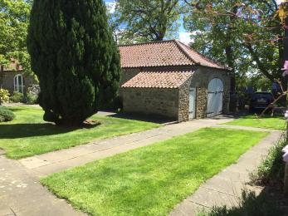
The paved paths leading around the courtyard and accessing Witton View and Wear View Cottages as well as the owner's house.

Arrival

Path to main entrance
- From the street to the main entrance, there is 1 step. There is no ramp and no lift.

Main entrance
- The door is 750mm wide.
- The main entrance has 1 steps.
- The main door is side hung and manual.
- When you arrive, we can help carry your luggage.
- Watch the video: A 360 degree tour of the courtyard, parking areas and surroundings of the two cottages.
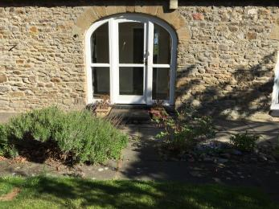
The doorway from the courtyard to the corridor of Wear View Cottage, a wooden removable ramp is available for this 240 mm step
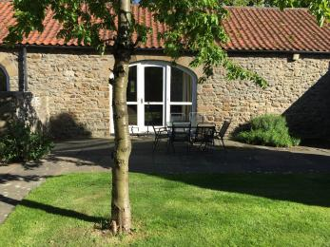
Wear View Cottage doorway from the courtyard to the living room is 750 mm wide and has a 125mm step
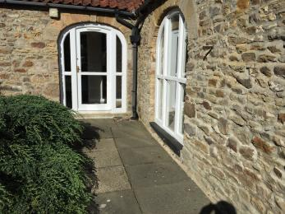
Witton View Cottage doorway to the courtyard is 750 mm wide and has a step 150 mm high.
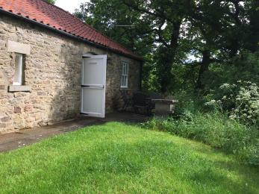
Witton View Cottage doorway to the patio area is 730 mm wide and has a 140 mm step

Getting around inside

Visual Impairment - General Information
- Watch the video: 360 degree tour of both cottages and the surrounding area

Bedrooms
- All bedrooms have windows.
- Bedrooms have ceiling lights and bedside lamps.
- Lights are LED and energy saving. TVs have subtitles.
- All bedrooms are non-smoking.
- We have non-allergic bedding.
- Some bedrooms have fitted carpets.
- We can move the bedroom furniture, to improve accessibility.
- We have bed blocks.
- From the main entrance to this area, there is level access.
- The direction of transfer onto the toilet is to the left and right.
- Watch the video: 360 tour of all interiors and exteriors

Self catering kitchen

Wear View Cottage Kitchen
- We have an open plan kitchen.
- From the main entrance to the kitchen, there is level access.
- The route is 720mm wide, or more.
- The door is 720mm wide.
- The work surface is available at a height between 650mm and 900mm.
- The hob is available at a height between 650mm and 900mm.
- The sink is available at a height between 650mm and 900mm.
- The oven is available at a height between 650mm and 900mm.
- The table and plates have high colour contrast.
- 360 degree tour of the cottage interiors including the kitchens
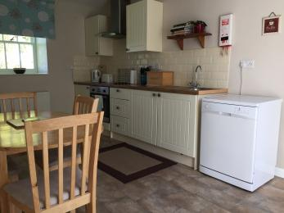
Wear View Cottage kitchen view 1
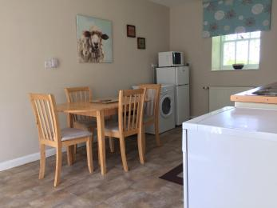
Wear View Cottage open plan kitchen diner view 2

Self catering kitchen

Witton View Cottage kitchen diner
- We have an open plan kitchen.
- From the main entrance to the kitchen, there are 2 steps. There is no lift and no ramp.
- The work surface is available at a height between 650mm and 900mm.
- The hob is available at a height between 650mm and 900mm.
- The sink is available at a height between 650mm and 900mm.
- The oven is available at a height between 650mm and 900mm.
- The table and plates have high colour contrast.
- The steps between the lounge and the kitchen diner are 170 mm and 140 mm
- Witton View Cottage kitchen diner
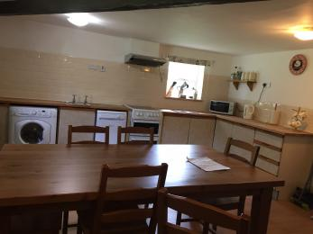
The kitchen at Witton View Cottage

Lounge

Wear View Cottage Lounge
- From the main entrance to the lounge, there is level access. The route is 1020mm wide, or more. The door is 720mm wide.
- Watch the video: 360 degree tour of Wear View Cottage and Witton View Cottage showing all rooms and the exterior
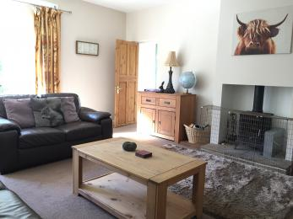
Wear View Cottage lounge
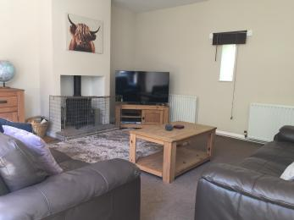
Wear View Cottage lounge 2

Lounge

Witton View Cottage Lounge
- From the main entrance to the lounge, there is level access. The route is 1020mm wide, or more. The door is 720mm wide.
- The Lounge has an entrance from the corridor and also leads into the kitchen. There are two steps into the kitchen form the lounge. 170 mm and 140 mm
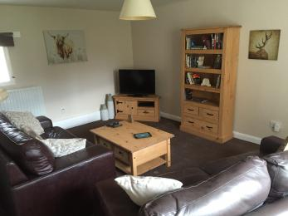
The lounge in Witton View Cottage

Getting around outside

courtyard from Wear View Cottage and Witton View Cottage
- From the main entrance to the area, there are 2 steps.
- 170 mm step from Wear View Cottage to the courtyard
- Watch the video: a 360 degree tour of the cottages and courtyard
Entrance to Wear View Cottage from the courtyard
Witton View Cottage entrance to the courtyard
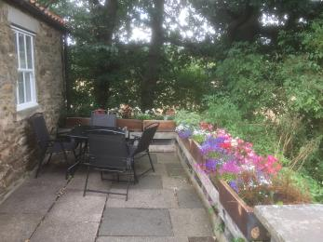
Witton View Cottage Patio and entrance

Customer care support

Accessibility equipment
- Bed blocks
- For a list of more items, please go to https://www.redcross.org.uk.
- outside the gates of the properties there are open fields as well as footpaths and rights of way to exercise animals and to complete their toilet. bins are provided outside each cottage to store "poo bags" prior to the customer disposing of the waste in the council bins.
- We have an area to charge mobility scooters and battery powered wheelchairs.
- You can hire mobility equipment from British Red Cross by calling 01913 324196.
- You can hire mobility equipment from Wright Mobility Services by calling 01388 531010.

Customer care support
- Staff are available 24 hours a day.
- The owner lives on site and can be called on for emergencies 24 hours a day.

Guide last updated: 6 June 2019

