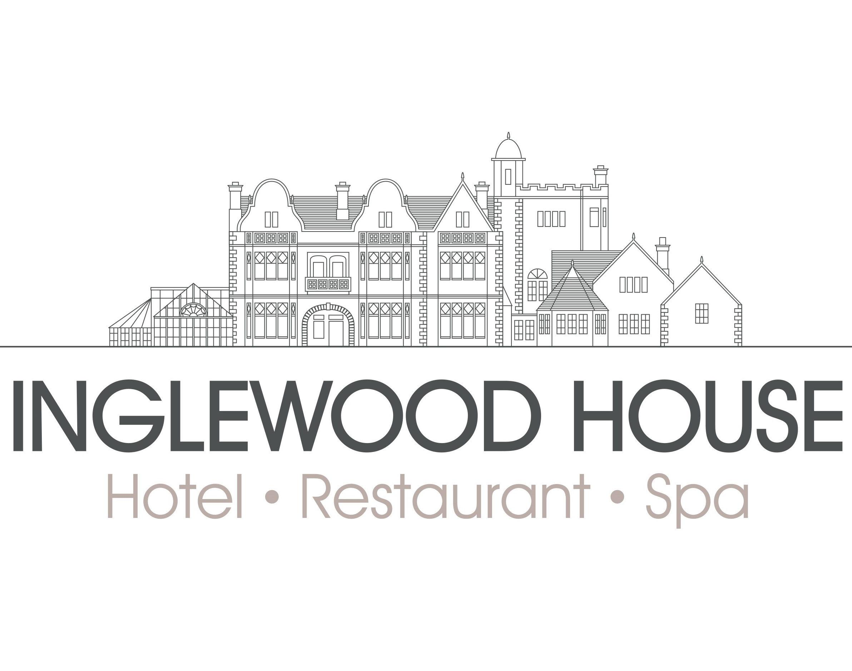

Accessibility Guide for Inglewood House and Spa
info@inglewoodhouseandspa.co.uk, 01259 216156, www.inglewoodhouseandspa.co.uk
Contact for accessibility enquiries: Hotel Reception or Duty Manager
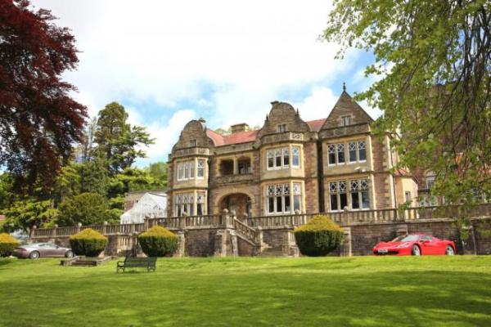

Welcome
From your first sight of Inglewood House, you know you have arrived somewhere truly special. Set in 25 acres, this stunning Jacobean mansion house has been sympathetically transformed into a luxurious boutique hotel and spa, near Stirling. It is now the perfect destination for weddings, relaxing spa breaks, romantic weekends, conferences and other events or celebrations.

At a Glance

Level Access
- There is level access from the main entrance to:
  - Hotel reception
  - Dining Table
  - Grand Hall
  - Library Bar
  - Leisure Club Gym changing area
  - Leisure Club Gym
  - Private Dining Room
  - Ballroom
  - Smoking Area at rear of hotel
  - Terrace at front of Inglewood House

Access with steps
- There are steps from the main entrance to:
  - Inglewood House Gardens

Bedrooms
- We have non-allergic bedding.

Level access bedrooms
- From the main entrance to the bedroom, there is level access.
- The route to the bedroom is 750mm wide, or more.
- The bedroom door is 750mm wide, or more.

Hearing
- The (bedroom) TVs have subtitles.
- Some staff have disability awareness training.

Visual
- Some parts of the venue have low lighting.

General
- Staff are available 24 hours a day.
- Some staff have disability awareness training.
- We have emergency evacuation procedures for disabled visitors.

Getting here
Inglewood House
Tullibody Road
Alloa
FK10 2HU

Travel by public transport
- You can get to Inglewood House and Spa by bus and train.
- The nearest bus stop is on Tullibody Road, Alloa approximately 200m from the start of our driveway. The bus stop is 0.5 miles / 0.8 km from Inglewood House and Spa.
- The nearest train station is Alloa Train Station. The train station is 2 miles / 3.2 km from Inglewood House and Spa.

Travel by taxi
- You can get a taxi with Buchan Town Car by calling 01259 213 215.
- You can get a taxi with RSW Cabs by calling 01259 219999. The taxi company has a wheelchair accessible vehicle.

Parking
- We have a car park. There are accessible parking spaces. The parking is less than 50 metres from the main entrance. Parking is free.
- There is a drop-off point at the main entrance. The drop-off point has a dropped kerb.
- From the car park to the entrance, there is level access. The route is 1800mm wide, or more.
- For disabled access, please drive to the rear of Inglewood House as signposted. At the rear entrance, there are 2 disabled parking bays approximately 10m from the rear entrance to the hotel. The rear car park is tarmac and there is level access into the reception of the hotel from here.
There is also level access to the Spa and Ballroom from this carpark.
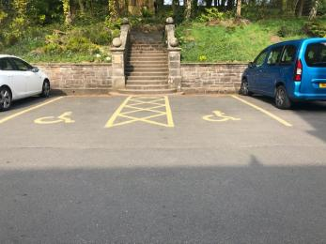
Parking Bays
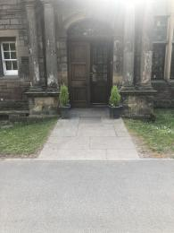
Rear Entrance

Arrival

Path to main entrance
- From the street to the main entrance, there is level access.
- The path is sloped.

Main entrance
- The main entrance has level access.
- The door is 1000mm wide.
- The main door is side hung and manual.
- From Tullibody Road to Inglewood House the driveway is relatively steep.
We recommend driving or getting a taxi to the rear entrance of Inglewood House where we have disabled parking bays and level access to the hotel.
Rear Entrance

Getting around inside

Visual Impairment - General Information
- Some parts of the venue have low lighting.

Hotel reception
- From the main entrance to reception, there is level access. The door is 1000mm wide.
- You can sit down at reception.
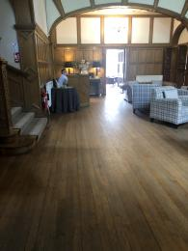
Hotel Reception

Bedrooms
- All bedrooms have windows.
- Bedrooms have ceiling lights, wall lights, bedside lamps and natural daylight.
- Lights are LED and energy saving. Some lights can be controlled independently.
- TVs have subtitles.
- All bedrooms are non-smoking.
- We have non-allergic bedding.
- All bedrooms have fitted carpets.
- From the main entrance to this area, there is level access.

Lounge

Grand Hall
- From the main entrance to the lounge, there is level access. The route is 1000mm wide, or more. The door is 1000mm wide.
Grand Hall

Bar

Library Bar
- From the main entrance to the bar, there is level access. The route is 1000mm wide, or more.
- The door is 1000mm wide.
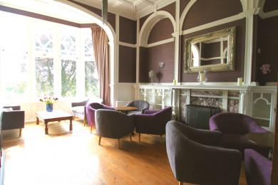
Library Bar

Gym

Leisure Club Gym
- From the main entrance to the gym changing area, there is level access. There is a permanent ramp. The route is 900mm wide, or more.
- The door is 900mm wide.
- There is a wide changing cubicle for a wheelchair user.
- From the changing area to the gym, there is level access. There is a permanent ramp. The route is 800mm wide, or more.
- The door is 800mm wide.
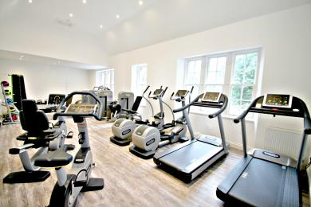
Gym

Place to eat and drink

Forrester's Restaurant
- From the main entrance to the dining area, there is level access. The route is 1000mm wide, or more. The door is 1000mm wide.
- To get to a table, there are no steps.
- If you need table service, staff can help you.
- The route through the dining area is 800mm wide, or more.
- There is background music.
- We cater for sugar free (diabetic), vegetarian, gluten free (celiacs), lactose free (dairy free), nut free, vegan, kosher and halal specific diets.
- If you have any dietary requirements please let us know in advance and we will be happy to accommodate where possible.
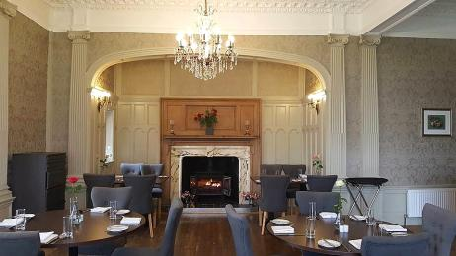
Forrester's Restaurant

Private Dining Room
- From the main entrance to this area, there is level access. The route is 1000mm wide, or more.
- The door is 1000mm wide.
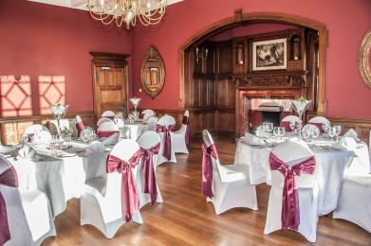
Inglenook Private Dining Room

Ballroom
- From the main entrance to this area, there is level access. There is a portable ramp. The route is 1000mm wide, or more.
- The door is 1000mm wide.
- From the main entrance to this area, there are 3 steps. There is no lift and no ramp.
- There are 3 steps from the main hotel reception down into our Ballroom. We do have a ramp which can be set up with advance notice, however, we have a separate level access entrance to the Ballroom which we find is easier to use. This involves travelling 20m externally.
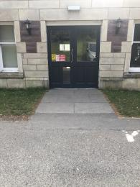
External Entrance to Ballroom

Getting around outside

Inglewood House Gardens
- From the main entrance to the gardens, there are 10 steps. There is no lift and no ramp.
- The route is sloped.
- The grounds are on a slope and it would be difficult for wheelchair users to access them.
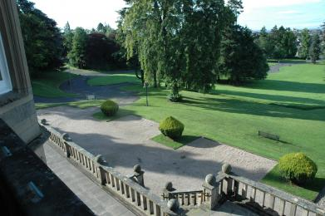
Gardens

Smoking

Smoking Area at rear of hotel
- From the main entrance to the smoking area, there is level access. The route is 1000mm wide, or more.
- The entrance is 1000mm wide.

Terrace

Terrace at front of Inglewood House
- From the main entrance to this area, there is level access. There is a permanent ramp. The route is 900mm wide, or more.
- The entrance is 900mm wide.
- To get to a table, there are no steps.
- There are 5 steps from the front door of the hotel onto the terrace, however, it is possible to go around the building on sloped pathways to get to the terrace. Please ask a member of staff for more information.

Customer care support

Accessibility equipment
- We have 27 acres of gardens and woodlands so the nearest toilet area for assistance dogs can be found very easily. We do ask that dogs are kept on leads at all times and that all dog waste is collected and disposed of.
- We have an area to charge mobility scooters and battery powered wheelchairs.
- Please speak to a member of our team who will be happy to assist.

Emergency evacuation procedures
- We have emergency evacuation procedures for disabled visitors.

Customer care support
- Some staff have disability awareness training.
- Staff are available 24 hours a day.

Guide last updated: 25 April 2019

