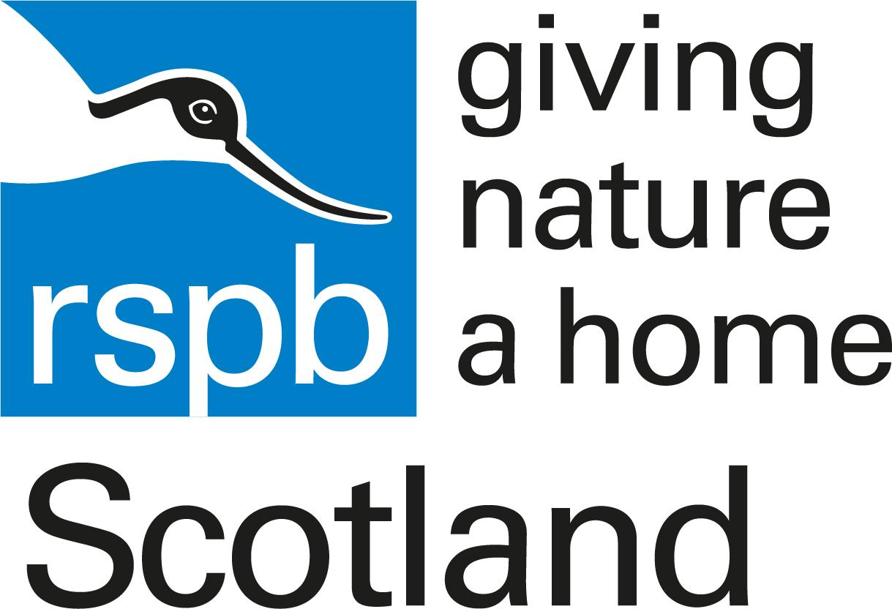

Accessibility Guide for RSPB Loch Gruinart Nature Reserve
loch.gruinart@rspb.org.uk, 01496 850 505, rspb.org.uk/lochgruinart
Contact for accessibility enquiries: Mark Shields
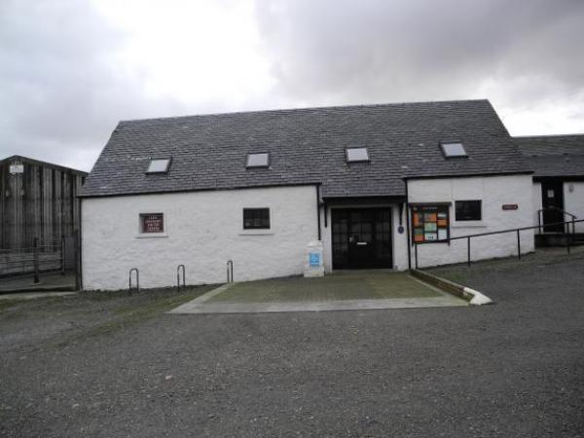

Welcome

At a Glance

Level Access
- There is level access from the main entrance to:
  - Visitor Centre Toilet
  - Visitor Centre
  - Viewing Platform
- The hide entrance has level access.

Hearing
- Some staff have disability awareness training.

Visual
- The walls and the doors have high colour contrast.
- Some parts of the venue have low lighting.

General
- There is at least 1 public toilet for disabled visitors.
- Some staff have disability awareness training.

Getting here
Loch Gruinart Visitor Centre
Gruinart
Isle of Islay
PA44 7PP

Travel by taxi
- You can get a taxi with Islay Taxis by calling 01496 850170.
- You can get a taxi with Lamont's Taxis by calling 01496 810449.
- You can get a taxi with Carol MacDonald Taxis by calling 01496 302155.

Parking
- We have a car park. There are accessible parking spaces. The parking is less than 50 metres from the main entrance. Parking is free.
- There is a drop-off point at the main entrance. The drop-off point does not have a dropped kerb.
- From the car park to the entrance, there is level access. The path is sloped.
- The route is 1000mm wide, or more.
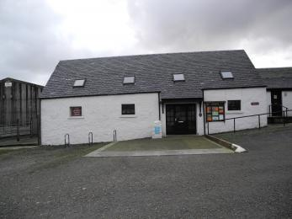
Visitor Centre Disabled Parking area

Arrival

Path to main entrance
- From the street to the main entrance, there is level access.
- The path is sloped.

Main entrance
- The main entrance has level access.
- The main door is side hung and manual.

Getting around inside

Visual Impairment - General Information
- We have high colour contrast between walls and doorframes.
- Some parts of the venue have low lighting.

Public toilet

Visitor Centre Toilet
- There is a public toilet for disabled visitors.
- From the main entrance to the public toilet, there is level access. There is a permanent ramp.
- The direction of transfer onto the toilet is to the left.
- The toilets have handrails.

Visitor Centre
- From the main entrance to this area, there is level access.

Getting around outside

Designated Walking Trail

Woodland Trail
- The trail is 1448metres long. Some of the trail has a loose surface. There are steps and bridges to cross along the trail. The trail is sloped. The trail has seats. There are bird hides along the trail.

South Hide
- At the hide entrance, there is level access. There is a permanent ramp. There are low windows in the hide, so wheelchair users can see outside.

North Hide
- The hide entrance has 1 step. There is no lift and no ramp.

Viewing Platform
- From the main entrance to this area, there is level access. There is a permanent ramp.

Customer care support

Accessibility equipment
- We have an area to charge mobility scooters and battery powered wheelchairs.

Emergency evacuation procedures
- We have emergency evacuation procedures for disabled visitors.

Customer care support
- Some staff have disability awareness training.

Guide last updated: 24 April 2019

