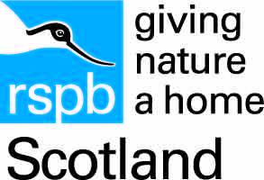

Accessibility Guide for RSPB Scotland Troup Head
strathbeg@rspb.org.uk, 01346 532017, https://www.rspb.org.uk/reserves-and-events/reserves-a-z/troup-head/
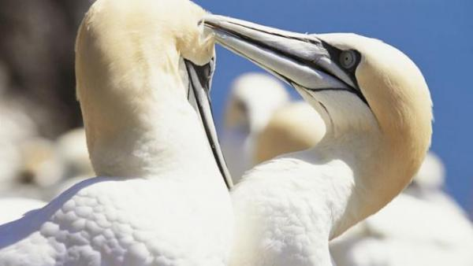

Welcome
The high cliffs of Troup Head provide a spectacular setting for Scotland’s largest mainland gannet colony. There are also thousands of kittiwakes, guillemots and razorbills here, along with several other species, including puffins. You may even be lucky enough to see porpoises, minke whales or dolphins offshore.

At a Glance

Getting here
RSPB Scotland Troup Head
Banff
AB45 3JJ

Travel by public transport
- You can get to RSPB Scotland Troup Head by bus.
- Troup Head is found between Pennan and Gardenstown on the B9031, east along the coast from Macduff. The bus stop is 1.0 miles / 1.6 km from RSPB Scotland Troup Head.
- Buses run between Fraserburgh and Banff on the B9031, please see bustimes.org for details.
From the road end to the reserve car park it is approximately 2km walk along unpavemented road and rough farm track
Troup Head nature reserve is signposted off the B9031. You will also see a sign for Northfield Farm at this turn off. Follow the RSPB brown signs until you reach Northfield Farm. Continue through the farmyard and onto a rough track until you reach the Troup Head reserve car park.

Parking
- We have a car park. Parking is free.
- There is a small car park with unmarked bays.
There are no designated accessible spaces.
Main path from car park to reserve gate is 920m of unconsolidated hardcore, sloped in places 1.2m wide with 1 accessible gate.
Gates on to reserve have restricted opening, the smallest is 35cm.
Steep flights of steps.
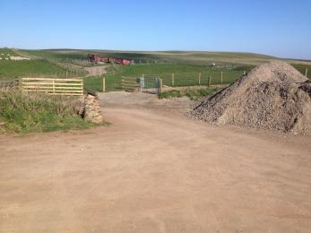
carpark photo

Arrival

Path to main entrance
- The path is sloped.

Main entrance
- Main path from car park to reserve gate is 920m of unconsolidated hardcore, sloped in places 1.2m wide with 1 accessible gate.
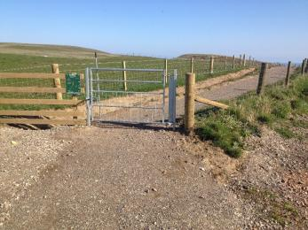
gatephoto

Getting around inside

Getting around outside

Designated Walking Trail

Troup Head Path
- The trail is 1500metres long. Some of the trail has a loose surface. Some gates have restricted width openings to 35cm. The trail is sloped.
- Main path from car park to reserve gate is 920m of unconsolidated hardcore, sloped in places 1.2m wide with 1 accessible gate.
Gates on to reserve have restricted opening, the smallest is 35cm.
Steep flights of steps.
550m of path on reserve which is narrow uneven and unsurfaced, going close to the unprotected cliff edge in places.
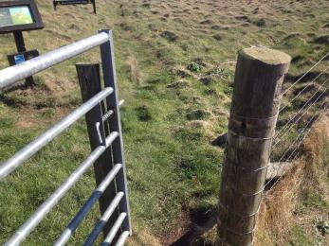
narrow gate photo
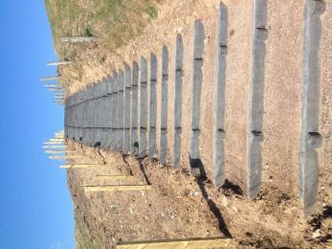
steps photo
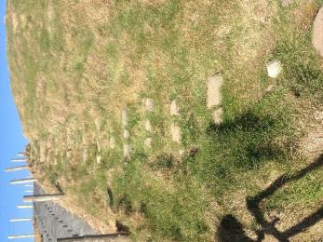
stone steps photo
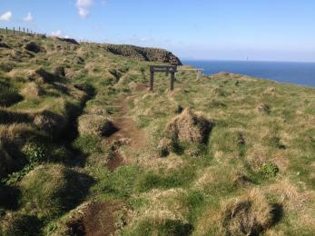
path photo

Customer care support

Guide last updated: 24 April 2019

