Accessibility Guide for RSPB Geltsdale Nature Reserve
geltsdale@rspb.org.uk, 016977 46717, http://www.rspb.org.uk/reserves/guide/g/geltsdale/
Contact for accessibility enquiries: Jill Jones
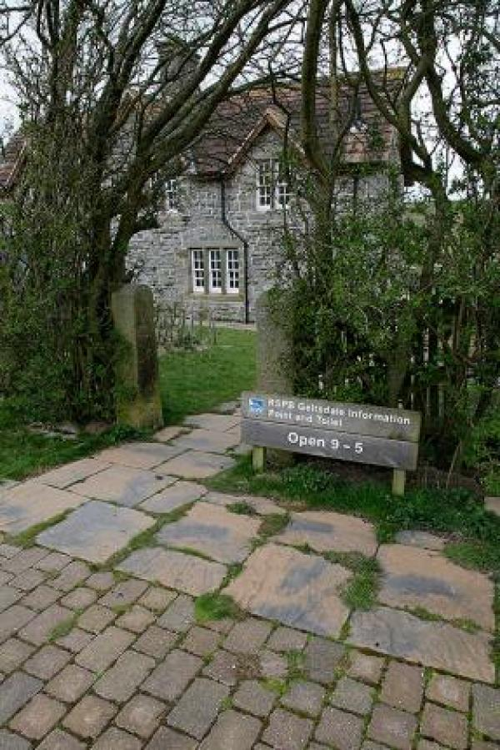

Welcome
RSPB Geltsdale reserve contains 5000 hectares of heather moorland and farmland. Wildlife highlights include breeding waders, black grouse and miles of open space.
The reserve is situated in the North Pennines AONB (Area of Outstanding Natural Beauty) and the nearest town is Brampton in Cumbria.
The reserve centre is situated in a valley with a steep descent down a rough track. Further details about the reserve can be found on our website http://www.rspb.org.uk/reserves/guide/g/geltsdale/.

At a Glance

Level Access
- There is level access from the main entrance to:
  - Stagsike Visitor Centre and Gallery

Getting here
Stagsike Cottages
Hallbankgate
Brampton
CA8 2PW

Travel by public transport
- You can get to RSPB Geltsdale Nature Reserve by bus and train.
- The nearest bus stop with a regular service is Brampton town centre approximately 3.5 miles / 5.6 km from the reserve. The bus stop is 3.5 miles / 5.6 km from RSPB Geltsdale Nature Reserve.
- The nearest train station is Brampton Junction. The train station is 3 miles / 4.8 km from RSPB Geltsdale Nature Reserve.
- Brampton Junction Station is situated out of Brampton town centre at Milton

Travel by taxi
- You can get a taxi with Brampton Cars by calling 016977 3386.

Parking
- We have a car park. Parking is free.
- There is a drop-off point at the main entrance. The drop-off point does not have a dropped kerb.
- From the car park to the entrance, there is level access. There is a permanent ramp.
- The path is sloped.
- The route is 1500mm wide, or more.
- Car parking is free of charge. There are 8 spaces at the reserve's public car park with seating, information and trail maps.
Two accessible car parking spaces are available outside the visitor centre. These are reached by opening a 12 foot (3.6m) wide gate and driving 1 mile along an uneven track with a severe gradient. Occassionally two additional 12 foot (3.6m) gates need to be opened along this track.
The accessible parking is situated 85 feet (26 metres) from the visitor centre entrance. The approach is paved, unkerbed and unlit. This is a suitable drop off point.
The approach to the visitor centre is paved with a 5 foot (1.5 metre) gate. The path has a 1:10 gradient at its steepest point. There is a wooden handrail 3.5 feet (1.1metres) high leading to the gate. There are no steps.
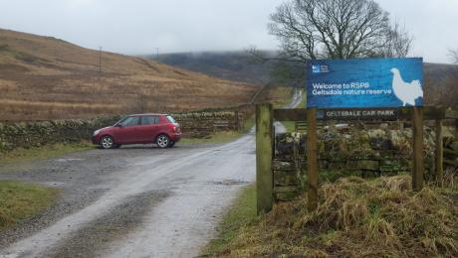
Main Car Park
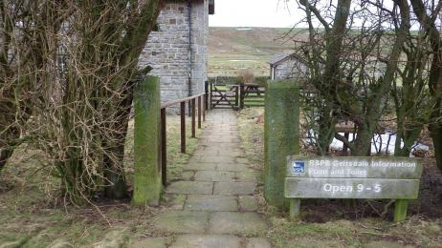
Path leading from Accessible parking to Visitor Centre Entrance

Arrival

Path to main entrance
- From the street to the main entrance, there is level access.
- The path is 1500mm wide, or more.
- The path is sloped.

Main entrance
- The main entrance has level access.
- The door is 760mm wide.
- The main door is side hung and manual.
- The approach to the visitor centre is paved with a 5 foot (1.5 metre) gate. The path has a 1:10 gradient at its steepest point. There is a wooden handrail 3.5 feet (1.1metres) high leading to the gate. There are no steps.
The entrance door is manual with a rounded metal and rubber threshold of 3 inches(75mm) wide, 0.75 inch (20mm) high. The door is of medium weight, needing a firm push to open it.
The door opens inward with a clear opening width of 30 inches (760mm).
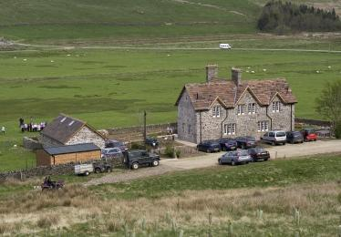
Stagsike Visitor Centre & Gallery
Pathway to Visitor Centre

Getting around inside

Stagsike Visitor Centre and Gallery
- From the main entrance to this area, there is level access. The route is 110mm wide, or more.
- The door is 75mm wide.
- The centre is open from 9am – 5pm daily and is free of charge. You can alert staff by use of a doorbell (5 foot/1.6m high) located within the visitor centre.
The visitor centre is level throughout with no steps. The floor is surfaced with uneven slate flagstones. Movable chairs are available.
There is no reception counter or ticketing area. There is no hearing loop system.
The centre is lit with flourescent tubing and the art gallery has spotlights. All lights are sensor operated.
Information on the walls is in clear print format. Signage is limited.
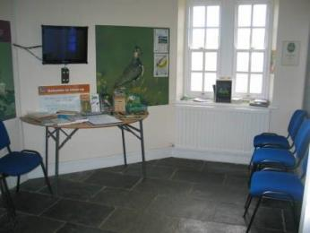
Inside the Visitor Centre
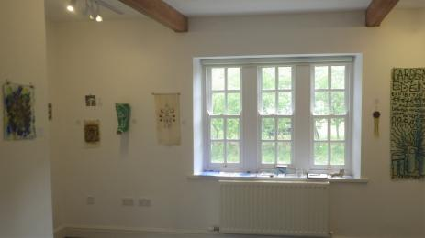
Geltsdale Gallery

Getting around outside

Designated Walking Trail

Stagsike trail
- The trail is 4828metres long. Some of the trail has a loose surface. Some of the trail has cobbles.
- The trail covers areas with rough road surfacing and steep slopes. There are sections of muddy track, a ford and several bridges, one which is 17 inches (430mm) wide. The trail is sloped. The trail has seats.
- Stagsike Trail is a circular walk almost three miles in length and starts in the reserve carpark. Allow 1-2 hours to complete. It is signposted in red and is drawn in red in the Geltsdale trail guide available from the main car park.
The trail follows uneven tracks and grassy paths through farmland with some muddy patches.
Halfway along the trail, 600 feet(200 metres) from the visitor centre, the trail reaches a ford. This is spanned by a bridge 17 inches(430 mm) wide with a handrail and a step up of 9 inches (230mm). The trail has 2 other bridges; one 30 inches(660 mm) wide, the other 8.5 foot (2.6m) wide, both without a handrail.
There are four field gates along the trail to open; three twelve foot (3.6m) wide and one nine foot (2.7m) wide. There is a five foot (1.5m) wide gate which can be used to avoid a cattle grid. All the gates on this trail are fitted with accessible latches. In addition there is a kissing gate next to a cattle grid at the trail end.
Two thirds of the trail follows a stony track 6.5 feet (2m) wide, also used by the reserve vehicles.
The trail passes a viewing screen at Tindale Tarn after almost a mile. The visitor centre is reached in just over one mile. This trail has some seating but has no interpretation.
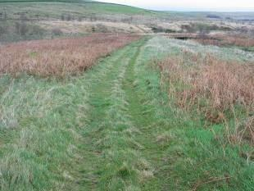
Grassy Path on Stagsike Trail
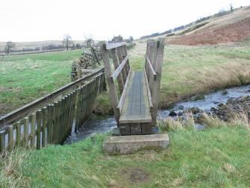
Narrow Footbridge with rails Crossing Stream
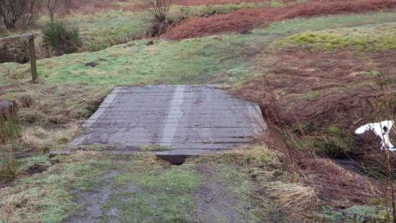
Bridge without Rails on Stagsike Trail
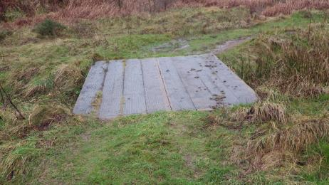
Bridge without Rails on Stagsike Trail
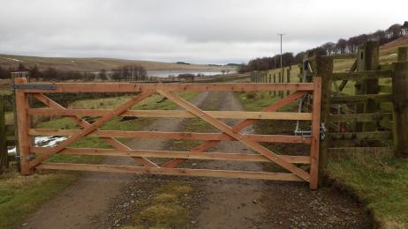
Large Fieldgate on Stagsike Trail
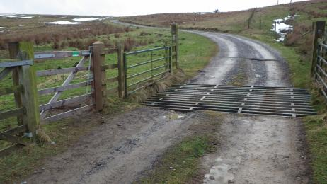
Cattle Grid on the Main Access Road to Stagsike Visitor Centre
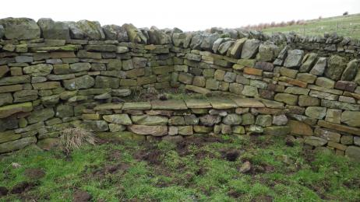
Stone Seating Area on Stagsike Trail
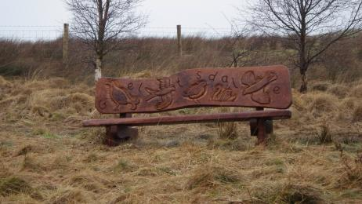
Carved Wooden Bench on Stagsike Trail

Designated Walking Trail

Woodland Trail
- The trail is 2414metres long. Some of the trail has a loose surface. Rough, steep and narrow footpath The trail is sloped. The trail has seats.
- This is a circular trail of one and a half miles, starting from the visitor centre. Allow 1-2 hours to complete.
It is signposted in green and drawn in green in the trail guide.
The first section takes a rough path, one metre wide up the fellside through recently planted woodland. This section is very steep,starting at an altitude of 675 feet (225m) at the visitor centre and summiting at 900feet (306m), over a distance of 600feet/ (200m).
The second section replicates a part of the Stagsike trail, crossing the same three bridges.There is a stone seat at the apex of the trail as well as seating in the visitor centre.
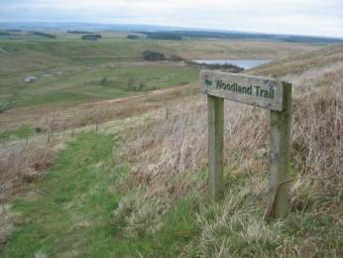
Woodland Trail Marker
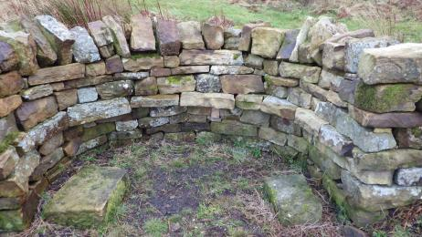
Stone Seating on Woodland Trail
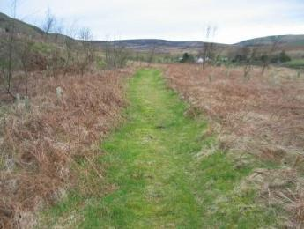
Section of Woodland Trail
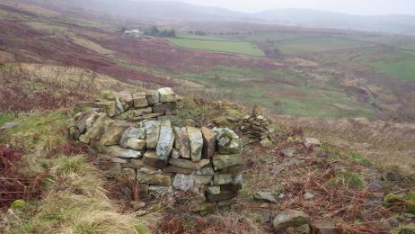
View from Stone Bench

Designated Walking Trail

Bruthwaite Viewpoint
- The trail is 4828metres long. Some of the trail has a loose surface. Steep and grassy route with a cattle grid in one section The trail is sloped.
- This is a linear trail of three miles return, starting from the reserve carpark. Allow 2-3 hours.
It is signposted in blue and drawn in the trail guide in blue.
The trail follows a steep path for almost a mile up the fellside through recently planted woodland onto moorland.
The path starts at an altitude of 721 feet (220m) at Howgill cottages and summits at 1476 feet (450m), over a distance of 1312 ft/ (400m).
The path is approx 6.5 feet (2 m) wide. It passes through a nine foot (2.7m) wide gate. There is also a kissing gate next to a cattle grid at the carpark. There are no bridges or seats en route.
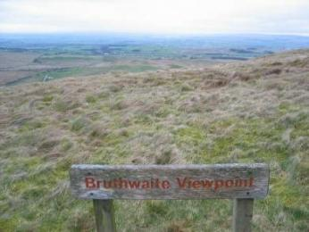
Bruthwaite Way Marker
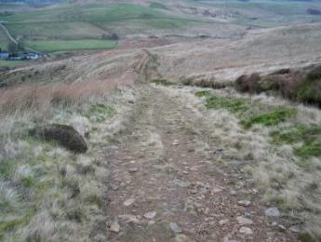
Bruthwaite Track
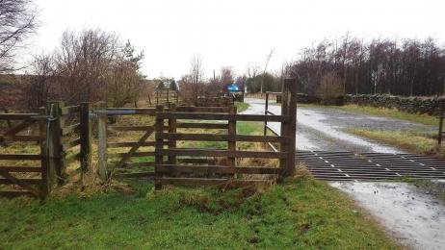
Cattle Grid and Kissing Gate on Bruthwaite Trail

Designated Walking Trail

Gairs Viewpoint
- The trail is 8047metres long. Some of the trail has a loose surface. The track is narrow with a rough and muddy surface at certain points. There are 2 large farmgates and 2 kissing gates on the route. The trail is sloped.
- This is a linear path of five miles return, starting from the reserve carpark. Allow 3 hours to complete.
It is signposted in orange and drawn in the trail guide in orange.
It is a rough, undulating track, 6.5 feet (2 m) wide, through moorland and newly planted woodland. In some parts the trail can be soft and muddy underfoot.
The viewpoint on the trail is reached at an altitude of 859 feet (262 metres).
The trail is accessed through a kissing gate next to a cattle grid at the reserve carpark.
The first part of the trail duplicates part of the Stagsike trail, taking an undulating stone track, eight feet (205m) wide.
Two ten foot (3m) gates need to be opened to reach the start of the trail.
A second kissing gate is then reached with five steps leading up to it. Each step up is 8 inches(300mm).
There are no bridges, stiles or seats.
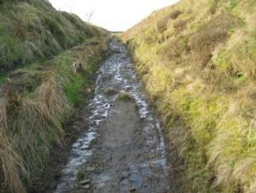
Narrow and steep area of track
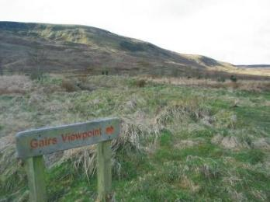
Gairs Viewpoint sign and open moorland
Kissing gate and cattle grid at the Trail start
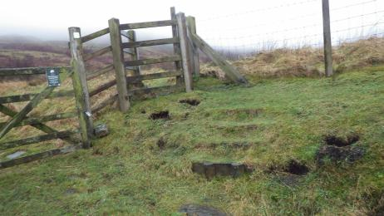
Second Kissing Gate

Designated Walking Trail

Forest Head Quarry Trail
- The trail is 3220metres long. Some of the trail has a loose surface. Wet, steep and uneven track with one kissing gate on the route The trail is sloped.
- This is a circular trail of two miles, starting from the reserve carpark. Allow 1-2 hours to complete.
It is signposted in purple and drawn in purple in the trail guide.
The first section takes the old railway line, seven feet (2m) wide, past a limekiln with a drop of 5 feet (1.5m) between the path and the limekiln. It passes through a gate 12 foot (3.6m) wide into a disused quarry and scheduled ancient monumnent with interpretation.
The second section is a wet grassy path, underlaid with matting. There are two short steep sections; 30 feet (9m) long with a 1:3 gradient . The path then leads over the old quarry with a drop of 15 feet (4.5m) to the side of the path. This leads through a 5 foot (1.5m) gate into planted woodland.
The third section replicates a part of the Gairs trail, taking a rough track down an old railway cutting to a kissing gate with five steps leading from it. Each step down is 8 inches (300mm).
The last section joins the Stagsike trail and follows a wide, stony track back to the carpark, through a kissing gate next to a cattle grid.
There are no stiles, bridges or seats
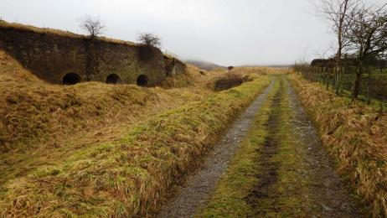
Old Railway Track at start of Walk
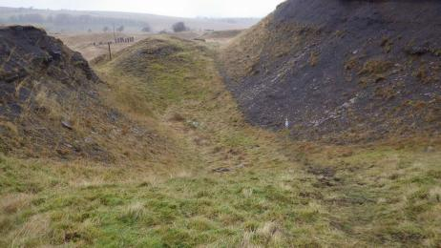
Quarried landscape at Forest Head Quarry
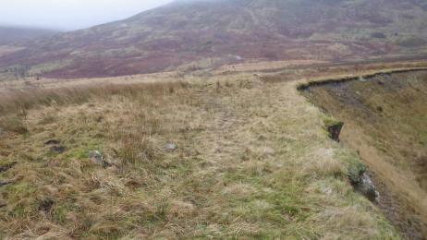
Open moorland with steep drop to the right above Quarry
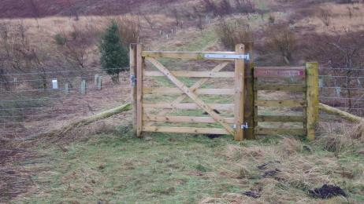
First Kissing gate
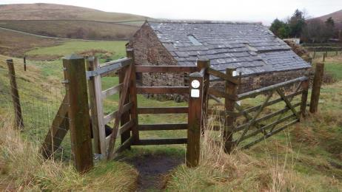
Second Kissing Gate

Customer care support

Accessibility equipment
- No Accessibility equipment available
- There is no toilet area for assistance dogs , however the Visitor Centre is surrounded by open countryside. Dog owners are asked to bag dog waste and dispose of at home.
- You can hire mobility equipment from Cumbria Mobility by calling 0800 6120 109.

Emergency evacuation procedures
- We have emergency evacuation procedures for disabled visitors.
- Fire Alarm will sound throughout the building in the case of fire.
All visitors to assemble in the car park in front of the building.

Customer care support
- Staff can assist members of the public 9:00am to 5:00pm Monday - Friday.
If visitors have special accessibilty needs or enquiries ring 016977 46717 or email geltsdale@rspb.org.uk

Guide last updated: 29 April 2019

